Mama Africa’s Vision

It's all Child's Play at Mama Africa Thanks to you!

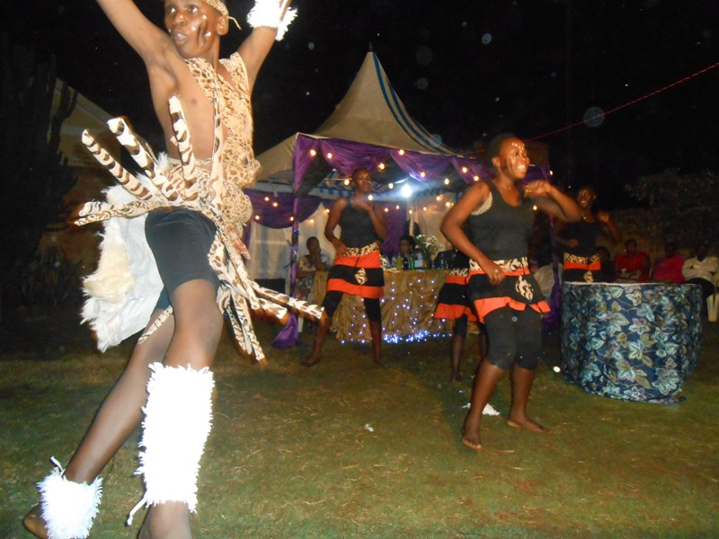

Kwera children’s Voice choir at Mama Africa l!
With your support, the kids at the orphanage are learning fast. They love school, and the older kids delight in helping the little ones learn their letters and numbers. They have finally recorded their song about Love and their video is out as well
But it’s not just about schoolwork at the orphanage. Uganda recently celebrated its major yearly festival were cadre’s graduated with their security course and Kwera was invited to bless the guests. The staff marked the event with a party – and the kids all dressed in costume! They had an absolutely brilliant time.
Without you, the children and staff at the orphanage would spend their days worrying about where their next meal was coming from instead of deciding on the best costume for this choir. Your generosity makes all the difference.
Global Giving will be matching all donations by 30%. That means that tomorrow, if you give just $25 you could feed all 63 children in the orphanage's care for a whole day.
We hope you’ll help provide a secure future for the kids at the orphanage by making a donation tomorrow. If you can’t give, we hope you’ll share https://www.globalgiving.org/projects/support-talent-education-skills-for-50-ugandan-orphans/ with friends and family and let them know how easy it is to change lives in Uganda East Africa
Thanks so much for your support, and we wish you all the very best!
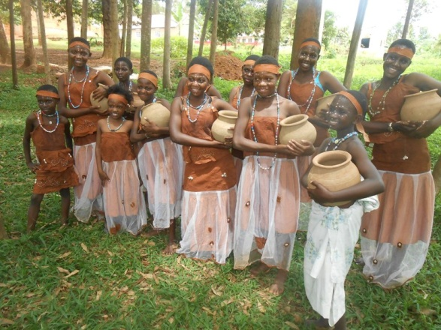
Playing dress up for Video shooting

Enjoy Love by Kwera children choir

