.

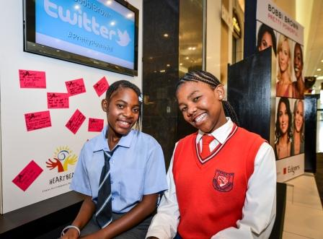

**Thepiso Tsomane**

**Youth Ambassador Katlehong**

**Shadie Masilela**

**Youth Ambassador Nellmapius**

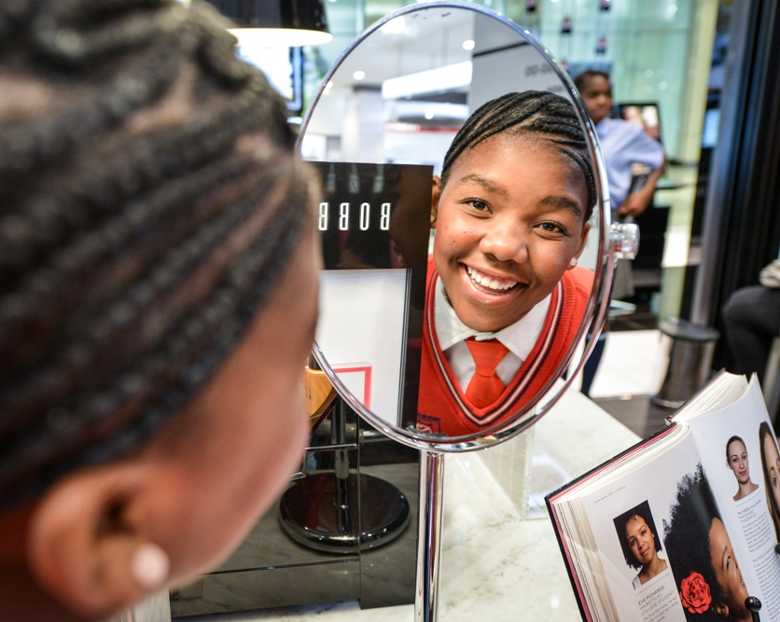

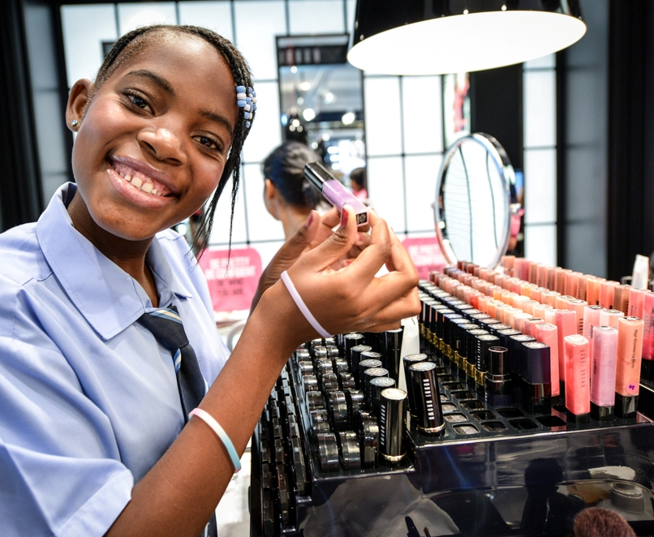

**Shadie and Thepiso received make-overs**!

**This is what Shadie has to say…..**

*“I was living with my mother and three siblings until my mom passed away in 2005. That is when I met Heartbeat and up to now I’m still a child of Heartbeat. It took me from a very bad situation and raised me. That is why I have almost everything I need. Heartbeat has made a big change in my life because when I walk in the streets, there is no mark that shows people that I’m an orphan. I have received more love and care than children who have parents. As beautiful as I am today, I am proud to say that I am a child of Heartbeat. I’ve received more than enough from Heartbeat and I dream that other children could get the same things. I also dream that Heartbeat could help me in terms of further education. Maybe I will help one of you as I wish to become a dentist! I must thank Heartbeat and the way to do it is to do what they want – to finish my school and to go further until I reach my career.”*