USAID/Ethiopia’s Proposal to Continue the Ambassador’s Girls Scholarship for Secondary School Students

A. Background

Although remarkable achievements have occurred in the last few years, the Ethiopian education system is still far below the sub-Saharan Africa standard. During 2002/2003 academic year, less than one in five girls attended secondary education. The gender gap in secondary schools increased from 1.8 percentage points in 1994 to 9.7 percentage points in 2002/2003 in favor of boys. Moreover, the repetition and dropout rates for girls at the secondary school level far exceed that of boys.

Girls’ access to school, their survival in the school system, and their academic performance are greatly affected by cultural and socio-economic factors. Studies indicate that the majority of rural families, who have very limited resources, frequently choose to send their boys to school and see no advantage to educating girls. Girls are encouraged to get married and establish families at a very early age. In fact, early marriage is major socio-cultural reality that curtails girls’ education. Also, many girls are responsible for household chores and caring for their younger siblings, leaving little time for homework and studying. As a result, their school performance suffers and girls end up either repeating grades or dropping out of school altogether.

As a result of the major challenges that Ethiopian girl students face, only 19.0% of all girl students who begin first grade are able to finish grade eight. This trend continues through the later grades, and only a very small percentage of girls stay in school long enough to complete the final secondary school leaving certificate examination. This has resulted in very limited access for girls to tertiary education and consequently in fewer professional women in the civil service and very few role models for aspiring young girls.

In response to situations like this in a number of African countries, the US Government’s Education for Democracy and Development Initiative (EDDI) and its successor program, the African Education Initiative (AEI), have been providing scholarship support to secondary school girls since 2000/2001 to promote girls education through financial assistance, tutorial services, and school clubs. The Ambassador’s Girls Scholarship Program (AGSP) in Ethiopia has been instrumental in supporting a total of 1,424 girls and young women (1,380 secondary school students and 44 university students). The scholarship program provides financial assistance to girls with good academic performance who would otherwise not be able to continue their education due to their poverty. The majority of scholarship beneficiaries come from remote rural areas where local access to education beyond primary school is non-existent.

B. Impact of the Girls Scholarship program

To-date, a total of 572 girls have completed secondary education. Some have succeeded in joining higher education institutions around the country. As indicated above, most of these girls are from rural areas, and most have been uprooted from their families to live alone in nearby towns where they attend secondary education. These are, therefore, girls who otherwise would probably not have continued in education without the support of this program.

The program has targeted girls in pastoralist and Muslim-populated areas around the country. These are the most disadvantaged communities in the country, and any support that addresses these communities goes a long way to remedy the critical inequalities in access to education.

Here is the story of a young girl, among many, to underscore the benefits of the AGSP:
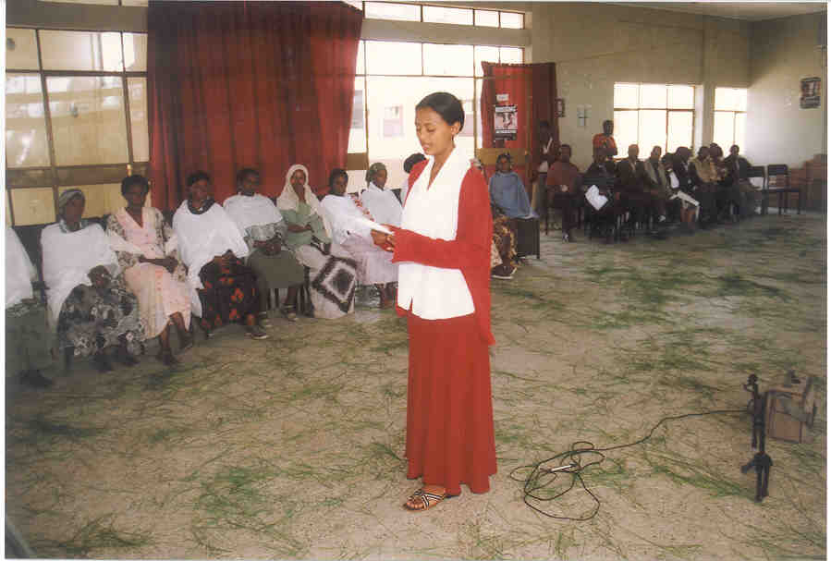

“My name is Segenet Wendawok. I was born in Gojam, Ethiopia. When I was five years old my mother died, and I lived with my father until he remarried. His new wife did not like me, so when she and father decided to move to Addis Ababa, they left me behind. Luckily, my grandmother took me in, and I lived with her and started attending school. When I was nine, she died and I was left with my aunt. At first she would not let me continue to go to school, and I was forced to stay at home to help with the family chores. After a year, my aunt relented and I was allowed to start school again. I attended school until grade 8, when my life became very difficult. My aunt’s husband began sexually harassing me, and the rest of the family also became abusive. Things were so hard that I finally summoned the courage to leave my aunt’s house, moving in with a friend. I worked hard to keep up with my schoolwork, but I was surrounded by so much chaos that I was unable to concentrate. At this point, my father heard what was happening to me and took me to Addis. Unfortunately, my life with my stepmother continued to be unbearable, and I decided to quit school and move away. I had just made this decision when I noticed the bulletin advertising a scholarship program. This opportunity was a ray of hope for me. Though my father and stepmother moved away I was able to remain in Addis and continue my studies. Now I am 20 and am graduating this year. I live on my own, with a friend from the scholarship program. I recently took the university qualifying exam, and hope to major in tourism management. I am very thankful to the Ambassador Girls Scholarship Program, FAWE, Pact and USAID for helping to provide me with a bright future. What I have learned from life is that if you are patient and able to endure the suffering around you, eventually you can succeed!”

C. Program Description and Budget

Program Objective

The overall objective of this proposed program is to motivate disadvantaged but academically high performing primary school girls to continue in their education. This program will particularly target girls with high academic performance. The Program will promote greater women empowerment; improve the lives and well – being of women, access to education and gender equality in the Ethiopia through educational system by:
- Establish Girls scout clubs: Through the already existing Girls Education Advisory committee “GEAC”, members of the scout club will play a critical role in educating the society towards girl’s education, gender equality and participate in community health care. The scout club will be providing humanitarian assistance to the community by supporting elders and the community as a whole.
- Fostering mentoring and tutorial services; In Ethiopia, one of major challenge in educating girls is socio – cultural influence and availability of high school around the rural areas. In order to face these challenges, the scholar ship program will include fostering. As these girls coming from different language speaking society, tutorial services especially in language, math and science is very helpful for them to achieve their goals.
- Organizing girls sport club; under this program, girls sport clubs will be established to enhance girl’s physical and mental development to bring positive change in young girl students.

In the previous AGSP schools, there is a committee called Girls Education Advisory Committee (GEAC). GEACs are composed of parents, teachers and students. The main objective of this committee is to work with the community to send their girls to school and as well as to solve the problems that these girls face at school. This committee will be strengthened to provide support to girls scout and sport clubs.

Under this proposal, five hundred secondary school girls from two cohorts of 10 each will be provided with scholarship support until they complete their four-year secondary education starting 2005/2006 (1998 E.C) academic year. According to the table below, the total budget required for the five-year support is $807,000

Program Activities and Budget

No. | Type of support | 2005/2006 |  | 2006/2007 |  | 2007/2008 |  | 2008/2009 |  | Total  Budget
No. | Type of support | # of girls | Budget | # of girls | Budget | # of girls | Budget | # of girls | Budget | Total  Budget
1. | Stipend (Food, clothing and school kits) | 500 | 128,000 | 500 | 128,000 | 500 | 128,000 | 500 | 128,000 | 512,000
2 | Tutorial services | 500 | 16,250 | 500 | 16,250 | 500 | 16,250 | 500 | 16,250 | 65,000
3. | Girls Scout club |  | 2,000 |  | 2,000 |  | 2,000 |  | 2,000 | 8,000
4. | Girls sport club |  | 5,500 |  | 5,500 |  | 5,500 |  | 5,500 | 22,000
5. | Program sustainability |  | 10,000 |  | 10,000 |  | 10,000 |  | 10,000 | 40,000
6. | Sub Total |  | 161,750 |  | 161,750 |  | 161,750 |  | 161,750
7 | Administrative cost |  | 40,000 |  | 40,000 |  | 40,000 |  | 40,000 | 160,000
 | Grand Total | 500 | 201,750 | 500 | 201,750 | 500 | 201,750 | 500 | 201,750 | 807,000

* Unit cost for stipend is $256.00
** Unit cost for tutorial is $32.50

Program Sustainability

USAID/Ethiopia believes that greater programmatic emphasis needs to be built into the AGSP on how to sustain girls’ scholarship, tutorial services and mentoring programs beyond the AGSP program. The Mission proposes to address the sustainability issue through a two-tiered approach. First, the technical committees within each school responsible for administering the AGSP will work closely with other stakeholders, including schools, education bureaus, and local organizations and associations that could partner with the private sector to raise funds to support girls scholarships. Various fund-raising training modules can be explored and provided to interested parties to enhance their fund-raising abilities. Second, the Mission proposes to work towards revitalizing and strengthen the Woreda (District) Education office, Parent Teacher Associations (PTAs) and Girls Education Advisory Committees (GEAC), including representatives of the private sectors. Moreover, the responsibilities of this committee should include advocating for girls’ education and raising funds for girls’ scholarships. The Mission believes that different approaches towards sustainability need to be discussed with relevant partners at the onset of the program, and benchmarks established.

USAID/Ethiopia proposes the provision of seed money in the amount of USD 20,000 each year to support activities that would lead to the establishment of a national fund for girls’ scholarship. The indicated amount will support activities working towards forging partnerships among various actors including government institutions, the private sector, and the donor community, and raise funds for girls’ scholarship.

D. Oversight and Implementation Mechanisms

The Mission has identified constraints and successes from the previous experience and believes that lessons learned from the past will put it in an excellent position to implement an even stronger program. Technical committee members mainly composed of the community and GEACs manage the program by working closely with the implementing partner, Woreda Education Offices and PTAs. These committees have better knowledge and understanding of their responsibilities in administrating the scholarship program including advocating girls’ education in the community. GEACs will work closely with the students and the school administration to identify the challenging problems that girl students face and seek a mechanism to solve it and keep the students in the school.

The Mission will ensure that solid implementing modalities and mechanisms are in place prior to the start of implementation. A clear understanding with respect to the implementation of activities, reporting, and monitoring and evaluation will be reached with all partners. AGSP will be implemented in close collaboration with Government, implementing partners, and other relevant parties such as schools and regional education bureaus. A technical working group comprised of USAID/Ethiopia and implementing partners will be formed to oversee implementation and will meet quarterly.

E. Monitoring and Evaluation

The proposed AGSP program is linked to the Mission’s education portfolio “Basic Education Services (BES)” – Use of Quality Primary Education Services Enhanced. In particular, increased enrollment of girl students contributes to the Missions efforts to advance gender equity in Ethiopian primary schools.

In collaboration with its partners, USAID/Ethiopia will develop a performance-monitoring plan for tracking specific results in supporting girl’s education through the AGSP program. One way of measuring program progress would be to monitor beneficiary girls’ academic performance. Proxy indicators might include the percentage of beneficiary girls passing the regional exam.

The Mission will closely monitor compliance with reporting requirements. All partners will be encouraged to collaborate in order to achieve maximum impact in implementing AGSP. A mid-term evaluation of the program and end of project evaluation will be carried out. The Mission will carry out its own small-scale evaluations during implementation as part of its oversight and monitoring responsibilities to ensure that the AGSP stays on track.

F. Contact Persons
USAID/Ethiopia’s Office of Basic Education Services of USAID/Ethiopia, which manages the Mission’s education programs, will be responsible for AGSP program implementation and oversight. Elfaged Amanuel, a member of the BES team is the immediate contact person for AGSP and he can be reached at 251-1-510-088 ext.331 and e-mail: eamanuel@usaid.gov . Aberra Makonnen Office Chief of BES will supervise the overall implementation and is the back-up contact person for this program. He can be reached at 251-1-510-088 ext. 203 and his e-mail is abmakonnen@said.gov.

