Global Giving Income-Generating Activities Program
Report on activities between September – December 2011

NEW GG IGA BENEFICIARIES
Over the last four months, Pathfinder International, with support from GlobalGiving, has provided six new women with support for income-generating activities.

- Yeshareg Abate Yeka sub-city August 2011
- Aylush Denbel Yeka sub-city August 2011
- Worknesh Teshome Yeka sub-city August 2011
- Tsige Mekonnen Yeka sub-city August 2011
- Meriem Kemal Arada sub-city November 2011
- Emebet Abebe Arada sub-city November 2011

As a sustainability strategy, the newly selected IGA beneficiaries have been linked to a microfinance office within their respective district administration. This network enables the beneficiaries to receive legal status for their businesses, training and loan services, and assists them in securing work space. Below, please find brief profiles for the six new beneficiaries of the income-generating activities program in Ethiopia.

Yeshareg Abate lives in Yeka sub-city, Woreda 9 and is a single mother with one daughter. She was working as a daily laborer to feed her baby and herself, but through this, did not earn enough money to buy a daily meal. Since receiving the GlobalGIving IGA program support, Yeshareg has started her own business, baking and selling Enjera. She says, “I am very grateful for the GlobalGiving support, now I feel self secured, with this business I can support my family and feed my child properly.”

Aylush Denbel is from Yeka sub-city, Woreda 9. She has a diploma in hotel management, and has embroidery skills. Aylush is a single mother of one daughter. She is educated and has business knowledge and ambition like baking and selling Enjera (local bread), but due to financial issues is unable to work and support her family. Thus, after assessing her problem, the Yeka sub-city women’s association recommended her to the AAWA executive committee to become a beneficiary of the GlobalGiving IGA assistance program. After receiving the GlobalGiving IGA support, she started working on a small business, baking and selling Enjera bread and she also prepares embroidery products in her spare time.

Worknesh Teshome is from Yeka sub-city, Woreda 13. Her husband abandoned her and their two children, leaving Worknesh with no support. She was working as house maid to support her family; however she makes very little money in this work and cannot properly feed her family. As a result of the GlobalGiving support, Worknesh has no now started a small business baking and selling Enjera bread in order to sufficiently feed and care for her family.

Tsige Mokenen is from Yeka sub-city, Woreda 13. Her husband recently died and she is now the sole supporter for her three children. As a daily laborer, she makes a very small amount of money and is unable to feed her three children and herself.

Though Tsige strongly believes that baking and selling Enjera bread would be productive and profitable work, she had insufficient funds to start the business. The sub-city women’s association reviewed Tsige’s application, assessed the extent of her problems, and as a result, recommended her for the GlobalGiving IGA program support, which was approved by the AAWA executive committee. After receiving the financial support, she started a small business of preparing and selling Enjera as she had hoped.

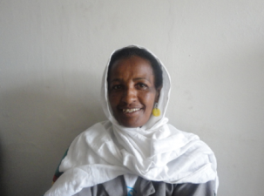
Merima kemal lives in Arada sub-city, Woreda 7. She has limited education, as she stopped going to school in 9th grade. She is widowed and has two daughters and one son who all attend school. However, as a single mother and housewife, supporting her family is extremely difficult. She has the desire and drive to work, but has lacked sufficient funds to run any kind of business. As a result, she was provided with a seed grant from GlobalGiving to start up a small business. She is now running a poultry business with her friend who has also received the GlobalGiving support. She is extremely pleased with the GlobalGiving financial support as it enabled her to start a business and in turn change her life and the lives of her children.

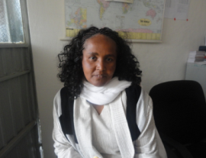
Emebet Abebe lives in Arada sub-city, Woreda 7. She also stopped going to school in 9th grade, so has limited professional skills. She is a divorced and has 2 daughters and one son, all of whom attend school. As she had no income and no one else to help support her children, it was incredibly difficult for her to properly feed and educate her children. As a result, the sub-city women’s association recommended her for the GlobalGiving seed grant. After receiving the support, Emebet started a small business running poultry in collaboration with Merima Kemal, another GlobalGiving beneficiary. Emebet said, “I am very much delighted and grateful for the GlobalGiving seed grant support, and I am confident enough that, I would work hard, so as to bring a change in my future life and properly educate my children.”

