GLOBAL GIVING SCHOLARSHIP PROJECT Update

Introduction
Pathfinder International, with support from Global Giving funds, started providing scholarship support for economically vulnerable and academically strong girls in order to increase the retention of female students at a higher level of education. Between 2008 and now, a total of 65 girls have been supported. Many girls are just now starting the school year and as a result of the Global Giving scholarship funds, are able to buy their mandatory school uniform and other necessary school materials.

Profile of current scholarship beneficiaries

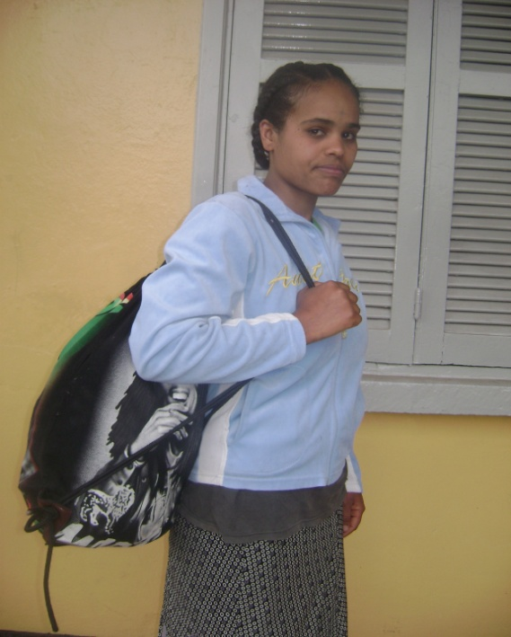
1. Etaferahu Dange was born in the Gulele sub-city Woreda 3. She is currently 17 years old and an 11th grade student at the Dilber Secondary School.

Her father died in a car accident so she lives with her mother who makes a living by washing clothes as a daily laborer. Despite this job, there are some days that her mother does not get paid and thus cannot buy daily bread for Etaferahu.

Etaferahu is an outstanding student, ranking 1st out of 33 students, but due to her family’s financial problems, she had difficulties fulfilling the necessary educational requirements and continuing her education. She was then identified by the sub-city women’s association and the AAWA executive committee then recommended her for the Global Giving girl’s scholarship assistance. As a result of the Global Giving scholarship support, Etaferahu now goes to school consistently and is able to meet all of the requirements of her class.

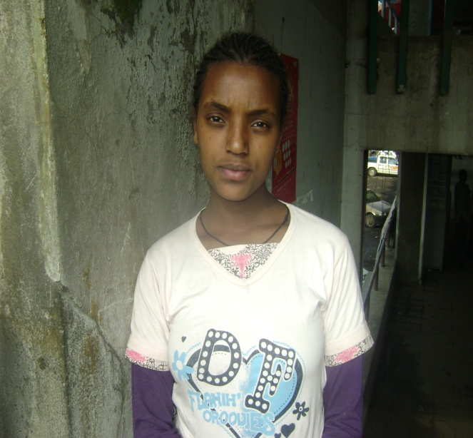
2. Amarech Masresha was born in south Gonder of Nefas Mawcha woreda. Her parents are farmers in the remote area of the woreda and have insufficient income to support Amarech. At age 5, she went to Addis Ababa to live with her aunt and enroll in grade one of school.

Unfortunately, her uncle, the supporter of the household, died and there was nobody to support Amarech and her aunt. She struggled in school, and was on the verge of dropping out when the school community understood her problems and applied for scholarship assistance on behalf of Amarech. As the result, the AAWA executive committee approved the Global Giving scholarship grant and Amarech is currently in 11th grade at the Entoto Amba secondary school. She ranked 3rd out of 52 students this year and continues to be an incredible student.

3. Yematawork Bezawork was born in Amhara region of Bulga Awraja. Her parents led their life through very low subsistence farming. She is disabled (likely due to polio virus).

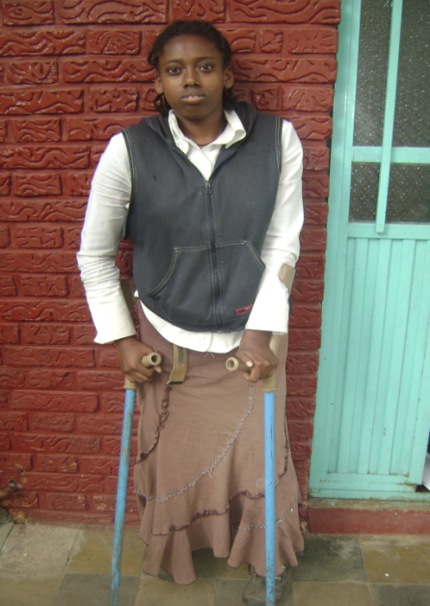
At an early age, Yematawork was sent to a charitable organization called Meskane Huzunan children fund in Addis Ababa. When she was a 9th grade student, the institution closed and there was nobody to support her with a home or food. Yematawork’s disability combined with hunger, lack of clothing, and shelter, was an incredibly challenging situation.

Fortunately, an older woman found her and offered her a temporary place to stay in a kitchen corner. Yematawork attended school, but there were times she went with no breakfast and came home with no dinner. The sub-city women’s association, recommended her for the Global Giving scholarship opportunity, and since May 2008, Yematawork, has been a beneficiary of your support. She understands the value of this great opportunity and works hard to be the outstanding student that she is. Yematawork said, “The Reproductive Health, Gender and HTP as well as the life skill training given by the A.A.W.A, along with the global giving scholarship financial support has given me strength, courage, self confidence and self realization, in all my studies and other life aspects. As the result of this, I have scored 350 points in the E.S.L.C. examination, which enables me to join university at the architectural engineering department which is my primary choice. Thanks to the Global Giving scholarship support I reached one stage. I will make all the necessary effort and struggle to accomplishment my study and change my life in the future.”

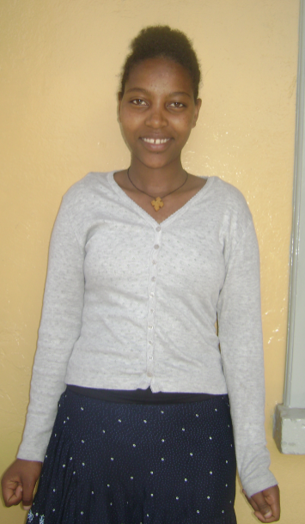
4. Desta Melaku: Was born in the Amhara region of Lasta. At age 4, she came to Addis Ababa with her parents, two brothers, and her sister. Her father is a priest at the local church and her mother is a house maid. Combined, they make very little money to support a family of five.

Desta is an outstanding student but her parents were not financially in the position to continue to support her education. While she was on the verge of dropping out of school, the school authority recommended her as a recipient of the Global Giving scholarship. She has now been a beneficiary of this support since August 2009.

Desta recently took the ESLCE exam scoring an average mark of 417 and passing on to University. In the future, Desta plans to join the medical college and become a Doctor to help the poor and society at-large.

Desta explained her experience as a beneficiary, “Since my parents get sick very often, I was at the verge of dropping my education so as to replace my mammy, and cover all the house chores. The scholarship assistance has given me strength, courage, and full confidence to continue my education… I would like to express my utmost gratitude to Global Giving for the scholarship support they provided me and enable me to reach this stage and shape my future.”

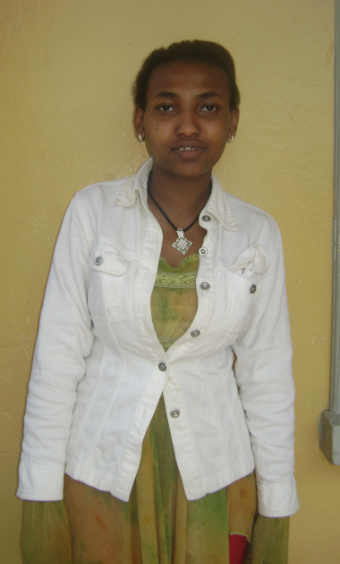
5. Rediet Abebe was born in Addis Ababa. Her parents got divorced at a young age and Rediet was forced to live with her aunt. She was expected to support her aunt with household tasks and as a result was unable to attend school regularly.

Considering her burden, the school community recommended her to the AAWA for the Global Giving scholarship support, and she has now been a recipient since May 2008.

Rediet is now 19 years old and the scholarship support has changed her life. “This support has inspired the darkest and gloomy ambition I had. I feel very lucky for being able followed my education properly with great desire and ambition. It has given me carriage, with this I did work hard and succeeded in my high school education, for this, I have scored an average of 370 in the ESLCE which would help me join the university and get graduated as health officer”. The knowledge that I got from gender and reproductive health and life skill training I took along with the scholarship support helped me to develop my self confidence and have vision and to continue working hard in my future education as well as future career.”

Rediet also said that, “I would like to express my heartfelt gratitude to Global Giving for their assistance, had it not been for their support I would not reach this stage, such kind of scholarship assistance would help to change girls who have similar life challenges and it would save girls life from being victim of different gender based violence and sexual exploitation and enable them to change their life.”

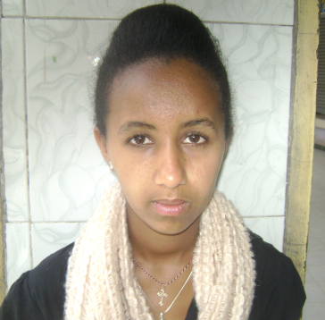
6. Samrawit Engdashet: was born in 1994 in Addis Ababa. She does not know her mother and was raised by her father who then died when Samrawit was only 6 years old. She then moved in with her aunt and was supported by her uncle. After some time, her uncle also died, leaving his 6 children and wife with little support or finances. Samrawit was unable to continue her education until the sub-city women’s association recommended her for the Global Giving scholarship support and she has now been a recipient of this support since May 2008. She is now 17 years old and has completed the 12th grade. She took the ESLCE exam and scored a 303 which will put in her in a good position to attend University. Samrawits plans to be a medical doctor in the future.
“As a student, I need not luxurious things except very simple and very important things for my education. Thus, I am very much pleased and delighted to get such kind of scholarship assistance that enables me to buy the school materials I need. The scholarship assistance has enabled me to continue my education properly; it gives me strength, courage, self-confidence and self-realization. Thus, I would like to extend my gratitude to Global Giving.”

7. Chekolech Tegeng was born in Gayint district of Amhara region, and came to Addis Ababa at the age of 9 to start living with her aunt. Her aunt worked as a house maid with a very minimal salary and could not afford buying school materials for Chekolech.

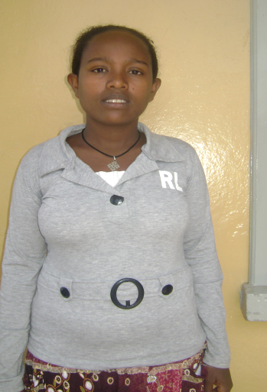
Chekolech was a very clever student, always ranking 1st - 3rd in her class. However, as a result of her financial limitations, she could not continue school. Thus, she was offered a Global Giving scholarship in May 2008 and has since completed her secondary education. Chekolech took the university entrance exam, the ESLCE, and scored a passing grade of 392.

Chekolech explains her gratitude for Global Giving stating that, “I am very lucky for getting this scholarship opportunity; it helped me to reach this stage. The scholarship was a big support for a girl coming from a difficult circumstance like me. I have not enough words to express how much I am delighted and grateful to the Global Giving fund for giving me such scholarship support. Moreover, I plead and suggest that giving such kind of scholarship to more misfortunate and clever female students will contribute a lot in changing their life and will also help the country at large to create more empowered and productive female citizens.”

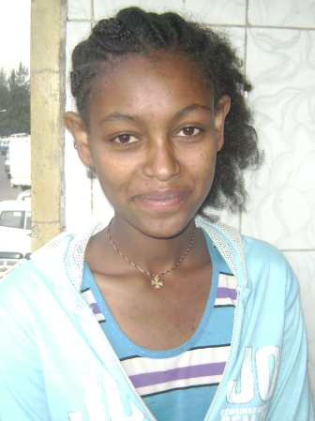
8. Fikrte Tene was born in Addis Ababa. Her father sells firewood and her mother is a house maid. Their daily income is very limited they cannot afford supporting their eight children. The sub-city women’s association recommended her for the scholarship opportunity and since January 2010 she has been a beneficiary. Fikrte is an outstanding student who often ranks 2nd in her class. This year she took the ESLCE and scored 334 points, which allowed her the opportunity to apply to University. “I am very much grateful for the global giving scholarship opportunity. In the future I would like to join university at engineering factuality; I have a dream to become future productive engineer. “

