GlobalGiving Scholarship Program
Report on activities between July-September 2012

As this reporting period coincided with the end of the academic year, there were no new recruits during this reporting period; however, a one-month scholarship extension was given for three girls whose accounts ran out of money before they were able to take their exams and complete their school year. Providing additional support to selected girls so that they are able to complete their education is essential. Those who face financial barriers often do not return to school. Scholarship extension support was given for three female students: 1) Yetmwork Bezawork, 2) Chekolech Tegegne, and 3) Rediet Abebe in order to enable them finish the academic year.

Additional students will be recruited at the beginning of the Ethiopian school year and be provided with 24-month scholarships dependent on funding levels. As indicated in the last quarterly report, we have a total of 70 GlobalGiving scholarship beneficiaries.

Scholarship Extension Recipients:

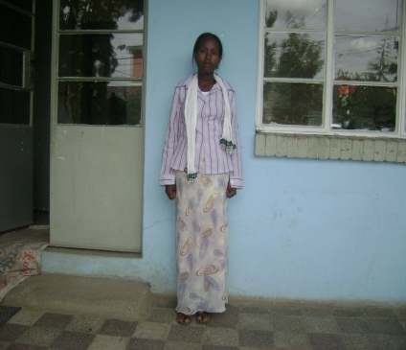
Chekolech Tegegne lives in Addis Ababa Yeka sub-city with her aunt. When both of her parents died, her aunt took her in and helped her with her education. Chekolech is an outstanding student, however, her aunt is very poor and was unable to support Chekolech education for the long-term. Chekolech applied for a GlobalGiving scholarship and after the school committee and based on her educational performance and financial need, she was granted a scholarship. Chekolech was able to finish her secondary school and passed her exams to enter university with high marks. She was given a four month scholarship extension to help her finish this academic year.

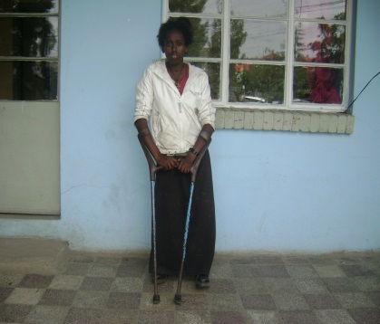
Yematawork Bezawork is living at Gulele sub-city. She is disabled and she lost both of her parents when she was a child. She is living with a good Samaritan woman who voluntarily offered her home to Yematawork. Yematawork is an outstanding student, but because of her economic hardship she had difficulties continuing with her education. She then received a GlobalGiving scholarship and was able to continue at school. Yematawork has received remarkable results on her exams for university and is one of the highest achievers in her school. She received a four month scholarship extension to help her finish this academic year.

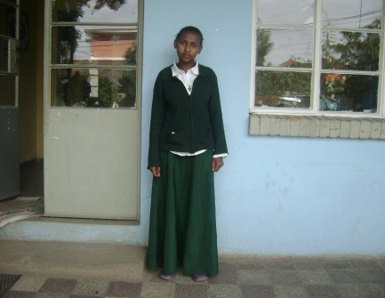
Rediet Abebet is living Arada sub-city with her mother who is poor and working as house maid. Though Rediet is an outstanding student, her mother was unable to support her education properly. Rediet received a GlobalGiving scholarship to support her education. Rediet is completed secondary school and is now able to move on to university study. She received a four month scholarship extension that allowed her to finish this acadamic year.

