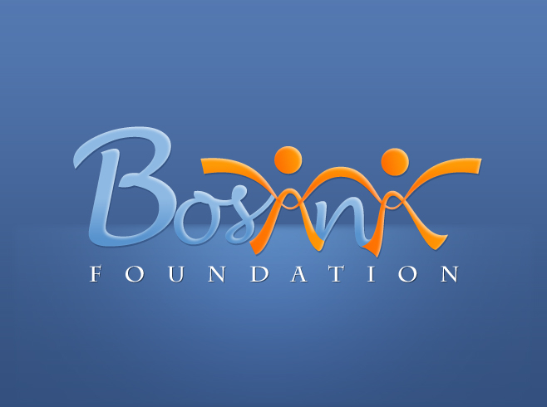

BOSANA FOUNDATION
Scholarship and Professional Development Program
Quarterly Report
January – March 2013

Executive Summary:
Finishing with our holiday party in Los Angeles, we have also continued full steam in this quarter as we had to organize our promotional event in March in Sarajevo and silmultaneously start planning our annual event coming up in April. These events have been very important for the success of the scholarship program because it is directly connected. The amount of money that we are able to raise at these events directly affects how many new students we are able to accept for the following school year.

Students and Program Update:
Most importantly, the program has been strenghtened as far as reporting and monitoring & evaluation. We have had also a number of significant donors contibute towards the program, not only financialy but also providing their resources as mentors and advisors to the program.

As for students, the majority of our students have successfully complete their fall/winter semester. Our of our twenty one (21) students, there are only about four students that might concern us. For those students that we managed to match a mentor have also shown great progress and benefit. Mentor not only provide an additional help to our students but they also serve as an additional helping hand to make sure that we do our best to help students succeed. Where we are not able to provide even closer relationship with each of our students, mentors fill in the void by speaking to our students on regular basis, encouraging them and visiting when possible.

This march, we had an opportunity for all students to meet and spend the day together in Sarajevo. Reason for the gathering was our Promotional event with the Sarajevo Film Festival; however, we used the opportunity to do some sightseeing, have lunch together, exchange students' experience and find ways how we can make the scholarhship even more effective. It was so fullfiling to see students really bond, enjoy each others company and really become part of a large family. These sort of gatherings have proven to be very effective so we hope to have many more. Here are few photos:
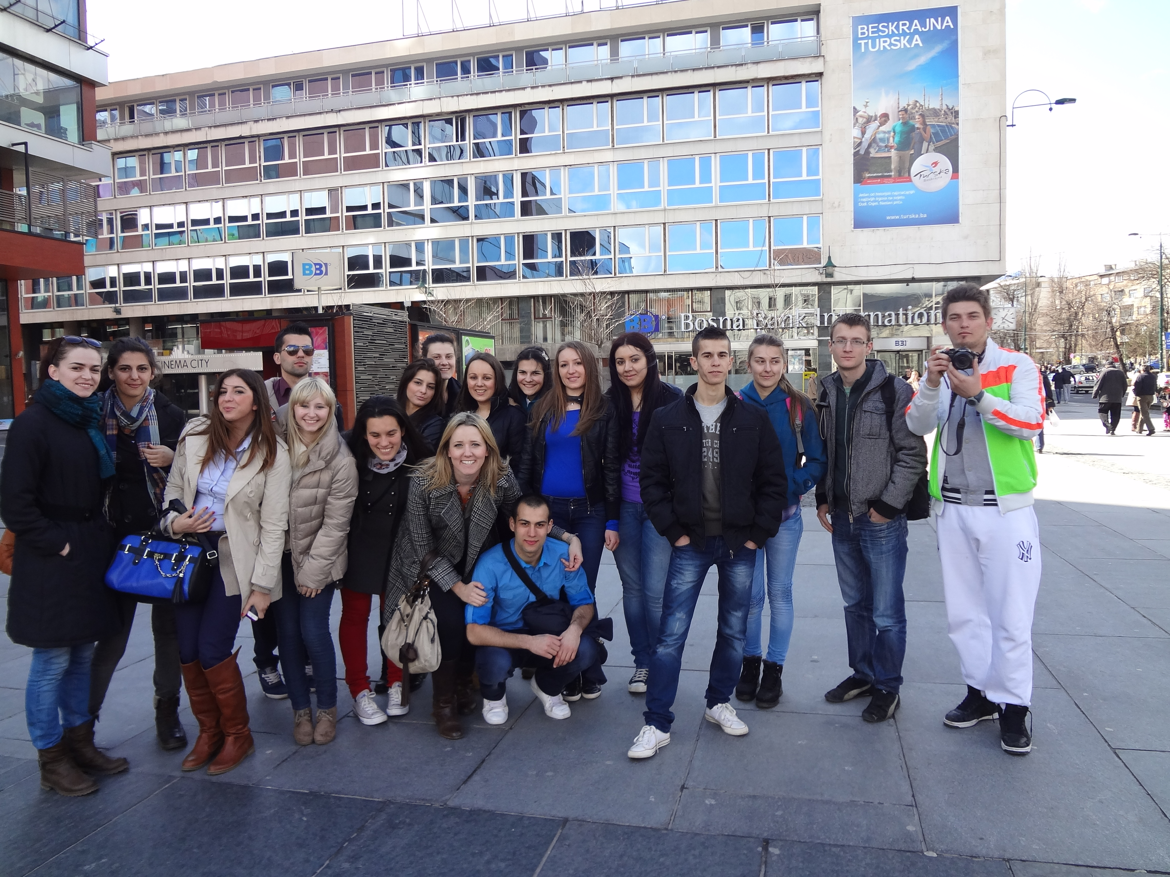
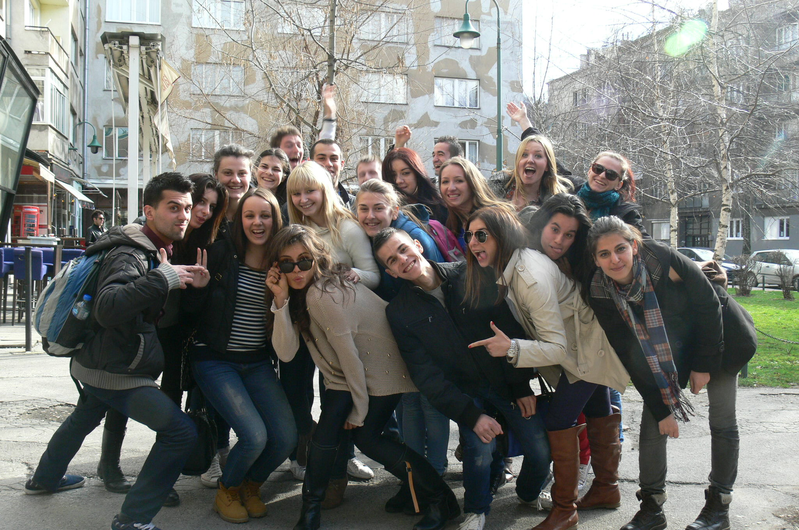

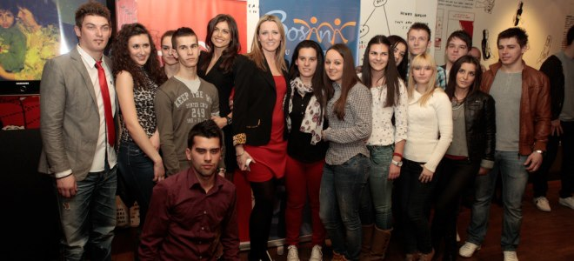

Noticable Improvements:
We have had a number of improvements not only with our students but also with our monitoring and evaluation of the program. Some of the most important ones are:
- We have motified our scholarship application to include more information about our potential students that would help us better monitor their progress.
- We have improved our monthly progress and volunteer report that each student fills out monthly so that we have more information about their progress during the semester.
- This quarter we have also included «Student Progress Card» that each student has to fill out at the beginning of semester to inform us when he/she has exams so that we can provide additional support when necessary.
- We have also noticed that our older students are helping the new students to get more familiar with the scholarship, they help each other with reports and to pass exams. This was done before but it was not as systemic as it has become evident this year.

CHALLENGES:
Challenges in this semester have been with those students who have not passed all of their exams. The educational system the way it is set up in Bosnia and Herzegovina, it is normal that student have to retake their exams, sometimes more than twice, while they are able to move to the next semester and year. However, they can only take 2 classes to the next year. Some of our students have not passed four classes but that also is not of concern because they can retake it in summer. Cause for concern is if they do not do well in this coming semster and have too many classes to take during summer. Currently, out of our twenty one (21) scholarship recipients, there are only four that we are worried about. To lessen the chance of losing the year, we have already encouraged our students to take tutoring lessons.

