
Help empower low-income communities! 
Make a secure,
tax-deductible donation online.
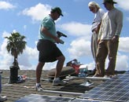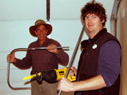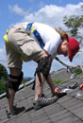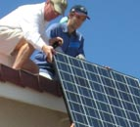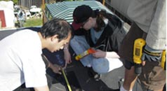
Latest News | eNewsletter | GRID in the News | Additional Resources

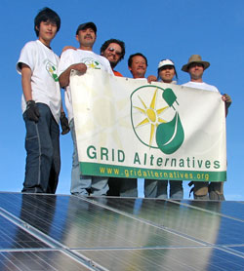
Letter from Erica Mackie, Executive Director and Co-Founder
It feels like spring just started, but 2008 has already been a year of growth here at GRID Alternatives. We've got a lot of great new faces around here, and I want to make sure I welcome them all - Jahahara Amen-RA Alkebulan-Ma'at, our new Outreach Coordinator; Recheal Allamby, Volunteer and Training Coordinator for the Bay Area; Michelle Andry, Program Assistant for Greater Los Angeles; Anna Bautista, Volunteer and Training Coordinator for Greater Los Angeles; Colin Bright, Program Assistant for the Bay Area; and Shamir Chauhan, new Project Manager. We're continuing to spread our Solar Affordable Housing Program throughout the state - in the Central Valley we've just completed our first six installations in Fresno, and in Southern California we're building a pipeline of new projects in partnership with several local jurisdictions and Habitat for Humanity - see below for the details.
Unfortunately we've also recently had tragedy in the GRID Alternatives family. One of our clients from last year, Ken Arthur, was senselessly killed in Bayview last week. You can read the details at SFGate.com or the Habitat SF website. Habitat has helped set up a memorial fund to help the family with arrangements. To contribute, please send checks made out to “Ken Arthur Family” or “Angela Lincoln-Arthur” to Union Bank of California, c/o Arthur Family Memorial Fund, 3801 3rd Street, Suite 100, San Francisco, CA 94124.
On a more uplifting note, we also want to congratulate our most recent Solar Installer Job Trainee, Kwok Leung. That's him on the left in the photo above, showing off the results of a long day's work along with some of our Fresno homeowners, GRID staff and volunteers. Kwok came to us from the Treasure Island Job Corps program, and is now finishing up his three month paid internship with GRID Alternatives building his hands-on experience on our low-income solar installations, and has recently been accepted into PG&E's PowerPathway training program. We're now bringing on our next Job Trainee, Sherroy Moore, who is a recent graduate from our partners at Richmond BUILD, and have created a new job training partnership with JobTrain/OICW in San Mateo County. It's great to be able to support these great job training organizations and help folks from the low-income communities we serve get the experience they need to secure long-term careers in the renewable energy industry. Here's to green jobs, solar rooftops and better futures in low-income communities. --Erica

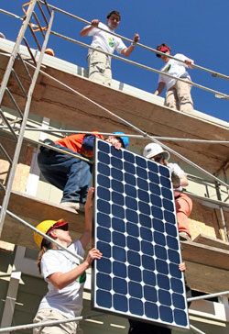
GRID Alternatives 3rd Annual SOLARTHON!
Individual signups are now open for Solarthon 2008, our third-annual major fundraiser and installation event. This year's event will be on Saturday, June 28th from 8:30am to 4:30pm at Habitat for Humanity East Bay's new Buena Vista Commons development in Alameda. We'll be installing eight solar electric systems in one day while raising money for GRID Alternatives' work to bring solar power to low-income communities throughout the state. This promises to be our best Solarthon event ever, and is a great celebration of the GRID Alternatives movement as we all work together to make renewable energy a solution for all of our communities, regardless of income level.
Corporate sponsorship opportunities are already completely full, but we still have limited space for individual fundraisers who want to participate. Individuals commit to raising at least $350 from their family, friends, coworkers, and others, with prizes for the top fundraisers from great Bay Area restaurants - last year's top fundraiser, Maikhanh Nguyen, raised over $2,000! Check out the SOLARTHON website for all the details or to sign-up. If you have any questions about individual participation, please email Tracie Troxler, Development Assistant, at ttroxler@gridalternatives.org. Hope to see you there!

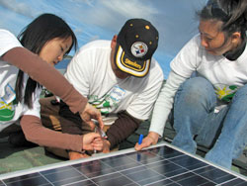
Volunteer Projects, Multi-Lingual Volunteers, and a Volunteer Social Event!
Over the last three months we've installed systems in Fresno, San Francisco's Bayview/Hunter's Point and Outer Mission neighborhoods, Redwood City, Richmond, Brentwood (Contra Costa County), and Oakland, and completed Energy Efficiency Team projects in San Francisco, Oakland, the Peninsula, and Silicon Valley. Some of these projects have been installed in partnership with local job training programs where low-income trainees provide the labor, so please hang tight if you haven't been able to get onto a recent solar installation - it's all for the mission! Upcoming projects include installations in San Francisco, Richmond, Oakland, Redwood City, East Palo Alto, Fresno, and Alameda in Northern California, and El Monte in Southern California.
We are also looking for another group of volunteers - folks who speak multiple languages and are willing to help with translation on the occasional outreach call, construction site visit, or installation with a non-English-speaking client. Please send us an email if you're interested, letting us know what languages you speak and your general availability to help. Finally, we're hosting an after-work volunteer social event on Friday, May 16th at the Rickshaw Stop in San Francisco with food, entertainment and a short movie screening - check our online calendar for the details. Thank you to all of our great volunteers who make GRID Alternatives possible!

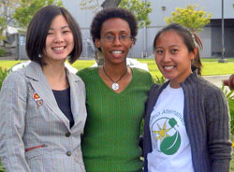
Greater Los Angeles Regional Update
GRID Alternatives' Greater Los Angeles office was kicked off last fall with 30 solar electric systems installed as part of Habitat for Humanity International's Jimmy Carter Work Project 2007 event. Since then our great local staff has been pounding the pavement to build up a pipeline of local retrofit projects in partnership with local government agencies.
As a result of their hard work, the Greater Los Angeles office will have their first retrofit project in May in the City of El Monte! GRID Alternatives is working with the City to provide a 1.8 kW system to a homeowner who has lived in El Monte for over 50 years. The installation will take place with the help of our patient Southern California GRID volunteers, as well as with local job and PV training program participants. Future installations will be scheduled throughout Los Angeles County, including in the cities of Huntington Park, Inglewood, South Gate, and South El Monte, as well as on future developments built by Habitat for Humanity Greater Los Angeles. If you know folks in Southern California who are interested in being notified of future volunteer projects, send them to our website to sign up under "Get Involved" on the right-hand side, and make sure they check "Southern California" as their area of interest.

Thank You!
Once again we have many people and organizations to thank over the last three months who have made all of our work possible. Of course we want to thank PG&E again for sponsoring another year of their flagship Solar Habitat initiative that supports solar installations on Habitat projects throughout Northern and Central California. A big thank you also goes out to our new partners at Wachovia for their support through a combination of direct financial support and in-kind assistance.
Thanks to Mark Van Lue and Habitat for Humanity of Greater Los Angeles for donating office furniture and equipment for our Greater Los Angeles offices. Thanks also to GRID Alternatives' client Kim for donating a used Isuzu Rodeo for our construction crew, to Schneider/Square D for donating additional disconnects for our projects, to Solmetric for donating another Solmetric SunEye electronic solar access and shade analysis tool for our Greater Los Angeles office, to Sun Light and Power for donating a server for our main office, and to Connor English for donating a UPS for the server. We also want to thank Salesforce.com for their generous donation of CRM licenses for GRID Alternatives' database, and to the Taproot Foundation for our recently completed database implementation project and recently approved Annual Report Service Grant. We want to thank the Clif Bar Family Foundation for including GRID Alternatives in their new On Your Behalf Gift Card Program, a gift card you can give folks who can then make a donation to one of a menu of pre-screened nonprofits. Finally, we want to thank Whole Foods SoMa store - now if you bring your own bags to shop there, you can have them donate the 5 cent per bag credit to GRID Alternatives.
We appreciate all of our volunteers, but we particularly want to thank some of the many volunteers who have supported us through their professional skills. Thank you to our Taproot volunteer team, including Mark Shervey, Bob Johnson, Vyji Mankani, Siu Chang, and Evelyn Chiang, who implemented our new Salesforce.com database. A big thank you goes out to Jim Meehan for his technical assistance with the Drupal content management system that runs our website. Thank you to Jenny Spitz, Martha Keeley, Kate Hunter and all the folks over at Mullen for providing pro-bono public relations work, and to Wachovia for matching us up with them. Thank you to Ralph Chesley for his volunteer work helping plan for our Solarthon event and secure in-kind donations. Finally, thank you to our wonderful office volunteer, Barbara London, who has helped us with everything from email and the phones to getting ourselves organized in our new office.

GRID Alternatives eNewsletter - Spring 2008
Bay Area Office: 1610 Harrison Street, Suite C, Oakland, CA 94612, (510) 550-8535
Greater Los Angeles Office: 969 Sandhill Avenue, Carson, CA 90746, (310) 324-8146
www.gridalternatives.org

Upcoming Events
Volunteer Training in San Diego
Tuesday, August 12, 2008 5:30pm
San Diego Habitat for Humanity Installation
Wednesday, August 13, 2008 8:30am
Habitat for Humanity Fresno Install
Saturday, August 23, 2008 8:30am
more upcoming events

Get Involved!
Want to get involved? Sign up for one or more of our email lists below.
Top of Form

First Name
Last Name
Email
Please send me the quarterly GRID Alternatives eNewsletter
Please keep me posted about upcoming volunteer opportunities in:
Northern California
Southern California
Bottom of Form

Video Clip
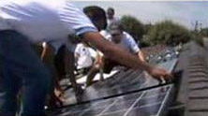
Watch a short movie from GRID Alternatives' Solarthon 2006 event, courtesy of our friends at TreehuggerTV.

Newsletter Archive
Winter 2007-08 eNews
Fall 2007 eNews
Summer 2007 eNews
Spring 2007 eNews
Fall 2006 eNews
Spring 2006 eNews
Fall 2005 Newsletter
Home | About Us | Our Projects | Donate | Volunteer | News
©2008 GRID Alternatives • 1610 Harrison Street, Suite C, Oakland, CA 94612 • 510-550-8535 • 510-225-2585 fax • info@gridalternatives.org

