Update: Algiers Charter School Association Schools

Through the generosity of donors worldwide, Global Giving and Relief International-Schools Online (“RI-SOL”) raised over $50,000 for New Orleans schools struggling to reopen following the devastation of Hurricane Katrina. RI-SOL, functioning as the fiscal and operations agent for these funds, has been working steadily with the administrators of the schools to which the funds were directed. Predictably, the New Orleans school system has been in a state of transition since the storm. The consulting firm Alvarez and Marsal originally came in to oversee the redevelopment of a group of schools located in an area of New Orleans called Algiers. After it was determined that these schools could reopen sooner by going through the charter school designation process, Alvarez and Marsal assisted the schools in doing so, such that they could self-govern via the oversight of a nonprofit agency. Once this nonprofit management agency, known as the Algiers Charter School Association (“ASCA”), was on solid ground, Alvarez and Marsal team members handed over the management oversight of these schools to ASCA.

As the fiscal agent of the funds raised by Global Giving donors, RI-SOL staff members established a Memorandum of Understanding (“MOU”) with ASCA to manage the distribution and expenditure of these funds. This MOU specified that the funds were to be spent by teachers and school administrators on teaching materials, classroom decorations and materials, workbooks, manipulatives, and other essential teaching tools. Further, it was agreed that the total sum of donations would be divided into four equal payments, to be distributed in succession once documentation of previous expenditures had been provided. This arrangement allowed for significant oversight, while simultaneously allowing the funds to be spent at the discretion of those who will, in fact, be the end utilizers.

The first of these payments was provided to ASCA personnel in April 2006. Working with a local educational supply outlet, each teacher in these designated schools was allotted $50 to spend on materials as they saw fit. The lengthy invoice documenting these expenditures has been provided to RI-SOL and is appropriately illuminative. By way of example:

- One kindergarten teacher purchased name plates, sticker books, “Wow” certificates, and a food guide pyramid

- One elementary teacher purchased writing workbooks, reading comprehension books, and a math resource workbook

- Another elementary teacher purchased typical classroom essentials, such as dry erase markers, a large clock, banners, and a calendar

- A high school teacher purchased a comprehensive life skills program, attesting to the comprehensive nature of a curriculum for older students

- Another high school teacher used the funds to purchase SAT prep materials for his students, knowing that these important materials were often overlooked for purchase by administrators;

These invoices that document each teacher’s expenditures provide a unique window into the teaching world, and to the needs of students both young and older. To get further insight, RI-SOL staff was fortunate enough to visit the schools just days after reopening for the new 2006-2007 school year. Any school year reopening brings about new hopes, optimism, challenges, and plans for any school administration and student body. In post-Katrina New Orleans, it was common to hear that seeing a full class of children returning to school was an incredible emotional and psychological boost for all involved. In spite of each school still having great needs for revitalization, there is a palpable sense of optimism among those involved with the schools. For means of update, this report will feature two of the schools which received funds from Global Giving: Dwight Eisenhower Elementary School, and Edna Karr Secondary School both of which are now charter schools operating under the purview of ASCA.

DWIGHT EISENHOWER ELEMENTARY SCHOOL

Dwight Eisenhower Elementary School has been serving the needs of elementary students since it opened in 1970. Located in a neighborhood of upper-income homes, this school is conversely dominated by a student body of low-income children from the areas surrounding this affluent neighborhood. The principal, Cynthia Bernard, and the assistant principal, Peta LeBlanc, gave RI-SOL staff a tour of the school and discussed recent developments.

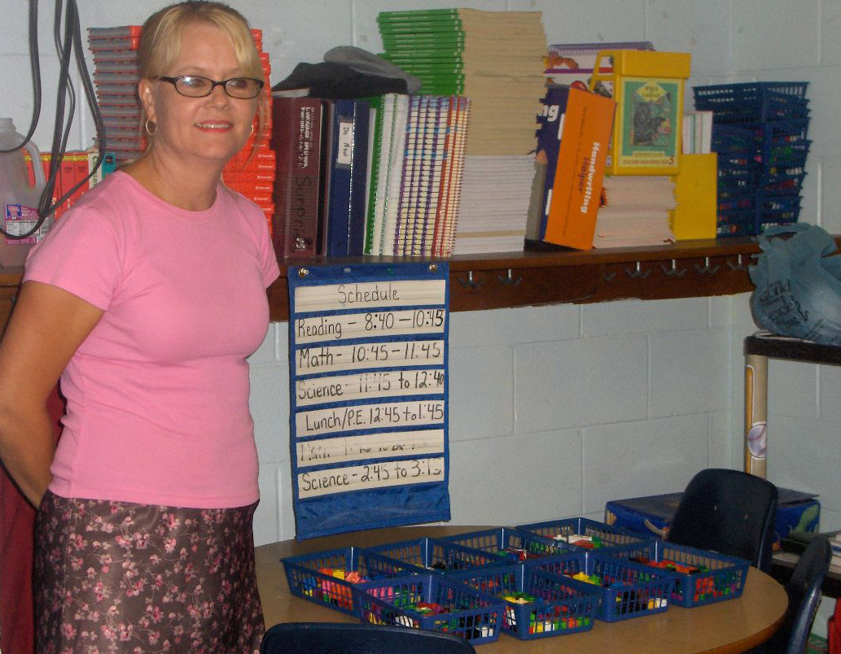
Carol Firneno, 3rd grade math and science teacher

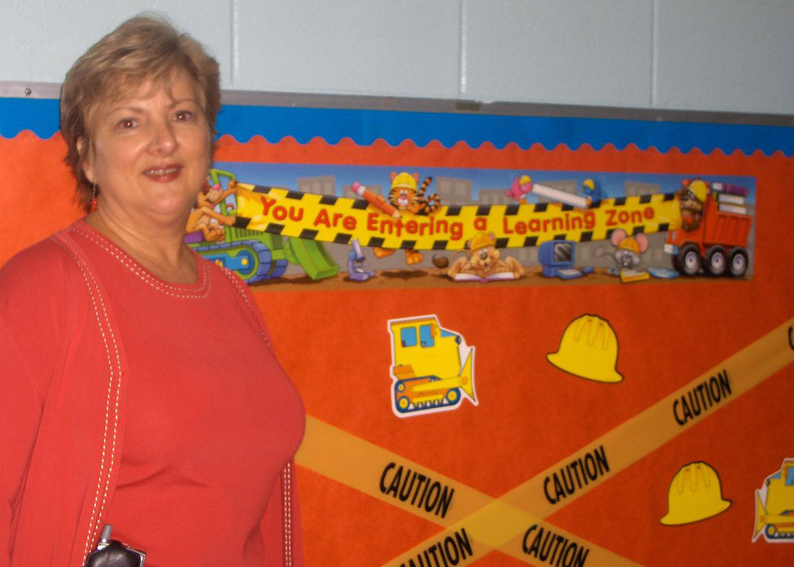
Assistant Principal Peta LeBlanc next to one of her favorite boards, purchased with donated funds

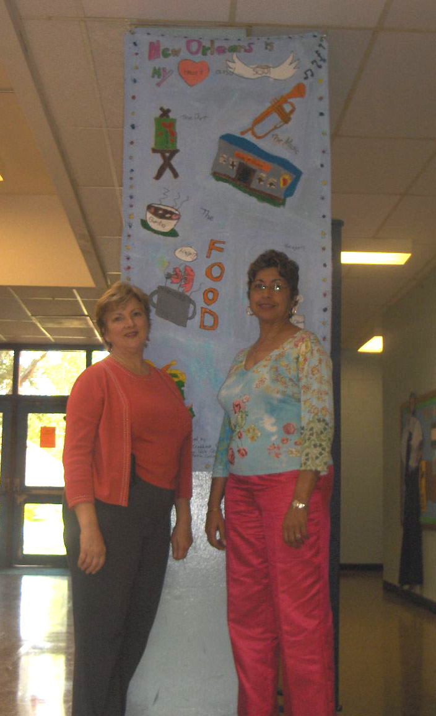
Peta LeBlanc & Cynthia Bernard, in front of Katrina memorial banner made by their elementary students

The administrators are pleased to report that enrollment now rivals pre-Katrina numbers – 585 students – which is a hopeful indicator of this area’s recovery. Their school serves those in kindergarten through 8th grade, though they have had to expand significantly to accommodate recent increases in numbers of older students. Teachers at Eisenhower were eager to display recently acquired materials for their classrooms, as evidenced by the photographs in this section.

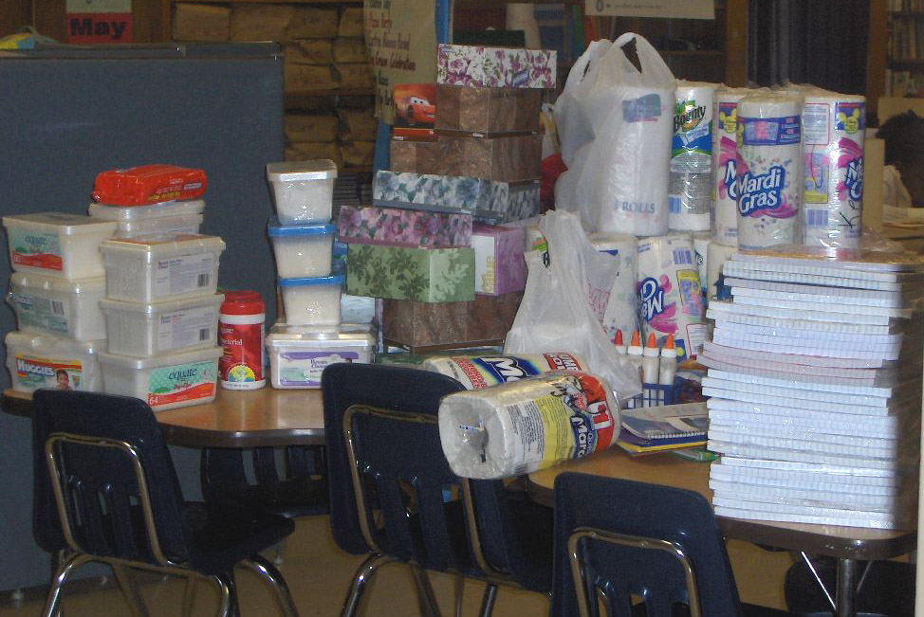
A table of necessities ready for distribution and use
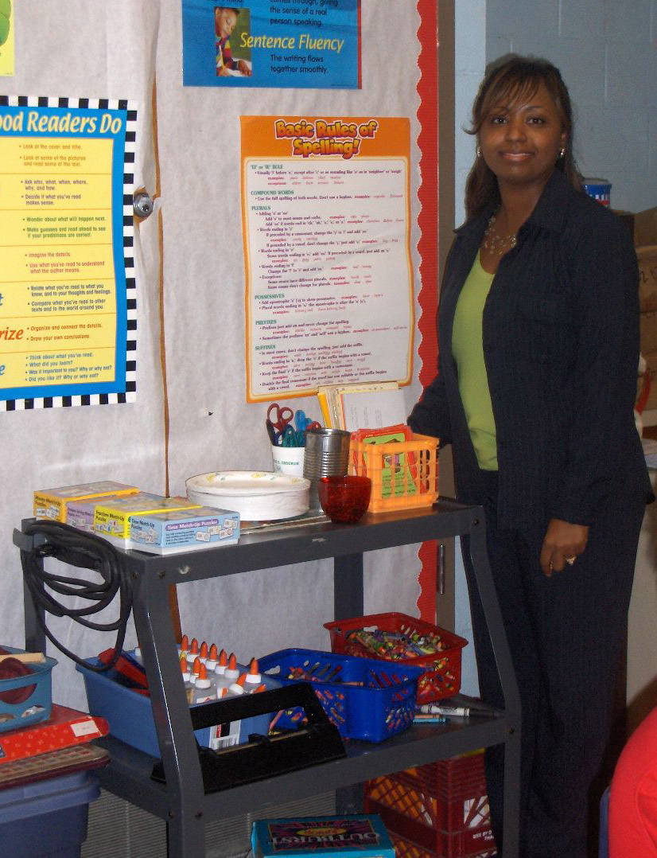
T. Kelly Knox, 4th grade teacher

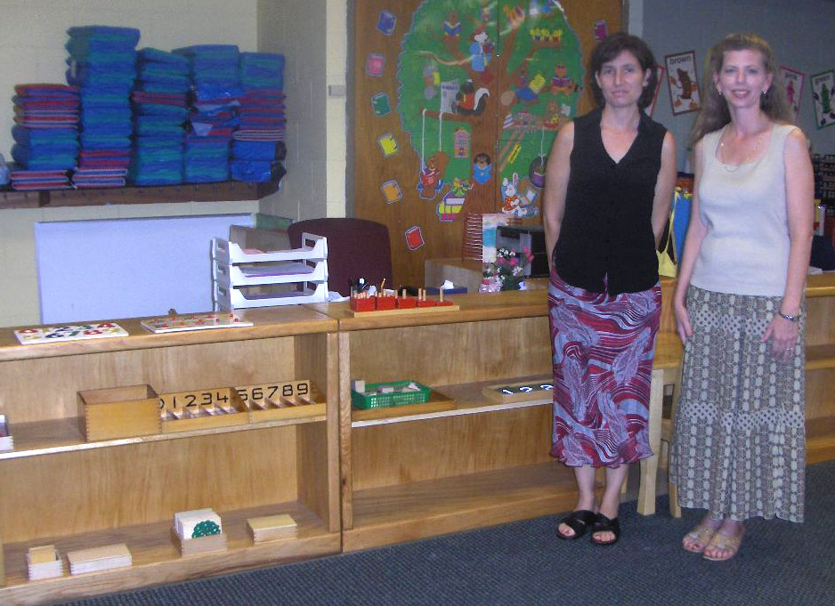
Patricia McKevitt and Wanda Chenevert, Kindergarten Montessori teachers

Eisenhower Projected Needs

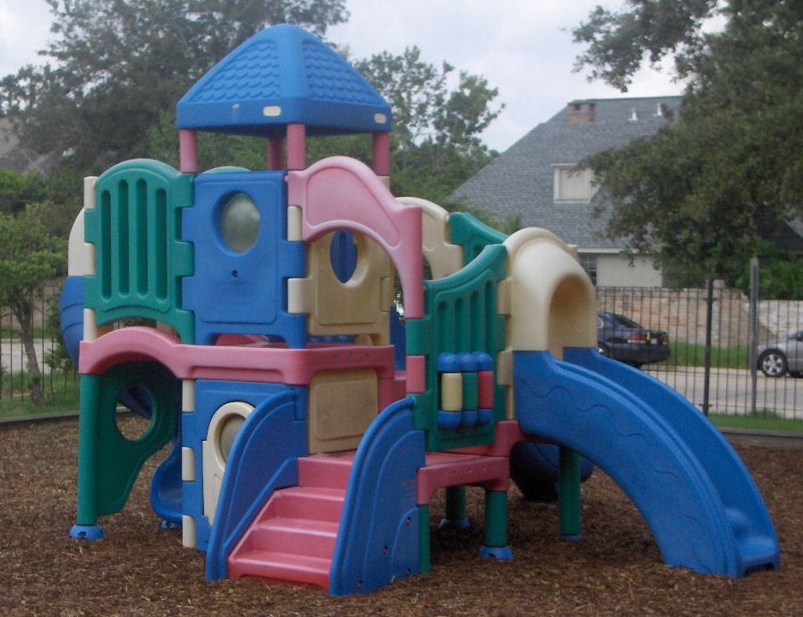

Assistant Principal Peta LeBlanc, who has over 20 years’ experience in the public elementary school system, made the following observation: “We’re dealing with the consequences of years and years of deferred maintenance.” As such, the maintenance issues for these schools are at times overwhelming. In discussions with Ms. Bernard and Ms. LeBlanc, several specific areas of need were identified for the current school year. A special concern regarding safety of the children’s play area has emerged, such that safety surfacing underneath the play equipment is substandard. As is typical of these costs, safety surfacing is prohibitively expensive for the school at this time, and this remains a concern for all involved. By means of demonstration, Ms. Bernard mentioned that when using yard mulch (less desirable than rubber surfacing), the standard is four inches of mulch; however, for the play area for the youngest students, they were only able to afford one inch of mulch, as shown in the photograph above.

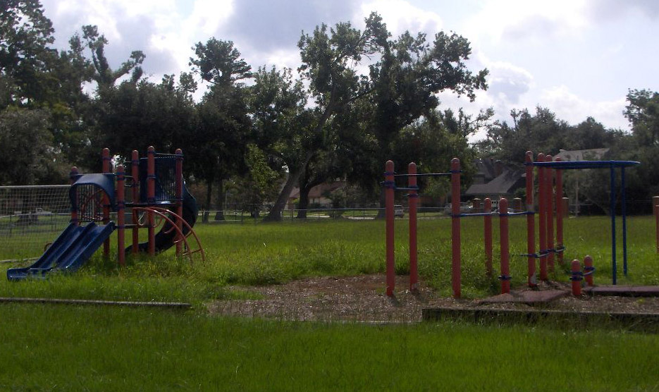
Wide view of the poorly surfaced, overgrown play area

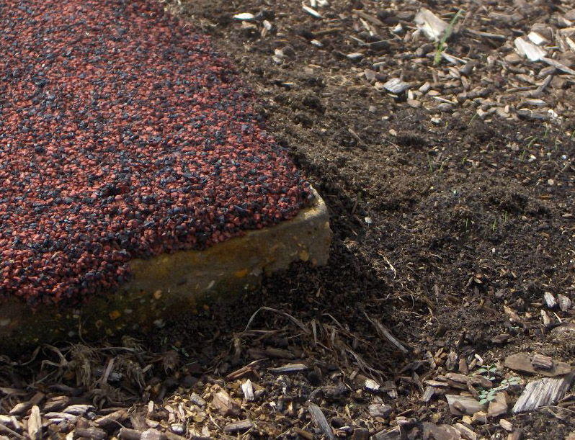
Close-up of one of the concrete corners exposed by weathering of rubber

For their older students’ play area, in years past there was an effort to cover the ground with the desirable rubber surfacing material, but this job was done sub-par. Photographs above and below demonstrate the safety issues of the underlying concrete now exposed by the weathered rubber.

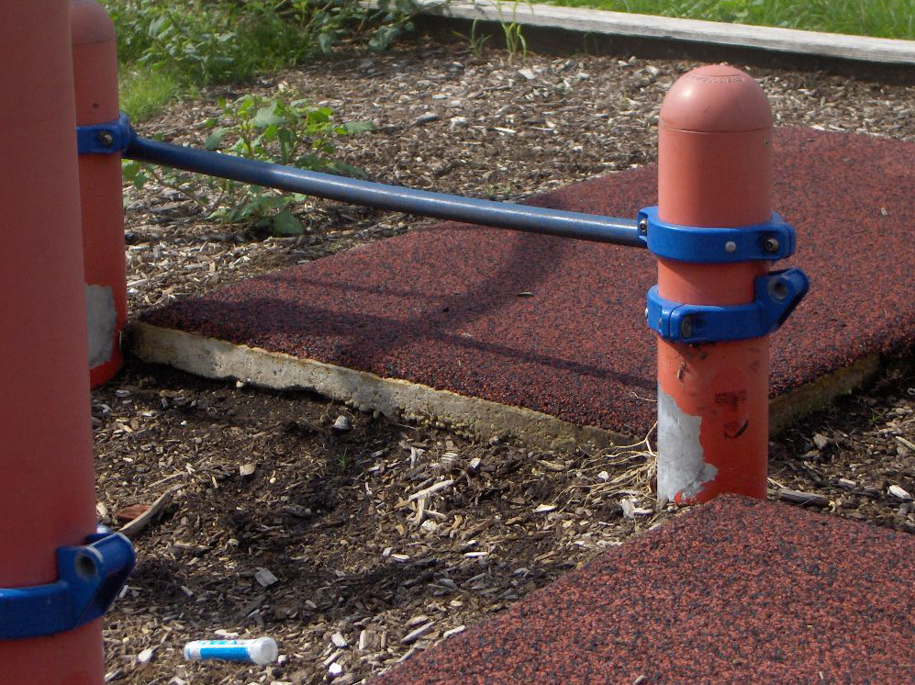
Another shot of the exposed concrete and weathered rubber surface

Both of the playgrounds shown above are in need of rehab, a very expensive undertaking. For example, a typical rubber resurfacing project for playgrounds of this size would cost around $20,000 for each. Moreover, as shown in these photographs, the play equipment itself is in a state of disrepair and neglect; new equipment would do much to enhance the learning environment and experience of these young children.

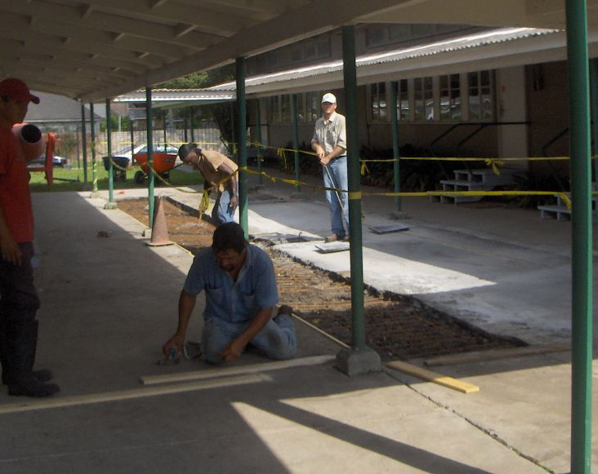
Emergency drainage and leveling work in middle school area

Another area of immediate need is the area designated for the middle school students, the bulk of whom are currently housed in portable, “temporary” buildings. It was discovered after Hurricane Katrina that this area was prone to flooding, even during a relatively light rain. Thus, emergency funds had to be expended for a basic draining and re-leveling, as shown above. Principal Bernard also mentioned that this area has a significant (and dangerous in this tropical climate) lack of outdoor water fountains. They are also having to utilize leased, temporary outdoor restrooms to accommodate the student population, and to maintain separate restroom facilities for the older and younger students. Because of these issues, this area of the school continues to need support.

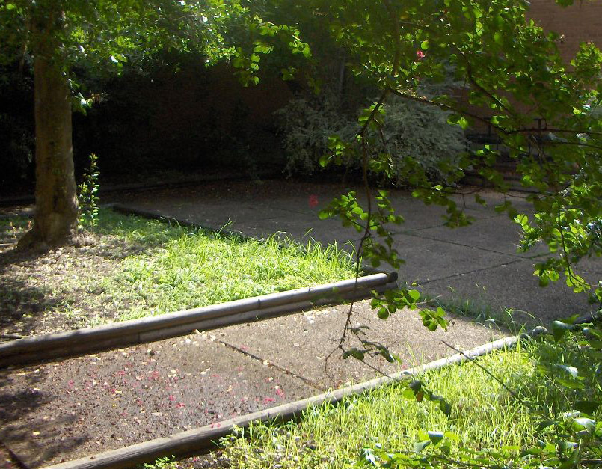
Partial view of outdoor courtyard
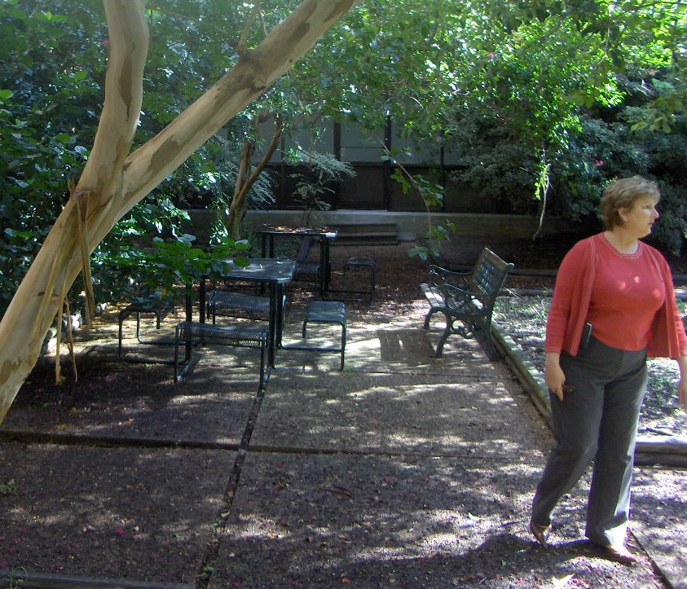
Another view of the outdoor courtyard

On a lighter note, the science teacher pictured with supplies earlier, Ms. Carol Firneno, has an idea for betterment of a common grounds student area. There is a large courtyard space in the center of the school building, which is currently fairly untended and underutilized. Having an avocational interest in cultivating butterfly gardens, Ms. Firneno is soliciting support to develop this area, shown in photographs above, as a butterfly garden and insect/garden animal habitat. Her passion for teaching young students about the life systems in their own backyards is propelling her to pursue this project, and any support she could get for this wide-reaching project would be a boon to all who utilize the school.

Other needs were identified by the administrators, which are in line with their objectives to expose these primarily inner-city children to the world around them. As such, it was noted that funds for field trips are non-existent, and funds designated for such endeavors would be very welcome to be directly donated.

EDNA KARR SECONDARY SCHOOL

RI-SOL staff was pleased to have had the opportunity to meet with John Hiser, Principal of Edna Karr Secondary School, a high school with a long-standing tradition of excellence in spite of challenges faced by limited resources. The enthusiasm of the principal was evident from the beginning, as was the support and respect he has from his staff. Karr High has been through significant changes pre- and post-Katrina. Prior to the devastating storm, the school served students from grades 7-12; post-Katrina, they modified their structure to serve grades 9-12. Like that of Eisenhower Elementary, Karr’s enrollment figures are in accordance with pre-Katrina numbers: they have 730 currently enrolled, with more expected each day. Further, when they ended the recent post-Katrina (shortened) school year, they had 52 employees; due to citizens returning to their area, they are slated this year for 66 employees, though they have had great difficulty securing enough qualified teachers to maintain their high academic standards.

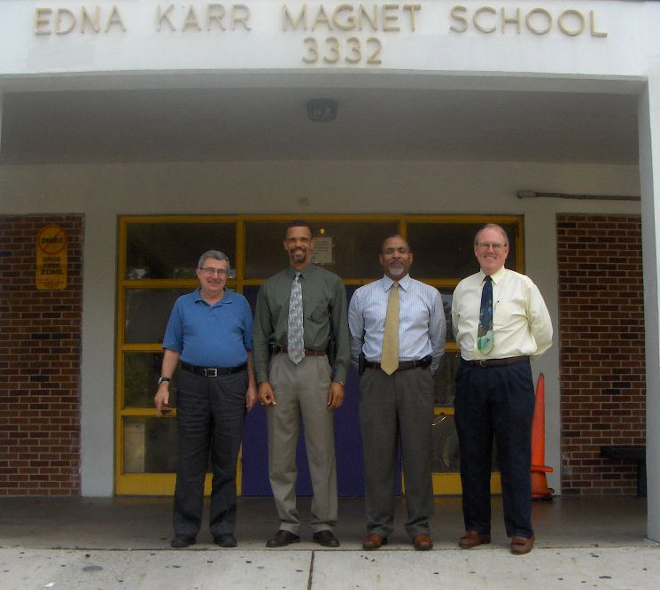
(L-R): Bob Tiller, Administrative Assistant; Wayne Hardy, Disciplinarian;
Bernard Robertson, Positive Behavior Support; John Hiser, Principal

Teachers at Karr were also enthusiastic about demonstrating materials purchased with donated funds, and students often joined in on the photography. The following photos show a few classroom scenes.

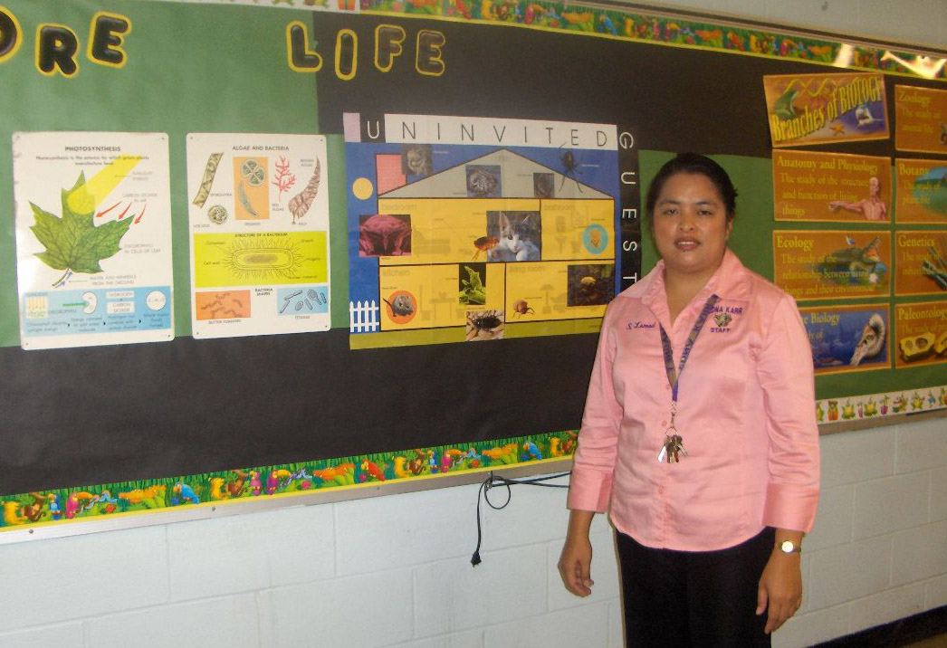
Sheila Lumod, 10th grade biology teacher

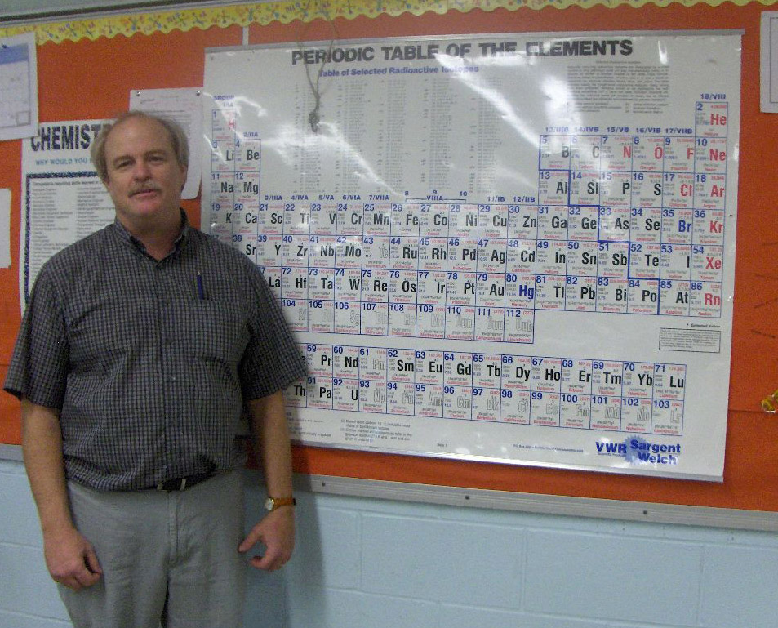
Don Bloomenstiel, 11th grade chemistry teacher

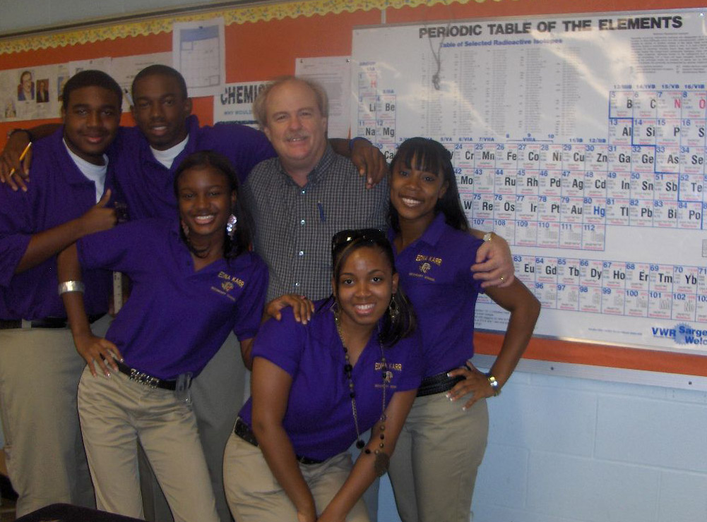
Mr. Bloomenstiel with several of his students who were eager to show their
enthusiasm for their teacher (and, of course, for the periodic table)

Karr Projected Needs

When meeting to discuss projected needs for the 2006-2007 school year, Principal Hiser and RI-SOL staff were joined by the school social worker, Ms. Edna Metcalf. Together they explained the nature of the needs which reflect some of the differences between that of the high school and elementary student populations. While the elementary school needs tend toward infrastructure, needs of this population tend toward enrichment.

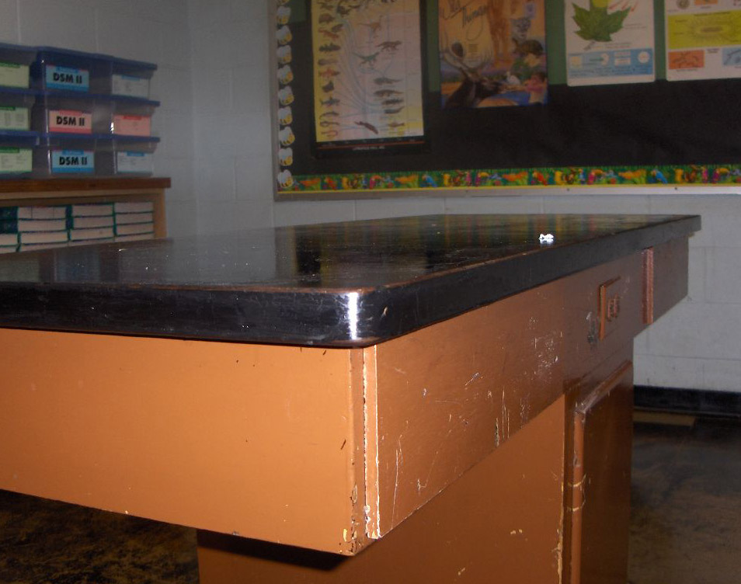

While their science curriculum is broad, with classes offered in biology, chemistry, physics, and other sciences, the classroom environments are not suited for an enriched, modern teaching experience. Mr. Hiser demonstrated that the science desks (shown below) were made in 1964 and are in a state of disrepair. For instance, the gas jets – a mainstay of science education – are either nonexistent or inoperable. Further, one science teacher with whom RI-SOL staff spoke said they have only one LCD projector for their department; the standard is one per classroom.

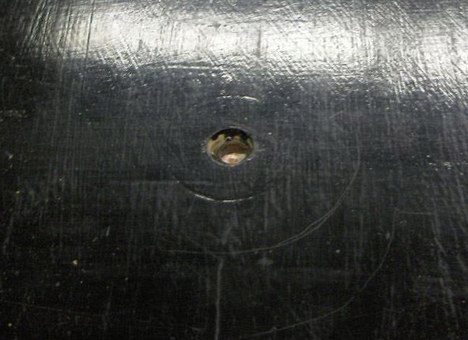
Photograph showing hole where gas spigot should be

It is widely recognized that a broad after-school curriculum improves student academic performance and quality of life. The student population of Karr High is from predominantly lower-income households, who pre-Katrina were struggling to make ends meet; post-Katrina, these families are often in even more extreme circumstances. Student participation in extracurricular activities has suffered as a result of this situation, as donors who once supported such activities have either disappeared or diverted their donations to recovery efforts. The administrators gave examples of typical annual costs of participation in extracurricular activities:

- Cheerleading: $1,000;
- Dance team: $600
- Majorette/flag team: $400
- Volleyball team: $400
- Marching band: $300, plus instrument purchase
- Camp, meets, retreats for any of these: $250

Sponsoring high school students’ extracurricular needs would be an excellent way for donors to get a tangible sense of benefit for those often overlooked by school fundraising endeavors.

In closing, it should be noted that throughout the city there are signs of hope and revitalization, but everyone is in agreement that the status of the school system is a bellwether for the community at large. New Orleans has the unprecedented opportunity to remake their long-troubled school system. By coupling the enthusiasm of administrators, teachers, and personnel, such as those with whom RI-SOL spoke, with the dedication of donors such as those affiliated with Global Giving, real change and tangible progress can most certainly be made.

