AFRICA'S CHILDREN'S FUND, INC.
"Saving Children To Heal The World"

Project HOPE
Give a Child HOPE for a better future!!
Provide Food, Water & Skills to 177 South African AIDS Orphans
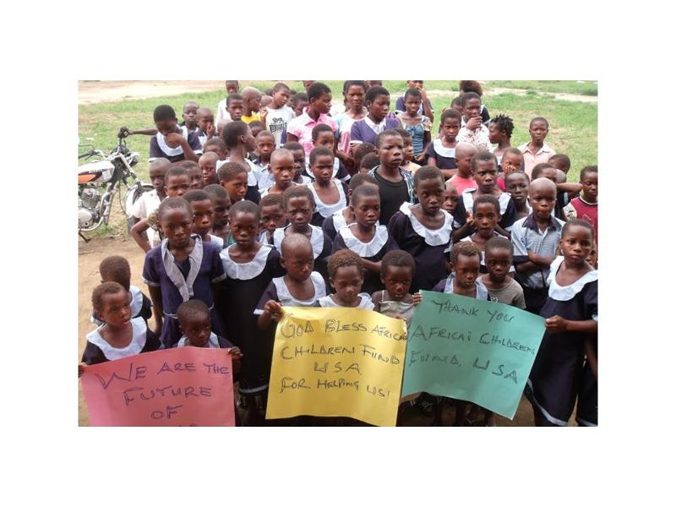

Summary
Children at the SKY Children’s Center were spared from the AIDS pandemic that claimed the lives of their parents. Today, at this center, that has outgrown its capacity, the children are facing hunger and water shortage that may claim their lives. This project seeks to establish a community garden, a food bank, a water tank, and a vocational skills center to address the needs of these children who need our help the most.

What is the issue, problem, or challenge?
In Kliptown, a slum in the largest black township in South Africa, over 10,000 people live in wood and corrugated metal shacks, crowded together, with no running water, electricity or sewage systems. In the middle of this impoverish Kriptown community is an orphanage named SKY Children Center which takes care of over 177 orphans annually, mostly children whose parents have died of AIDS. The center does not have enough resources to operate and as a result it cannot provide all the important necessities of life such as adequate food, clean water, recreation, and functional education. Therefore, children at the SKY Children Center remain a sharp focus for help in order to be alive and healthy and in school. The most important needs of the children at this center at this time are (i) adequate food, (ii) clean water, (iii) vocational skills.
How will this project solve this problem?
This project will provide short and long term solutions to the problem of food and water scarcity which threaten the survival of orphans and vulnerable children. The food bank will provide immediate food source for the children. The community garden will help the children and the community to acquire gardening skills to produce their own food to achieve self sufficiency. The water tank helps to collect water during time of surplus for storage and purification for daily use by the children. The vocational skills development aspect of this project will help to break the cycle of poverty in this impoverish community in South Africa.

Potential Long Term Impact
The people of Soweto will gain from this program because the most vulnerable children and youth in their community are given the resources they need and are engaged in productive activities that enable them to become successful and productive members of their community. By ensuring food security, good health, and optimum school graduation, this project will help to transform people in need to people who are able and willing to respond to the needs of others.

Project Message
Childhood experiences have a lifelong impact on people, and orphans are no exception to this situation. This project provides the best opportunity for all of us to join hands to help provide positive experiences for children that help our help the most. Thank you for joining us!
-Victor Mbaba, President & CEO, Africa’s Children’s Fund

