General Report March 2014 A.D.

Thanks For All Donors and Global Giving Team for this possible.

Project Name : HOPAD Children and Women Capacity building Project.

Partnership : Global Giving USA and HOPAD Child and Women Promotion Society, Nepal.

Project Completed :
- 31 Marginalized women 6 months tailoring.
- 30 Marginalized one month's advanced course women Tailoring Training.
- 20 Orphan children three months educational support.
- 75 children received School Tie and belts with educational materials.
- 30 Women needy women completed Embroidery professional three months training.

Recently Completed Project:
- 30 Women needy women completed Embroidery professional three months training.

Ongoing Training:
- 18 School stationary materials for needy children.
Project Directed By: Purna Bahadur Khatri
Dear Sir/ Madam
Namaste! (Our All honorable Donors and Global Giving Management Team)
HOPAD, Nepal.
First of all HOPAD give more Priority to do effective project management for the target group of the project. On the reporting process, in our project evaluation, it is good and effective. It is in the rural mid western area of Nepal, where our Global giving projects is ongoing.
Thanks to great generous donations, we were able to run our project permanently on the Global Giving website, which will hopefully help us to keep up sustainable help for needy women and children in the rural areas of Nepal. It is only possible from your support with love. It is effective for the empowerment women and support needy children educational development of Nepal. Now, HOPAD has not fund further run this project. So, please try to contribute for these women and children project. Only we are supporting for the 18 children educational support in rural area of Dang and two months educational support for HOPAD Children.
- A. Women Project:
a. 6 Months Tailoring Training:

A (Women participant swing cloths for her personal uses) and for their evaluation we provide them a pair of cloths to them for sewing for themselves. They finished it in time. They are all total 31 in two groups. It was successfully completed as first group. They spent 6 hours per day for effective practice.
- 3 Months Advanced Course professional Tailoring Training ( Changed One month's Training) :
20 women completed one month's advanced course training for their professional work. This tailoring project was professional and selected best for their business development in the rural area of Dang. Due to the cause of financial problem we make it only one month.
It helps to change the life and economic standard in their family life from their children better education. It also helps to extend their source of income and become more independent. Our target not only girl/women trained but also support their children in to get quality education for their better tomorrow.
B. a. First 3 months Embroidery Training:
30 women completed for their professional capacity building embroidery training program. They are happy in their achievement. They were in two groups with 15 -15women /participant per groups.
It was fruitful for their betterment. HOPAD is impressed from their development of Technical knowledge. They are really excellent in their training. The farewell program also completed.
- b. Second 3 months Embroidery Training Completed:
Second group embroidery program is successfully completed. It was divided in two groups' morning and afternoon. There were 15 participants in the first group and also 15 in second groups. All total we had 30 needy women in this training program. This program was excellent and effective for the development of women and support for their children. It is completed 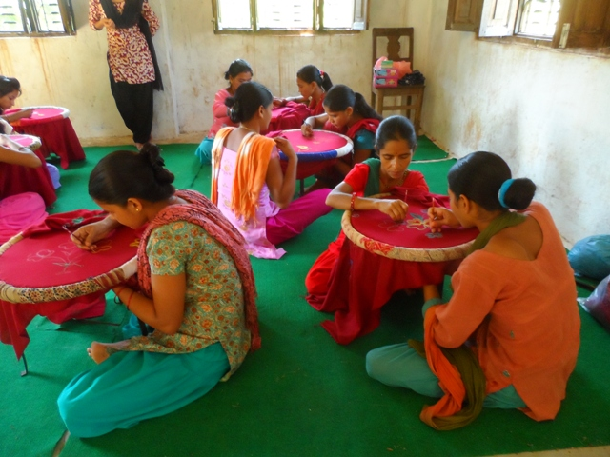
2. Children Educational program:
a. Rural area children education program:
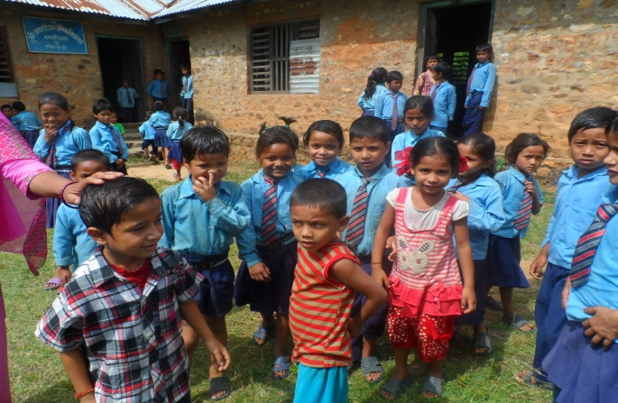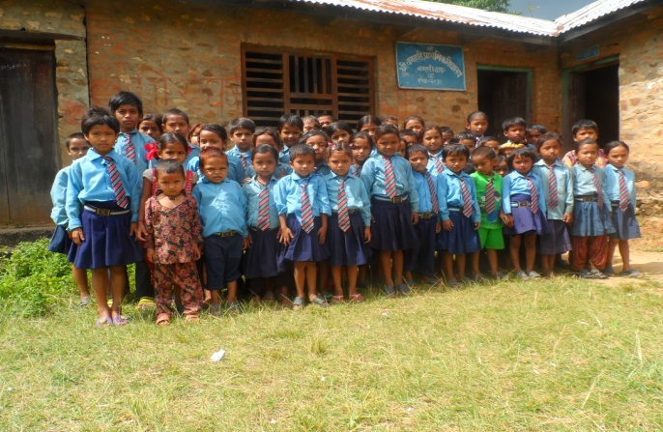
Our children Education program is going well for 16 poor and needy children in rural area Government school with necessary materials for like English Books and stationary, as well as classroom equipments in front of their poor parents. They need not take any things for their Quality education.
- HOPAD children education Support:
Due to the lack of support for HOPAD children are also facing financial problem since last January. HOPAD used some donation for orphan children educational fee for their quality education. It helps to attain their final exam for 20 children new grade. Thanks, it makes possible to run this program.
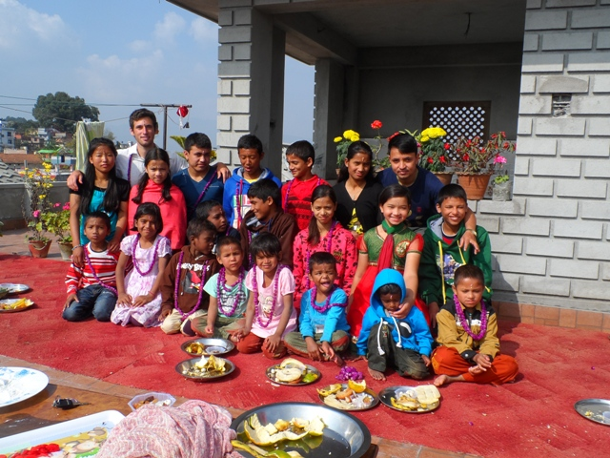
Your donation is great to change lives of Nepali women and children. We are waiting for your next support and valuable suggestions for better work.
Note: Now, we are unable to continue women project because of insufficient fund for this project. Please, donate now.
Finally, please try to support more. We have not for finished this program and continue further service. Thanks
An excellent Trainee Become a perfect Trainer;
Sushila Chaudhari is trained in our First 3 months Embroidery Training programs. Now,she is Trainer for second 3 months Embroidery Training program. So, we are proud of her excellent performance. She is in a poor and needy indigenous Tharu community family single girl.

Sincerely,
Purna Bahadur Khatri .
Program Director /Founder President
09 March 2014 A.D. Kathmandu, Nepal.

