Project Proposal

1. | Title of the project | : | Community Based Rehabilitation (CBR) to HIV and AIDS Infected and Affected cases in Bapatla & Karlapalem in Guntur district of Andhra Pradesh, INDIA.
2. | Name and Address of the Applicant | : | Society For Integrated Rural Development (SFIRD)# 15-12-68, Venkat Rao Nagar, GUNTUR – 522 001Andhra Pradesh, India.
3. | Contact Details | : | Phone: 0091-863-2226452  E mail: sfird_org@yahoo.co.in  sfirdguntur@gmail.com  Mr. K. Ravi Pradeep – Secretary
4. | Proposal submitted to | : | Global Giving - USA
5. | Time Frame | : | One year (Phase I, initially)

BACKGROUND OF THE CONVENING AGENCY:
Society for Integrated Rural Development, SFIRD, the implementing Organisation of the proposed project, is a non-profit agency working for the empowerment of the downtrodden communities in the remote areas of Guntur Prakasam and Krishna Districts in the state of Andhra Pradesh. The organization has been strengthened since the year 2001, by a group of trained and experienced professionals in the area of Child Development, Eco development, Dalit Rights, Gender Justice and Empowerment, Target Interventions with HIV and AIDS cases. SFIRD has sufficient experience in working with the HIV and AIDS infected as well as affected children and adults with the support of certain donor agencies and is capable of effectively executing and co-coordinating the related programmes. SFIRD has been implementing developmental interventions with ‘Cluster Approach’ in the coastal villages with thrust on ‘Better Villages’.

Involvement & experience in the Region:

- SFIRD was selected by the district authorities to work with the “Community Convergence Action” strategy of UNICEF through DRDA in Nizapatnam, a coastal revenue sub-division comprising of Traditional Marine Fisher-folk. It has been working in several parts of Krishna, Guntur and Prakasam Districts which are prone to endemic natural calamities.

- Around 200 Women Self Help Groups (SHGs) have been formed and strengthened besides providing them Micro credit for undertaking income generation programs and village enterprises

- Child labourers from Cotton mills, Tobacco and Chillies grading factories were provided with special education and mainstreamed into formal educational schools.

- Capacity of stakeholders from Dalit and Tribal villages was built to take up Alternative Livelihoods

- Skill development and village Entrepreneurship training programs were conducted for women belonging to Dalit and Fisher folk communities in the coastal region.

- Implemented Reproductive and child health program in 12 Fisher folk villages.

- Implemented Water and Sanitation activities in coastal villages.

- Implemented Livelihoods Restoration – locally feasible and viable - activities for Tsunami affected traditional Marine Fisher folk and other deserving families of the coastal communities.

- Organized community infrastructure re-building such as building multipurpose Community platforms in Tsunami affected villages.

- Implemented Community Based Disaster Preparedness (CBDP) program in Karlapalem revenue mandal which is located close to the coast with the support of CARITAS through the Guntur Diocese Social service and welfare Society.

- Coastal Eco system development – Mangroves conservation and regeneration in the coastal villages was implemented.

- Mobilized village communities for Advocacy and Lobbying with the Government Departments and corporations - entitlements.

- SFIRD worked previously in partnership with IGSSS, Ministry of Health and Family Welfare, Missions Prokur, RCM Foundation in the implementation of several developmental activities.

- Target interventions with Swagati – High Risk Groups – Female Sex Workers (FSWs) and Men having Sex with Men (MSMs) for control and prevention of HIV and AIDS.

- AP Migration project – Educational improvement of children belonging to down trodden sections migrating from different districts in search of livelihoods is underway.

- SFIRD is presently implementing Vocational / Skill development activities for Dalits and Backward youth in Nagaram cluster and is also implementing Women Empowerment program in Kuchinapudi cluster.

- Working with ‘cluster approach’ with thrust on Better Villages for Better Lives and Future with components such as Empowerment, Enlightenment, Education and Environment (4 Es).

Socio - economic Background:

Bapatla and Karlapalem are two among the other Coastal revenue sub-divisions in Guntur district and people are frequently affected by / with endemic natural calamities.

Our target area comprises of Dalits, Tribes and Traditional Marine Fisher – folk belonging to over 20 small villages along the coastal zone of the Bay of Bengal in , Andhra Pradesh – South India. The target groups fall Below the Poverty Line (BPL) status and they work as seasonal agricultural labourers in the neighbourhood. While conducting base line survey for micro planning, the functionaries of SFIRD found that there are many deserving, unreached and poorest cases which are infected and affected by the HIV and AIDS pandemics. When infected with HIV and AIDS the persons become less productive and / or non productive and are tend to be further affected with opportunistic diseases.

The infected and affected people are now desperately looking for assistance (i) nutritional support as they have to undergo meditation (ii) to undertake feasible and viable income generation activities under Community Based Rehabilitation (CBR) process and referral / consultation / accompaniment services to the clinics and hospitals as and when needed.

Social stigma and discrimination is at higher level in interior villages and most of our target communities comprise Dalits, Tribes and Backward Classes. Most of these socially and economically backward groups are convert Christians. On top of the caste based differences, when they are infected or affected with the HIV and AIDS trauma, they are still treated as ‘Untouchables’.

SFIRD intends to help the most deserving cases by providing care and support services. These services will help them to lead normal life situation with dignity. SFIRD intends to undertake the proposed care and support services by using participatory methods and a well documented system which has been proposed and designed by the involvement of the local communities and other stakeholders.

A survey and research was conducted in our operational clusters, mainly at Bapatla amd Karlapalem clusters, and it is noticed that there are:-

- Infected widows whose husbands expired owing to HIV and AIDS infection.
- Women headed families who have to take care of the infected children as well as the other dependents in their families.
- Deserted women / men whose partners elope as their counterpart is being infected.
- Orphan children who lost both their parents with the infection and are presently taken care by their grandparents or maternal relations.
- Semi orphan children who lost either of the parents and are dependents – who are also looked after by the distant relatives as guardians / care takers.
Problems Encountered by the Infected / Affected Children or Adults:
- Non productive or less productive in earning daily wages for livelihoods
- Unwilling of employers / land lords to take the infected as wage workers
- Social stigma and discrimination (being Dalits as well as infected with infection)
- Denied access in Community based Organizations or Self Help Groups
- Looked down as untouchables or out castes or as cursed
- Residing in far-flung local villages with improper transportation
- In accessibility to Government hospitals or private clinics / hospitals
- Infected children not allowed to mix or mingle with other children in schools
- Forcibly sent out from schools - sometimes denied admissions
- Insulted and humiliated in public places or to avail common facilities
- Basic services (laundry / saloon / barber services, etc) are denied
- Feeling of shame / guilty / inferiority of the infected

Proposed Activities:

Counselling and Referral Services:

The staff of SFIRD are continuously meeting the infected cases, their kith & Kin, their neighbours and others concerned and interacting with them on the discrimination and social stigma aspects, the livelihood support, infected children’s’ education, health care, low – cost and high effective food items, etc. These cases are to be provided with family counselling services to lead normal life situations.

The staff of SFIRD at Bapatla cluster are already in regular contact and identified over 160 cases of which 30 are children - with the infected cases of their target villages and are accompanying with them to the Hospitals for medical checkups and Health care services. The infected cases are taken to the Govt. General Hospital located in Guntur, the District head quarters (situated at a distance of 60 Kms from our operational target locations) and to the area Hospitals located at Repalle, Bapatla and Tenali Towns.

Information dissemination sessions and Information Education Communication (IEC) will be displayed in our cluster resource centers with information on the services extended Viz., Integrated Counselling and Testing Centers (ICTCs), Support and Care centers, STD clinics, etc. The infected cases are referred to the clinics for appropriate Medical services.

Medical / Health Care Services:

Most of the 160 infected patients are not provided with proper prescribed Medicines / Drugs for the opportunistic Diseases in the Hospitals. The patients expressed that some middle men at hospitals / clinics are exploiting them by demanding for money. Therefore, SFIRD intends to provide accompaniment services to the infected cases while they go for regular / periodical screening tests and Anti Retroviral Treatment (ART). And also for Cell Division 4 (CD4) tests. This will give them courage and to boldly claim the medicines at free of ‘cost’ for which they are entitled.

Awareness Generation:

The following activities will be undertaken and the reference communities will be provided with knowledge and information.

- Regular Medical Checkups at periodical intervals
- Usage of condoms (Male as well as Female condoms)
- Sensitization of grass-root level functionaries at CSOs
- Capacity building on practices of safe sexual behaviour

Community Based Rehabilitation (CBR):

SFIRD plans to extend financial support to 30 the most deserving infected cases with feasible and viable income generation activities for sustainable economic development of the individuals in their communities.

The following types of families will be selected for extending the financial support for undertaking CBR activities.

- Families headed by women – widowed / deserted / separated
- Families of downtrodden sections (Dalits / Minorities / Tribes)
- Families which possess more number of children and dependents
- Families having no land and existing Below Poverty Line (BPL) status
- Families in which both husband and wife are infected
- Families of kith and kin of the orphan or semi orphan children.
- Families in which more number of dependents exist
It is a fact that these unfortunate cases are denied to get financial support from local banks or money lenders with the fear that the infected may ‘die’ suddenly or at any point of time and that the amount will not be repaid. Therefore individualised income generation activities are to be undertaken after studying the situation at the family and community / village levels. SFIRD will motivate such cases to also contribute their might. These amounts cannot be repaid by the infected cases and SFIRD as an implementing partner has to give the amounts as grants. The following are some of the locally feasible and viable income generation activities which will provide regular income to the families of the infected cases under the proposed community Based Rehabilitation services under the project.
- Sewing machines / working capital and basic accessories
- Small / petty shops or provisions / groceries shops
- Bicycles / materials – selling essential commodities in neighbourhood
- Vegetables / fruits / coconuts selling – pushing carts
- Fishing nets / work instruments
- Goats / Sheep / country chicken units and provision for kitchen gardens
- Saris / blouse pieces / petty coats selling units
Each of the above said units coast varies from one to another. This has to be studied and undertaken at individual level. Therefore, SFIRD proposes an amount of Rs. 8000 per unit on an average.

Other Activities / Services to be extended:

- SFIRD also plans to provide the needed assistance to Persons Living with HIV and AIDS who are in need of legal support as their cases are pending in the respective courts.
- Awareness generation on HIV and AIDS trauma in local schools and Women Self Help Groups through Information, Education and Communication materials at community levels.
- Exploring possibilities of procuring assistance, through information dissemination from local Govt. Departments to help their families – stipends, house sites, pensions and all other welfare measures as part of entitlements.

Proposed Budget (initially for one year):

SN | Budget Item | Amt Required  (Rs.)
1 | Community Based Rehabilitation (CBR) for income generation and alternative livelihoods – for 30 most deserving infected cases  @ Rs. 10000 X 30 | 3,00,000
2 | Allowances for 2 counsellors / Para medical Health workers at 2 clusters for Counselling / Referral / Accompaniment services - Sensitization of Women Self-Help Groups / School children and youth – Capacity Building Sessions.  @ Rs. 8000 X 2 X 12 | 1,92,000
3 | Coast of one Mopeds and one Motor cycle -  For mobility of the 02 counsellors to meet the infected and other stake holders concerned  Maintenance cost @ Rs. 700 per month X 2 units X 12 month | 90,000  16,800
4 | Administration cost 10 % of the program cost  Supervisory cost / Travel / documentation / photography and other logistics | 59,880
 | Grand Total in Rs. | 6,58,680

In words Rupees. Six lakhs Fifty Eight Thousand Six Hundred and Eighty only for one year / USD 12005.

Location Map:

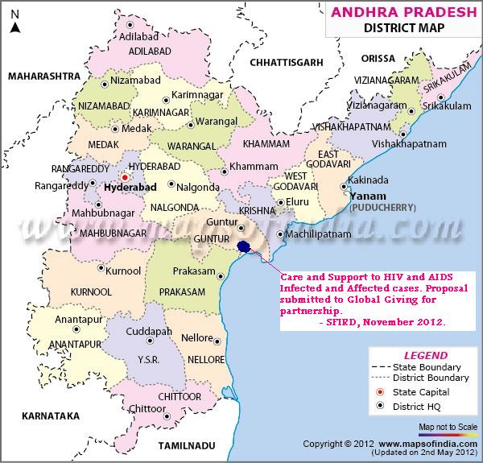

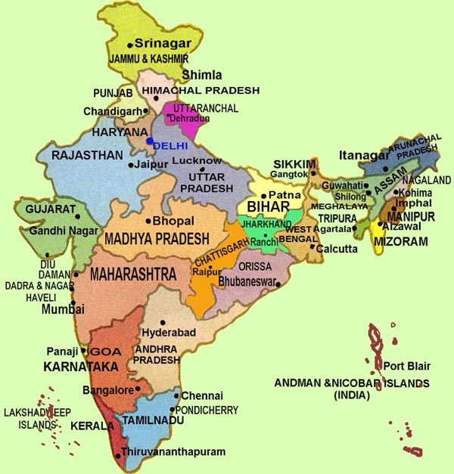
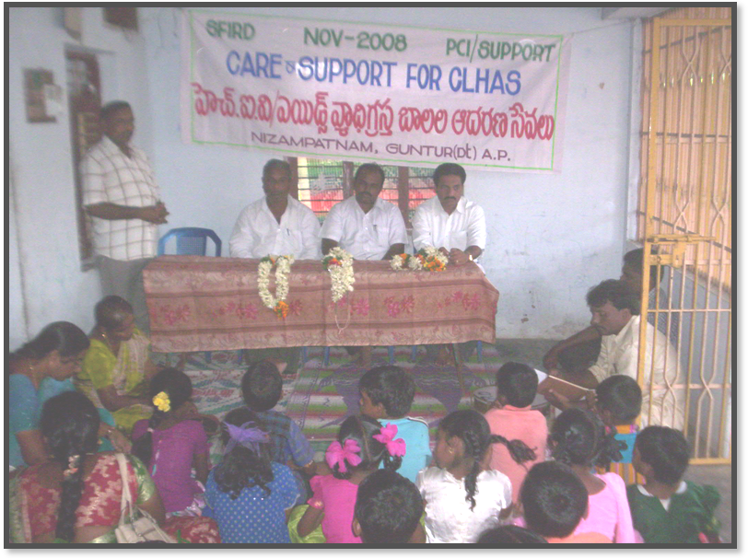

Care and Support services for Children Living with HIV and AIDS (CLHAs)

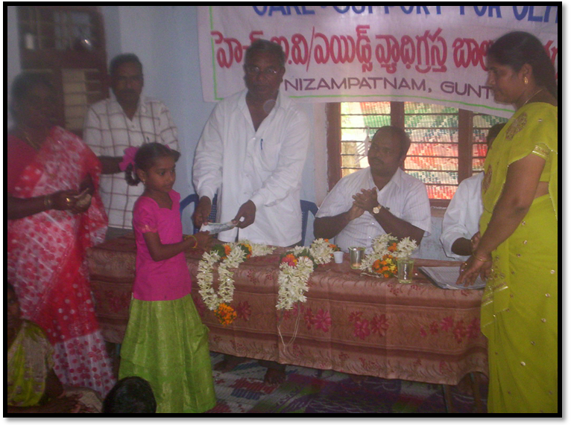

A Child receiving Nutrition Support

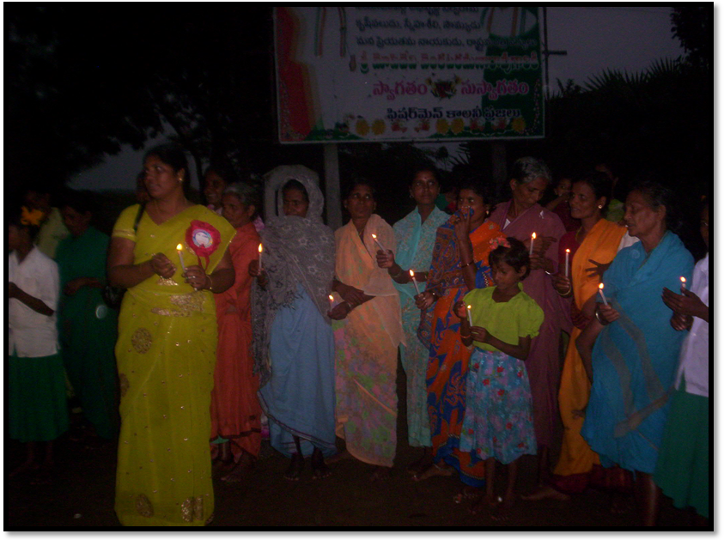

Candle Light Rally on World AIDS Day

Submitted by :
Society For Integrated Rural Development
#15-12-68, Venkatrao Nagar, GUNTUR – 522 001, A. P. India.
sfird_org@yahoo.co.in; Contact : 91-863-2226452.

November - 2012

