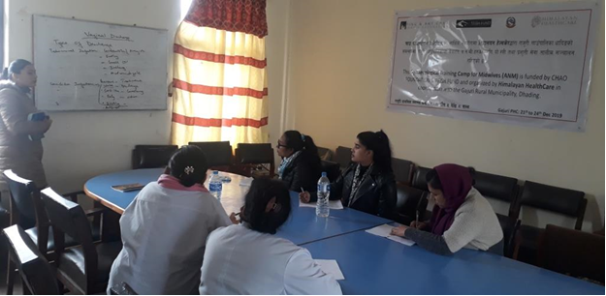
Second cohort of trainees at the end of the training
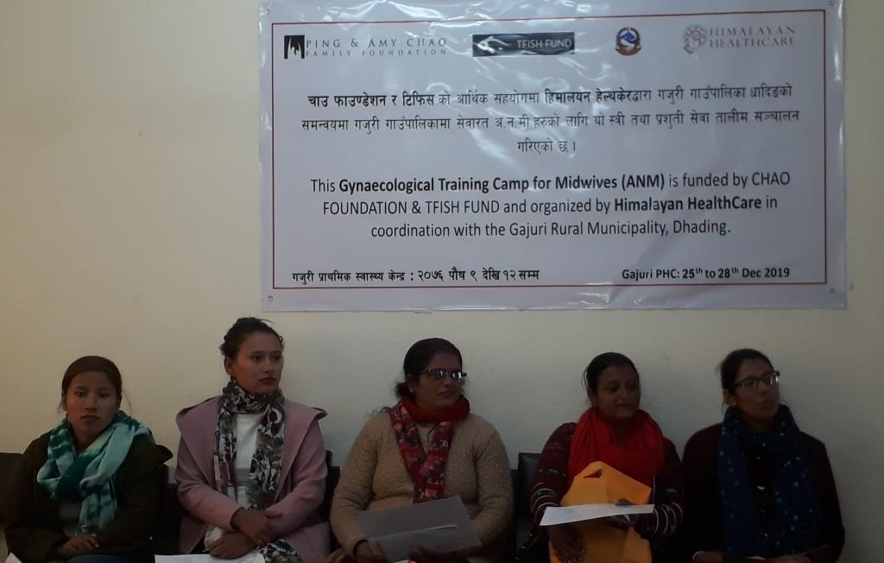

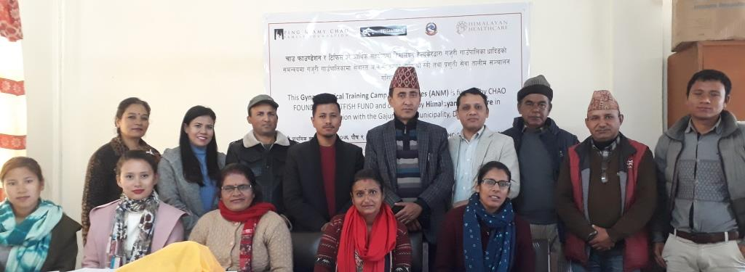
The Chairman of the Rural Municipality (hat) with second cohort of participants and HHC reps

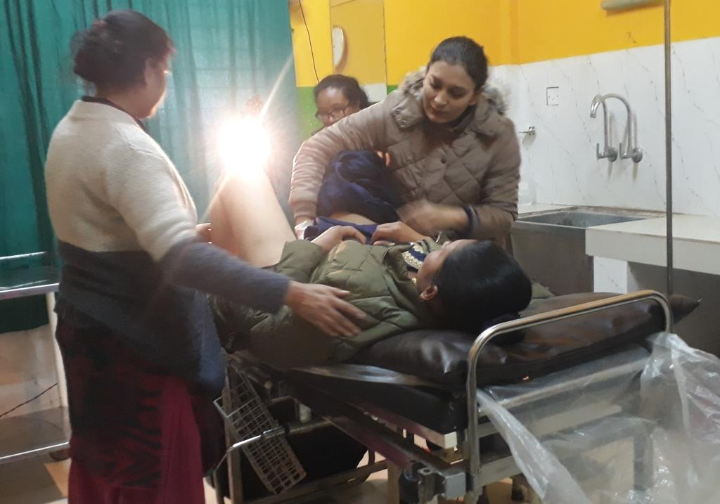
Dr. Richa teaching about patient examination to midwives
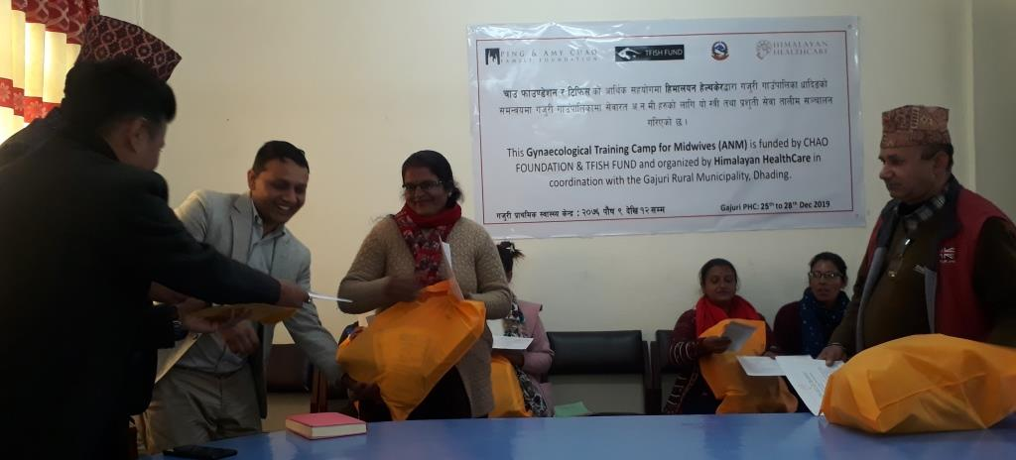
Handing out medical kits to the participants
Dr. Richa teaching about patient examination to midwives

