THE GYNECOLOGICAL TRAINING OF ANM (MIDWIFE) REPORT DECEMBER 202-

Training date: 16th to 19th December, 2020.
Participates: 11 health workers from different Health Units of Benighat Rorang Rural Municipality
Training Venue: Benighat Health Post, Benighat Rorang Rural municipality, Dhading
Training Doctors: Drs. Rakshya U & Richa J
Paropakar Maternity and Women's Hospital, Thapathali, Kathmandu

HHC had discussion with the District Health Office in regards to expansion of the training to Benighat Rorang Rural Municipality after they requested for such training. HHC had conducted similar training in Ruby Valley and Gajuri Rural Municipalities in 2019 and 2020. Benirorang RM also has health posts in isolated remote village sites and helping the midwives with gynecological training was a continuation of HHC’s support to this rural municipality as well as improving services to the women patients of the region.
Benighat Health Post where the training was conducted is three hours’ drive from Kathmandu and one hour from the Dhading District HQ of Dhadingbesi and is the center of the region but the participants had to travel for several hours and bus ride to reach this center from other village sites which are spread out in the region. HHC Officer Mr. Nabin M escorted the specialists from Kathmandu for the training. They all were provided food and stay at a local hotel during the 4 days training period.
Altogether there were 11 trainees and they were divided in to 2 groups, A and B. Group A was conducted by Dr. Rakshya U and group B by Dr. Richa J. As both the trainers were from the same hospital, they had worked on the training materials and handouts together.

Group A: Dr. Rakshya Upreti
S.No. | Participates | Position | Working HP
1 | Amrita R | ANM | Benighat HP
2 | Pratigya S | ANM | Jayapuri CHU
3 | Aasha Ku. C | ANM | Syadul CHU
4 | Sujata D | ANM | Charaudi BHC
5 | Shristika K | ANM | Salanghat CHU
6 | Dipa Shahi T | ANM | Dandagaun CHU

Group B: Dr. Richa Jha
S.No. | Participates | Position | Working HP
1 | Samjhana S | AHW | Benighat HP
2 | Birsana N | AHW | Mahadevsthan HP
3 | Sabina C | ANM | Dhusa HP
4 | Tulasa DBM | SAHW | Gogimara HP
5 | Jayanti B | ANM | Jarung CHU

Additional training and tips were given by Dr. Dipak J, who also accompanied his wife Dr. Richa J. Likewise, Chief Consultant of Obstetrics and Gynecology of Paropakar Maternity and Women’s Hospital also accompanied to see the first day of training as the trainers were selected by her who are working under her supervision in the hospital.

First day of Training (16th Dec 2020)
Due to covid 19 situation no formal inauguration was planned therefore the program started with introduction with the trainees, trainers and HHC representative. After the introduction, HHC coordinator briefed about the trainers, their background, subject matter to be discussed and importance of the training. Then, Chief Consultant Obstetrics and Gynecology, Paropakar Maternity and Women's Hospital, Thapathali Dr. Madhu S gave some tips to the participants on women’s problem, causes and cure and how they can learn and benefit from this specialized training. She wished all participants and trainers for the success of the training.

Day One of Training (16 Dec, 2020)
The training started about 11am in two separate groups. Started with basic history taking and examination of gynecological cases.
History taking 1
- Introduction
- Chief complain
- Menstrual history
- Obstetric history, GPAL (gravid, para, abortion, living), any problem during birth, delivery place - health institution or home
- Contraceptive history, temporary OPC, Depo, Norplant , IUCD or permanent vasectomy and laparoscopic
- Past or present medical history: Any chronic diseases like TB, HTN, diabetes, thyroids and medication
- Personal history: Smoking, alcohol and diet like veg or non-veg
- Occupational history: Which profession?
- Family history: Any disease in family member

EXAMINATIONS
General Physical examination:
Pallor, Icterus, Edema, Dehydration, HT / Weight, Pulse, BP, Temp, Resp Rate

Specific Examination
Per Abdominal examination
Inspection / Palpation / Percussion / Auscultation
Per speculum Examination:
Per Vaginal Examination:
Resuscitation of the newborn baby who has the respiratory distress problem by Dr. Richa Jha.

Additional training by Dr. Deepak J
Dr. Deepak J, who accompanied Dr. Richa J gave further training on management on diarrhea and dysentery in children.

By the end of the day, there were 2 gyne patients and the trainers gave hands on training to the participants. Both the cases were of vaginal discharge and taught the participants to take history and examination properly.

Day 2 of training (17 Dec, 2020)
The second day of training started at 10:00 am and finished by 16:00 pm. Before the start of the training, Mr. Shankar B D, Health Coordinator of Benghat Rorang Rural Municipality visited the training venue and welcomed all the participants & trainers and thanked HHC for the training.

The ANM team was very keen to learn about vaginal discharge as it was one of the major complaints of the patients. The trainers informed on the following:

Types of vaginal discharge:
1. Physiological- reproductive age, menstrual and hormonal
2. Pathological - infected and non-infected
Infected: Sexually infected- TV, Chlamydia, Gonorrhea, Syphilis, HSV Non sexual infected- BV, Candida (mostly below 25 Years)
Non infected: Foreign body, atrophic (dryness) and
3. Malignant Diseases

Major Causative Agent and Nature of Discharge:
- Candida fungal agent with curdy discharge with itching
- Bacterial vaginitis causes by chlamydia bacteria with grayish white discharge
- Trichomonas protozoal agent with greenish discharge with frothy nature
- Gonorrhea bacteria discharge Fishy odor
- Syphilis bacterial ulcer on vagina

The Participants were also interested to learn about the labor and its mechanism and management.

Definition of Labor and Delivery
Stages of labor
First, second, third & fourth
Identification of true and false labor
Mechanism of labor: Video demonstration where participants could see all procesess through dummy
Management of first stage, second and third stage of labor
After the brief information on stages of labor, participants were taught on diagnosis of abnormal labour such as:
Breech presentation
Transverse lie
Cord presentation
Compound presentation

Practice of resuscitation of baby by showing the participants the demonstration.

At the end of the session Dr. Deepak J gave lessons on causes, symptoms, cure and treatment on measles, mumps & rubella

Day three of Training (18 Dec 2020)

Postpartum hemorrhage (PPH) being the major cause of death among the women in Nepal, the participants were taught how to manage PPH

Definition of PPH:
Types of PPH: Primary / Secondary
Estimation of blood loss
Management of PPH:
Pharmacological: Oxytocin, misoprostol, tranostat, mothering
Non Pharmacological: Aortic compression, uterine compression and condom tamponade

Identification and treatment of jaundice, fever, and kangaroo mother care.

The trainers conducted a practical drill and role plays on estimation of blood loss and management of PPH and were able to conduct it confidently. After that, patients were examined in the presence of participants in OPD.

The day ended with session by Dr. Deepak J on chicken pox - cure and treatment, burn- cure and treatment and management of wound.
Day Four of Training (19 Dec 2020)
On fourth day participants were interested to know about hypertension complicating pregnancy. Therefore they were given basic information to diagnose:
Gestational Hypertension
Preeclampsia/ Eclampsia
Chronic Hypertension
Chronic Hypertension with superimposed preeclampsia
Discussion on how to do proper counseling to the patient and revision of previous days training topics were also discussed. Total 6 patients were checked while conducting practical training.
 | Patient Name | Age / sex | Diagnosis | Management | Remarks
1 | Nirmala S | 45/F | Candidasis Cervical Erosion | Tablet Infect- V6, Tab Metron
2 | Nabina N | 21/F | Irregular Menstruation cycle | Advice TFT test & USG
3 | Riki K | 32/F | Candidiasis | Tablet Onidazole/tablet infect v6
4 | Tara S | 46/F | Cystoces, vaginal candidiasis | Tablet Infect v6 | Follow-up after 7 days for insert of ring pessary
5 | Sarita P | 30/F | Fungal infecion | Tablet Infect v6
6 | Rekha P | 37/F | Inguinal hernia | Dj citral, tablet flontin

Closing program
During the closing program the officials of Benighat Rorang Rural Municipality wished to thank the HHC and the trainers for the effective training given to the participants therefore about 6 political and administrators of Benighat Rorang RM were present. The closing ceremony was carried out following the protocols of covid 19 situation.

Individuals Present During the Closing Program:
Chairman: Mr. Pitta B D, Chairman, Benighat Rorang RM
Guest: Mr. Devi P S, Vice Chairman, Benighat Rorang RM
Guest: Mr. Laxman P B, Chief Administrative Officer, Benighat Rorang RM
Guest: Mr. Shankar B D, Health Coordinator, Benighat Rorang RM
Guest: Mr. Roshan K S, Chairman, Benighat Health Post Development Committee. There were few other guests of ward nos. 3 & 5 of Benirorang RM

One the occasion, the chairman also handed out certificates and health check-up kits to all the participants provided by Himalayan HealthCare.

Thank you Note by Individuals

Mr. Pitta B D, Chairman of Benighat Rorang Rural Municipality thanked Himalayan HealthCare, trainers and donor organization for helping the midwives of Benighat Rorang RM with the needed training support. He highlighted how the area is populated by one the most backward community of Chepangs and how it would help them to get quality of treatment by this training. He wished to work with HHC in future too. He thanked all participants for the good work and ask them to utilize their skills in their practical day to day work.

Doctor Rakshya U thanked HHC for giving her an opportunity to indirectly help village women through this training. She also thanked all participants for their cooperation and their interest to learn. She thought that this kind of training would help develop the skills of the health workers and be able to carry out the intervention themselves.

Representative of HHC Kul B asked all participants to submit monthly report to HHC of patients served at their respective centers. They were also asked to keep track of all the patients, types of cases, and not down questions and doubts for the follow-up training session scheduled to be held in February 2021

After the briefing by HHC representative, the chairman then announced the conclusion of the training.

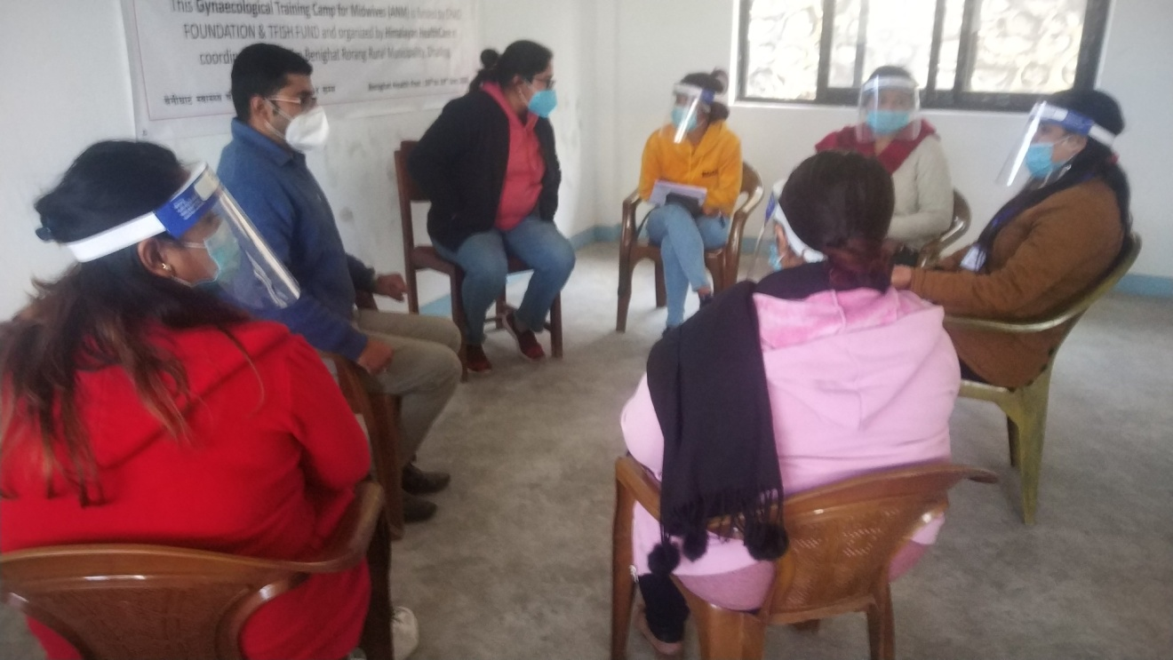
Dr. Richa J, explaining to trainers
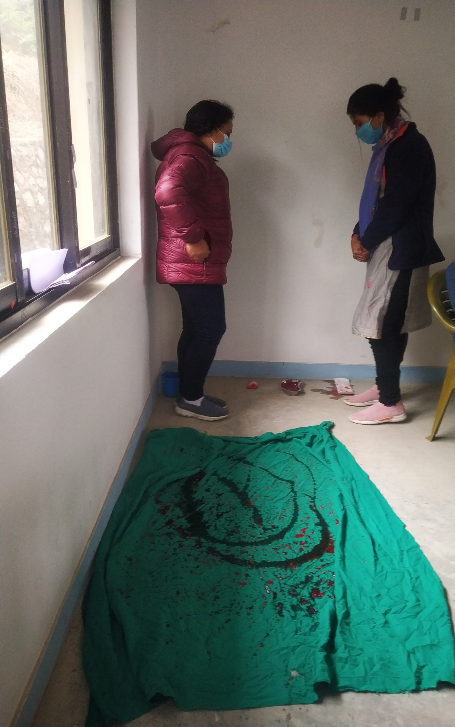
Dr. Rakshya U, demonstrating of bleeding patients

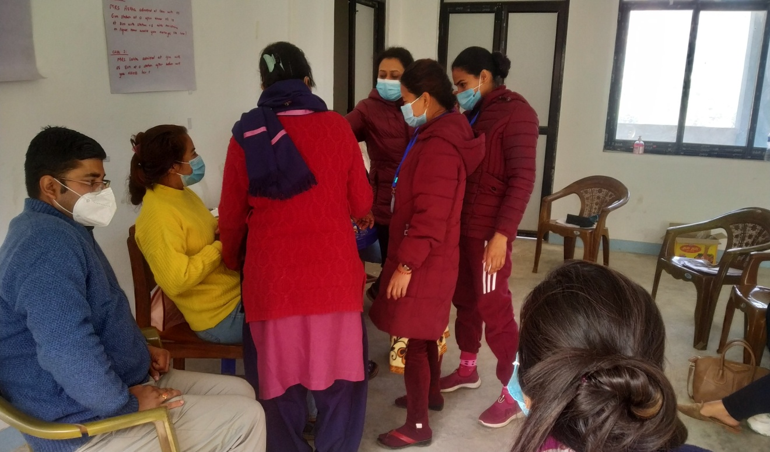
Hands on training with Dr. Rakshya U

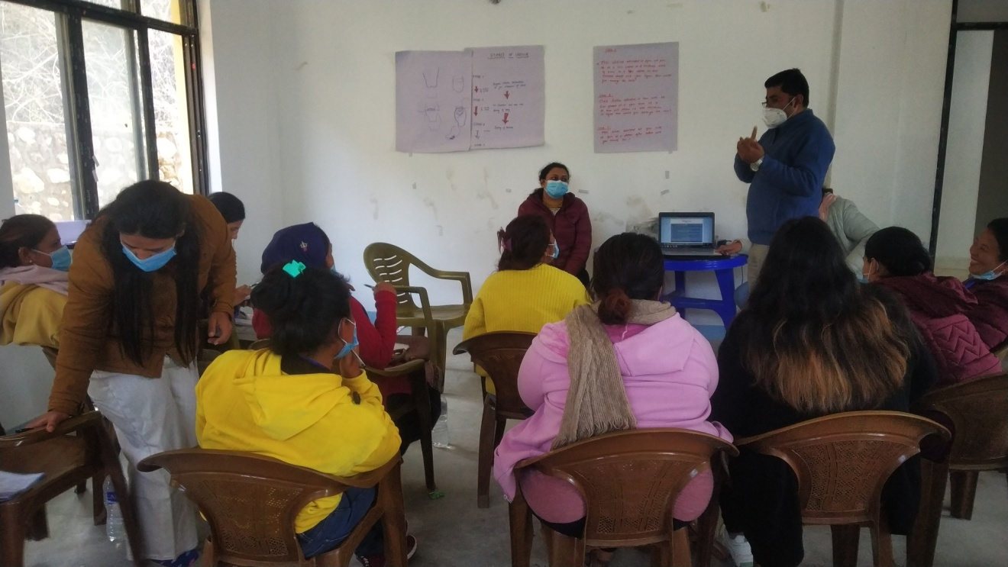
Dr. Deepak J, explaining participants on wound management & dehydration
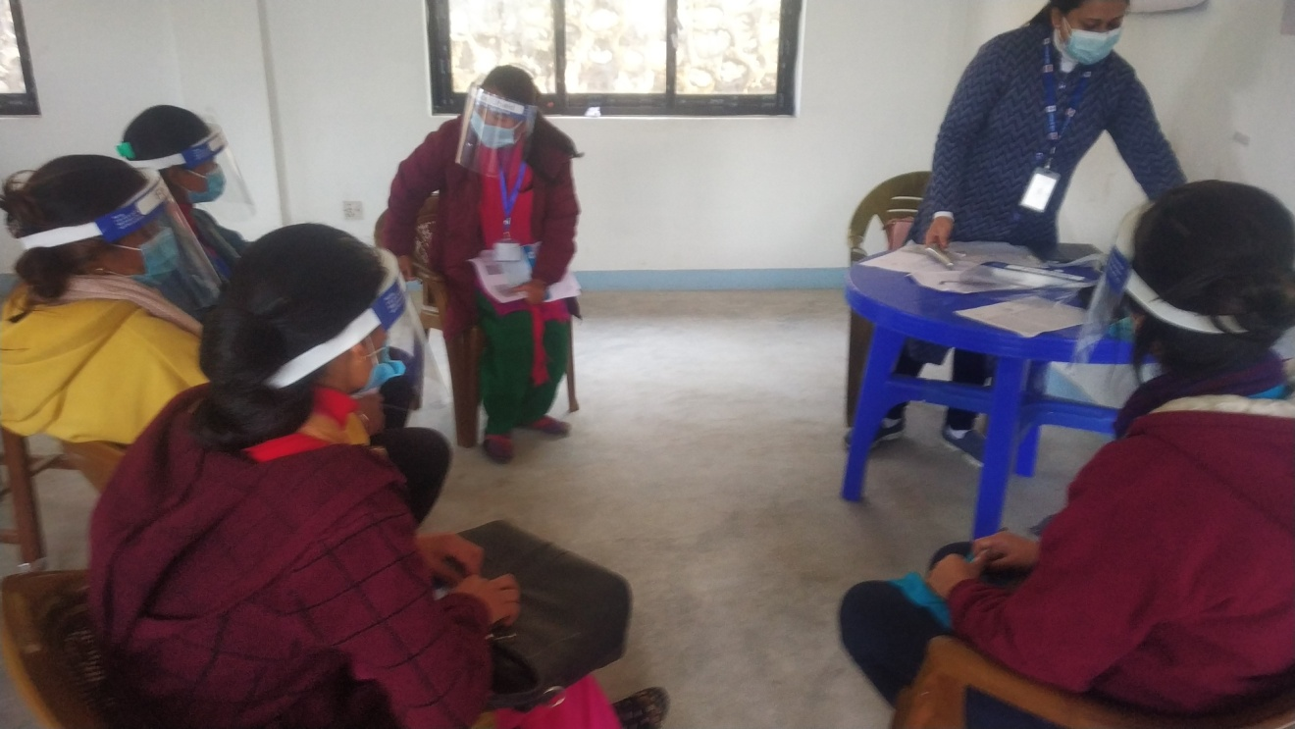 Dr. Rakshya U preparing for video demonstration

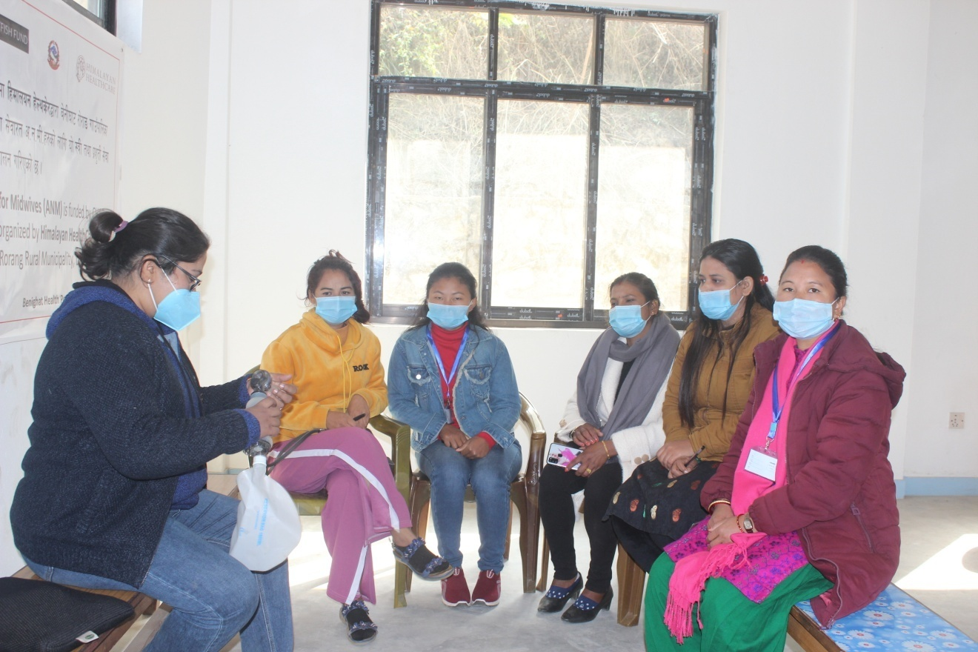
Dr. Richa J, demonstration of resuscitation
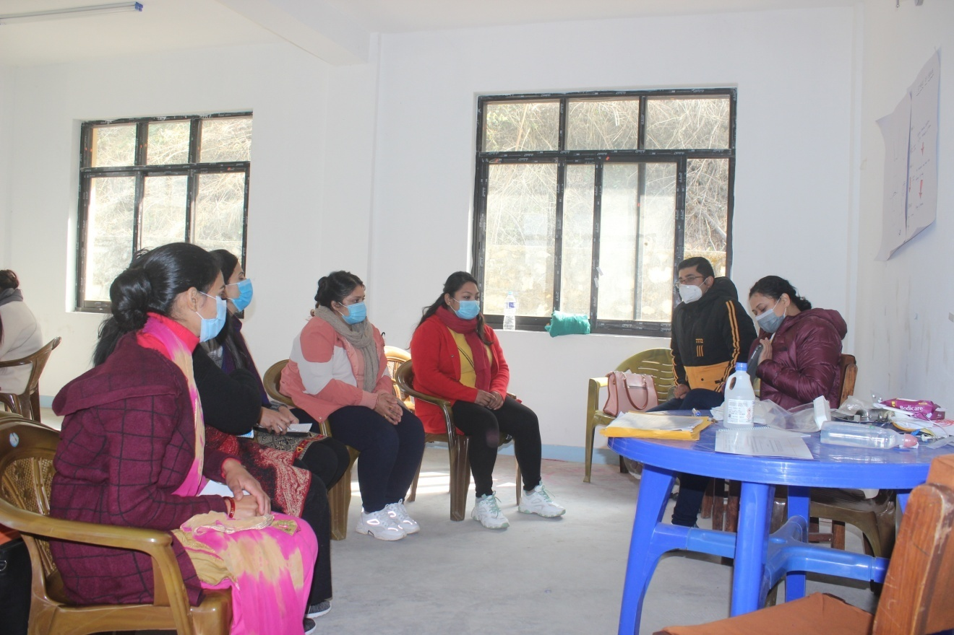 Dr. Rakshya U, video demonstration

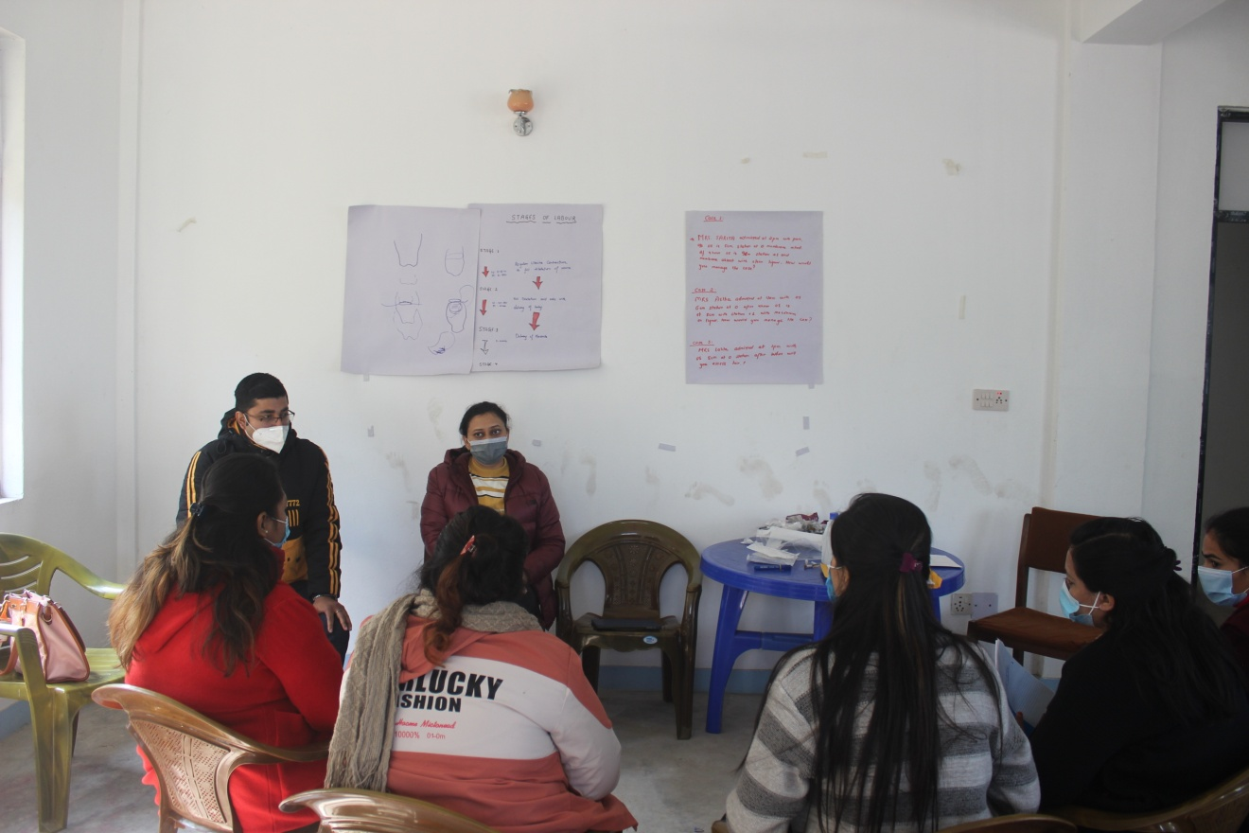
Dr. Rakshya U with trainees
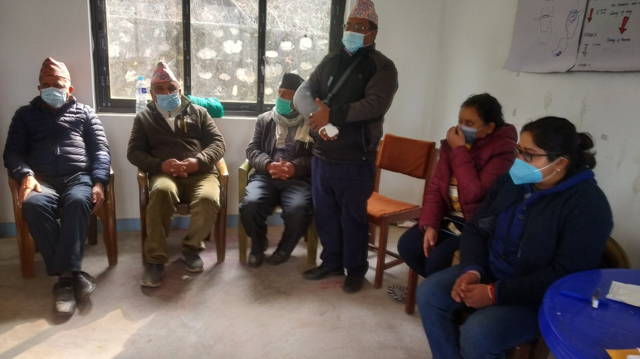
Chairman Mr. Pitta B D thanking all

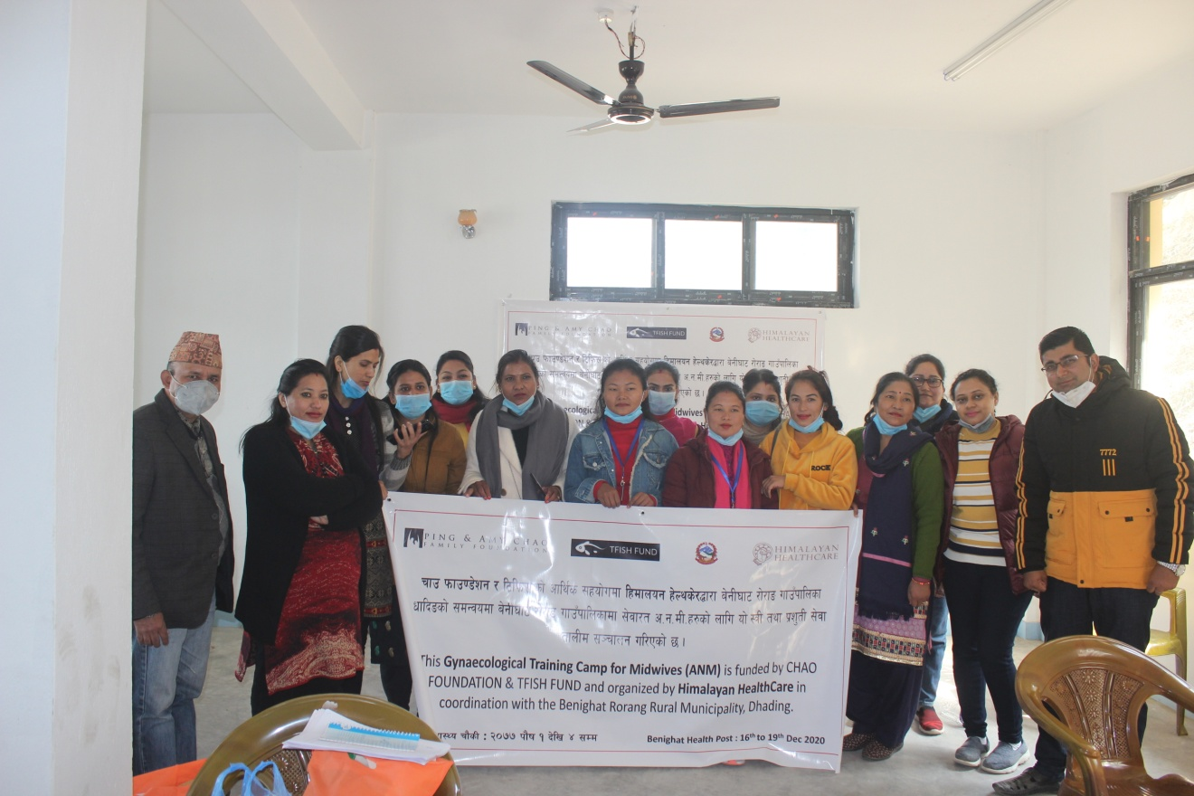
Group Photo of Trainers and Trainees with HHC Representative

