Case Studies

I. “I feel that the use of a toilet will prolong our life” Dhandeu T

“Gobre settlement 20 households in mountainous Ruby Valley are more remote and backward. 13 had received toilet support from organization Shanti Nepal but seven had no building materials.”
Hearing of HHC’s toilet program, 84 year old Dhandeu T sent in an application highlighting Gobre’s remoteness and negligence by authorities and NGOs.
“We could only go to the edges of the outlying fields for bathroom. It was really slippery and with snakes it was dangerous. I personally experienced these problems. Our neighbors also cursed us when our children defecated in the fields. We have had epidemics of diarrhea and dysentery.”

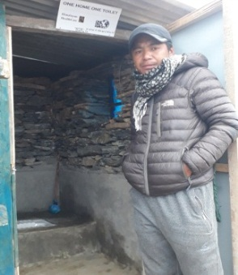
“Once toilets were built it felt like heaven and all the bathroom hardships felt like a bad dream. Now with the government micro-hydro electricity and taps at home as well, this is fantastic. Thank you.”

Toilet supervisor: Dhandeu T encouraged his villagers and involved his family in construction. Women collected rocks and sand while men constructed. It was so rewarding to see the enthusiasm of the family and community towards toilets and its care and upkeep.

II. “My relationship with members of my community changed after I constructed my own toilet” Somparni T
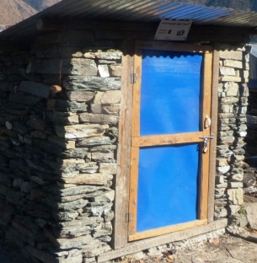
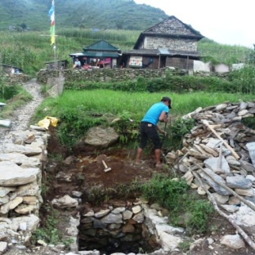
Somparni T with her family of four relocated to Chayotatole from Kharsha two years ago. “We used the neighbor’s toilet but with time they were reluctant to allow us to use it so we used a hole in the ground and some of my neighbors ostracized us because of the hole and the foul smell. So we started going to the bushes away from everyone but felt very uncomfortable of being watched and exposed. It was very difficult when we had diarrhea and had to go frequently. It was very exciting when HHC announced the toilet project and my son Tashi T put in an application. Because of our financially state, our application was approved immediately and we started construction at once.

Once our toilet was completed, my neighbors who had shunned me began to speak with me again and soon I was accepted in the neighborhood. I am so happy that we have a toilet at home. It feels so secure and it saves us so much time. Thank you for the toilet and making my life easy.”

Words from HHC Supervisor:
Sompani T and her family enthusiastically participated in toilet building and followed all the instructions as outlined by the organization.

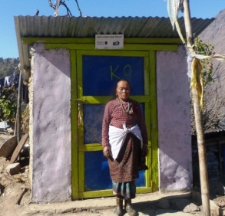
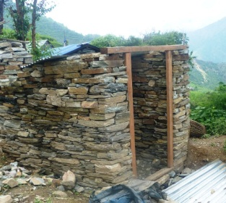
III. “Ward chief and no toilet, very embarrassing” Bahadur T
Bahadur T is from Kharsa cluster of Sertung village with 123 households. “My father was the former ward chief. Since three years HHC has been supporting toilets here. People came to see my dad at home and it was embarrassing that we had a hole in the ground under the Szechuan pepper tree beyond the yard for a toilet. You needed a flashlight and an umbrella to go in the night and in the rain. We wanted to build one for a long time but somehow did not know what materials and how to go about it and so we kept putting it off. But when HHC announced the toilet project we immediately applied and once approved I hired two laborers to help me with construction and we did it in just 10 days!
For the 13 toilets in our ward, we got all the households together to discuss and help plan. Once our toilet has been built, it is clean around the house and no smells! It’s so convenient now and it saves us so much time! We feel civilized and thank HHC. Now adding 10 more toilets will help make Kharsa ‘open defecation free’ which would be historic.

