THE GYNECOLOGICAL FOLLOW-UP TRAINING OF ANM (MIDWIFE) REPORT 2021

Date: 17-20 February 2021
Place: Benighat Health Post
Benighat Rorang Rural Municipality
Dhading District, Central Nepal
Participants:
11 AMNs from village health posts and community health units of Benighat Rorang Rural Municipality
Trainers (Ob/Gyne): Dr. Rakshya P and Dr. Rakshya U of Indra Rajya laxmi Maternity and Women's Hospital, Thapathali, Kathmandu
Implemented by: Himalayan HealthCare Nepal

In the past, the ob/gyne trainings were conducted in two phases one after another with involvement of five ANMs from different health institutions. When the first batch finished and went back to the village, the second batch would get the training. But this year, the two groups consisting of 5 participants in each group were given training simultaneously by the two specialists.
Group ''A"
Facilitator - Dr. Rakshya P (Ob/Gynecologist), Indra Rajya laxmi Maternity and Women's Hospital, Thapathali, Kathmandu
Participants
 | Participant | Station/Health Post | Designation
1 | Jharana S | Benighat HP | ANM
2 | Sabina C | Dhusha HP | ANM
3 | Tulasha D M | Gogimara HP | Sr. AHW
4 | Jayanti B | Jarung CHU | ANM
5 | Pratigya S | Jayapuri CHU | ANM
6 | Amrita M | Irang CHU | ANM
Note: Trainees names are protected

Group ''B"
Facilitator - Dr. Rakshya U (Ob/Gynecologist), Indra Rajya laxmi Maternity and Women's Hospital, Thapathali, Kathmandu
Participants
 | Participant | Station/Health Post | Designation
1 | Aasha K C | Syadul CHU | ANM
2 | Sujata D | Charaudi BHC | ANM
3 | Shristika K | Salanghat CHU | ANM
4 | Dipa S T | Dandagaun CHU | ANM
5 | Nirmala R | Mahadevsthan HP | ANM
Note: Trainees names are protected

First Day of Training (17 Feb 2021)
This training being the follow-up, no inauguration program was planned but was communicated in advance and was planned and executed in coordination with Benighat Rorang Rural Municipality.
The first day of training on 17th February started at 10:30 am. It was inaugurated by the health In-charge of Benighat Health Post. In the opening session the trainers and participants once again introduced themselves and the health institutions that they are associated with. After the introductory program, HHC staff briefed and overviewed the women patient report sent by ANMs, experiences and challenges faced by the participants especially after the training. Also discussed about the importance of the follow-up training and the opportunity to share the experiences and shortcomings with the senior trainers and to learn from them. After this, the facilitators took the following classes and discussions were held in an interactive manner.

Trainers asked the trainees to present their experiences at work prior and after the training, cases that they handled and how they managed the situation. All trainees shared one case each that they managed such as LBW, PPH, Meds indication and contraindication to pregnancy.

Dr. Rakshya U overviewed mechanism of Hyoscine Butylbromide and advised not to use this medicine during pregnancy as it is antispasmodic and that it can start labor.

Dr. Rakshya P overviewed mechanism of Losartan and advised not to use this during pregnancy as this is antihypertensive and that it may lead to a death or harm of a fetus.

Practical patient checkup: only one ob/gyne patient during the day
Patient | Age/Sex | Diagnosis | Treatment | Remarks
Sabita C | 28Y/F | Trichomoniasis | Metronidazole 400mg

Both Drs. overviewed on the following:
History taking
- Introduction of patient
- Chief complain
- History of present illness (HOPI)
- Menstrual history (most important)
- Obstetric history
- Contraceptive history
- Past medical & surgical history
- Personal history
- Occupational history & family history
Physical examination:
- GC (general condition): fair, ill looking, conscious or unconscious,
- Vitals: T,PR,RR, BP (temperature, pulse, respiratory rate & blood pressure)
- PILCCOD: (pallor, icteric, cyanosis, clubbing, edema, dehydration)
- Chest examination: B/L normal vesicular breath sound and equal air entry, crepitation and wheezing
- CVS (cardiovascular system): s1 s2 or any added sound
- A/P (per abdomen): any mass feel and tender
- P/S (per speculum): polyp, discharge, erosion on cervix and its position
- P/V per vaginal: feel any cyst or mass and motion tenderness on cervix
- Breast examination: standing and hands on waist, press by palm on the breast on four quarters of both the breasts

Second Day of Training (18 Feb 2021)
Amenorrhea: This topic was not covered at time of training in December 2020. So, a brief session on amenorrhea was conducted. Amenorrhea means absence of menstruation, often defined as missing one or more menstrual periods. There are two types of amenorrhea:
- Primary amenorrhea refers to the absence of menstruation in someone who has not had a period by age 15. The most common causes of primary amenorrhea relate to hormone levels, although anatomical problems also can cause amenorrhea.
- Secondary amenorrhea refers to the absence of three or more periods in a row by someone who has had periods in the past. Pregnancy is the most common cause of secondary amenorrhea, although problems with hormones also can cause secondary amenorrhea.
Cause- physiological and pathological
Treatment- of amenorrhea depends on the underlying cause.
Dysfunctional Uterine Bleeding (DUB): is a condition that affects nearly every woman at some point in her life. Also called abnormal uterine bleeding, DUB is a condition that causes vaginal bleeding to occur outside of the regular menstrual cycle. Certain hormonal conditions and medications may also trigger DUB.
Signs | Symptoms | Investigation | Management
Anemia, abdomino-pelvic examination is usually normal. If uterus is enlarged, fibroids are likely | Heavy or prolonged vaginal bleeding, dysmenorrhea (on/off) | Pregnancy test, CBC, TFT, USG | Tranexamic and Mefenamic acid are useful to decrease loss during periods, ocp to regulate irregular cycle

Menorrhagia (more than 80 ml) is very common among age below 45 years

Food and Drug Administration (FDA) Risk Classification: In 1979 the FDA established five letter risk categories- A, B, C, D and X to indicate the potential of a drug to cause birth defects if used during pregnancy.
Category A: adequate and well controlled studies have failed to demonstrate a risk to fetus in the first pregnancy, eg. Folic Acid
Category B: studies failed to demonstrate a risk to the fetus and no adequate and well controlled studies in pregnant women, eg. Metformin
Category C: studies shown adverse effect to fetus and no adequate and well controlled studies in human, but potential benefit may warrant use of the drugs in pregnant women deposit risk, eg. Amlodipine
Category D: there is positive evidence of human fetal risk based on adverse data from investigation and marketing experience or studies but potential benefit may warrant use of the drugs in pregnant women deposit risks, eg. Losartan
Category X: studies have demonstrate fetal abnormalities and positive evidence of human fetal risk based on adverse reaction data from investigation and marketing experience and risk involved in use of the drugs in pregnant women clearly outweigh potential benefit, eg. Atorvastatin
Patient Checkup, hands on: two women patients who had to the health post were checked by the trainers and all the participants observed history taking to management of the cases with great interest
Patient | Age/Sex | Diagnosis | Treatment | Remarks
Sita A | 46Y/F | VDS | CAT regimen
Sarita M | 35Y/F | Candidiasis | Fluconazole 150mg

Dr. Rakshya U highlighted the importance of Folic Acid during pregnancy and how it helps in forming neural development and bones of a fetus.
Dr. Rakshya P taught on Visual Inspection with Acidic Acid (VIA). This is manual procedure on cervical cancer screening method in the remote areas.

Third Day of Training (19 Feb 2021)
Miscarriage: defined as the spontaneous loss of a fetus before the 20th week of pregnancy.
Types:
Threatened, Inevitable, Incomplete, Complete, Missed,Recurrent
Ectopic Pregnancy: also called extra-uterine pregnancy or when a fertilized egg grows outside of the uterus (90% in fallopian tube).
Types: tubal and non-tubal
Causes: scars of fallopian tubes, hormonal, genetic, birth defect and medical condition
Symptoms: amenorrhea, irregular menstruation, severe pelvic or abdomen pain mostly one side, fainting and shoulder pain
Management: surgical
Dr. Rakshya U spoke in detail about surgical procedure of ectopic pregnancy. USG is first step to confirm the ectopic pregnancy or other problems such as mole, cyst, atrophy or cancer.
Post-Partum Hemorrhage (PPH): any amount of blood loss that threatens woman’s hemodynamic stability (blood loss >500 ml from vaginal delivery & >1000 ml in caesarean section or 1500 ml at caesarean hysterectomy).
Types:
- Primary: 3rd stage labor to 48 hours of delivery
- Secondary: 48 hours to 6 weeks of delivery
Causes: 4 Ts (tone, trauma, tissue, thrombin)
Management: there are three methods use in PPH
- Use of medicines- Inj. Oxytocin 20 units in each drip, tab Misoprostol 800mcg per rectal, Inj. Tranexamic acid 1gm IV stat
- Manual- if bleeding doesn't stop using medicine, apply bimanual compression, inspect trauma and suture them
- Condom tamponade- if point 1 and 2 intervention failed, then proceed to this procedure. Counseling and prepare instruments
Inflate 250-500 ml saline & bleeding stops in 0-15 min in most cases
Patient checkup, hands on: The patient below was checked and treated with detail history taking and management of the case
Patient | Age/Sex | Diagnosis | Treatment | Remarks
Gayatri A | 26Y/F | VDS | CAT regimen

Fourth Day of Training (20 Feb 2021)
Types of Vaginal Discharge:
- Physical: reproductive age, menstrual and hormonal
- Pathological: infected and non-infected
- Infected:
Sexual infected- TV, Chlamydia, Gonorrhea, Syphilis, HSV
Non sexual infected- BV, Candida (mostly below 25 Year
- Non infected:
Foreign body, atrophic (dryness) and malignant

Type of discharge | What it means | Other symptoms
Bloody or brown | Irregular menstruation, cancer | Abnormal vaginal discharge, pelvic pain
Cloudy or yellow | Gonorrhea | Bleeding between period, urinary incontinence
Frothy, yellow or greenish with bad smell | Trichomoniasis | Pain and itching while urinating
Thick, white cheesy | Yeast infection | Swelling and pain the vulva and dyspareunia
White, gray or yellow with fishy odor | Bacterial vaginosis | Itching or burning redness of the vagina

Management: treatment provided as per the symptoms mentioned above.
Pelvic Inflammatory Disease (PID): Can be caused by ascending infection from the endo cervix or from descending infection from organs and 25% caused by Chlamydia and Gonorrhea.
Following minimum clinical criteria with lower abdomen pain present in the PID.
- Cervical motion tenderness or
- Uterine tenderness or
- Adnexal tenderness
Management of PID: there are different regimens to manage the PID
CAT (Cefixime, Azithromycin and Tinidazole) is the first line of management of PID. If no response by CAT regimens then refer to gynecologist.

Closing program
Chairman: Roshan K S, Chairman of Management Committee of Benighat HP
Chief Guest: Devi P S, Vice-Chairman of Benighat Rorang Rural Municipality
Guest: Laxman P B, Chief Admin Officer, Benighat Rorang Rural Municipality
Guest: Dr. Madhu S, Senior Ob/Gyne Consultant, Indra Rajya Laxmi Maternity and Women’s Hospital, Thapathali, Kathmandu
Guest: Shankar B D, In-charge of health unit, Benighat Rorang Rural Municipality Guest: Bhuwan T, Chairman of ward # 3, Benighat Rorang Rural Municipality, 4 HP staff, 2 HHC staff, 2 facilitators and 11 participants

Few Words from the Guests (as it is):
Guest (Shankar B D): We received IMAM and 4 days gynecological training few months ago with financial support from HHC and now 4 days follow up training has also been successfully completed. Special thanks to the trainers for their effort and enthusiasm to pass on the maximum knowledge possible to the village health providers. I hope and request all participants to use the skills and knowledge learned during this 4 days gynecological training hope that the patients get better quality service and correct diagnosis and treatment from you.
Chief Guest (Devi P S): I personally and on behalf of Benghat Rural Municipality thank Himalayan HealthCare for such a very useful and needful training. I am confident that this training strengthens the health service provided from health posts and I am hopeful that this will help the health issues of the entire women patients of the respective health posts. We expect more support from HHC in the future too. I request all to impart the lessons and skills learned during the training and work honestly in imparting the services.
Chairman (Roshan K S): I want to thank Himalayan HealthCare on behalf of the health post family, for such important and needful training. We are very happy to serve the women patients of rural municipality using the knowledge and skills gained during the training and follow up training period. We expect more support from HHC in the future and I hereby close the training program.
DR Rakshya U, "It was really a wonderful experience working with Himalayan Health care. The gynecological training camp for midwives and female health worker funded by CHAO Foundation and TFISH Fund in coordination with rural Benighat Municipality provided the female local health workers an opportunity to deal with gynecological cases in their local setup. It helped in identifying the local health problem of female and approach to deal with it. The entire participants were highly enthusiastic and dedicated. I feel that this was definitively one of the best program that helps not only in diagnosing and treating the disease at rural level but will definitely help rural women to get more concerned about their disease and problem in developing country like ours. Thanks to Himalayan HealthCare. Working with them felt really like working in a very hospitable environment. Thank you".
DR Rakshya P, "It was my pleasure to be a part of HHC’s program again. The stay was wonderful. However, I have few points to put forward as where we can improve for another time. I think we should now focus on building a certain curriculum sort of framework for what needs to be taught to the participants. We also need to focus on how to make the class more interactive so maybe we can provide some reading material to them which they can read prior to coming to classes and we can help them solve their queries. Also, we need more patients so that participants can have hands-on training. I hope we can work together to solve these issues. Thank you".
HHC Staff: training was conducted in a very interactive manner and ran smoothly. Benighat Health Post staff were very supportive, helpful and motivated. Participants were very enthusiastic and attentive during the entire training period. This shows their motivation and eagerness to learn and impart the service to the community. In the coming days, we should have tentative package of 4 day training with prior preparation in consultation with the trainees and the topics that are relevant to them in carrying out their duties in the remote settings. We personally feel that this type of training would be very useful and effective if we conducted in the health posts of the villages.

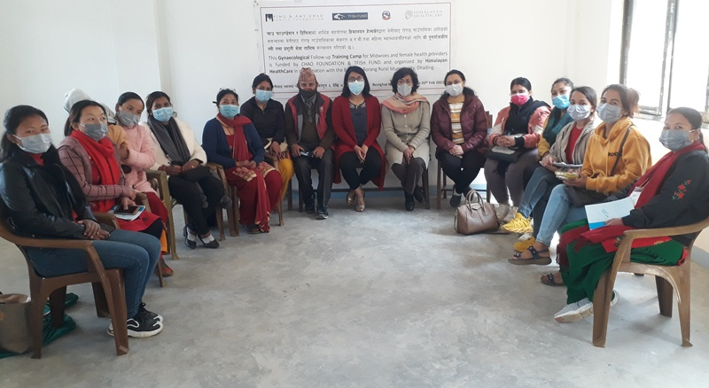
Group picture of facilitators, participant and HHC staff
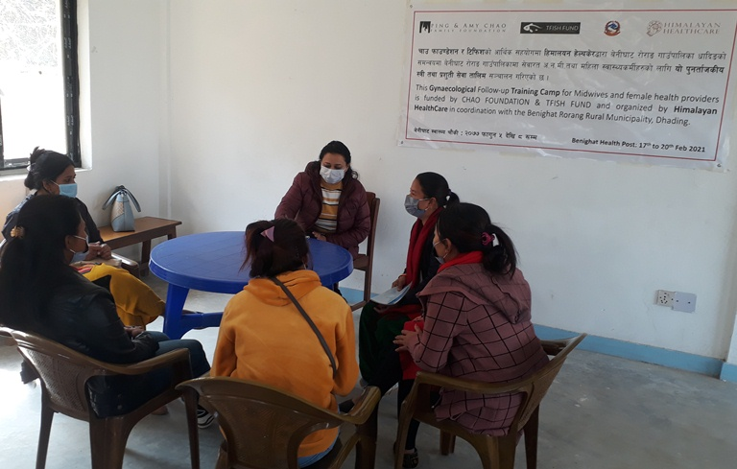
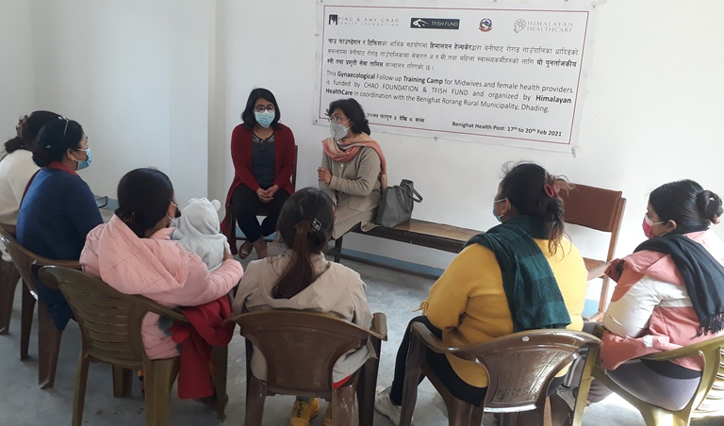

Dr. Rakshya P and Participants
Dr. Rakshya U and Participants
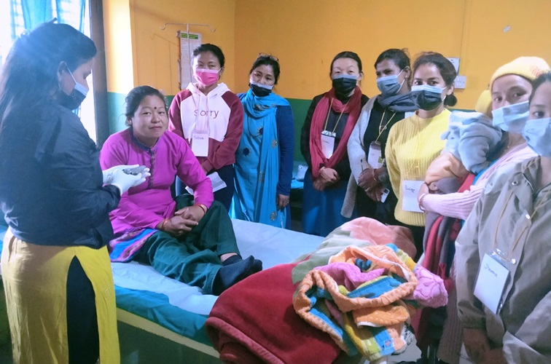
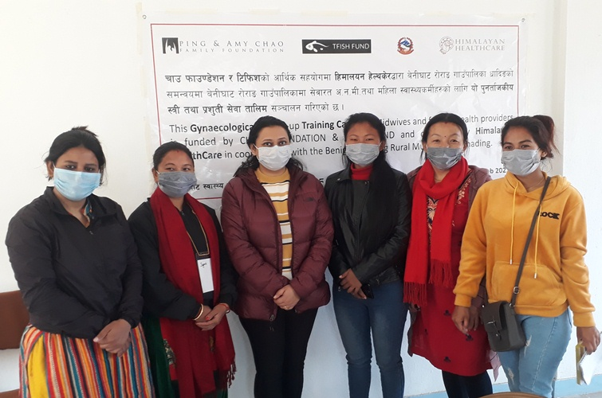
Practically patient examining by participants
Final day, facilitator and 5 participants

