**Fall Medical Camp Photos (2 to 13 October 2018)**

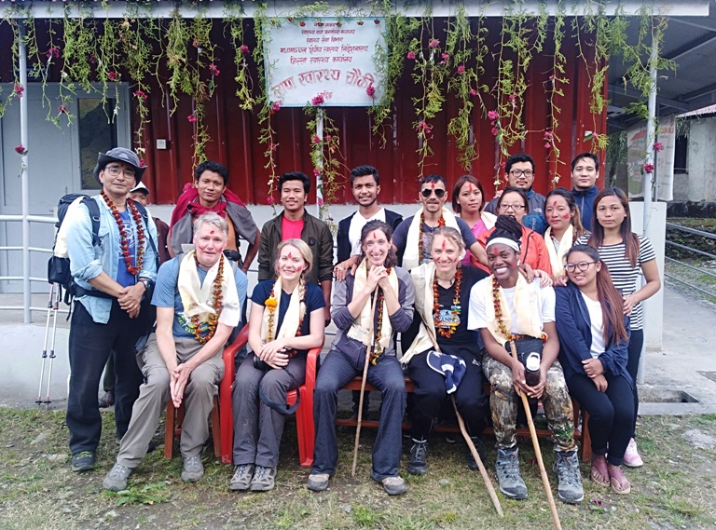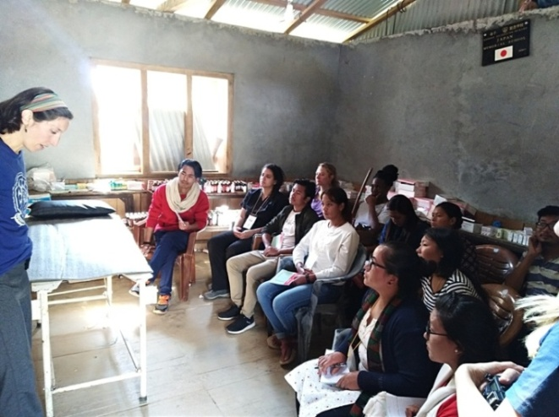  
*HHC Fall Medical team at Lapa Health Post Dr. Sarah Cassel teaching village health providers*

