Lighting Liberia with Solar Energy

1. Why Liberia?

Devastation and Recovery. For 14 years Liberia was engulfed in civil war and terrorized by war lords such as Charles Taylor. The country’s economy and its infrastructure – including the electric grid – were destroyed.

After the civil wars ended democracy was restored and Ellen Sirleaf Johnson was elected President in 2006. After governing for five years Sirlealf Johnson was awarded the Nobel Peace Prize for her extraordinary accomplishments in rebuilding Liberia. Despite embracing democracy and having enlightened leadership, economic recovery has not followed: Liberia is still one of the poorest in the world, ranking 162nd on the UN’s 169 country per capita income rating.

2. Why Solar Lights?

A Country in Darkness. One of the biggest barriers to Liberia rising out of poverty is the country’s lack of energy: less than 5% of the country has access to an electric grid, and when the sun sets Liberia goes dark. Trapped in 19th century conditions of darkness and poverty, Liberia cannot compete in the 21st century global economy.

Solution. There is a solution to Liberia’s energy crisis: portable, inexpensive solar lamps that do not need electric grids or generators. Powered only by the sun, these lamps will provide lighting for Liberians’ medical facilities, schools, homes, and businesses, and will also power their cell phones and other small electric devices – with no monthly charges.
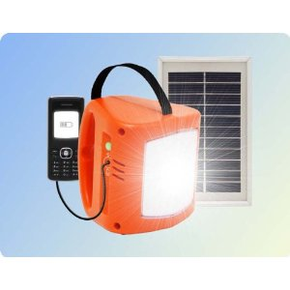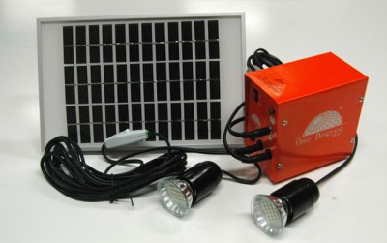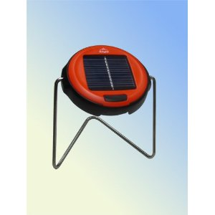
Lights for midwives and night travel Lights with multiple bulbs and long cables Reading lights
for hospitals, households and businesses for students

3. Lights for Learning Project

Lights to Study By. Liberian students from elementary school through university level lack adequate light for studying at night, relying on kerosene lanterns, wood fires, or sometimes standing outside under street lights. LEN has launched a project to raise funds sufficient to donate 600 reading lights to students at the Obama Elementary School and other schools in the greater Monrovia area. The project will allow students to study and do homework at night with solar lights that are bright and safe, and will be charged in the sun every day so that there will be no cost to the students or their families.

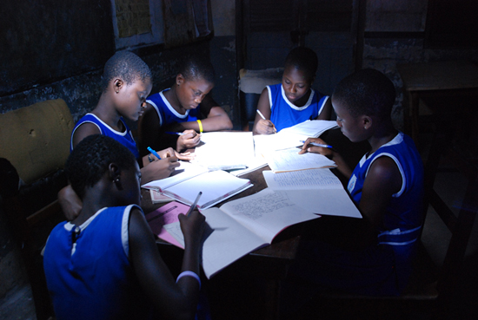

Students studying with solar lighting

4. How is the Liberian Energy Network (LEN) Transforming the Lives of Liberians?

Health: By providing light for hospital wards, clinics and midwives that enables critical medical services to be delivered at night - LEN furnishes lights to the Ganta Methodist Hospitals, serving ¼ of the country, and to their midwives;

Education: By providing light for students so they can study at night, and for job-training classes that can now be conducted
during the evening hours - LEN is providing lights to the Obama Elementary School (see kids in yellow shirts on the next page) and to the Advanced Youth Project’s job training classes for former child soldiers;

Households: Households now have light so that families can be productive in the hours after the sun goes down, - lights
are distributed to households through LEN’s Monrovia shop and kiosks in markets throughout the country.

Businesses: Small businesses, women’s markets, and fishermen can now extend working hours into the evenings –
lights are sold in our shop to Monrovia’s women’s markets, and to Kru fishermen along the coast.

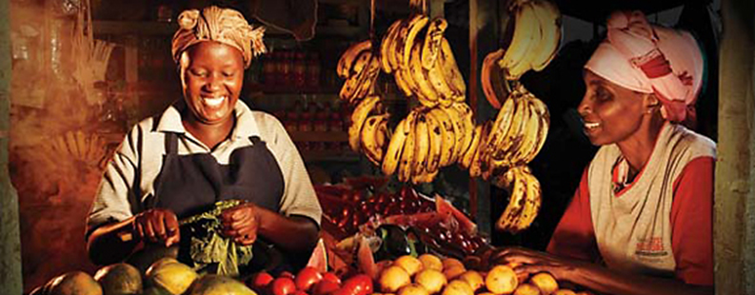

Market women able to do business in evening hour

5. The Economic Model

Business Model. LEN is not a give-away program. It has created an elaborate business structure, which was highlighted in a 2012 Harvard Business School case study about LEN, in which we distribute solar lights through existing medical, educational, civic and religious organizations throughout Liberia, using distribution methods that include having these organizations purchase the lights, selling the lights to individual members of the organization, and developing programs for individual organization members or students to become entrepreneurs and sell the lights. LEN has also opened a retail shop in Monrovia where it sells lights to the public, and has kiosks in small town markets throughout the country.

Lights are sold on a break-even basis so LEN can recover its actual costs of purchasing, shipping, and distributing the lights. Prices are kept low so lights will be affordable, and no profit or extra cash for expansion is generated from sales. Donations of lights are made to certain programs, including for midwives, school children, and families in extreme need.

Affording the Solar Lights; Charging Cell Phones. Despite Liberia’s extreme poverty, cell phones are widespread in Liberia,, and Liberians use roughly one-quarter of their annual income to charge their cell phones. Solar lamps will charge cell phones “free”, and Liberians can pay for their solar lights with the money they save by not having to pay to charge their cell phones.

6. The Liberian Energy Network’s Goals.

LEN’s short-term goal is to ship and distribute 90,000 solar lights to Liberia in the next five years which will provide solar light to some 460,000 people making up almost 13% of the country's population. LEN’s long-term goal is to make Liberia the first country in the world whose light is provided predominately by clean, renewable solar power.

.

