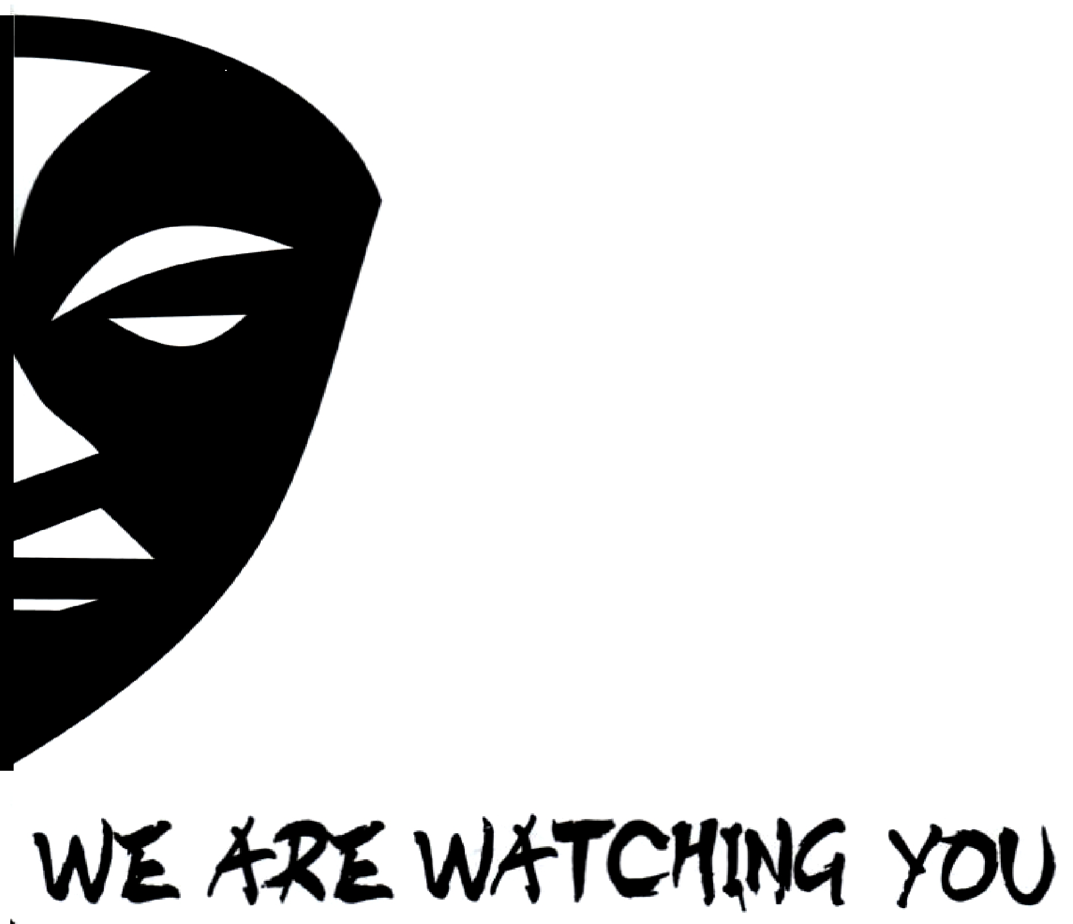

We Are Watching You is a campaign to create political accountability in Kenya by increasing citizens’ vigilance and civic participation. The campaign uses elements of popular culture to sensitize citizens and works in collaboration with civil society leaders.

THE NEED

Behind the political violence experienced in Kenya in 2007-8 is deeply ingrained impunity for Kenyan politicians at all levels: not only in courts but also in the minds and loyalties of the wananchi. Politicians are able to use inciting language and bribery on the campaign trail to mask over their lack of accomplishments, or even their implication in scandal. High- level corruption prevails with in government institutions, but politicians are rarely held accountable for involvement in corruption. Citizens are often too willing to forget the corruption and scandals that arise as well as the lack of follow through on political promises; and, when they do recognize and wish to act on this, they rarely have the leverage to be heard by politicians. To tackle the lack of political accountability and high levels of corruption, there is thus a need to provide an outlet for citizens and civil society organizations to speak with a collective and powerful voice that will be heard by Kenya’s politicians.

This lack of real political account ability means that politicians are able to rally groups along tribal lines and to incite conflict and tensions in order to mask over corruption and a lack of real accomplishments and win votes for elections. There is thus a need to introduce real accountability for politicians to all Kenyans as a countering force against tribalized and incendiary politics. Political accountability is also crucial for the creation of positive change and development in Kenya through the government and not only civil society and NGOs.

WHAT WE DO

As the political campaigns begin for the 2012 elections, the We Are Watching You campaign will be a simultaneous campaign voicing the desire of the wananchi to be taken seriously. It will be an opportunity for Kenya’s citizens to express their dedication to civic participation, and, most importantly, active and diligent scrutiny of politicians’ behavior on the campaign trail and their record in achieving the agenda set forth during their tenure in office. The campaign will contribute to a long term political consciousness amongst Kenyan citizens, changing the current situation in which there is a lack of monitoring and follow up for politicians’ campaign trail behavior and promises.

We Are Watching You reaches the common wananchi by using popular media, specifically music, and local forums engaging youth in conversation and education on these subjects to create a culture of vigilance and monitoring of politicians and their actions. Through these mediums and through open collaboration with civil society organizations, the campaign creates a significant constituency speaking together in one voice.

Bringing Together Civil Society Leaders: The campaign aims to bring together civil society and NGO leaders to participate and bring their constituents into the campaign. A concert by Kaleleo and other musicians will introduce the campaign to select civil society and NGO leaders, demonstrating to them the power of music and the ideas behind the campaign while seeking their engagement. The concert will include speakers and provide an opportunity to civil society leaders to confirm commitments to the campaign.

Local artists are able to join the campaign by committing to engaging in “edutainment” and including an educational component of their concerts and any public speaking roles they engage in.

Forums: We Are Watching You forums will engage youth in hotspots for violence in discussion and education surrounding the need for long term political accountability and civic vigilance as an alternative to short term promises and payments. These discussions, facilitated by youth leaders, create important mentorship relationships and engage youth in conversation and a learning process instead of a typical training or workshop in which they are given only facts or specific information.

Original Song Featuring Celebrities and Concerts: The campaign uses Edutainment, a combination of education and entertainment, to create a country wide consciousness of the campaign and its message. A ‘We Are Watching You’ original song and music video will feature Kenyan musical celebrities. By bringing together Kenyan celebrities in support of greater vigilance and accountability, this song will attract youth to the campaign, and will begin to make active civic participation “cool” amongst Kenya’s large stage group. By using the popular medium of music, the campaign will reach throughout Kenyan society, and not only to individuals who are already active, to create a culture of civic participation and political accountability.

Country wide concerts by local artists will also promote the message of We Are Watching You, and a Kaleleo tour to politically contentious and volatile parts of the country will bring civic education and increase campaign awareness.

WHO WE ARE

The We Are Watching You campaign is run by Kaleleo, a band that has been working in the community for many years. The band not only entertains, but also educates the community. Before responding to a problem, the band engages in research to understand the nature of the issues faced by the community in order to create relevant responses through music. After creating music to directly address community issues, Kaleleo performs at our theatre at the ACREF Centre, Baba Ndogo. Kaleleo has worked closely with Eric Wainaina, Komboni Brothers, Tangaza College, World Friends, Sisi ni Amani, and various additional community groups and youth.

GET INVOLVED

The We Are Watching You campaign is currently looking for partnerships on three levels. We are seeking funding and partnerships with donor organizations, partnerships with organizations already engaged in monitoring and civic education, and, finally, partnerships with local artists engaged in edutainment.

