- Project Name: Shradhanjali Integrated School
- Entity : The Association of People with Disability (APD)

- Program Name : Education Program
Summary details:

Greetings from The Association of People with Disability (APD)!
Sincere thanks to Global Giving for supporting APD’s 200 children with disability of Shradhanjali Integrated School. One of the major purposes of SIS is to promote Inclusive Education and this model is much needed to sensitize the mainstream schools to accept the Inclusive Education system convincingly. Through your long term support, we have been able to achieve the desired results and give education to children with disabilities in the school.

We are working towards improving the quality of education by continually enhancing the skills of our teachers and Innovative teaching practices, planning for digital teaching and for computer lab, incorporating alternative communication & teaching for children with CP, as per the measurable indicator 90% of the learning progress is achieved in last year. For Continuous and Comprehensive Evaluation (CCE) we follow methods like Formative assessment (FA) and Summative assessment (SA) to assess the student’s level of learning. Overall 120 children have been rehabilitated like speech therapy, sign language, physiotherapy, and occupational therapy. SIS is resource canter shares knowledge and skills among model school teachers and the partner staff.

- Key Actions and Outcomes of the Program:
Date | Event | Description | Outcome
4-Oct-18 | Founder's Day | All the Staff of APD, Board Member and Chief guest gathered to commemorate the founders day. Nominees for an award from the different aspect in the disability sector were announced .NS Hema award was Presented to the award winner .SIS student started the event with an invocation song | Students and staff accepted the need for equity in the disability sector in India The notion of “disablement” was both socially and culturally defined by the speakers in the event .
5-Oct-18 | Parent-Teacher Meet | Class teachers met the parents regarding student performance in their summative assessments report card was handed over. | Parents were involved in the discussion, promised the staff to maintain cleanliness in their ward.  Guidance in academic performance was guaranteed by staff and parents as a mutual consent
5-Oct-18 | Screening for wheelchair tennis | Provision Asia conducted a screening camp for a student on a wheelchair. The Screening was to select a student for a Wheelchair tannish Clinic | Student performed their best and with enthusiasm participated in the screening. 7 students were selected.
8-Oct-18 to 14-Oct-18 | Dasara Vacations | SIS closed for Dasara
 | Shivamogga adventure camp in Honnemaradu | The camp was held at Honnemaradu.  15 students from 3 to 7trh participate in the event  Swimming. Rock climbing , campfire, forest tracking were the main events | To develop and practice the principals of togetherness and self-reliance.  The environment in the camp enabled teamwork, leadership, and unity.  The process of learning through practical approach with a balanced profile and attitude.  To instill the lifelong values of teamwork and individual responsibility in daily tasks in a healthy environment.  To build individual character and confidence level.
16/10 2018 | Advocacy meeting | Meeting with parents  Discussion and terms stated on minority and disability scholarship by Ms. Surya | Parents benefited from this meeting as the awareness was created on completing all related scholarship allotted to them by government
20-Oct-18 | Dasara Celebrations | Our teachers along with the staff of other departments celebrated Dasara at APD. Skill games were conducted and sweets Distributed. | Participation in skill games was a stress buster. To all; the staff members
2o- to date | Sports practice | All Student have a regular practice for the sports events | Enables complete participation spirit, and a competitive spirit
22-Oct-18 | Dental Check-up | A team of 12 Dentists from R.V Dental Hospital Guided by a Senior Lecturer/ Professor. Attendees and Nurses were present.  A Dental Van to carry out the examination and procedure enable a complete screening of 128 students in the first camp | Each and every member at SIS encouraged the screening of the students.  Oral health and hygiene is the main need of every child and this concept was clear during the screening,  The screening paved the way to further treatment and oral care
25-Oct-18 | First Half Yearly Review | The review was done by the SIS team | Details were discussed and follow up is in progress
26-10-18 and 27-10-18 | International Workshop on Assessment Training and Guidance Centre | International Workshop on Learning Disabilities was held at Mahalaxmi layout by Asha Foundation. Special educators, parents, and teachers attended the workshop Doctors, The experts have overcome their disabilities and are in a high profile today, they shared their experience which was very impressive. .Dr. Ruth. Dr. Dieon, Dr. Edward from Malta and Dr. Maria from India involved in interactive sessions  Ms. Catherine and Anita Roy attended the workshop | It was a wonderful experience.  Enables us to support the students in all aspect of life. To identify children with different learning disability especially in reading and writing.  To identify their learning disability and to correct them. To share be empathetic , render love , be encouraging ,throw a sense of trust, anchoring and not to be judgemental
27-Oct-18 | Tata Class edge Nominated Teacher Training | A basic training session for TCE Nominated Teachers was conducted at Carmel High School, Basveshwar Nagar. 50 NT’s from selected schools across Bangalore had attended the session. Basic problems were discussed and knowledge was shared; areas of improvement were also discussed. SIS also received a special appreciation for Overall usage for the academic year 2017-2018. | Solutions were obtained for various problems that the schools across Bangalore faced. The roles and responsibilities of an NT were also briefed by the TCE Academic Manager.
27-Oct-18 & 28-Oct-18 | All the abilities wheelchair tennis clinic  Provision Asia n. | The event was arranged in SAT sports kothanur. From our school 7childrens are participated in a tennis workshop. The event went on well it was a wonderful opportunity for our children’s they learn the basic skill of te | All participant received medals and certificates. Parents were impressed with the various training given by the organizers
29-Oct-18 | ALT Lab Orientation | A Visit to ATL Lab at Air force School, Hebbal was arranged by Intel for 4 teachers. The teachers were given an orientation on the prerequisites for the process. Pros and cons were discussed and an introduction to the Tinkering was given by Mr. Mayank and Mr. Ankit from Intel Corp. | This provided an opportunity for our teachers to interact and understand the setup and process involved in setting up a mini ALT Lab at SIS.
30-Oct-18 | ALT Tinkering Lab Training | Five-day training was conducted to our teachers (Ms. Amala, Ms. Rekha, Ms. Nirmala and Ms. Athulya) by a resource person from Intel. | The sessions played an important role in transforming each of our teachers into an Innovation coach.

.

 | 30-10-18 and 31-10-18 |  |  | CFL group | 14 students from the Center for Learning visited SIS along with four of their staff members  A student from VII and VI of SIS formed a buddy relationship with CFL.  Activities such as library utilization, Playable sessions, Usage of Adolpho kit, art and drawing were the major highlights.  Sharing their experiences were done with ease and discipline, |  | Students communicated with each other shared their experiences  Had hands on experience on all technology usage at SIS  Learned and enjoyed reading storybooks from the library. Drew pictures and presented each of their drawings with a message, in today’s issues ,such as a description of nature and natural resources.” Stop using plastic” was their slogan.
3/11/18 |  |  | Kannada Rajotsava Celebration |  | Students from Nursery to class 7, participated in various cultural programs and conveyed the importance and beauty of Kannada and Karnataka. |  | It was a day to celebrate the greatness of our beloved state. A spirit of patriotism was felt.  Every child was given a chance to cheer or to perform.
5/11/18 |  |  | Diwali Celebrations |  | The students made Diyas using clay. Classes Nur and Prep prepared sweets and snacks for the staff and the children. |  | Lamps were lit and the festival of lights was celebrated with a lot of joy. The children with intricate carving mad beautiful lamps
13/11/18 |  |  | Meditation |  | Need for meditation at least two days a week. Mrs. Monica performed the light meditation to our students |  | It is fully forced on love and peace. To create a peaceful atmosphere. To spread peace and love to everyone
9/11/18 |  |  | Sports Day |  | All our students took part in the sports meet held at Charles Ground. Wheelchair race, drill , rollator race, and relay events were conducted.  The mass drill was introduced to every child to participate in the same |  | It was observed that most of our student won prizes in one or the other event. Every participant was given a certificate.  The mass drill was appreciated by parents and well-wishers.
14/11/18 |  |  | Children's Day |  | A day of joy and happiness. The students were dressed in their best attires. They were entertained by our teachers who performed a variety of cultural events like dance, singing, and skit. |  | The children enjoyed the day. This brought out the love of the teachers towards their kids. The teacher-student bond was evidently visible.
14/11/18 |  |  | Prelims of Quiz abled 2018 |  | The Prelims of the quiz abled-2018 was conducted in 7 nodal centres across Bangalore, one of which was SIS-APD, Bangalore. The prelims hosted 42 students at APD alone with a total of 380 students from 50 different schools. 14 students from SIS participated in the prelims. |  | This provided an opportunity for our HI & CP students to participate in an inter-school Quiz show. For most of our students, it was a first time experience. 3 teams from our school were selected for the successive rounds of the quiz show.
14/11/18 |  |  | Drawing Competition |  | The students from classes IV to VII gathered to create beautiful works of art. To be consistency in the work of art the event was a hit. |  | The students displayed their creativity through beautiful drawings & paintings.  The paintings reviled the thought of our young children in them kindness
5/11/18 |  |  | Chinthana English Talent Exam |  | It is an English Exam based on grammar, totally 24 students took part in it. |  | It is fully computerized question paper. It was a wonderful experience for our students to face such talent exams.
20/11/18 |  |  | Inter-Scool Sports Meet at Kantirava Stadium |  | A Sports Meet was organized by the State Govt. of Karnataka for the specially-abled students. Around 30 students from SIS participated in this event. |  | Enthusiasm and sportsmanship was observed among the students. Most of our students were awarded as winners.
22/11/18 and 23/11/18 |  |  | Visit Jeevan Bheema Nagar |  | All students were taken to visit the garden fest at APD Horticulture center at Jeevan Bheema Nagar where they observed a variety of plants and seeds, vegetables, fruits, and medicinal plants. Different kinds of pots and the materials used for growing plants were also been present there. |  | It was not just a day of enjoyment but also a day of learning. The students were also able to understand the importance of plants in the environment.  Students came back from the venue with an open mind to maintain a garden and to have a small vermicomposting pit
24/11/18 |  |  | Final Round of Quiz abled 2018 |  | The final round of the Quizabled 2018 was conducted at BMS College of Engineering, Basavangudi. |  | Our students Saravana and Jeevan were the winners of the show. They were awarded momentoes, certificate and also a cash prize of Rs.8000/-
27/11/18 and 28/11/18 |  |  | CFL Camp |  | Selected students from class VI & VII along with the staff and parents went to a camping event conducted by The Centre for Learning. This was more like an adventure camp where students got to learn in the midst of nature. |  | Students explored the place and enjoyed the atmosphere, food, games, and the beautiful nature. They were also able to learn new skills like origami, movie and interactive session with friends and CFL staffs.
30/11/18 |  |  | Inter-school Drawing Competition |  | An inter-school drawing event was conducted by Concern India for children with special needs at Cubbon Park. 10 students from SIS participated in this event. |  | Our students Diwakar, Madesh, and Jaffer secured top places. The other students got certificates for participation.
 |  | 1-12-2018 | Intraschool drawing competition |  |  | Topic – The wonderful nature An Intra School Drawing competition was conducted at SIS-APD by IITF volunteers to provide an opportunity to the students to display their talents in drawing, coloring, and painting. Students participated with lots of enthusiasm and joy. |  | The students displayed their creativity through beautiful drawings & paintings. The best drawings were selected and winners were awarded indoor game cards.  Trophies were also given to the winners
 |  | 3-12-2018 | Inter-school sports meet at Kamalabai school |  |  | No. of students 37 SIS participant no.-of staff 06- No of support staff 02. |  | Enthusiasm and sportsmanship were observed among the students. Our students Emerged as winners.
 |  | 3-12-2018 | World disability day celebration at Freedom Park |  |  | Organized by Women and child welfare department - 40 students participated -- The theme for International Day of People with Disability for 2018 was 'Empowering persons with disabilities and ensuring inclusiveness and equality'. Chief minister and officials graced the occasion |  | The gathering created public awareness, understanding, and acceptance of people with disability. Their achievements and contributions were celebrated.
 |  | 3-12-2018 | Capacity building session on " Importance of Individual Living" |  |  | A capacity building session was conducted by Divya Shanthi School and Ms. Kavithamma & Ms. Nagaveni from SIS attended the programme. |  | The teachers were trained on the importance of individual living. They also learned how to enable children with special needs to be independent in their lives.
 |  | 7-12-2018 | Bal-Utsav |  |  | Bal-Utsav is a special cultural event organized by KSCCW for children with special needs. This was conducted at BAL BHAVAN, where 27 students from SIS participated in various events like group song, group dance and Fancy dress competition. |  | Children enjoyed participating in the programmes. They were excited to get Medals, Trophies, and Certificates. Mutual acceptance, pleasant surprises in the form of fancy dress depicted the need for our society to change.
 |  | 11-12-2018 | Class outing for class II & III |  |  | Venue: Orion East Mall The students played around in the play area; Snacks and juice were distributed. |  | This was a fun outing where students enjoyed a lot. This also provided a social awareness towards the role of the citizen in the shopping premises, signboard reading following cleanliness, and interactive way of displaying manners in public was dealt with the support of teachers.
 |  | 12-12-2018 | Class Outing for Nur to Class I |  |  | Venue: Elements Mall. A study based picnic to a Shopping Mall was arranged. A total of 65 students were taken to Elements Mall where they were explained about different shops and the concept of buying and selling by the concerned teachers. The students also played around in the play area; Snacks and juice were distributed. |  | Students learned about the concept of buying and selling and also thoroughly enjoyed the day.  Fun time with limits was very well understood by parents and children at the mall
 |  | 13-12-2018 | Class outing for classes IV to VII |  |  | Venue:NS Hema Horticulture Centre An exposure visit for the students of Classes IV, V, VI, and VII to NS Hema Horticulture Centre was arranged. |  | The students gained considerable knowledge of the different types of plants and how they are grown. It was observed that the students were enthusiastic to learn about the plants as they asked various questions to the horticulture trainees and got their doubts cleared.  The attitude of questioning encouraged by the staff.
 |  | 12-12-2018 TO 14-12-2018 | CRE program on "Teaching and learning for SHI students" |  |  | A CRE program was conducted by Chandrashekar Institute of Technology. Two teachers (H.I Special Educators), Mrs. Kavithamma & Mrs. Sudha S attended this training session. |  | The teachers were trained in various methods of teaching for children with speech and hearing impairment.
 |  | 14-12-2018 | Teachers workshop on “Communication Skills” |  |  | A workshop was organized for the teachers of SIS on Communication skills. |  | The aim of the workshop is to facilitate barriers of interpersonal communication through self-analysis. The importance of effective communication and different ways of communication was discussed in the workshop.
 |  | 15-12-2018 | Science & Technology Quiz Show |  |  | An inter-school science quiz was conducted by Samarthanam Education Trust for cwsn, where 7 schools across Bangalore participated. 14 students from SIS (V, VI and VII Std) were selected to take part in this event. |  | 4 students (2 teams) from SIS bagged the 1st and the 2nd places in the SHI category. This was indeed a special moment for SIS and APD. It was observed that most of the students prepared well and exhibited a true connection to Science & Technology.
 |  | 15-12-2018 | CSR activity by Accenture |  |  | The students of Class I, II, III and IV enjoyed the Fun games with the active volunteers and the students of V, VI, and VII were exposed to the world of programming through computer games. |  | The students enjoyed the fun incorporated learning session.
 |  | 17-12-2018 | Rehabilitation day celebration in APD |  |  | The Rehab Day celebration started with a brief welcome note, followed by an elaborate talk by Dr. Senthil on the needs and impact of rehabilitation in the lives of PWDs. The programme was closed with a great Drum Jam by the famous singer Vasundhara Das & Team. |  | The importance of rehabilitation in people's life was made known. A sense of respect grew for our therapists and psychologists.  The energy within each of us was trigged and all hand thumped to the rhythm of the beats
 |  | 17-12-2018 | Christmas grand party celebration at Big Brewsky |  |  | Students of Class V VI and VII were taken to a grand Christmas Party where an elaborated and a tasty 4-course meal were arranged. |  | The students sang and danced.  The grand lunch provoked the student's appetite. It was a totally new experience for them.
 |  | 19-12-2018 | Unnati Talent Exam (English) |  |  | A national level English talent examination from Unnati Talent Exams was conducted for 32, selected students from Class II to VII. |  | Our students put their effort and performed their best.
 |  | 19-12-2018 | Christmas gift distribution with volunteers (Ms. Zainab & Team) |  |  | A team of volunteers had come to school to distribute gifts and sweets. This was done by a volunteer dressed as Santa. |  | The children went back home happy and joyous.
 |  | 20-12-2018 | Christmas celebrations with volunteers from |  |  | Students took part in the Christmas Party games conducted. Many students came up, sang and danced. Sweets and gifts were distributed. |  | The magic of Christmas was seen throughout the school. The students sang, danced and enjoyed
 |  | 20-12-2018 | Unnati Talent Exam (Social Science) |  |  | A national level Social Science/EVS talent examination from Unnati Talent Exams was conducted for selected 30 students from Class I to VII. |  | The students prepared well and gave their best. They are now eagerly waiting for the results.
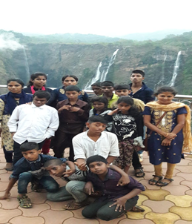
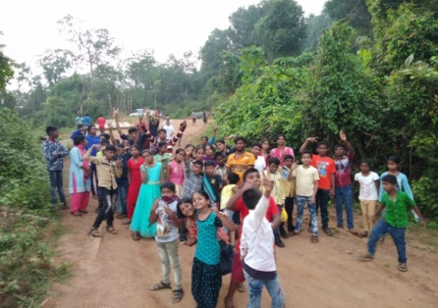
.

Shivamoga camp

Wheelchair screening by provision Asia Wheelchair event at SAT- Kothanur Medals and Certificate won by our students
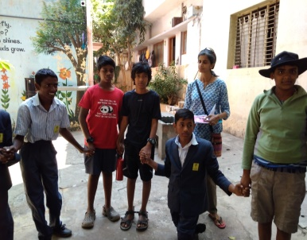
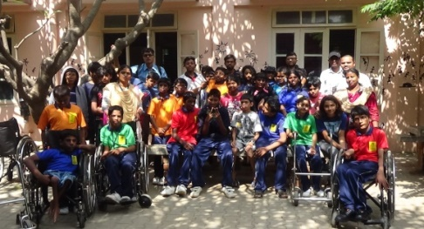

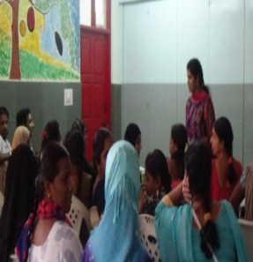
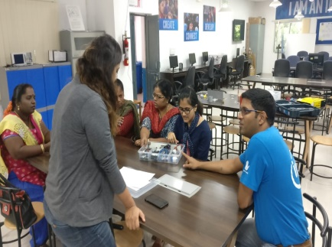
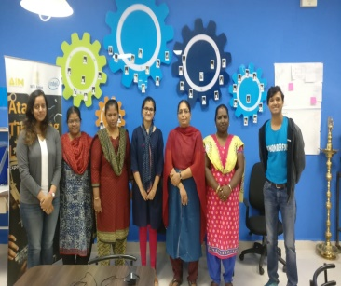
Students from CFL visited SIS
Advocacy meeting Intel Workshop and training ALT Tinkering LAB

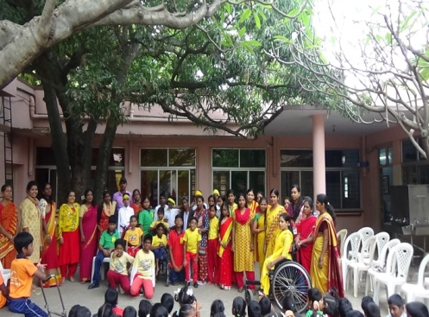
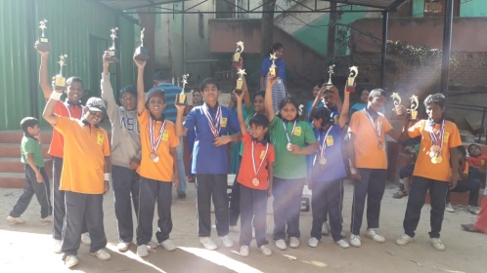

Sports Karnataka Rajautsova Celebration
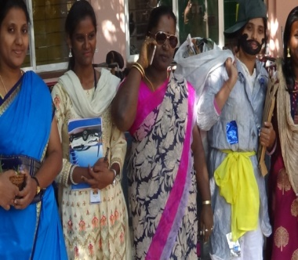
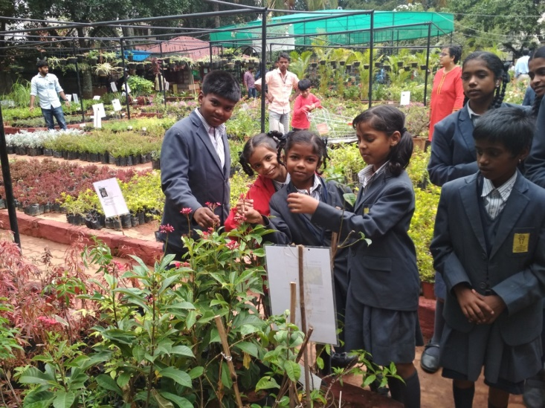

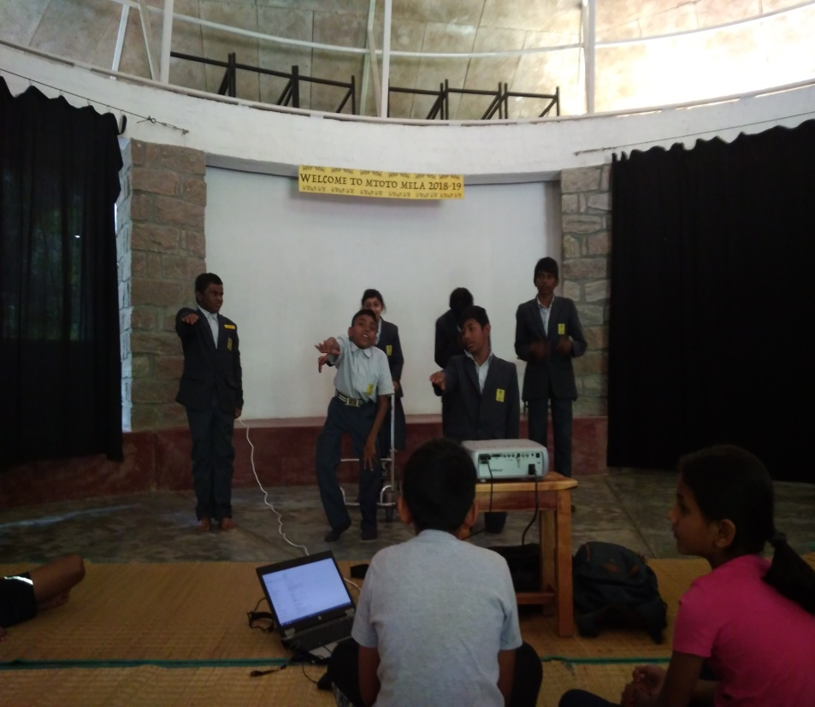
Children Day JBN

VISI to CENTER FOR LEARNING

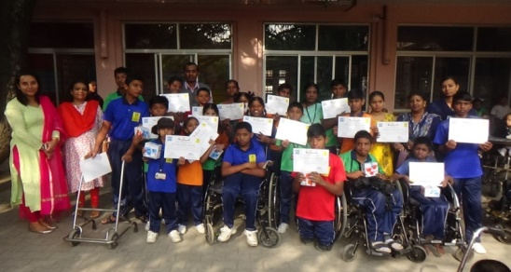
Kamala Bai school sports meet winners.

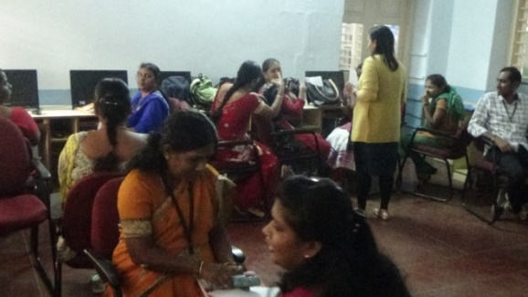

Workshop for teachers at SIS

