Dear Donors, Friends and Well-wishers of The Association of People with Disability (APD).
Greetings from The Association of People with Disability (APD)!
Thanks to the donations of caring people like you, we are making steady progress in our mission to build an equal and just world for people with disability (PwD).
The Association for People with Disability (APD) is a non-profit organisation based in Bangalore. APD runs the Shradhanjali Integrated School (SIS) since 1973 - that takes in young children with disabilities and transforms their lives. SIS gives wings to their dreams . SIS has transformed lives of many children & they have gone on to become successful doctors, IT professionals, engineers and most importantly - Confident and Independent citizens.
We are glad to submit to you the quarterly report of our Education Program for Children with Disability. Please find below few activities of SIS for the month of June, July and Aug 2018.

Shradhanjali Integrated School
June 2018

Event / Activity | Description | Outcome
School Re-open | All the students came to school with excitement to meet there friends and to be in their new classes. The teachers welcomed them on their first day with a special assembly and sweets. | The students seemed to be very happy to be back in school. They are curious to learn many new things that are going to be taught this academic year
Scottish Team Visit to SIS | We staff of APD, welcomed Scottish team with Garlanding flowers and keeping Kumkum on their foreheads. Mrs. Chrity Abraham (CEO of APD) gave welcome speech and students performed Dance and songs for them.  Various activities were planned throughout the week. This helped them to interact with the students at SIS. This also provided opportunities for us to learn more about each other’s cultures. | Scottish team was greatly impressed and appreciated the effort of students and staff.  Also our children enjoyed the time they spent with APD Students.
International Yoga Day Celebration | Children from Classes IV to VII, along with the team from Scotland were given orientation about Yoga, its need and impact in one’s life. They were taught few simple asanas which we can do in our daily lives. | Our students and the Scottish team understood the greatness of Yoga and its need in our lives.
PU students from St. Charles Pre University collage. | Ninety students from St. Charles PU College visited our school on 23 June 2018. They were given orientation about APD and SIS by Mr. Kantharaju (SIS Principal).  Post presentation, the guests performed a song and dance show for our SIS children (Nur to Class VII). They also encouraged our students to involve in their event. | The St. Charles students enjoyed the day along with our children. It was a fun filled day
Skit Program by Volunteers from i3 Technologies. | On Saturday 30 June 2018, around 11 volunteers from i3 Technologies (Corporate CSR Team) came to our School and performed a Skit on the inspiring story of Madam Ramya, an athlete. | The children enjoyed a lot. This also builds a lot of confidence in our students to do better and better by continuously working hard.

Scottish visit

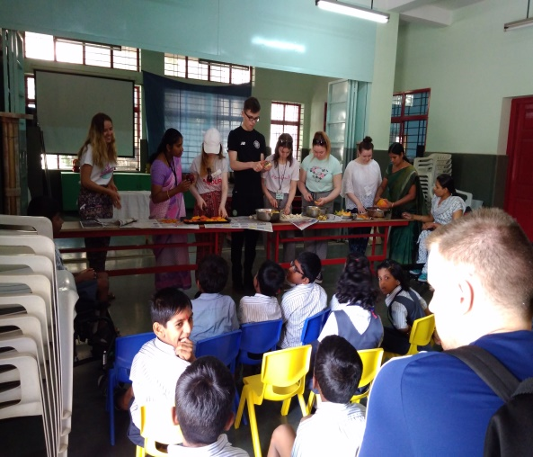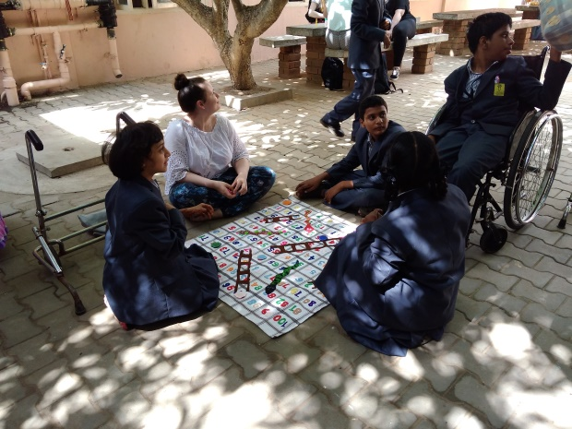

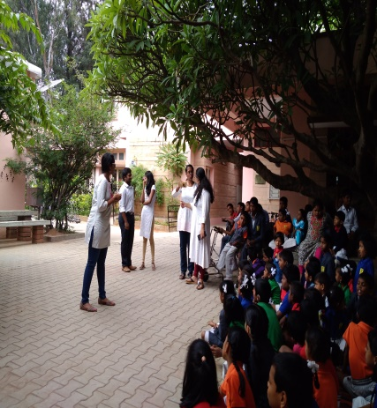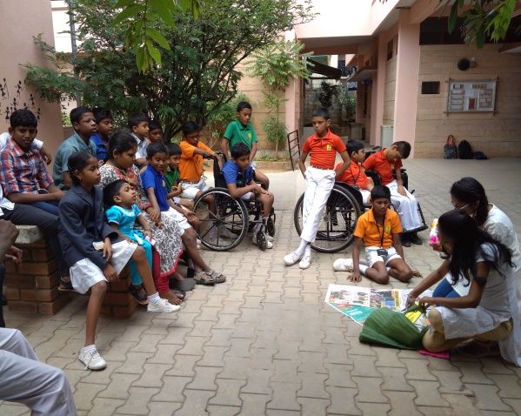
i 3 information group performing a craft activities and conducting few

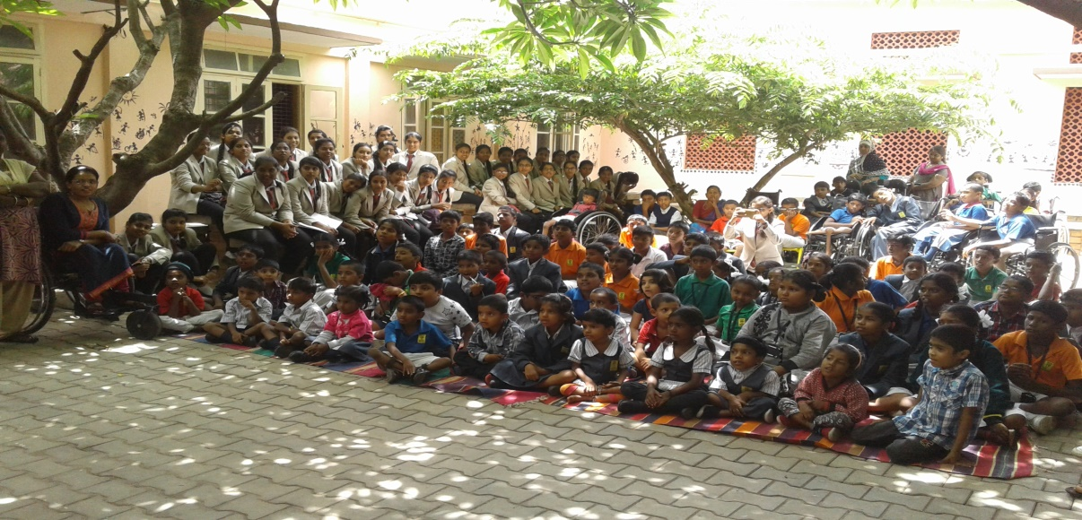
St Charles PU college visited SIS and presented few dance and singing sessions
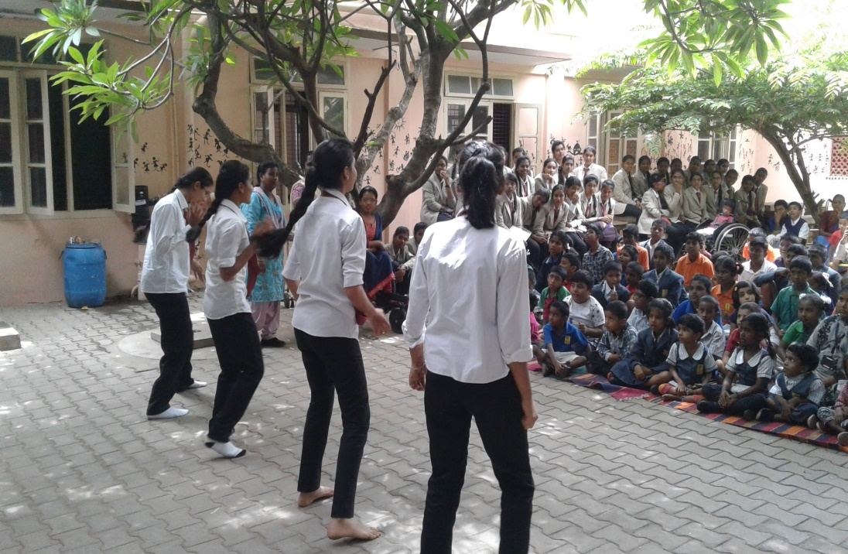
July 2018
Event / Activity | Key Actions | Outcomes & Details
Residential camps / outings/ Extra-Curricular Activities/Sports are planned for the children  Cultural programmes | Student Council Elections  The school set up a stage for the students of Class I to VII to display their unique talents.. few sang and danced, gave speeches, recited poems and told stories. “Green is wealth” Activity:The class teacher of Class III took an initiative to explain to her students the importance of greenery and visited the APD Garden | A voting booth was set up in the computer lab for the teachers and students to vote and elect their leaders. The voting and counting was done using computers. The teachers also used this day to brief students about the qualities in a true leader The School election results were announced in the assembly The Student Council for the academic year 2018-2019 was formed
Drawing completion with a theme | Topic – Nation symbols, reduce plastic  An Intra School Drawing competition was conducted at SIS-APD to provide an opportunity to the students to display their talents in drawing, coloring and painting. | The students displayed their creativity through beautiful drawings & paintings  .,
sports activities will be conducted | Sports activity by SAT Sports | Three children were selected for regular practice and weekly two days evening they are attending additional coaching sessions.
Clay modelling | Around 45 Students from Nursery to VII  Had a clay model modeling activity. The topics were Shapes, Flowers, Aquatic animals, Solar system, and Pen stands. The students were supported by 10 volunteers from Dell EMC. | The students made beautiful clay models and displayed them. These are now added to our school’s Teaching-learning resources.
Inter – House Singing Competition | Theme – Patriotism  An Inter-House Group Singing Competition was held at SIS on 28th of July, 2018. . | . The competition was judged and the winners were chosen.
Each class will be taken for a day trip to an Industry/ Factory/ Park/ Museum/ Organization during the year. | Venue: Lalbagh  Around 30 students from Nur. and Prep were taken to Lalbhag as a part of their educational trip. The students were very happy to see the flower show preparations happening at Lalbhag | The objective of socialization , appreciating nature and sharing was inculcate in this trip
Quiz for VI & VII | Two MSW students organized General Knowledge Quiz Show for students from classes VI & VII. | The students showed a great deal of enthusiasm and sportsmanship
Avni & Team Visit from USA | The staff and students of SIS welcomed Avni & team with a cultural program. This helped them to interact with the students at SIS They conducted confidence building sessions for Classes IV to VII and computer training classes for both students and teachers at SIS . | Both, the teachers and students of SIS benefitted from the confidence building and computer training sessions.  This provided an opportunity for the organization and the volunteers to share their experience with each other.
Mid day meal Needy children are provided mid-day meals to ensure a balanced diet | mid-day meals and 50 get supplementary nutrition | 75 children are getting regular midday meal and 48 children are getting supplementary nutrition.

Fond memories that were captured:

1. Talents Day

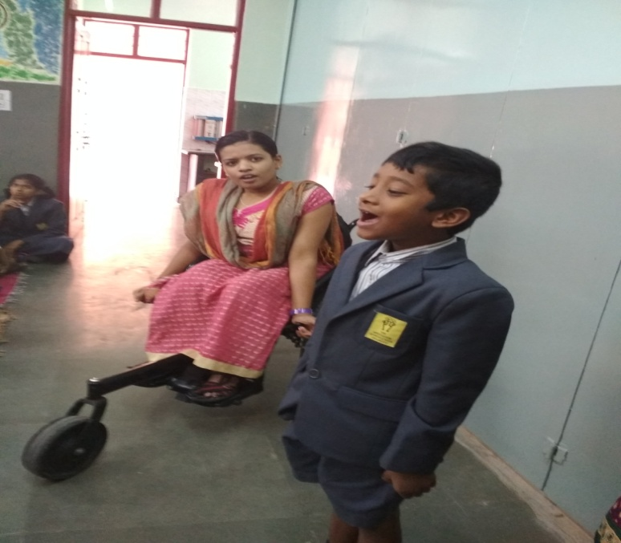
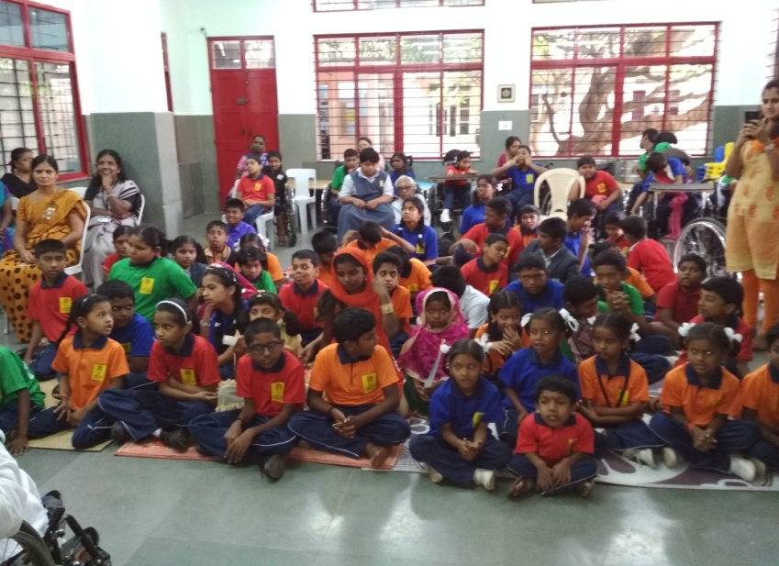

2. Garden Activity

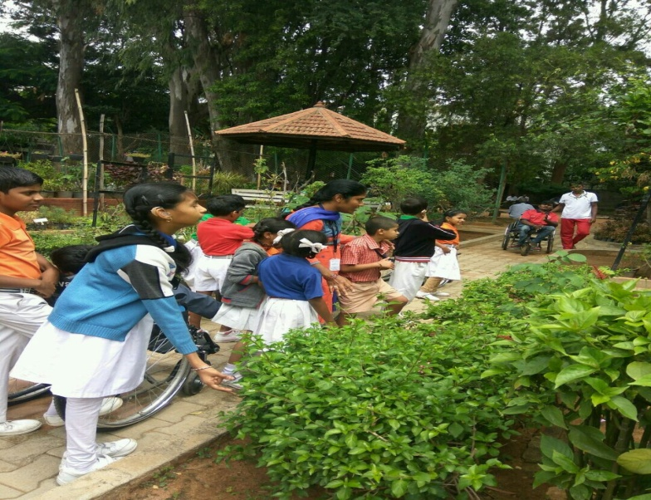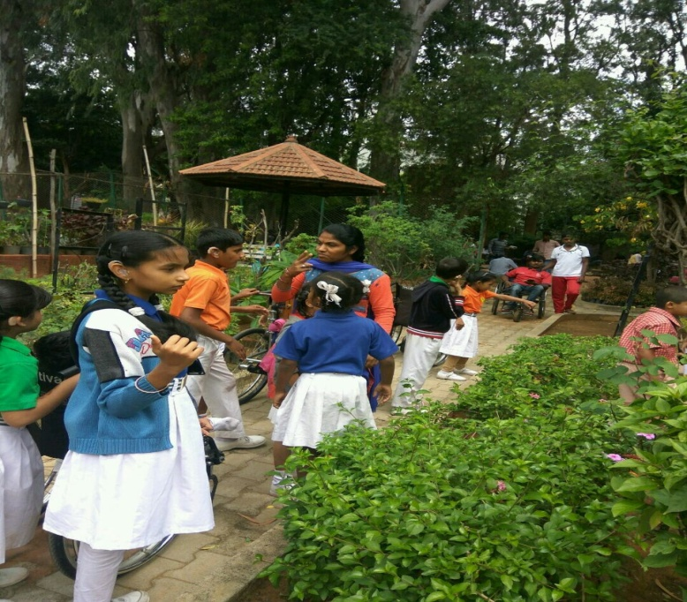
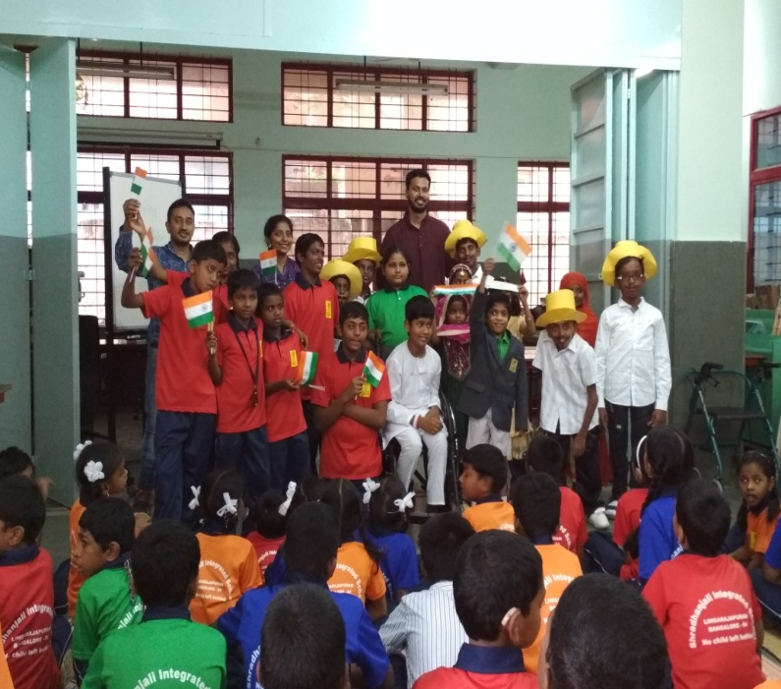
4. Inter-House Song Competitions: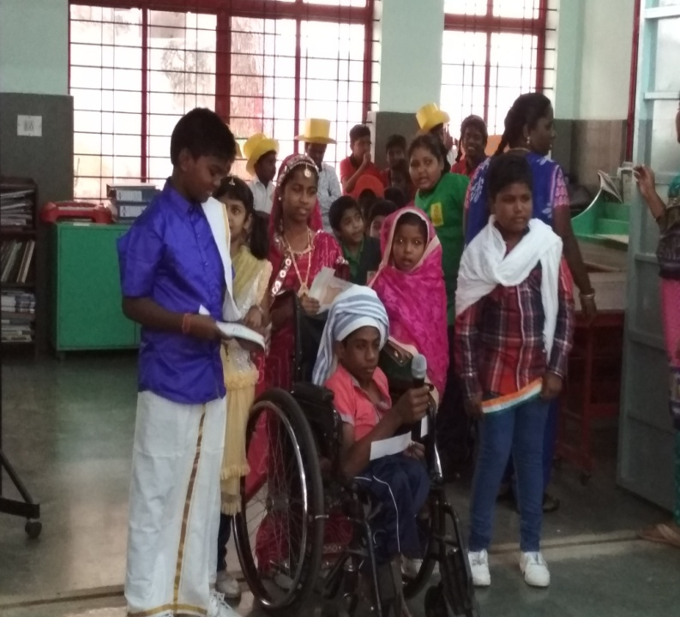
5. Avni & Team’s volunteering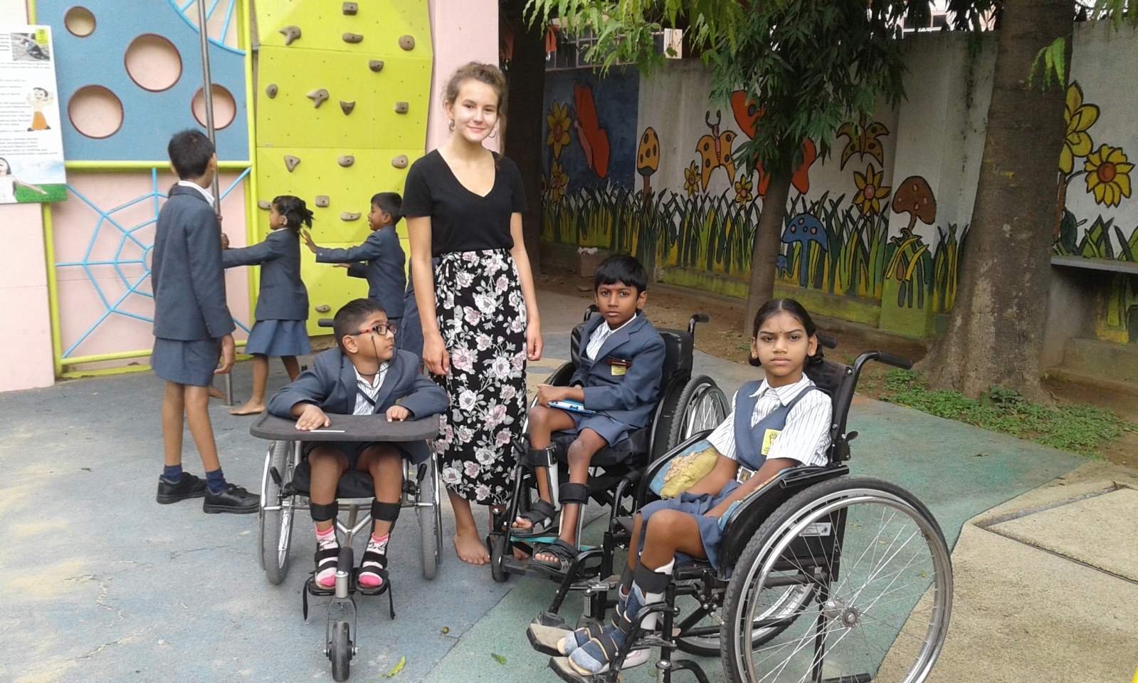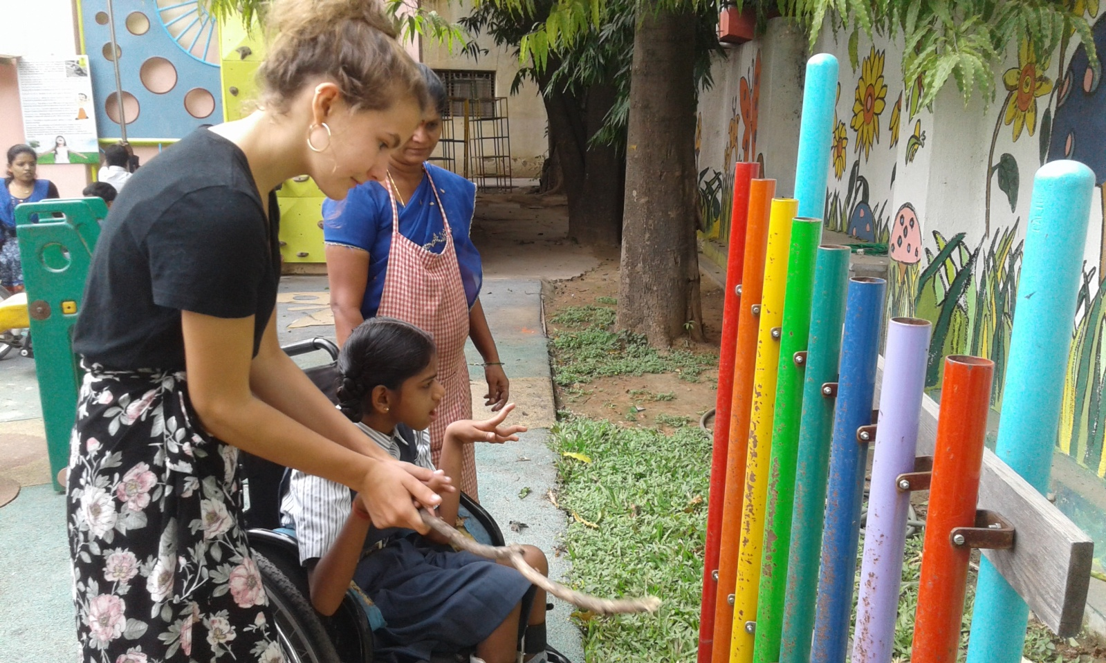
6. Nur-Prep Class Outing LalBagh
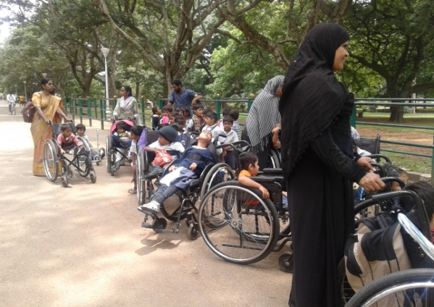 | 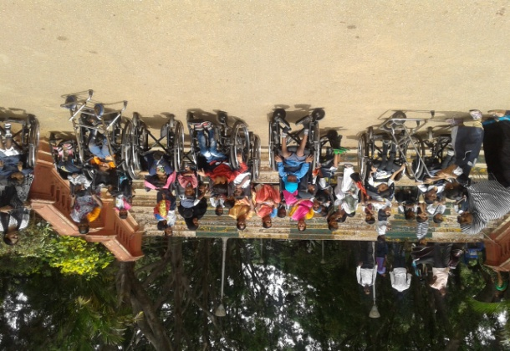
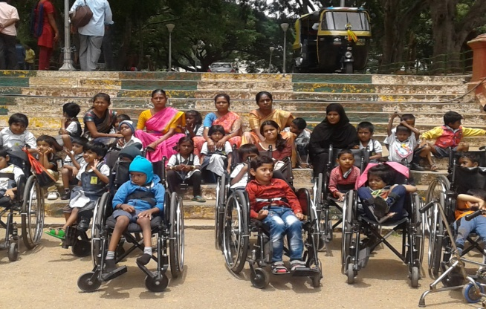 | 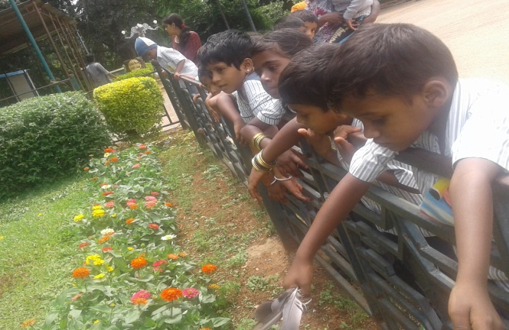
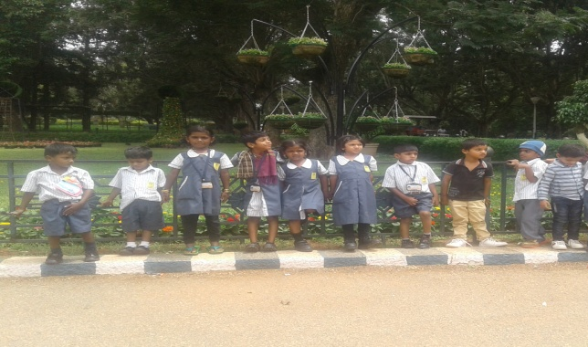 | 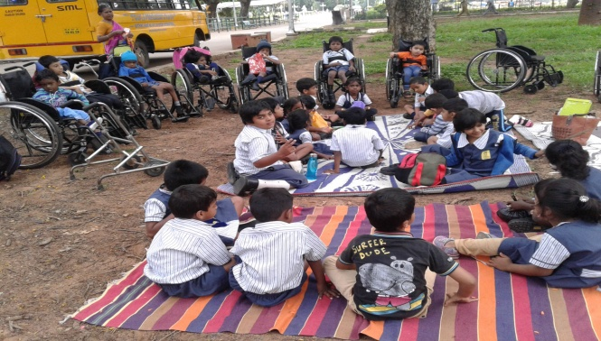
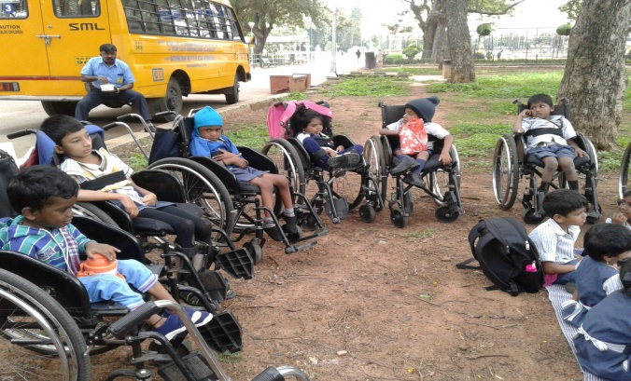 | 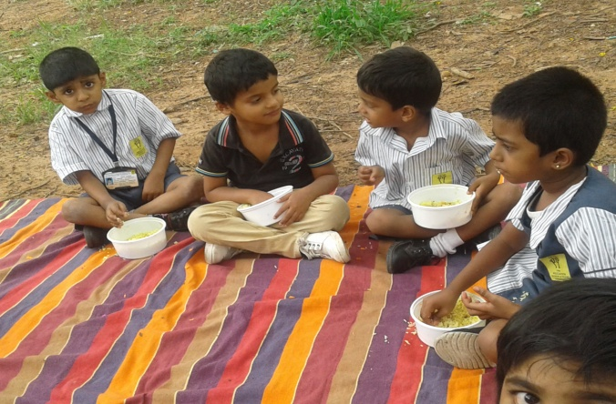

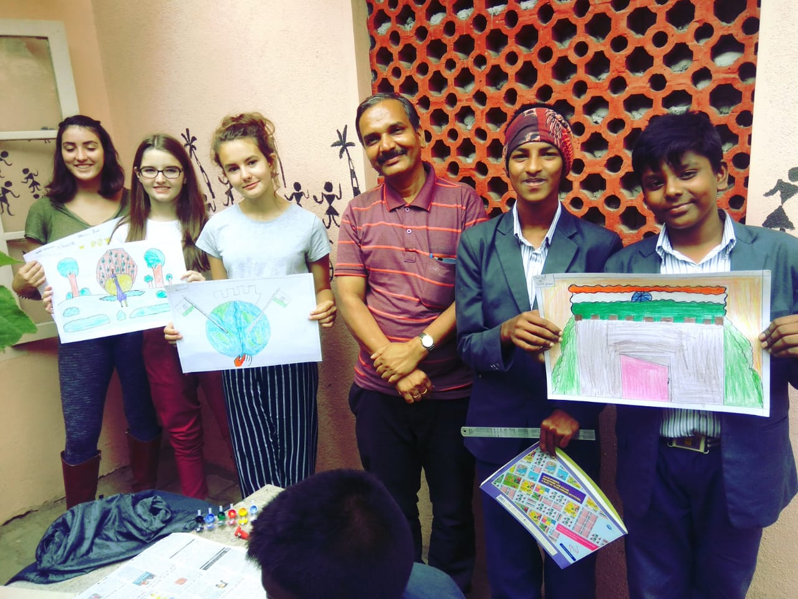
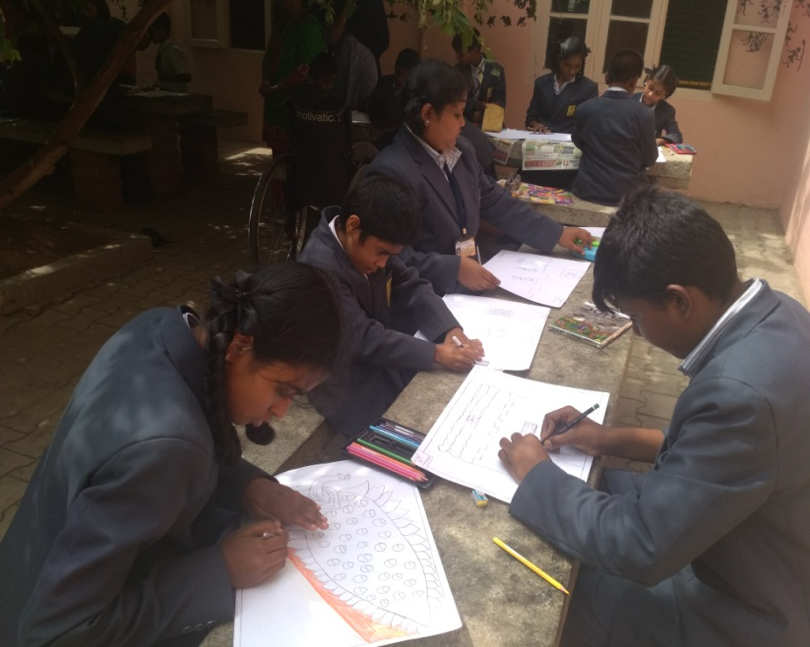
Drawing Competition

AUGUST 2018

Sl.  No | Activity | Key Actions / Target for 2018-19 (Project Commitments) | August 2018  Outcomes & Details
 | Independence Day Celebrations | The 72nd Independence Day Celebrations was held at APD.  Mrs Vimisha Nerro, Mrs. Usha and Mrs. Christy Abraham were the guests of honour.  The flag hoisting ceremony was preceded by a small patriotic song | The staff and students celebrated the Independence day. A spirit of patriotism was in the Air.
 | Parent Teacher Meet | The PTM was held to keep parents informed on the process and procedure in academics about their child’s overall performance till date.  This took place as two sessions.  Session 1: (9:30 am to 12:00 pm) – Classes IV to VII.  Session 2: (1:30pm to 3:00 pm) – Nur to Class III.  The teachers also discussed the future plans with the parents. | It was observed that the parents are very happy about the changes (uniform, infrastructure) made in school this year. The teachers shared the child’s progress and also discussed the plans to improve the overall performance of the students, Interactive sessions was accepted by the management.
 | No bag day | A No Bag Day was organized to encourage student and teachers to use the tabs, digi boards and enhance learning through technology  to enjoy and learn without books. The teachers planned lessons and executed them using the smart boars, tabs and lab. | This was a fun with learning experience for both the students and teachers. A lot of enthusiasm was seen an it was also observed that the incorporating fun into learning bettered the teaching-leaning experience
 | Rangoli Competition | Students from Class II to VII took part in the inter-house Rangoli Competition. The students created attractive rangolis which were evaluated by our judges (Ms. Amala from Physiotherpapy dept. and MS. Devikala from EI). | This created a platform for the students to bring out their creativity. It was observed that the students showed the values of team work , Interest colour blending and finger articulation.
 | Friendship Day | . This day was observed to celebrate the unwavering faith in friendship. Rendering help in the inclusive atmosphere was the main target | . This day provided an opportunity to all the children to share their love for each other in a special way by sharing and serving .
 | Dance Practice Session (Every Saturday | Our dance master, Mr. Dinesh started the dance pratice for our boys and girls . This is scheduled for eer | Our students started to learn the new steps with enthusiasm  .
 | Each class will be taken for a day trip to an Industry/ Factory/ Park/ Museum/ Organization during the year. | Exposure Visit for Class I & II : Bannerghatta National Park | To inculcate and contribute to conservation of nature and natural resources This also helped them to interact with others and build social etiquettes
 | Round worm Awareness Session | A session on Round worm awareness was conducted in the morning assembly on students on cleanliness and personal hygiene and its importance in life. They also shared the causes, symptoms and treatment for the round worm infection. | This was indeed an eye-opening session for the students and staff of SIS. After the session, a change towards better and cleaner  habits was observed among the students.
 | Formative Assessment II  (Class I to Class VII) | Formative assessment was conducted for all the subjects to monitor student learning. Exams (English, Kannada, Hindi, Maths, Science and Social Studies, Computer & Art) were conducted in the classrooms by the concerned teachers. | This assessment provided the necessary feedback to improve the teaching-learning process.  Question papers were reviewed and students were give feed back on their performance
 | Paper Weaving Activity for Class VI by EVS teacher | Mrs. Rekha conducted a session for the class VI students explaining the technique of weaving. . | The students were able to learn  Methods of weaving . Coordination hand movement and muscular articulation was observed in children during this activity
 | Krishna Janmashtami”. And  Varamhalakshmi pooja | Students of Nursery, Preparatory & Grade I gathered in Dining Hall and celebrated Krishna Jayanthi. The girls were all dressed like Radhas and the boys like Krishna. Teacher narrated a small story about Lord Krishna’s life and teaching. Varamhalakshmi pooja was celebrated by staff and students | The students were very happy and shared snacks and sweets to make the day more beautiful. Parent participated in the celebration
 | Art workshop/Calendar making event | An art workshop was organized by Northern Trust to make the 2019 Calendar. The students from classes IV to VII gathered to create beautiful works of art. The best works will be selected and printed in the next years calendar | The students created colorful and eye-catchy paintings with the help of our art teacher, Mr. Shivabhodha, the staff and volunteers from Northern Trust.
Investiture ceremony  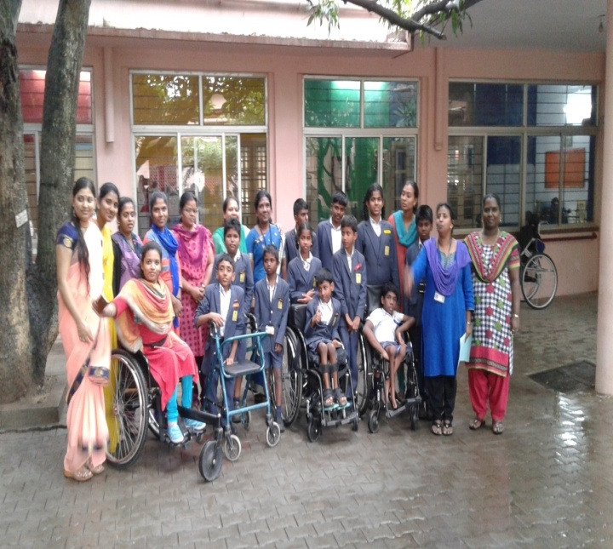 | 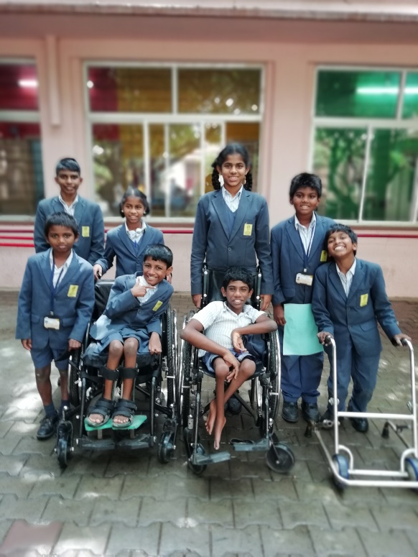
Independence Day celebration  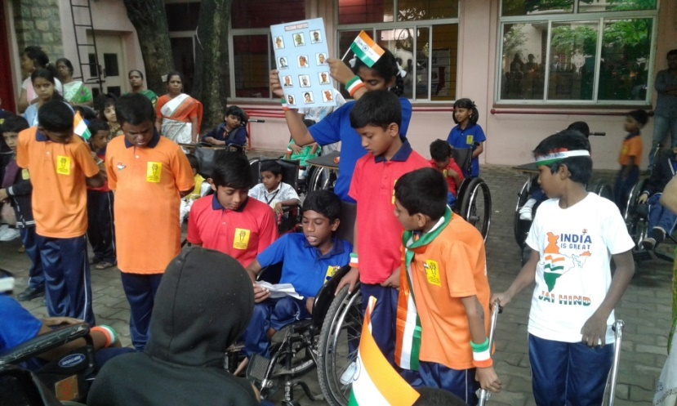 | 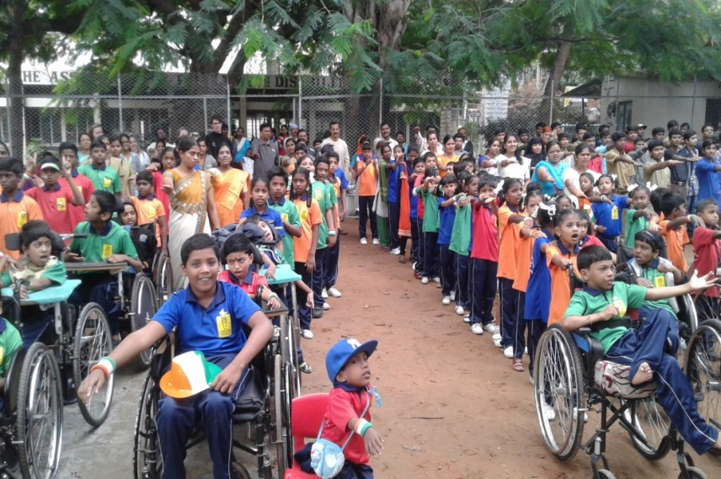
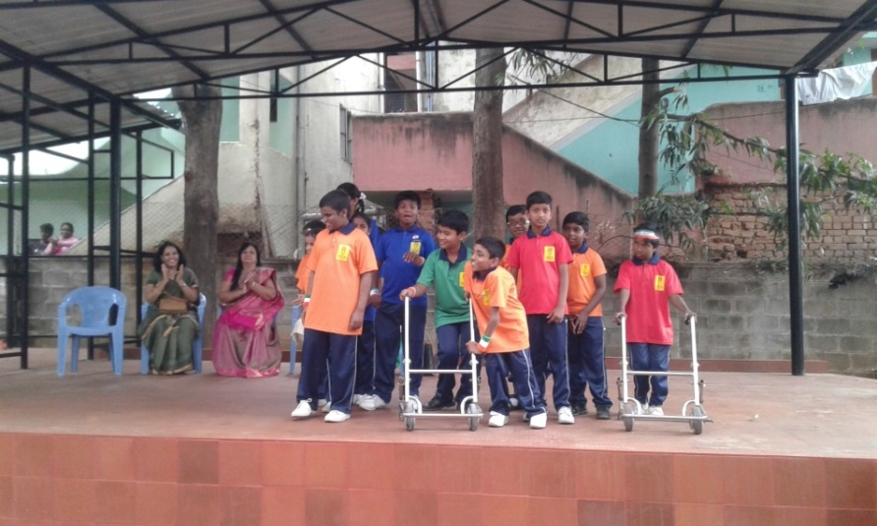 | 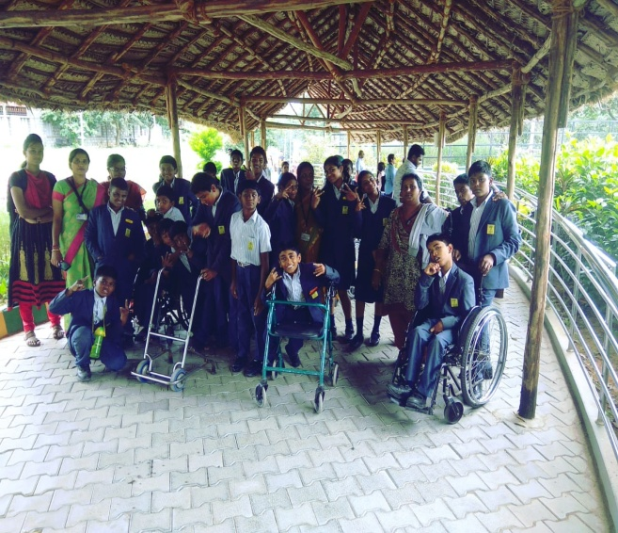
Parents meet

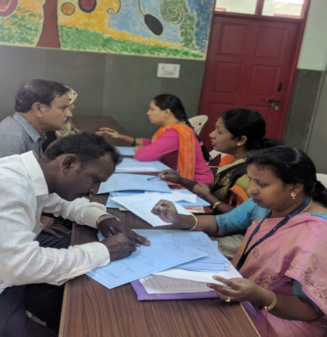

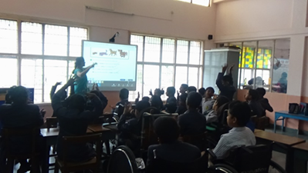

TATA CLASSES

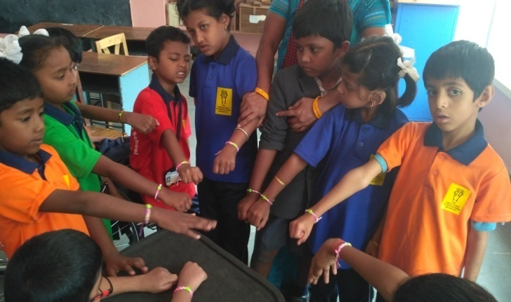
Friendship day

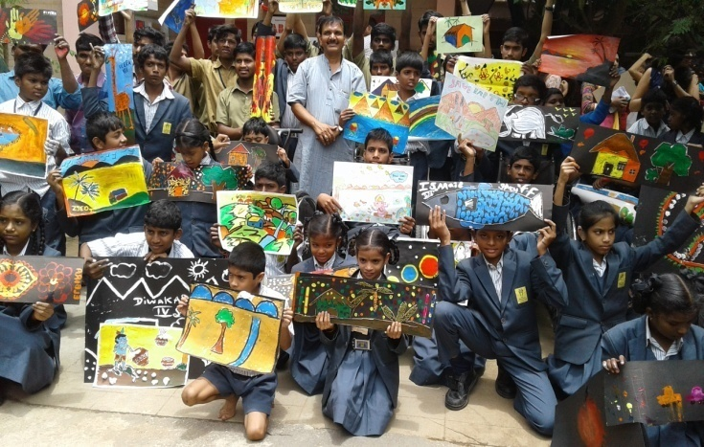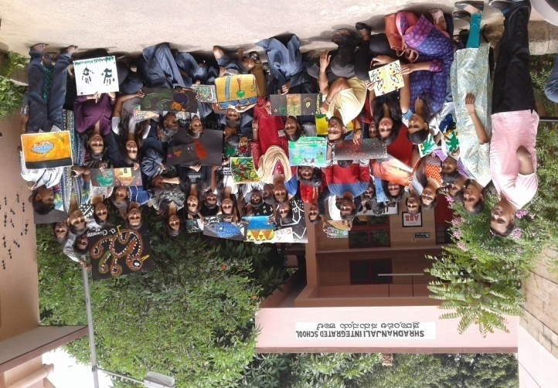
Art Workshop
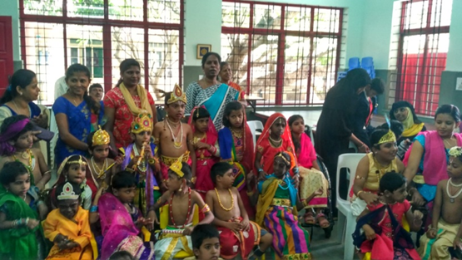
Fancy Dress Competition
We need your help to spread the word! Please share this opportunity with your friends and contacts, especially those who are USA tax payers . Post a link to our project page on your Facebook page asking your friends to donate.
Our sincere thanks to all our donors for their kind donations and love. We shall submit to you more news in the next report.

Best Regards,
Joyce M Periera.
Manager, APD
Contact No : +91 80 25475165

