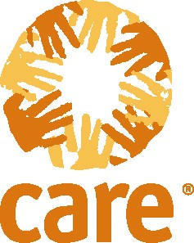

Hurricane Stan Hits Central America

CARE seeks $10 million from private donors

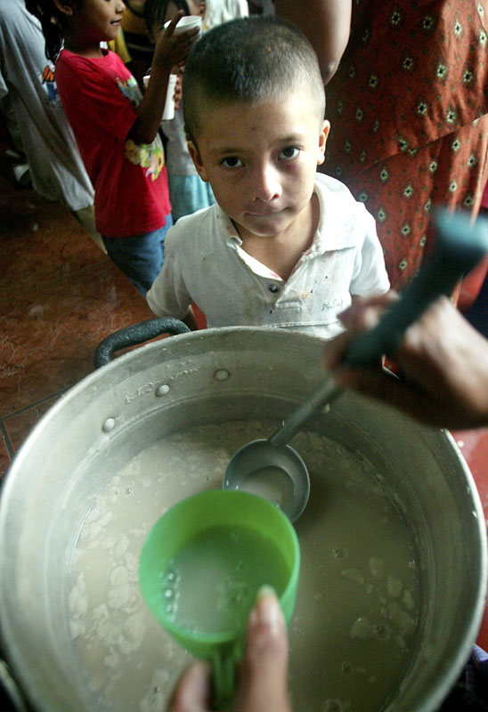

A boy in El Salvador waits for food at a shelter for people displaced by the floods

Reuters/Luis Galdamez, courtesy www.alertnet.org

Overview

Hurricane Stan made landfall in Central America on October 4th, causing massive flooding and landslides throughout the region. Guatemala and El Salvador were hit particularly hard. In El Salvador, the crisis is compounded by volcano Santa Ana whose recent rumblings have necessitated the evacuation of everyone living within a three-mile radius.

In these two countries, more than 300,000 people have been affected, and of that number, close to 200,000 people are currently displaced. Up to 670 deaths have been reported, and this figure is expected to rise as rescue teams delve deeper into affected areas. Sadly, the death toll in Guatemala has already exceeded that of Hurricane Mitch, which hit the region in 1998.

CARE immediately mobilized emergency response teams in both countries to assess the situation and develop a response plan. Initial activities include evacuation and rescue work, evaluating damage, and determining basic humanitarian needs. In both countries, CARE was already managing development programs in the areas affected by this disaster, so we know the people and their communities, and are uniquely positioned to execute an effective response.

In both countries, CARE is responding to immediate emergency needs, and we are seeking $10 million from generous donors in the United States for our Central America Response Fund to ensure that we can continue and expand our relief work, and remain with affected communities as they begin to recover and rebuild their lives and livelihoods.

Guatemala

The Problem

In Guatemala, local geography contributed significantly to the impact of the disaster and the difficulty of the response. Rains pounded the mountainous western region, and caused a series of dangerous landslides. Then, rain gushed down towards the densely populated southern coastal plains, causing flooding in the towns and farms.

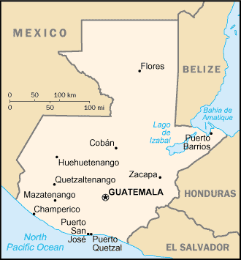
This is a particularly fertile area and is home to some of the most important farmland in Guatemala. Hurricane Stan destroyed this year’s crop, which will likely trigger severe food shortages for at least the next several months. The floods have destroyed infrastructure including roads, communications systems, bridges, highways, schools, and electricity supplies. In the short term, this has hampered damage assessment and relief efforts, and in the long term, the destruction will affect the local and consequently the national economy.
The western and southern regions were worst affected by Hurricane Stan

Most people in the affected areas are Mayan, living in communities with extremely high levels of vulnerability and poverty. These agricultural workers are highly vulnerable and bore the brunt of the disaster.

Due to the destruction of infrastructure and the floodwaters, many small communities remain isolated and with little access to assistance. Ongoing, inclement weather and rains have limited access to these communities by air or road. The rainy season is just beginning in Central America, further increasing the risk of more floods and mudslides.

CARE’s Response

CARE aims to support a minimum of 30,000 disaster-affected people in 134 shelters in the hardest-hit areas, including but not limited to areas where we are already at work.

In Guatemala, CARE envisages a three-phase strategy for our response to the disaster.

Phase I – Emergency Response: Our initial emergency interventions will target the urgent health, water and sanitation, food and shelter needs of affected communities, and will include supporting search and rescue efforts, establishing and maintaining emergency shelters, supplying food to at least 30,000 people living in shelters, ensuring a clean water supply and safe sanitation and hygiene practices, providing shelter and non-food items, and providing basic health services.

Phase II – Recovery and Rehabilitation: After the initial response, CARE’s goal will be to help communities return to normal life and livelihoods following the disaster through recovery and rehabilitation activities. We will ensure that our work complements and is coordinated with priorities of the Guatemalan government. Key interventions will focus on:
- Health – rehabilitation of health services, trauma recovery support, food security and nutrition;
- Education – reconstruction of school infrastructure and resumption of school routine;
- Infrastructure – rebuilding housing, water and sanitation facilities and environmental recovery;
- Income generation – reactivating programs to allow families to become self-sufficient; and
- Disaster preparedness – analyzing vulnerabilities, planning and programming risk reduction.

Phase III – Reconstruction: In the longer term, CARE will collaborate with Guatemalan and international stakeholders to ensure that the physical and social infrastructure is fully repaired, and that those most affected are able to fully recover. Activities may include the recovery and strengthening of infrastructure, education programs, livelihoods and disaster mitigation.

CARE’s history in Guatemala

CARE has worked in Guatemala since 1959 and has developed extensive partnerships with other organizations in the public and private sectors. We currently manage projects in water and sanitation, agriculture, agroforestry, primary and reproductive health care, girls’ education and small economic activity development.

El Salvador

The Problem

In El Salvador, the immediate impact of the rains has been the displacement of thousands of families who have fled flooded and destroyed houses and are now located in temporary shelters such as schools and churches. The number displaced as a result of floods and the Santa Ana volcano is now estimated to be more than 100,000 people.

In the west of the country, the Santa Ana volcano has been volatile, emitting dangerous gases and rocks, and showing potential for a major eruption. This has caused the evacuation of all communities living within a three-mile radius.

The rains and flooding of rivers have caused widespread destruction of infrastructure (roads, bridges, housing), and contaminated water and sanitation facilities. Crops have likely been destroyed. The full extent of the damage will not be known until the rains stop and complete assessments can be undertaken, yet significant loss and destruction can already be seen.

The situation in El Salvador remains vulnerable to further decline. The three key risks now faced by the affected communities are: expected eruption of the Santa Ana volcano, further rains or additional storms, and a possible dengue fever or other disease outbreak.

CARE’s Response

CARE aims to reach at least 30,000 people in and around Santa Ana, Sonsonante, San Vicente, La Paz, Cuscatlan, Ahuachapan and Usulutan. We will expand to other areas if unmet needs are identified.

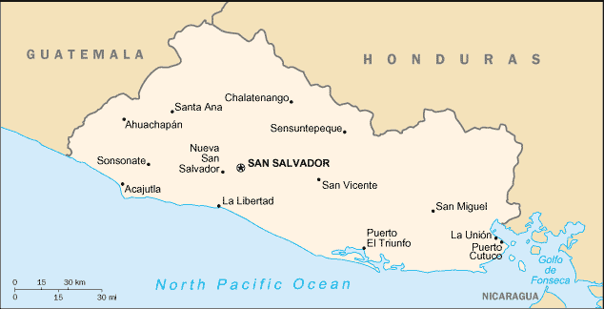
As in Guatemala, CARE is planning a three-phase strategy in El Salvador to respond to the disaster:
A large swath of El Salvador was affected by Hurricane Stan

Phase I – Emergency Response: Our immediate priority is to meet the basic emergency needs of a minimum of 15,000 people displaced by the storms and volcano evacuations. The primary target of CARE’s interventions will be women and children who are living in temporary shelters. Key interventions will include providing safe drinking water and latrines to shelters, distributing family emergency kits containing diapers, soap, towels, toothpaste, washing powder, sanitary pads and toilet paper, distribution of jars of baby food, and social programs such as psychosocial interventions using art and theatre to provide stress relief and educational stimulation for children in shelters.

Phase II – Recovery and Rehabilitation: To help affected families return to their lives and livelihoods as rapidly as possible, CARE will transition from emergency response to rehabilitation as quickly as possible, but timing may vary from family to family depending on the extent of destruction and, in the case of the volcano-affected communities, on whether Santa Ana erupts. Our primary aim during this phase will be to help families return home from shelters, and to rehabilitate houses, livelihoods, schools and other infrastructure. Where houses have been lost entirely, CARE will coordinate with other agencies to support reconstruction efforts. For families who face a prolonged period in shelters, we will continue to ensure adequate living conditions in the shelters and will promote social activities including advocating for the needs and rights of the affected communities. Our work during this period will include:
- Ensuring access to potable water by restoring potable water and sanitation facilities including wells, water systems and latrines;
- Rebuilding homes and basic infrastructure;
- Reestablishing livelihood activities including agricultural and other earning activities;
- Improving emergency preparedness to address the ongoing vulnerability to disaster of poor communities in El Salvador; and
- Continuing to help children, parents and teachers reestablish school routines and minimize post-disaster risks such as increased child labor.

Phase III – Reconstruction: During this phase, CARE will support reconstruction efforts in cooperation with other stakeholders to ensure that the destruction of physical and social infrastructure caused by the disaster is fully repaired and that the people affected are able to fully recover. The scope and implementation of our work during this phase will be determined following comprehensive assessments of the damage caused by the disasters and the progress achieved during the emergency response and rehabilitation phases. CARE will give attention to both physical reconstruction (including houses, schools, health facilities, water and sanitation facilities) and to the recovery and strengthening of communities’ self-support capacities (including education programs and disaster mitigation).

CARE’s history in El Salvador

CARE began working in El Salvador in 1956 and over the next two decades implemented a number of development projects. Forced to suspend programs during the disastrous civil war, in which 75,000 people were killed, CARE returned temporarily from 1985 to 1988 and, thanks to improved security conditions, fully resumed our programs in El Salvador in 1993. Rural water supply, sanitation construction and rehabilitation, primary health care, agricultural development and community organization are our priority programming areas in El Salvador.

CARE is rapidly reaching people in need with emergency aid, and we are committed to helping families rebuild their shattered lives. We sincerely thank you for your gift to our Central America Response Fund.

October 13, 2005

