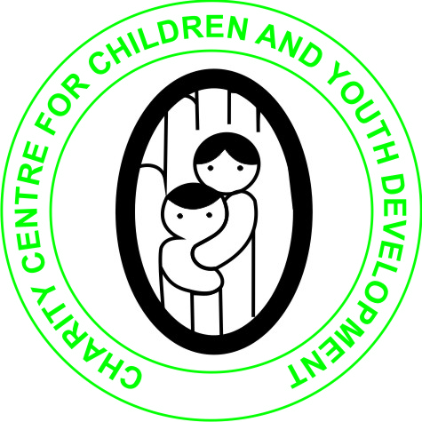
CHARITY CENTRE FOR CHILDREN AND YOUTH DEVELOPMENT
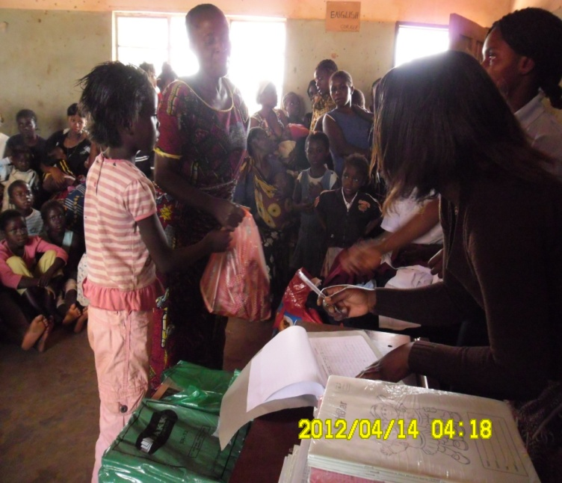

ANNUAL REPORT
2012 TO 30TH DECEMBER 2013
PO BOX 110048, SOLWEZI ZAMBIA
Email: info@charitycentreforchildren.org
Cell 0965/0955 737377

‘’Restoring Hope and Life in Children’’
- Project Background and purpose
In the last couple of years, there has been an increase in efforts to ensure the respect for the rights of children as enshrined in the UN convention on the rights of the child. Children need protection and care because they are mentally and physically young. All children have human rights and must not be discriminated in any way.
The advent of HIV/AIDS that has wrecked havoc in many lives has made an increased number of children orphaned and vulnerable. Many households bearing the brunt of HIV/AIDS are overstrained with the increasing number of Orphans and other Vulnerable Children (OVC).
The urgency of taking drastic action to help families living with OVC and improving their lives as well as providing shelter as one of their basic rights has been acknowledged by the community, government and civil society. This report therefore focuses on the role of the OVC project in HIV/AIDS prevention and impact mitigation.
Charity Centre for Children and Youth Development (CCCYD) is a community Based organization which was established to help Orphans and vulnerable children (OVCs), Youth, women and persons with physical challenges improve their standards of Living through the provision of several life skills, education of HIV/AIDS awareness, as well as financial and material support. In Solwezi district CCCYD is operating at plot NO. 917 Zambia Housing Compound off Kimasala Road after Chamuta community School west of Solwezi Town.
In Solwezi district the organization was established in the year 2010 in response to HIV/AIDS and other social and economical challenges faced by children and the youth. In most rural communities in the province there are numerous orphans and vulnerable children who have been rejected by their relatives and left without food, shelter, clothes and money. Therefore the goal for the organization is to provide and help Orphans and Vulnerable children with psychosocial, education and material support which they have been denied in the past. The organization has volunteers who go round in the community to identify the most vulnerable children in community. Our volunteers faced a lot of resistance from the community claim their children have been written by so many organizations who don’t come to their aid after the registration process they also fear to register their children because of the fear for Satanism among other things.
Charity Centre for children and youth Development submitted a proposal to the Embassy of the United States of America, Lusaka, Zambia under the PEPFAR Small grants program, for Orphans and Vulnerable Children (OVC) small grants coordinator and US Government interagency PEPFAR team selected Charity Centre for Children and Youth Development to be one of the grantees of these funds. PEPFAR small grants approved the sum of $7,719 equivalent to ZMK 36,277,500 to implement two activities namely: provision of Educational support (school requisites) and Poultry (Broiler Chicken IGA) for the support of 200 orphans and vulnerable children in the selected communities.
The organization received the funds in December 2011 and the full implementation of OVC project started in January 2012.
The orphans and vulnerable children are increasing everyday in our communities. We are familiar with what it means to be an orphan or a vulnerable child. How friends and families are torn apart and how through death, stigma and discrimination the social fabric of communities are destroyed.
CCCYD is striving to better the lives of orphans and vulnerable children in Solwezi District. Most of the children are made up of children whose parents died living them with grandparents who are unable to take care of themselves talk less of the orphans. Some are a result of divorce where the father is irresponsible and the women are forced to take their children back to their families thus increasing the burden on her mother who is a widow and has no source of income. These orphans are usually malnourished, dropouts and start roaming the streets at tender ages because they don’t have anybody to directly assist them. As a result, some of the orphans get involved in prostitution and burglary to make a living. Some of the young girls are forced in to early marriage which ends up breaking because they were not prepared for marriage.
By the end of 2013, the organization supported 205 0rphans and Vulnerable children in four communities, namely Muzabula, Kimasala, Zambia, and Highlland compounds providing them with educational support (Shoes, books, and uniforms in order for them to acquire basic education. This is just a tenth of those who effectively need support.
Organizations Management Structure and Capacity
The organization is managed by an executive committee comprising of 10 members elected after every three years as stipulated in the constitution. The executive comprises of: - Chairperson, Vice Chairperson, Secretary (Executive Director EX Official), Treasurer, Projects Co-coordinator, Assistant project Co-ordinator and four committee members.
The group has also identified, approached and mobilized volunteer community own Resource persons (skilled/trained personnel) especially in the area of HIV/AIDS, OVC Support, Entrepreneurship and vocational skills training. They work through provision of knowledge skills and ideas for projects identification, design implementation, management, monitoring, evaluation, documentation and reporting. They offer services on voluntary basis.
Organizations Accountability and Financial Transparency
The organization maintains accounting records that strive to secure transparency, accountability and effectiveness. The treasurer maintains a record of all funds received and expend from the organization. The treasurer reports are tabled before the executive committee and general meetings for deliberation and approval. The financial books are also available to the members for review. The projects and activities carried out by the organization are based on annual financial budgets. The treasurer prepares and presents cash flow analysis tools, petty cash book and the income and expenditure accounts. The organization accounting records also involves use of invoice, raising of vouchers verification, approval and systematic filling for reference. Reports on budget provisions and really expenditure are compiled and approved at all relevant levels including, project management level, executive level and general members level.
- Summary of Activities
2.1 Educational support and food supplement to Orphans and Vulnerable children (OVC)
Provision of educational assistance such as uniforms, jerseys and shoes aims at supplementing the efforts of parents and guardians to meet the needs of the children for them to remain in school and contribute the nation economy if they graduate. Education support was considered to be one of the priorities for the support of OVCs identified by the organization. So far 205 Orphans have been supported under our OVC support programme.
The organization distributed the following items:
- 67 pairs of school shoes
- 100 Jerseys
- 154 School skirt
- 44 School trousers
- 131Schools shirt
- 60 Jean dresses
- 500 Books
- 15 x 25kg bags of mealie meal
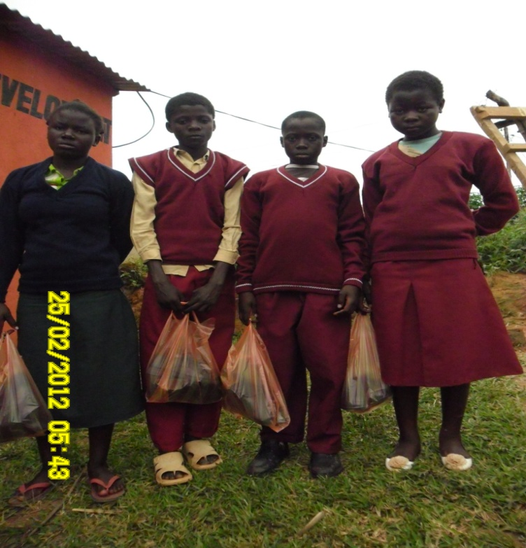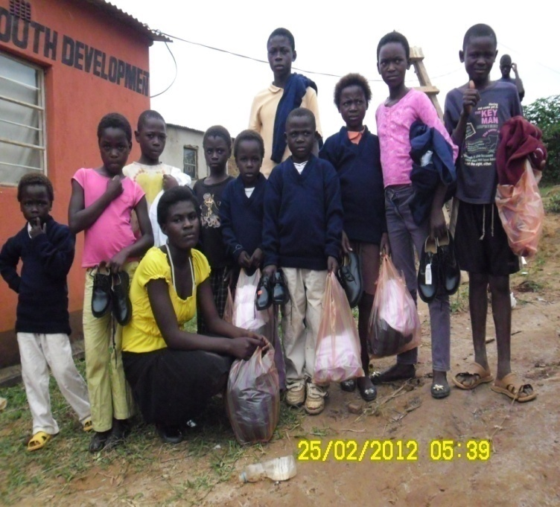
OVCs after receiving School requisites at Charity Centre for Children and Youth Development offices.
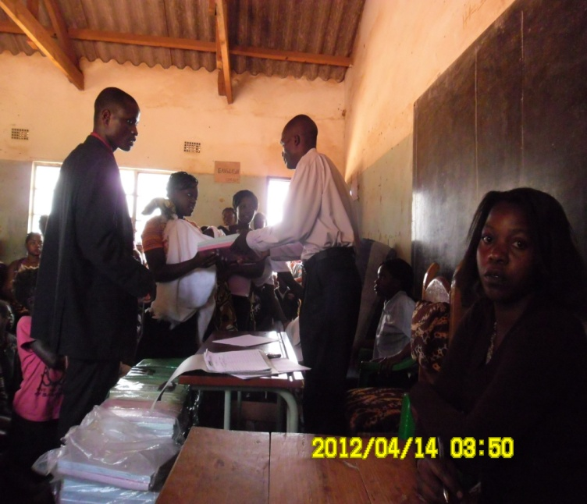
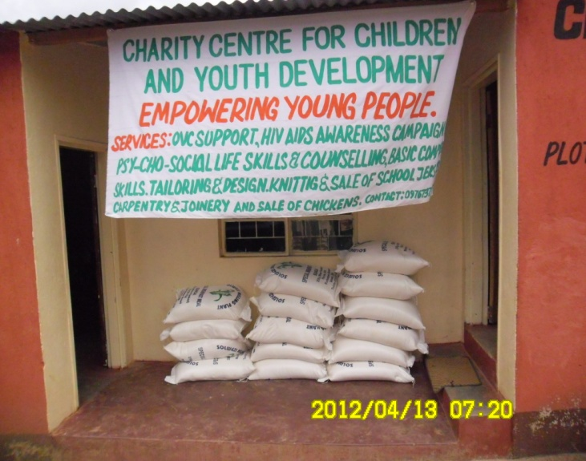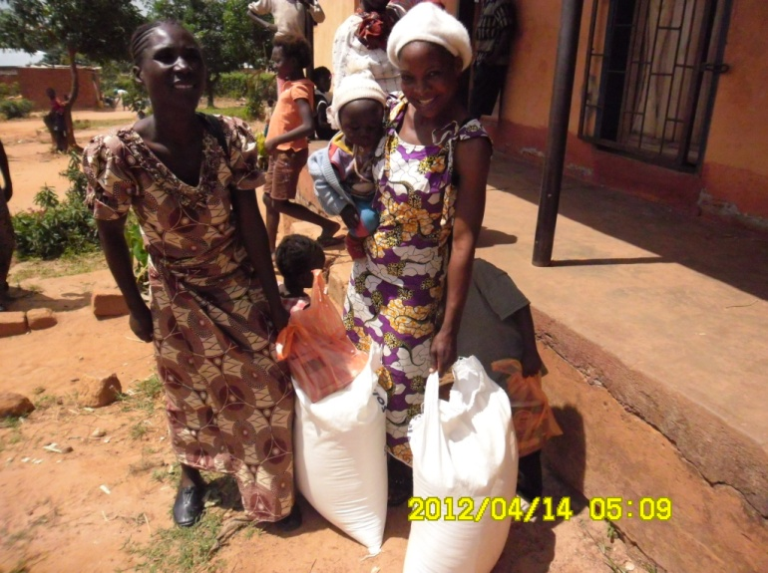
The ward councillor of Kimasala ward, Mr Dickson Chitambala, presented school assistance and food to Orphans and guardians at Chamuta Community School.

Communities Female Male Total
Muzabula 22 10 32
Kimasala 30 16 46
Zambia 60 34 94
Island 25 8 33
Total 205 OVC

Total number of OVCs reached by age

Girls 07-15 years=107
Girls 16-18 years=30
Boys 07-15 years=60
Boys 16-18 years=8

- HIV/AIDS Prevention

The organization distributed 4000 male condoms and 200 female condoms in the year 2013.

- Poultry Broiler Chicken (IGA)
The aim of this activity is to establish a meaningful sustainable income generation that would sustain the organization even when donor support comes to an end. The poultry project was constructed at plot number 917 at the same place where the organization is operating from.
The organization has constructed a 1x2 chicken run which can stock 500 day old chicks at a time. This activity has helped the institution raised money to sustain the organization even for some programmes which were not funded. However, the poultry project was suspended in 2013 due to insufficient funds to run the activity.
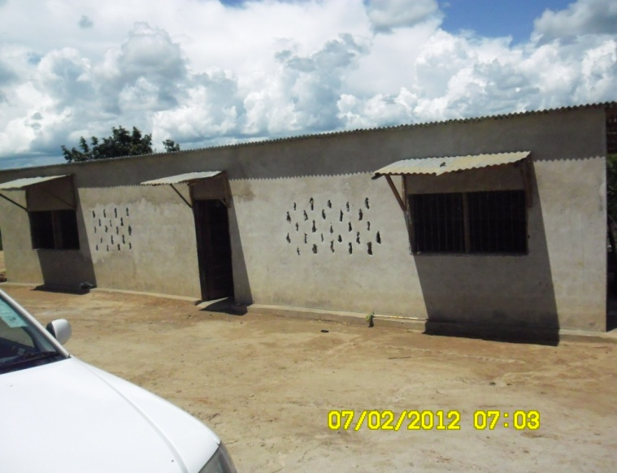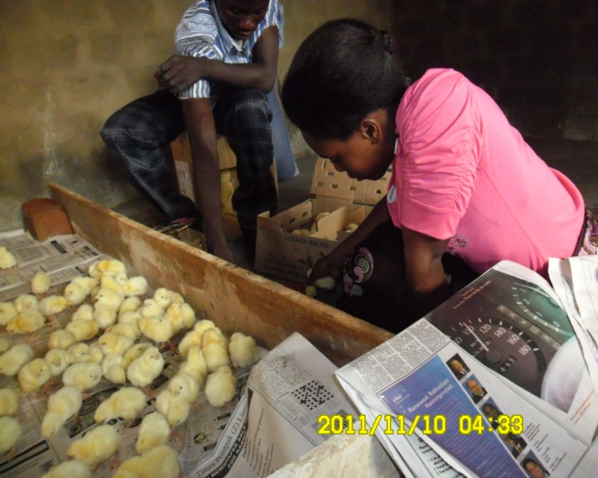
1x2 chicken run stocking day old chicks

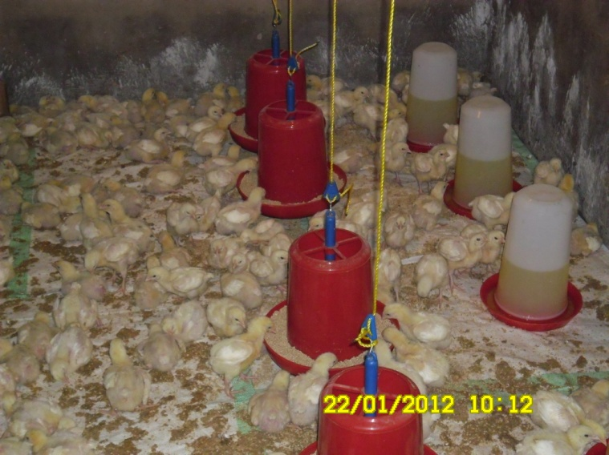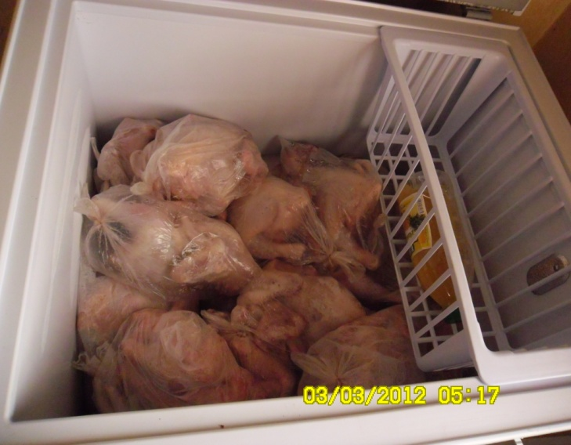
Dressed chicken ready for Sale

This activity is assisting the organization meet the daily needs and for the continuation for the support of OVCs, through the profits raised, we managed to buy 15x25kg bags of mealie meal and 500 books which were donated to orphans.

- Challenges
Some of the major challenges we faced during the period under review were that the families keeping orphans were not willing to register their orphans because they don’t want to give information about their children’s HIV status for fear of discrimination and because of the issue of Satanism in the area hence these orphans were left out. Luck of transport was another challenge during the registration process more especially that this exercise was done during rain season.
But we managed to register a good number of OVCs which we can not manage to support due to limited resources. The committee only considered the most vulnerable children who have so far received support from the institution. We have managed to reach 205 OVCs in line with the proposal we submitted to PEPFAR.
The other challenge that the organization is facing is luck of funds for us to employ professional people who can help the organization as currently the organization relies on voluntary professional labour.

6.0 Lessons learned.
- According to the assessment we carried out in four communities, we discovered that most of the children don’t go to school due luck of financial and material support. Though we could manage to provide material support, still finances is another major problem and we did not plan to support orphans financially due to limited resources. We would love in future if we could be considered again with Funding to allocate some funds towards school fees so that many children can access education.
- It was also discovered that some households are headed by children which has forced them to abandon school and take up responsibilities of the parents.
7.0 Future Projection and Way forward
- To train more Community Members on various relevant topics
- To train community health workers with a target of 60 CHWs per year to help managing referral, mitigation intervention in the communities.
- Train more youth on BCC (sexuality life)
- Acquisition of a plot from the Municipal council for construction of a youth resource centre and administration offices for the organization.
- Creation of community units in away of empowering communities to own projects
- Formulation of a sustainable checklist tool on Monitoring and evaluation.
- Micro enterprise development for the youth, widows, women, and organization members through initiation of Income generating activities for socio economic empowerment.
- Exchange visits for exposure of the organization members.
- Formulation of a sustainable strategic plan.

8.0 Summary and conclusion
The production of poultry has helped the organization to assist more families who are affected and infected by HIV/AIDS by providing the school requirement to the OVCs. This has given them the zeal to go back to school and reduce the burden on the budget for parents and guardians who are not in employment. CCCYD has a very strong goal of improving the quality of life of the vulnerable children and orphans through providing education, giving care, love and support. Additionally, it promotes empowerment of rural Community people in various areas affecting humanity. We commit our selves to continue helping Orphans and vulnerable children.

