Global Giving Report
Student Profile
Anushree
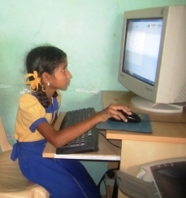
Anushree, studies in Class IV at SUKRUPA, and her brother Vikas studies in Class II. Their mother, a woman merely in her mid-twenties, is already widowed, without education or means to an income, and two young children, 6 and 9 years, to take care of. Anushree's mother now works as a domestic helper to support herself and her two children. Anushree is an extremely bright student. Her hardwork and sincerity not only makes her a student at the top of her class, but also makes her shine in her extra-curricular activities. Anushree has already cleared the first level of her French exam and is now taking an advanced French lesson at SUKRUPA.
It is extremely important that Anushree finds a sponsor to be able to continue her education at SUKRUPA.

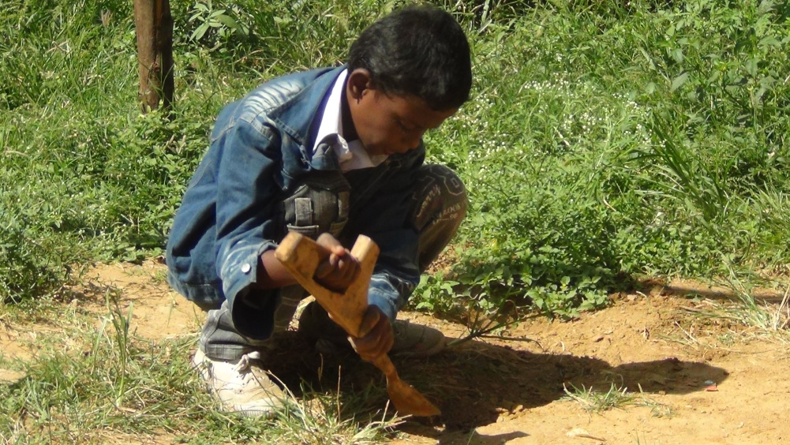
Dilip:
Dilip is a student of class V. He is 10 years old. He lives with his grandmother in the slums of Bhuvaneshwari, R.T. Nagar, since both his parents tragically passed away. His grandmother works as a domestic help to support Dilip, his brother and himself. With her less than a $1 a day income, she would never have been afford to educate Dilip and his brother. But thanks to SUKRUPA, Dilip and his brother are getting an excellent English medium education, meals, and health care. Dilip likes playing cricket and also likes dancing. Dilip likes Mathematics and Kannada and wants to become an Actor. He has been part of SUKRUPA for past 8 years.Above you can see Dilip during one of SUKRUPA's sapling plantation drives.
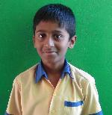
Karun Kumar
13 years old Karun Kumar has passion for books. A diligent student that he is, Kumar loves to read books on Indian history. He is also a regular visitor to the RT Nagar public library where he would spend time reading books on various topics. Student of 7th standard, his math teacher says that Kumar has the urge to learn and is one among the studious students of his class. Born to parents who works in garment factory, there was a time when it was difficult to continue his education since the school fees were high. At the time,an acquaintance of his father introduced them to SUKRUPA and Karun Kumar was enrolled to the 4th standard here. He reflects on his progress and says, " the time when I first came to SUKRUPA, I barely could speak in English but today, I am very comfortable with the language and also get proper guidance from teachers and mentors for any difficulties that I face in studies"

Activities at SUKRUPA

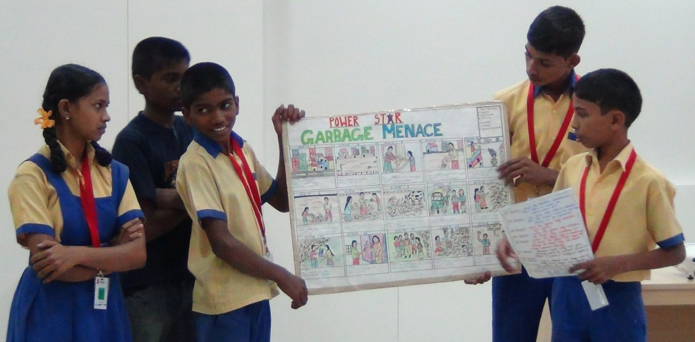
SUKRUPA's Young Movie Makers
Students from Class VII to X have been part of Adobe's Youth Voices program, through America India Foundation, for the past two months. As part of this program, the students learnt the entire process of making films, from the concept, to making a story board, shooting, editing, and even creating animation. After this intense learning experience, our students are making a series of five films about issues relevant to their lives. These movies will lend voices to problems that they face in their everyday lives and the solution they have conceived for these problems.
The movies will soon be ready and uploaded on our YouTube channel. So watch this space!

The children of SUKRUPA celebrated Christmas to their hearts' content....

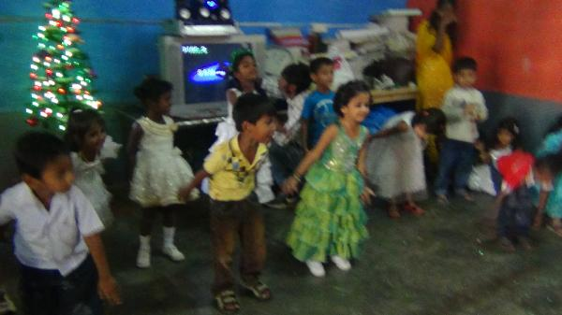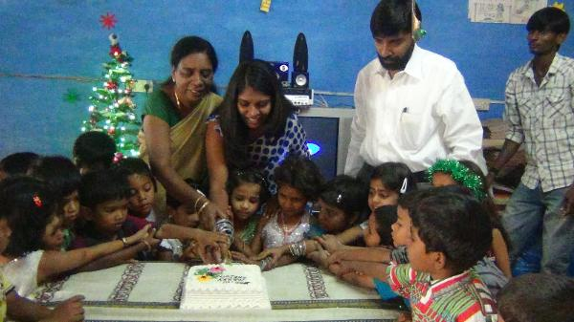

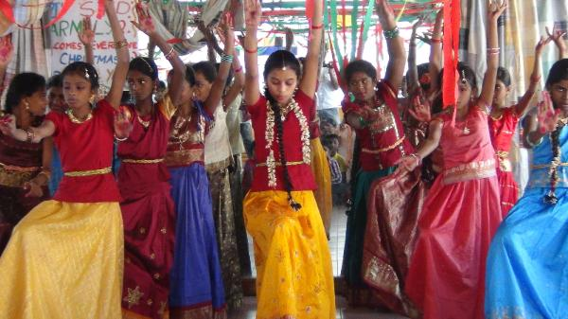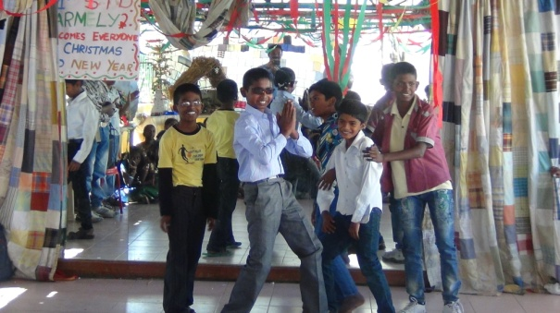
The hours of preparation by the children was reflected on the day when all of them gave their best performance as part of their Christmas celebration programme. The little wonders from the pre-primary danced on 'snow is falling' and 'jingle bells' and the high school children danced to Micheal Jackson's song 'Beat it' amongst many more programmes that added to the fun-filled day!
Sankranti Celebration
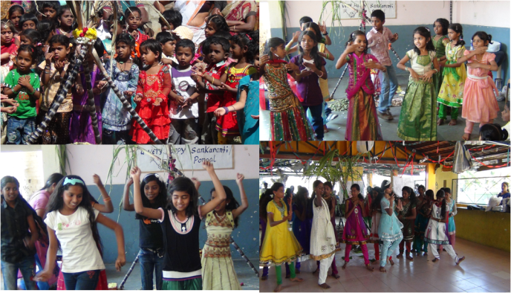
With abundance of joy, the children at SUKRUPA celebrated Makara Sankranti. The Spring Festival where the farmers worship Sun God for their harvest.
Little ones from pre-primary to high school teens everyone dressed in their best of festival outfits that spun the Sankranti celebration even more. The celebration continued with cultural programme and traditional rice preparations of sweet pongal and spicy pongal, sweet potatoes, ground nuts and sugarcane.

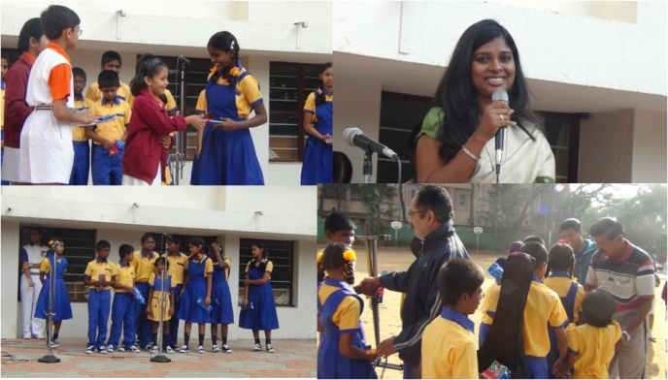
Children at National Public School
It was an amazing day for some of SUKRUPA children to visit National Public School Indiranagar.
The first expression of our children was WOW such a huge play ground!
Little Anna, Gowtham, Sudershan, Prathyusha, Harshitha and Raj Kumar, spoke on various topics such as education, learning, environment, keeping Bangalore clean. ‘Little Angel’s Choir Group’ of SUKRUPA who are learning music at SUKRUPA and Bangalore School of Music gave an excellent performance with Rajkumar on the guitar and keyboard. Ms.Krupalatha Martin Dass the Founder | Executive Director shared her childhood how her parents instilled the value of giving and sharing at a very young age that helped her to set up SUKRUPA along with her mother Suguna.
It was a day to remember for the children of SUKRUPA as the Headmistress of NPS made their day by asking all the kids to give a standing ovation.
SUKRUPA Thanks NPS Indiranagar for the generous donation and inviting the kids to their premises.
To watch one of their performance in NPS, please visit the link below:
http://www.facebook.com/photo.php?v=10151252656522343&l=3390301144325467202

