
South Asia Quake Disaster
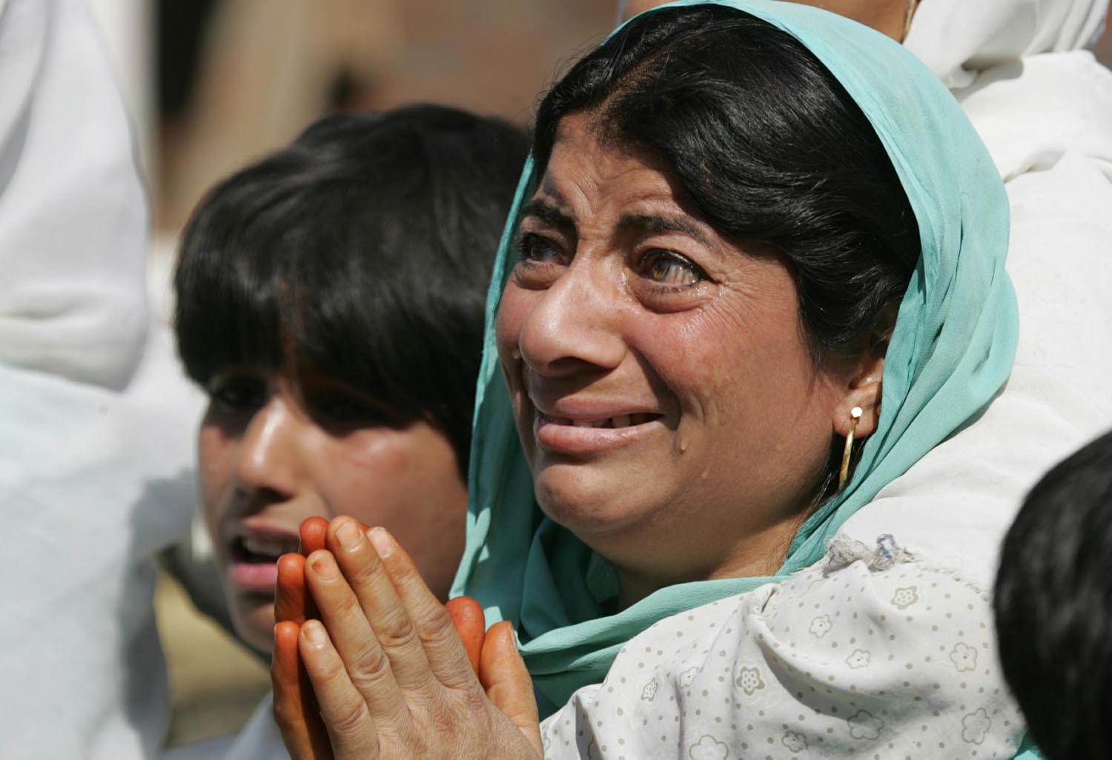
Reuters/Danish Ismail, courtesy www.alertnet.org

Earthquake Relief Fund for Pakistan and India
Goal: $8 Million

Overview
A magnitude 7.6 earthquake hit the South Asian subcontinent early Saturday morning, October 8. Parts of Pakistan and India were hardest hit, with the quake’s epicenter near Muzaffarabad, Pakistan — about 60 miles northeast of nation’s capital, Islamabad.
Widespread destruction has affected at least 5 million people in the area and claimed over 40,000 lives, a number that is expected to increase as rescue efforts progress. Many bodies remain buried in the rubble.
Homes, schools, hospitals and roads have been utterly destroyed, displacing as many as 2.5 million people, and storms, landslides and mudslides continue to hamper relief efforts. Survivors remain exposed to the elements, despite temperatures that have dipped below freezing in this unforgiving land at the foot of the Himalayas. Emergency food, shelter and medical care are needed immediately, before the harsh winter sets in.

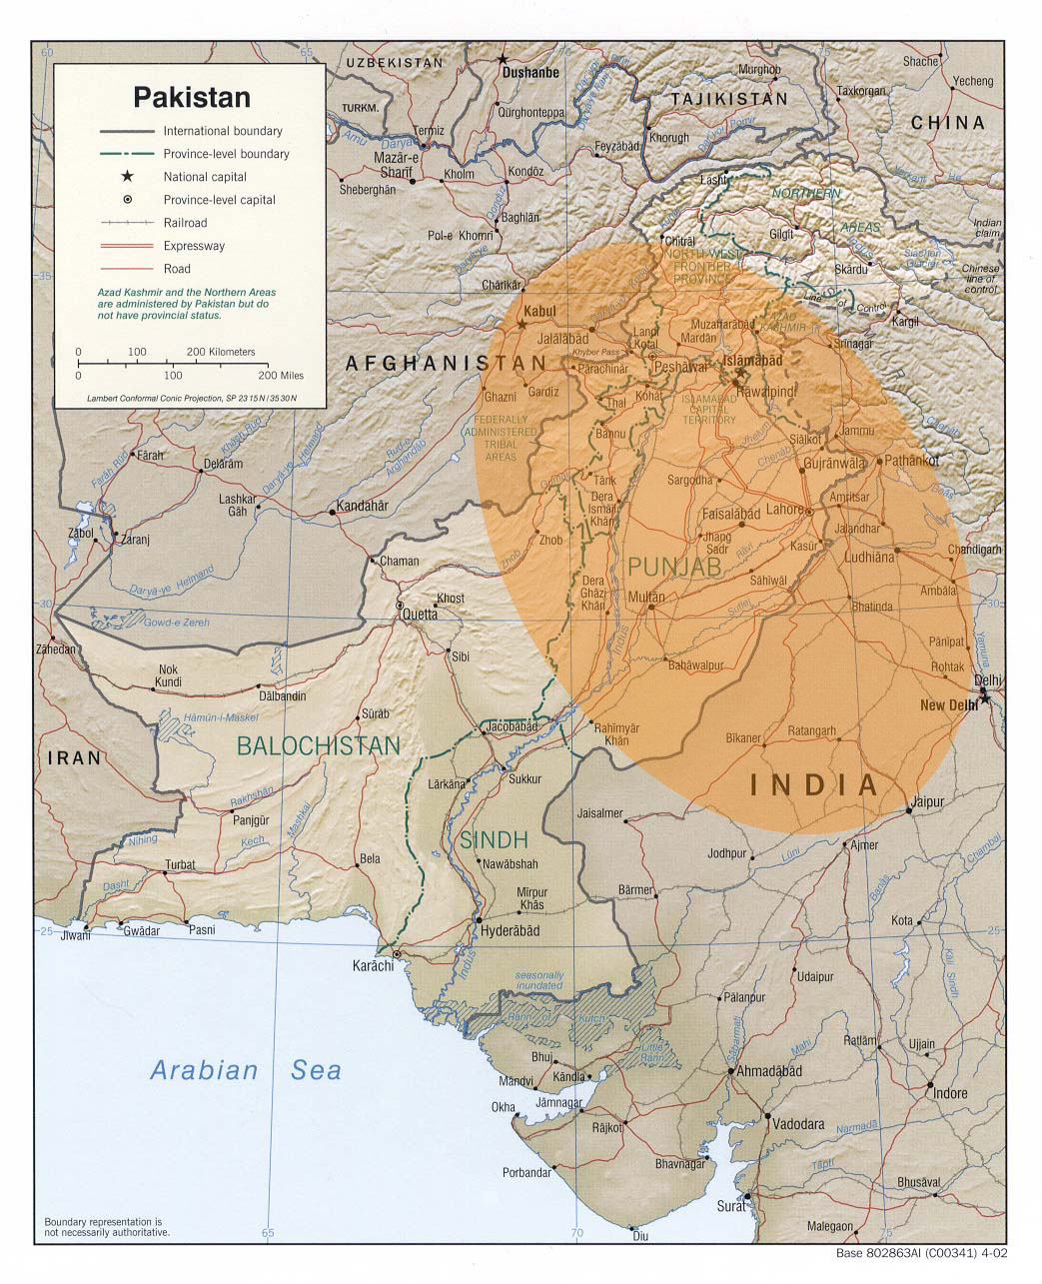
CARE representatives are just returning from assessment missions in both Pakistan and India and are reporting that health and hygiene conditions are very poor, especially for women and children. Survivors, many of whom have lost family members, are also suffering from psychological trauma.
We are beginning to transport lifesaving supplies to relief distribution centers. The most urgent needs for survivors in both countries include tents, blankets, warm clothing and water containers.
CARE has released preliminary emergency funding of $50,000 to each country to help meet immediate emergency needs, and we are seeking $8 million from generous donors in the United States for our Earthquake Relief Fund for Pakistan and India. These resources will allow our staff the flexible funding we need to ensure that earthquake-ravaged communities can survive the immediate emergency — and rebuild their lives and livelihoods in its aftermath.
More than 5 million people
have been affected in Pakistan and India.

Pakistan
At the quake’s epicenter, Pakistan bore the brunt of casualties, with the death toll reaching more than 30,000. Since roads and bridges in the hardest-hit areas have been wiped out by mudslides and communications have been severely damaged, it has been very difficult for all responders, including the national government, to mount large-scale relief operations.
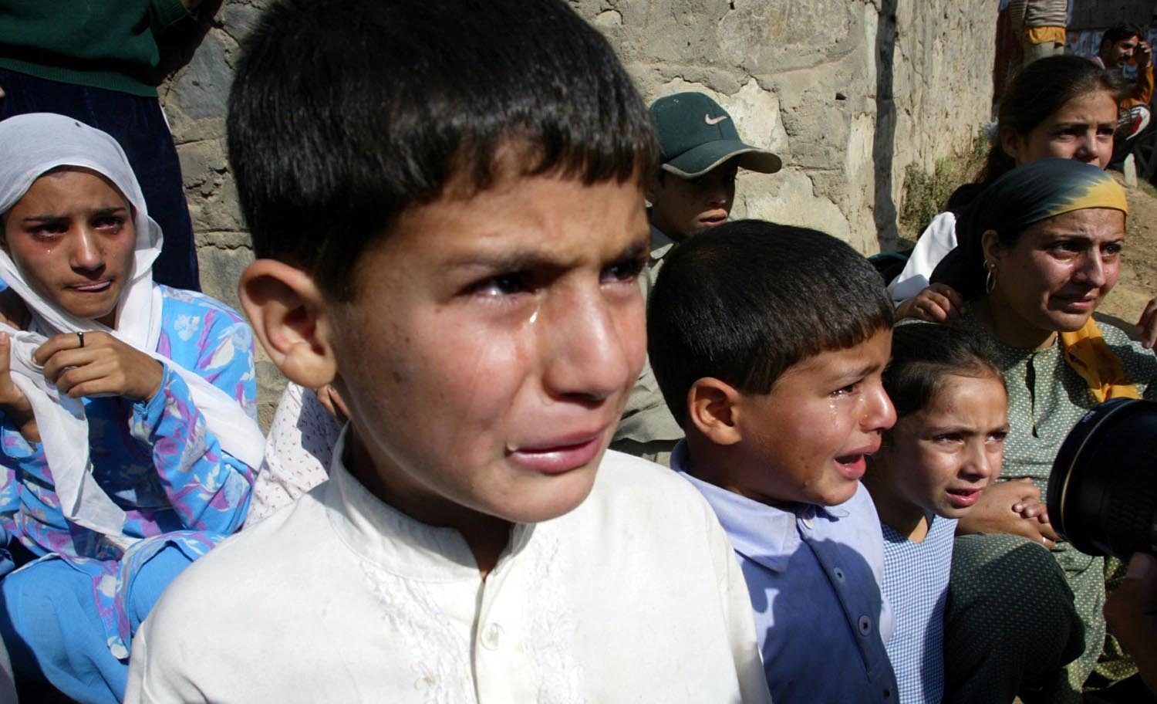
CARE will begin by working with our partner, Action Aid, to send a generator, tents, blankets and plastic sheets to 500 families the hardest-hit cities of Mansera and Muzzafarabad, and then expand operations to other regions.
Reuters/Danish Ismail, courtesy www.alertnet.org
Relief supplies from CARE’s office in Afghanistan — including 342 tents, 2,000 blankets and 1,000 plastic sheets and 1,000 metal buckets — are being loaded onto trucks in Kabul and bound for Pakistan. CARE workers in Pakistan are also trying to secure more tents and blankets from local vendors, though supplies of relief materials in the country are depleting quickly.
A field assessment conducted by CARE and other international humanitarian agencies has identified the need for medicine, hygiene kits for women and trauma counseling for women and children. Greatly needed as well are shoes, socks and winter clothing, especially for children.
Emergency experts from CARE offices in Afghanistan, India and Bangladesh have been mobilized; some are already on the ground in Pakistan and others will arrive within the week. We anticipate working with local partners as well as other international aid organizations, in a coordinated effort.

India
The death toll in India has risen to over 1,300, with 100,000 left homeless and more than 7,500 injured. CARE did not previously work in quake-affected Kashmir, but we immediately sent an assessment team to the region and have been invited by the state government to participate in the relief activities. (Access to the Kashmir valley is controlled by the military and requires permission on a case-by-case basis for travel).
Our assessment team in India has identified two badly affected districts — Uri and Tangdhar — where we will first concentrate our aid efforts. In Uri, about 80 percent of the homes have collapsed or were severely damaged, and 40,000 people are in need of immediate assistance. The road to Tangdhar has been blocked due to landslides, and five communities are completely buried beneath debris. The Indian army has been in the area to provide temporary shelter and warm meals for survivors, but their supply is limited and troops are likely to withdraw soon, leaving a greater, more immediate need for adequate shelter and ready-to-eat food.
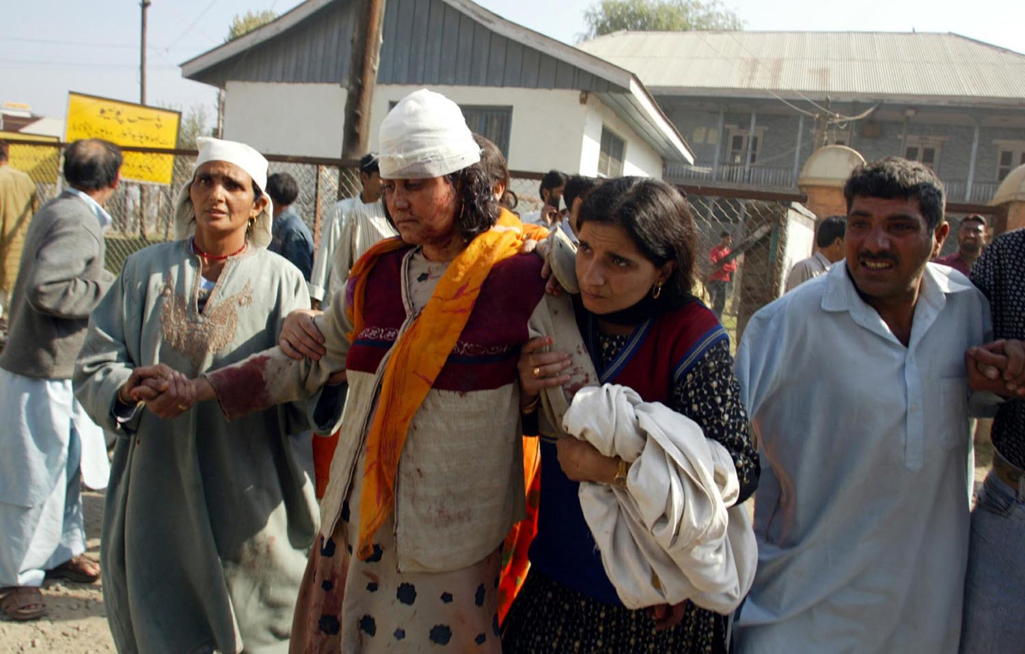
CARE has launched its relief operation in India by sending 8,000 blankets and 4,000 water containers from our warehouses in Delhi to 4,000 survivors in the affected states of Jammu and Kashmir. While water does not yet appear to be critically needed, containers are in short supply since households lost most of their possessions.
Reuters/Danish Ismail, courtesy www.alertnet.org
There is also an urgent need for kitchen utensils, hygiene kits and stoves, which CARE will begin procuring.
From our experience with the Gujarat earthquake of 2001 and the recent tsunami, CARE’s staff in India has developed particular expertise in providing trauma and grief counseling. We have developed a model with the National Institute for Mental Health & Neurological Sciences (NIMHANS) that rapidly deploys professional psychosocial care to a traumatized population.
CARE is working closely with other international organizations and exploring the possibilities of joint programming.

CARE’s Experience
CARE has 60 years of proven disaster relief experience. We were already in place in Pakistan and India before the recent crises struck, so we know the communities and cultures, and we work well with local partner organizations. We also know that careful coordination is key to mounting an effective emergency response.
We will continue to update this document as more information comes in from assessment teams and staff in the field. With the flexible resources in our Earthquake Relief Fund for Pakistan and India, CARE will rapidly reach those in need with emergency aid, and will help hundreds of thousands of families rebuild their shattered lives.
Even as we receive more information and the extent of the need becomes clearer, we know that millions will need help quickly, before the Himalayan winter sets in. We thank you for considering a generous gift to CARE at this critical time.

October 12, 2005

