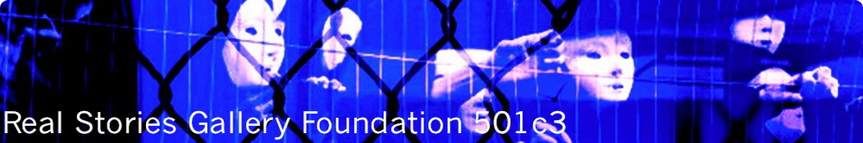

Real Stories Gallery Foundation, a registered non-profit charity in the USA, facilitates for boys, whose lives have been changed forever in the international sex trade, to free themselves from the burden of their experience and witness.

The boys believe the communities surrounding them prefer not to acknowledge the sex trade in boys exists and will never welcome a survivor with a history of sex work and HIV/AIDS into their homes or lives. It is a terrible thought for a child to endure.

Real Stories SHOWS the kids through a survivor-led and peer-mentored program, that we are listening, we believe the kids’ stories and every one of their lives is valuable to us. Over the years the initiatives have evolved into survivor-led and peer-mentored safe house art program; with an online dimension that reaches boys embedded in distinct localities around the world.

- Conflict, displacement, poverty and homelessness place boys at risk for a life in the international sex trades and HIV/AIDS-defining infections and diseases.
- When multi-cultural/lingual/racial boys travel (sex-trafficking, survival-sexwork), they do not live segregated lives. The boys interact and form relationships with other hard-to-reach boys (documented & undocumented boys) embedded in distinct localities of transit and destination within and across U.N. borders and continents.
- The VAST majority of men who rape boys and pay to rape boys live in all our communities as “married” men with kids.

After working with the boys and witnessing their stories, we concluded that the boys have a significantly higher chance of reaching their adulthood, when they can live away from social neglect and violence. In a place where adults who believe they own the boys and want their property back will not find the boys. In a place that allows the boys to access medical care and participate in programs that acknowledge and alleviate their diverse and substantial physical and psychological trauma. In a place where the boys can access legal counsel and representation, so they do not spend everyday looking over their shoulder and worrying whether men will take them away and place them in extremely male-child-survivor unfriendly detention centers and systems.

The skills the boys learn in the safe house art program (photography, filmmaking, poetry, etc.) shift how they perceive and represent themselves. The boys refer to themselves as artists/photographers/filmmakers/poets, rather than whores and failures. They begin to articulate their stories and visualize an adulthood in which they can earn a living away from violence and the sex trades.

Serving as peer mentors in the online art program is significant for the young survivors who emerge from such horror with a compassion that is breathtaking to behold. They believe their peers are worth guiding to safety and that the boys who are unable to reach safer places should know they are special, as they face their premature deaths feeling very scared and in tremendous pain.

We have explored every option for creating ‘model’ safe houses and expanding the art program to reach all the boys still left behind. The best solution is for us to just buckle down, take a deep breath and get on with creating them ourselves. The boys simply can’t wait another day for adults to discuss further whether survivors need safe houses or whether to reallocate funding to provide safe places for young survivors to live.

Creating a ‘model’ survivor-led & peer-mentored safe house, and strengthening their online art program, transmits a significant message to all the survivors (and to the perpetrators). The survivors are a strong intelligent and creative group and will not be bowed. The survivors, with guts and bloody hard work, are raising the quality of their lives and leading their peers to safety.

Why is it so urgent we create a model survivor-led and peer-mentored safe house art program? The most logical and clearest answer, I feel, is offered by the boys imagery and poetry.

Thank you for permitting the boys to stroll, just like that, into your lives with their stories; and a huge hug to you for believing the boys stories.

With friendship
Rachel Chapple, PhD
Founder, Real Stories Gallery Foundation 501c3
www.real-stories-gallery.org
realstoriesgallery@gmail.com
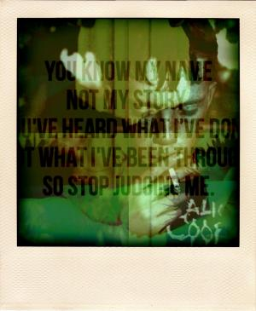
www.real-stories-gallery.org is one of our outreach, educational and advocacy webbased sites & channels; the content changes 24/7 reflecting survivors voices.

I love it when we get to see the guides and peer mentors fight like a bitch for us. No one ever did fight for me. I am not worth it. New weird experience. The people who support us are not rich. So we do what we can to support ourselves. When no one will help you then you gotta do it yourself. We built our own platform to communicate with one another. It is an outreach that says you can survive what they throw at you with the support of kids who live at risk lives just like you do. (14 year old)

How do you just walk up to someone you cannot bear to be without and say I love you? I cannot do it. We were homeless together. It has all been together. If we were broken up we would all fall apart. We went up north together. We all go to the same funerals. We act as one another’s medical advocate. You never go to the clinic just for you. You are going for another one of us too. We have stolen food from the same stores. We sold dick on the same streets. We got thrown into and raped in the same jails. We shit in front of one another in an attic toilet. When we go through withdrawal we puke in the same bucket. May be that’s love. (15 year old)

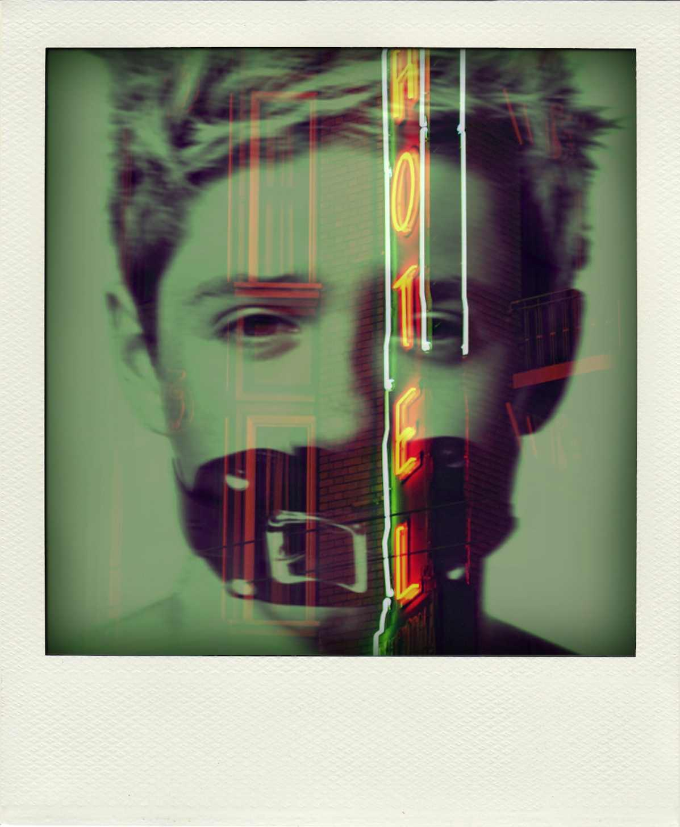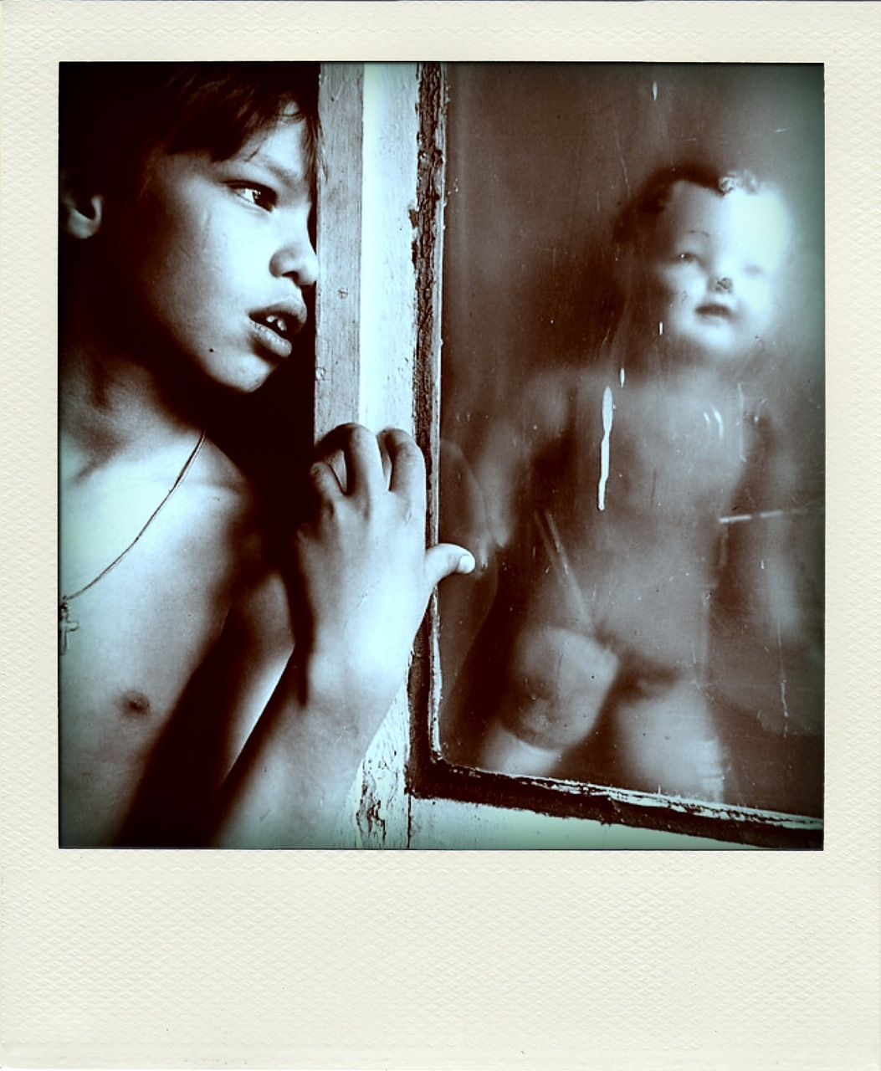

One time I was detained. I had to do sex work. The cops beat me up and took me to the jail. Men were throwing up in a room and they were drunk and throwing up on the floor and it had a drain in it where the throw up went. It smelled really, really bad. They make you be naked and they finger fuck you. They shave your head. They beat you bad. They noked my toth out. They will not let you go. The food will make you sick. If you have HIV they will not give you nothing. Girl gards will come and they want to know if you have drugs so they finger fuck you again. They will see your hole and your dick. They will have spray and they will spray you in the face and it will burn your eyes if you fite them. They can no way make me go back there and I will hang myself. If they come and say you are going to jail again I will stab my neck with a nife. I hate cops and I hate gards and I hate jail. Pleze pleze do not let them get me or my friends. I mean it. The end. (12 year old)
People wonder why I hate my life/ I hate my life because I am now/ always forced to be around doctors/ I hate them and I hate what they do/ 2 me and i hate nurses most of all/ because they humiliate me and I/ hate them and I do not want none/ of them touching me again/ (12 year old)

Poetry for mom. One day a man came. Mom was crying. She sold me. We had no money. I had to run. I ran. The man caught me. This man was mean and drank vodka. I hated him breathing. They did bad things to me, mother. You sold me. I ran hard. Children running. Men arriving. Run, children, escape. It was winter. My mother sold me. Now I want to sleep frozen in the snow. Until recently, it's been ICE. (12 yr old)
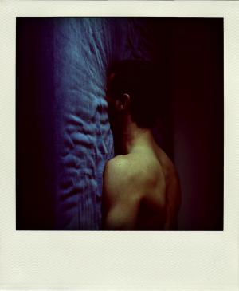
I wish no woman had born me. I was 8 years old. I did things in movies they made. I been bout and sold so many times I do not know who owns me no more. I got sick. They would still fuck me. Nobody would stop fucking me till I would be dead. I never want no more to get fucked again. That is how I got hiv. If I had to go back then I would have no pills like I do now cuz there was no pills for hiv there. If I had to go back then men would fuck me again and I would have to do it to earn them men who bout me money. But the drug ones will just shoot me like it was a lesson to the other boys.(12 year old)
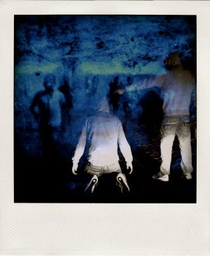
They said I had bugs crawling in my hair. Daddy shaved my head that time. Then he poured kerosene on me. Stinging my candle eyes. With burn. Then when I got the virus [HIV]. He could not make it better. Or cut the thing out of me. And he kicked me out and I could feel the cold wind around my head. (12 year old)
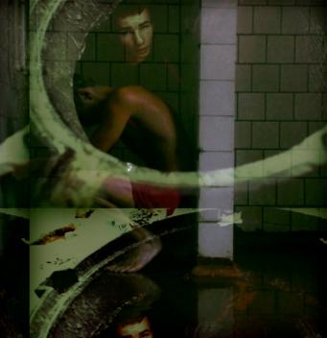
The men who put us on the bus had guns/ i did not want to go on that bus/ but they will kill you so we all got/ on the bus and some of them were/ crying but not me cuz i knew i/ would run away fast and i better/ not rite about it to much cuz/ those men are looking for me/ and they will kill me/ (12 year old)
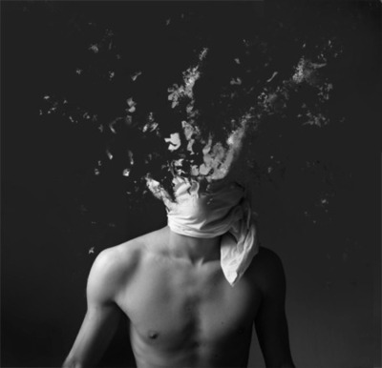
If they find me I will kill myself. I will not go back. I do not care what a court says. I will not go back. Her boyfriend gave me HIV. Fuck all of them. They made me fuck her. I fucked my own mother. Let her be alone in her empty house. I hope that cunt dies. If they make me go back I will kill myself. I will prove it. (14 yr old)
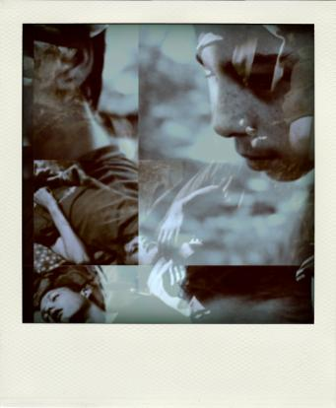
I am a pig. I am a pig in a room of 2 many beds where boys are fucking and fucking. I am in my pig bed and wish I was fucking no anyone. I am alone. I am a alone pig being gutted who is alone. I am a pig and my guts r out. Love, Chito. (14 yr old)
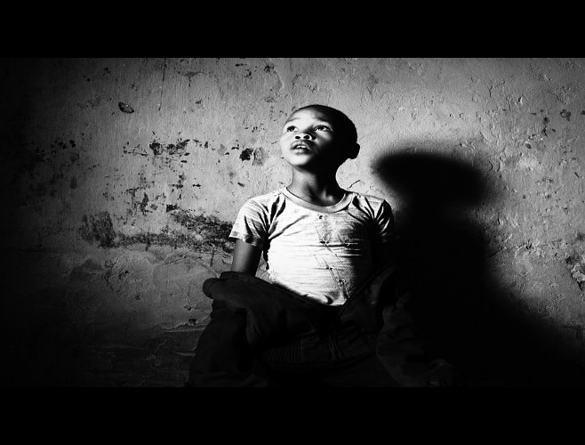
Getting Fucked at the Homeless Shelter. The bullet that goes through his brain whizzes by overhead. Missing me by less than an inch. I am so lucky. Now I can live long enough to go get fucked in the ass. By the older men in the homeless shelter showers. Where I shit out their cum. So no eyes could see the blood and cum go swirling. Down the drain. I am too tired. To care. (14 yr old)
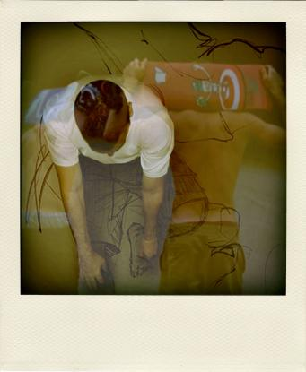
When I have no food/ Then I get these shakes/ And I have to lay down/ On the floor where I/ Sleep and put my coat/ Over me so I can try/ To stop shaking/ (14 year old)
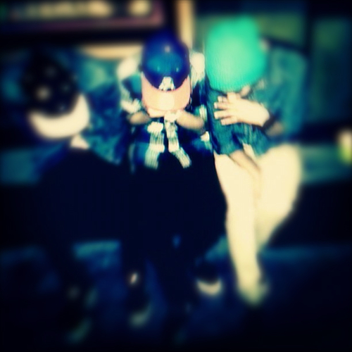
My tricks all like showing off. Driving big car tricks. Big/ Cock Daddy for his little boy. I gotta calculator running inside my head like the nurses have when you go the ER with like some pimp has broke your bones. Clicking off the numbers you will owe them/ You gotta be careful with the tricks cuz after they cum they want you out of there. They throw me out. And then they burn rubber out of there. Sometimes I wonder what kind of houses they live in/ All I know is that the houses must be big. You gotta big house and a big car and a heart smaller than my left tit in a deep freeze/ (14 year old)
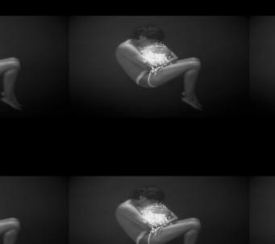
I was in detenshun 1 time. They fucked me day and night in there. I said to them that I had the hiv but they did not care. I did wanted to die a lot. (14 year old)
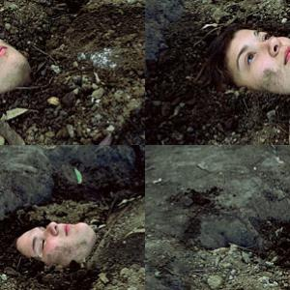
Skin and Hair. By dying, I no longer have to care. About what I look like in public. To people who do not know me. My skin has erupted with red bugs. That crawl into my demented brain. I am now bored by tragedy. Dangling from the high windows. Everyone falls. Like ladybugs trying to climb. Slick glass up. (14 year old)
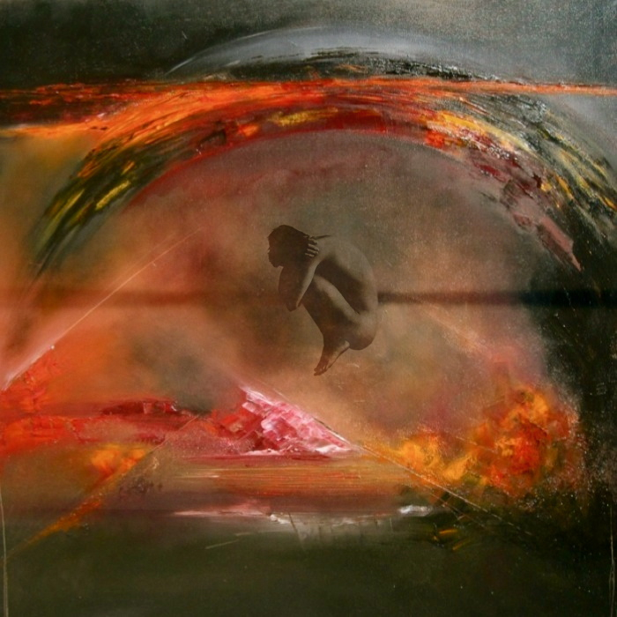
Only Want/ I want to die like a dog/ And be buried in a hole/ Dug into the ground/ I only want/ One person to care/ (15 year old)
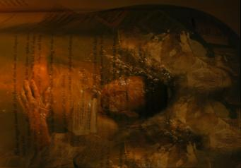
He kicked me out of the house and said to never come back. Now I have no idea where my parents are. I doubt they are still together cuz when he was fucking my hole she didn’t like it. When men are done fucking my hole, I just wanna die. Drugs hide the pain and then they fade and then you need more to keep the pain away. I am a hole. A big hole of shit, you know. I hope HIV kills me, you know. Will save me the trouble of doing it myself. I think about hanging all the time. I can’t get it out of my head. Maybe my parents would read about it in the paper but not really cuz they don’t read. But if they could read maybe then they would be sorry. (15 yr old)
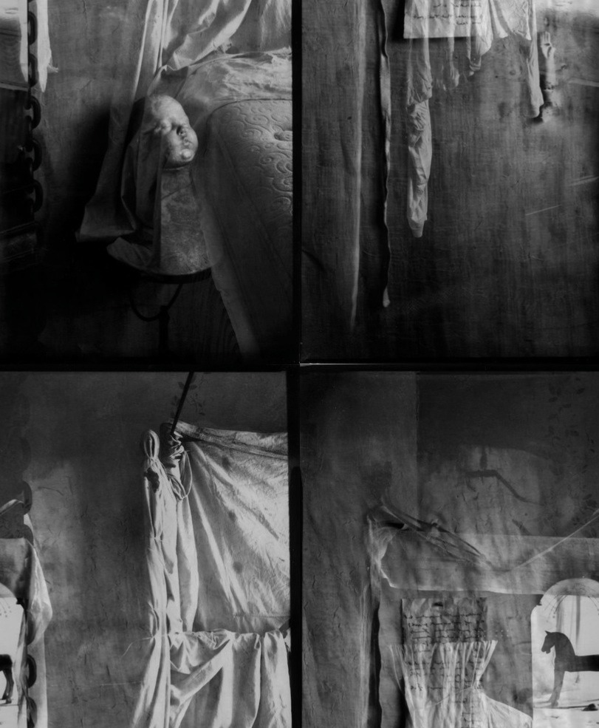
I had these sheets/ I took many of the men who paid me to have sex with them to my clean new sheets/ Like snow/ I was making love in snow/ Only really I was fooling myself we were making love/ Cos’ they did not love me/ It is hard to love me/ You have to be very strong. To do it/ Even I cannot do it/ I will admit it, that I wished some of them might love me/ Might take me to his home, in his arms/ But it is a joke. It could never happen/ They just wanted to come in me/ I just wanted to buy food/ When they left that little motel room I lived in/ I would try and not watch them go/ Cos’ I was always looking, at how his shit messed up my sheets/ Oh, before you know it. You will be on your knees/ My sheets in the backyard wind, were avenging angels/ (15 year old)

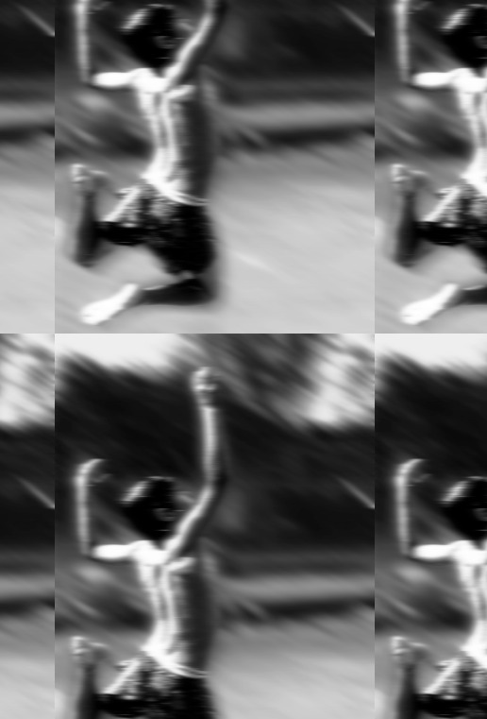

Now I am quietly waiting for the catastrophe of my personality to seem beautiful again/
And interesting/
And modern/
The country is grey/
And brown and white and trees/
Snows and skies of laughter are always diminishing/
Less funny, not just darker/
Not just grey/
It may be the coldest day of the year/
What does he think of that/
I mean, what do I/
And if I do/
Perhaps/
I am/
Myself again/

(17 year old)
