MAP logo full color.epsGLOBAL PROGRAMS

Founded in 1954 as Medical Assistance Programs, MAP International is a global Christian health organization that partners with people living in conditions of poverty to save lives and develop healthier families and communities. Recognized for our 99% efficiency rating, we respond to the needs of those we serve by providing medicines, preventing disease, and promoting health to create real hope and lasting change. MAP currently operates from 2 US-based offices and 8 country offices. Country offices are located in Asia, Central America, South America, West Africa, and East Africa.

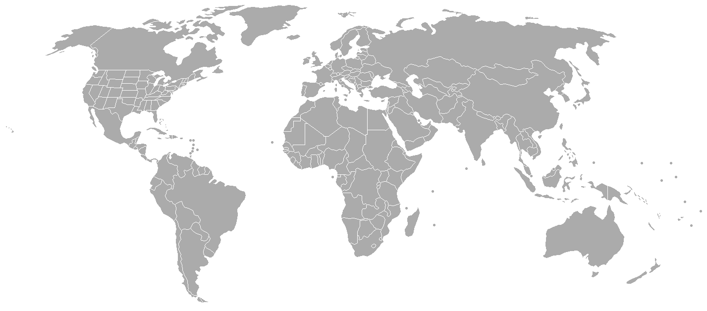

ECUADOR

KENYA

GHANA

UGANDA

COTE D’IVOIRE

BOLIVIA

HONDURAS

INDONESIA

THE SCOPE OF OUR WORK:

Since 1954, MAP has shipped over **4 billion** dollars worth of medicines around the world, impacting over **2 billion** people.

Since 1971, the MAP Fellows program has sent **1,951** medical students to **71** countries as an opportunity to complete requirements for medical school.

MAP played a key role in **eradicating Guinea Worm Disease** from Cote d’Ivoire along with the Carter Center and UNICEF Cote d’Ivoire.

Around **1,000** health promoters are trained each year in all eight countries where MAP has a country office.

Through the CUBE program in Bolivia, **855** victims of sexual abuse have received support and free social, medical, therapeutic, and juridical services, and **141** offenders have been convicted for their crimes.

There are currently **63** Total Health Villages in operation in 9 countries, impacting a population of over **85,000** people.



Bringing Health and Hope to a Hurting World through

Promotion Prevention Provision

Of Total Health Of disease & mitigation of disaster of essential medicines



MAP International | 4700 Glynco Parkway | Brunswick, GA 31525 | 1.800.255.8550

Global Programs & Fundraising office | 50 Hurt Plaza SE | Suite 400 | Atlanta, GA 30303 | 404.789.3970

**we are health and hope.eps**

WATER AND SANITATION

Indonesia, Honduras, Bolivia, Ecuador, Cote d’Ivoire, Ghana, Uganda, Kenya

Improved access to clean water and good sanitation make so much of a difference in the health of individuals and communities that water and sanitation projects have become an integral part of all MAP programs. Projects in water and sanitation include Community Led Total Sanitation initiatives, health promoter training, provision of water filters through a sweat equity program, repair and construction of latrines, wells, pumps, and bathing areas, and water system construction and repair. In 2010 and 2011, MAP distributed 1,149 water filters in 8 countries allowing over 10,000 people to have access to clean water every day. These filters cost only $65 each, but have a dramatic, long-term impact on families and communities. In many cases, the disease burden is reduced up to 75%. MAP Ecuador has demonstrated what it is like for a person living [without access to clean water](http://vimeo.com/32203871), and [the difference a filter makes](http://vimeo.com/32205464) for a daycare center in the linked videos.

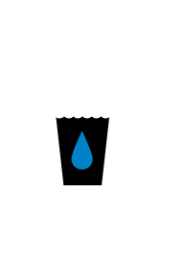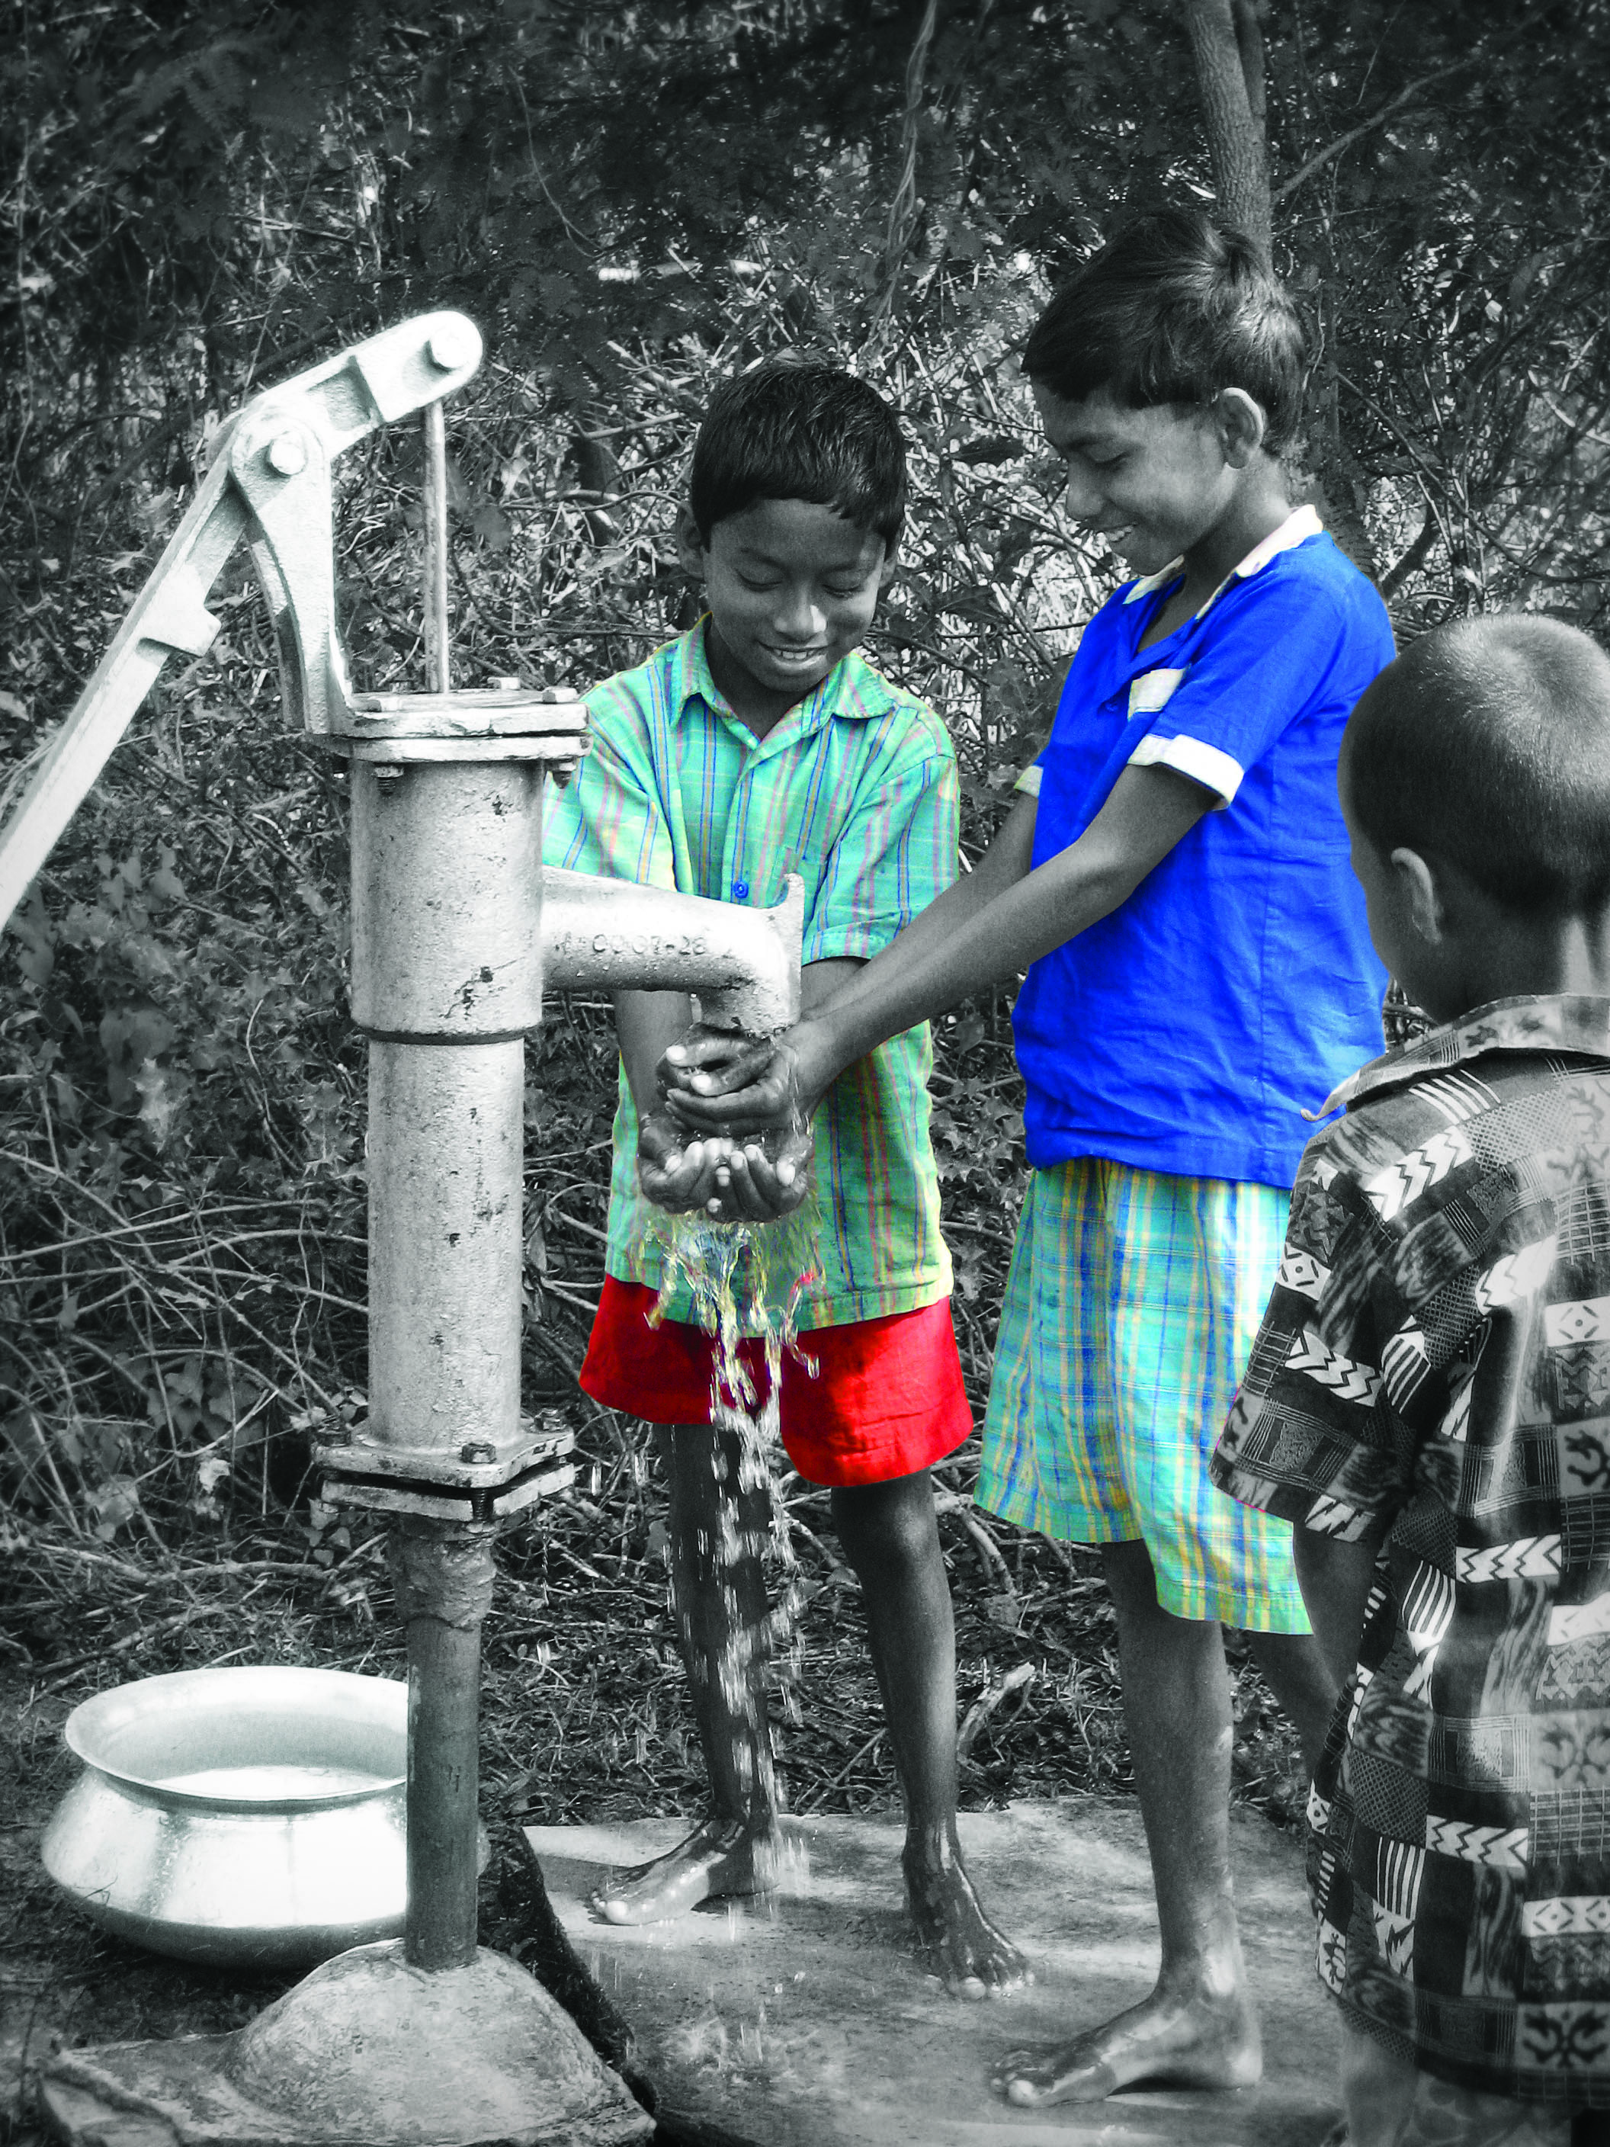

A Water Filter costs just **$65**

Bringing Health and Hope to a Hurting World through

Promotion

of Total Health

Prevention

of disease

Provision

of essential medicines

we are health and hope.eps

INTERNATIONAL HEALTH PROGRAMS

MAP has a long history delivering medicines to the places where they are most needed. With over 60 years of experience, MAP demonstrates significant expertise in supply chain management through the following programs.

**Long-Term Health Development |** MAP's Long Term Health Development (LTHD) program provides significant quantities of essential medicines to organizations with a long term medical presence in the field. MAP provides 20 ft. shipping container-sized shipments of medicine to our trusted partners, including World vision, Christian Aid Ministries and Operation Blessing, for use in programs, mission clinics and hospitals.

**Travel Pack Program |** The Travel Pack program is designed to provide medical mission teams with essential medicines for use in field programs and clinical settings. For a nominal handling fee, MAP will provide teams with a box that can be checked as baggage and is packed with thousands of dollars worth of essential medicines and supplies suited to short-term missions.

**Custom Orders |** The Custom Order Program offers individually-tailored formularies of medicines and supplies to meet specific field-driven needs from MAP’s extensive inventories of both donated and purchased medicines, giving the partner the ability to customize the list of FDA-approved and WHO-certified items sourced from MAP’s world-wide partner vendors.

**Relief Response |** MAP provides rapid response to both natural and man-made humanitarian emergencies in the U.S. and around the world through providing medicines, supplies, disaster assessment and monitoring and relief services to those in need. We do this both unilaterally and in conjunction with international-class partners such as International Medical Corps, International Relief Teams, and members of the Global Relief Alliance.

**GEMS |** GEMS (Global Essential Medicines and Supplies) provides low-cost purchased and donated generic medicines and supplies from the WHO Essential Drug List to aid organizations serving in the world's poorest communities. It accesses high-quality medicines and supplies from trusted manufacturers and wholesalers and delivers them to healthcare agencies and programs around the world. GEMS also offers consulting services in supply chain management, rational drug use, and monitoring and evaluation.

**Emerging Pandemic Threats |** MAP works as a contracted partner with John Snow, Inc and USAID as part of the ‘Deliver’ project to store and manage supplies and drugs for potential infectious disease outbreaks. Maintaining and managing this strategic U.S. Government inventory, EPT has distributed emergency drugs and supplies throughout Asia, Africa, and Latin America.

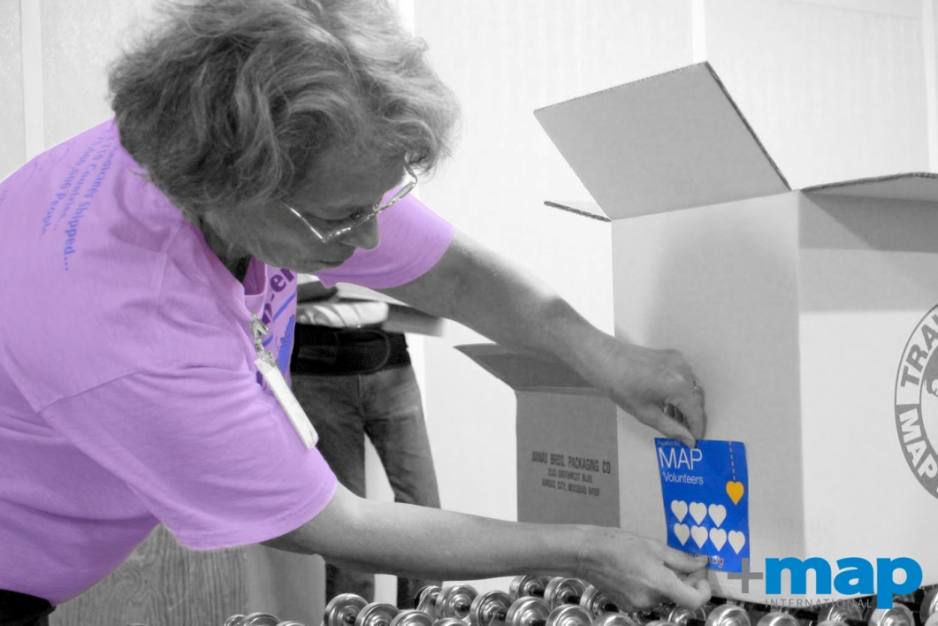

Bringing Health and Hope to a Hurting World through

Promotion

of Total Health

Prevention

of disease

Provision

of essential medicines





we are health and hope.eps