One Egg Program Report in Ninglang of Yunnan Province
The One Egg Program was started in Ninglang of Yuannan Province in 2010. By the end of last semester of 2015, the One Egg Program has been covering 15 elementary schools of Ninglang and ensured 1499 kids and teachers one egg a day. There are some pictures and stories of the children having eggs.
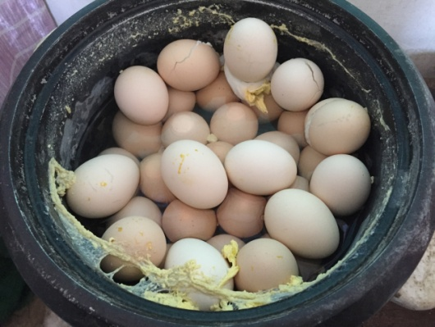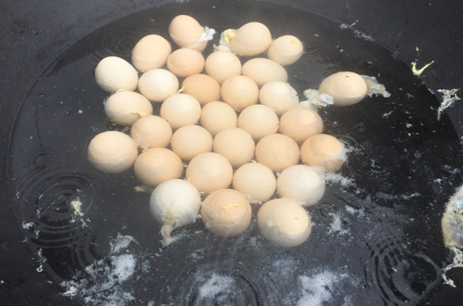
Eggs are prepared in a rice cooker or a large deep pot by a teacher every day. Teachers loved children more, so they persist at all times of the year.
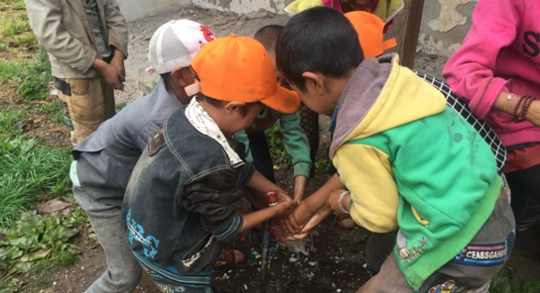
After the One Egg project is executed, washing before eating is everyone’s habit. Before, many children did exposed intestinal worms and had no other infection methods.

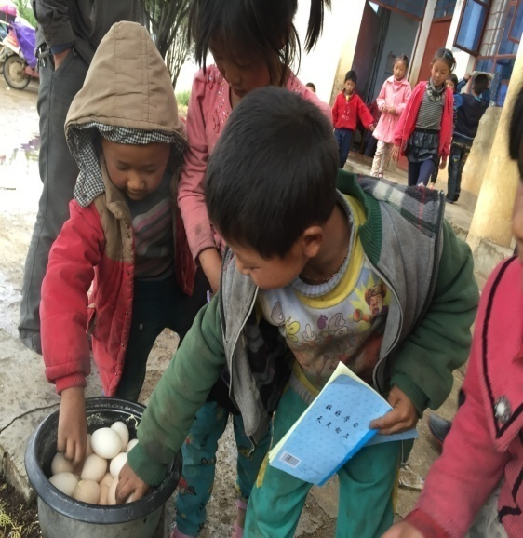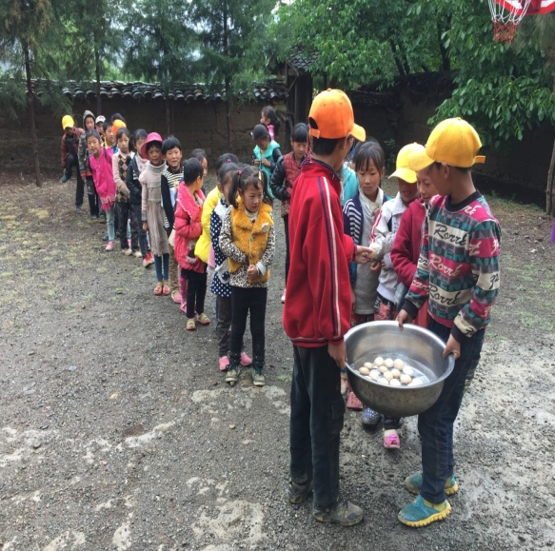
The children are queuing up for eggs, an egg each. They are non-residential, which means they have to spend more than one hour on daily travel to their lectures.
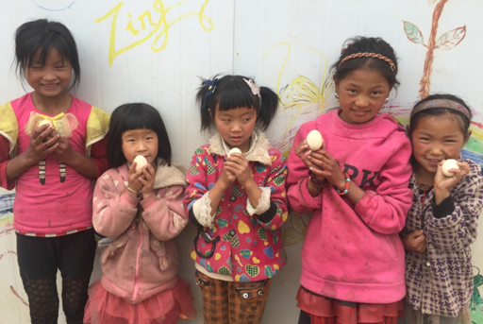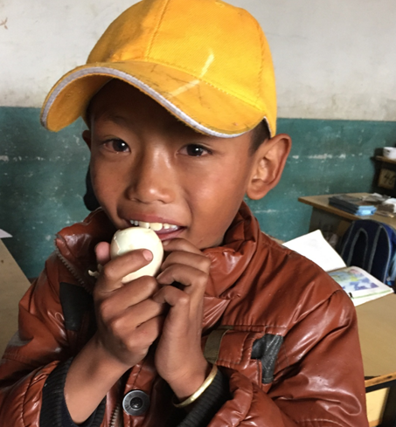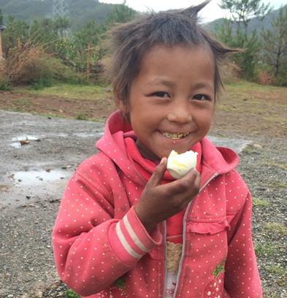
For most of the year, 80 percent of working-age population is absent. Village was lonely, leaving only old people and children, children smile pure bright, is the village only passion
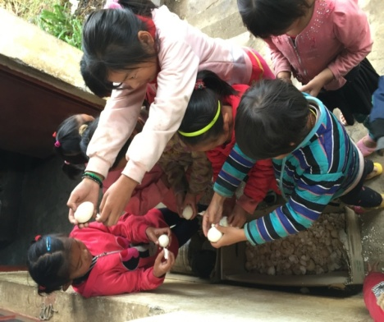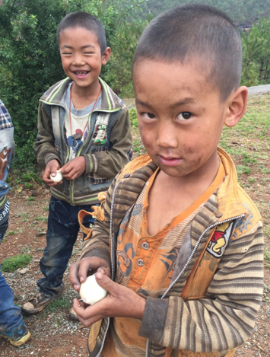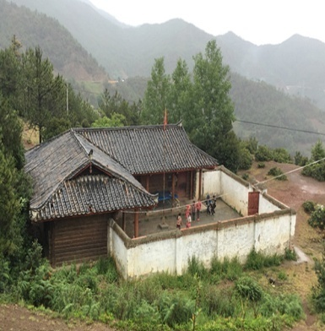
What we are doing and what we will be doing is not just donating supplies but love.
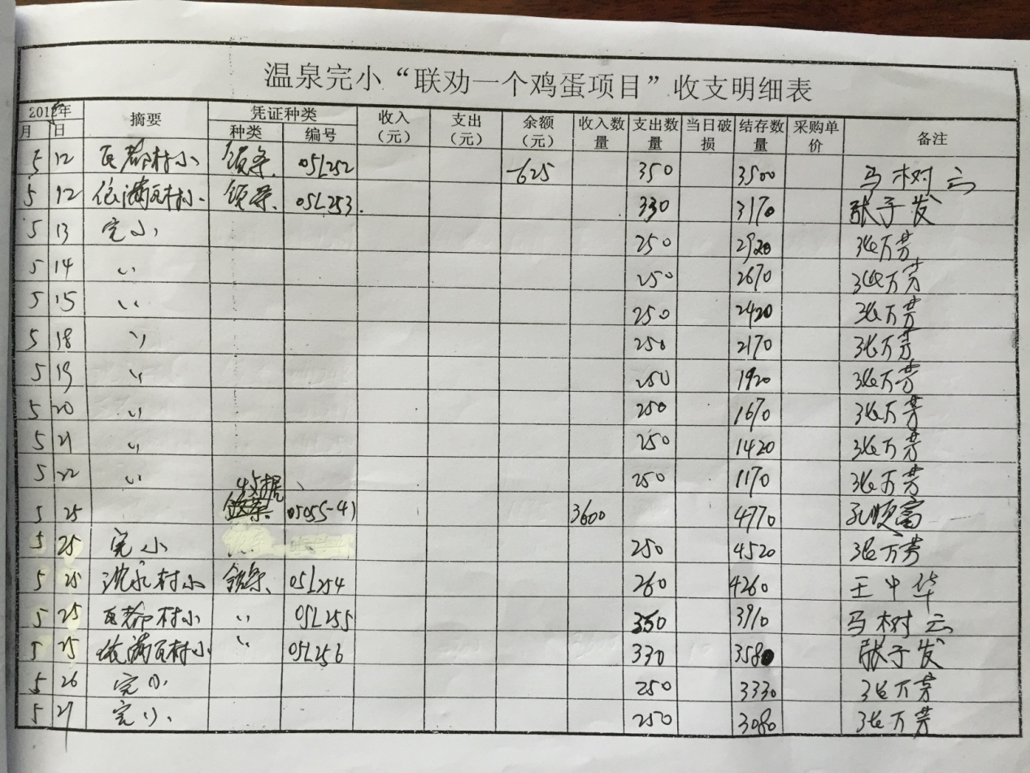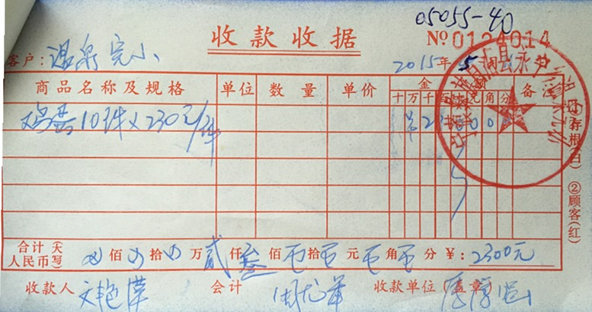
Many children benefited from your countless generosities, dear donors, teachers and project implementing agency.

