One Egg Program: Ongoing Progress
The One Egg Program: One egg for one kid per day, improving health situation in poverty areas in China. This program is initiated and executed by SUF and 9 local NGOS. By supporting children in poor areas an egg's per day, “One egg program” have enhanced their physical and mental development status during the last 3 years, and have ameliorate their diet structure, especially low nutrient intake, to ensure their physical and mental balanced development.
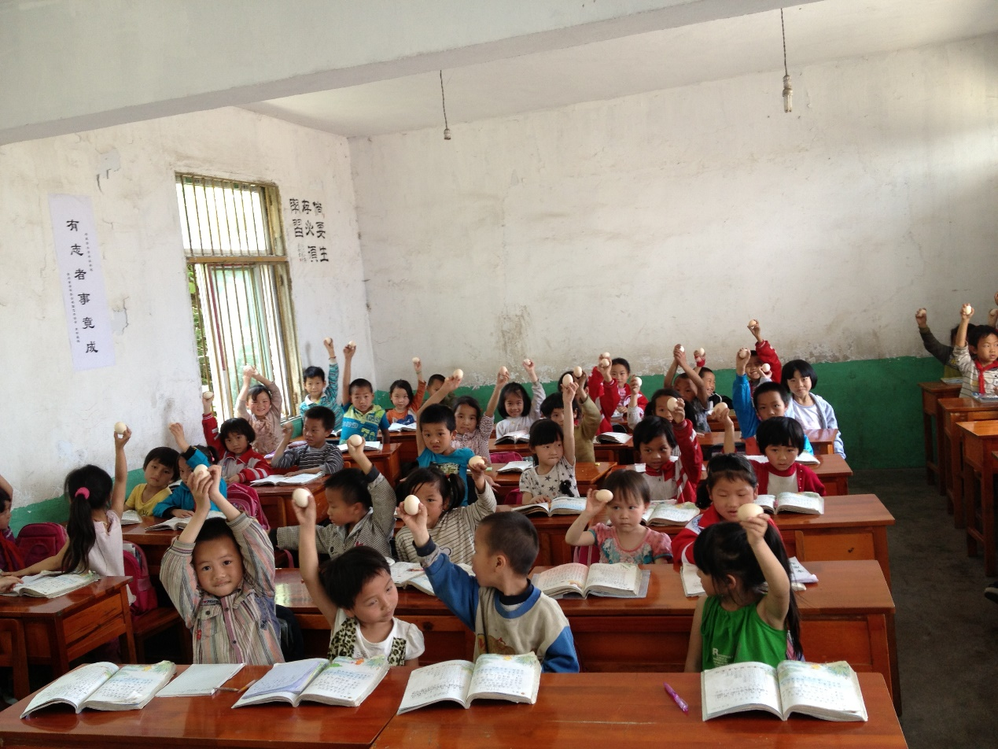

Recently, program volunteer in Liangshan state, Sichuan province visited Chenguang primary school, Lizi village, one of our 66 beneficiary schools.
Let us take a look at the latest progress through the photos and introductions:

1 Brief itinerary:
visited Chenguang school early in the morning, supervised the one egg project implementation, interviewed the principal and the executive teachers; played with the kids, returned in the late afternoon.

2 Boiled Egg Process:
Currently, school provides hard boiled egg by using high-power electric cooker.

3 Egg transport:
Egg purchase is regularly done by the assigned school teachers and eggs are transported to school directly.

4 Related Photos:

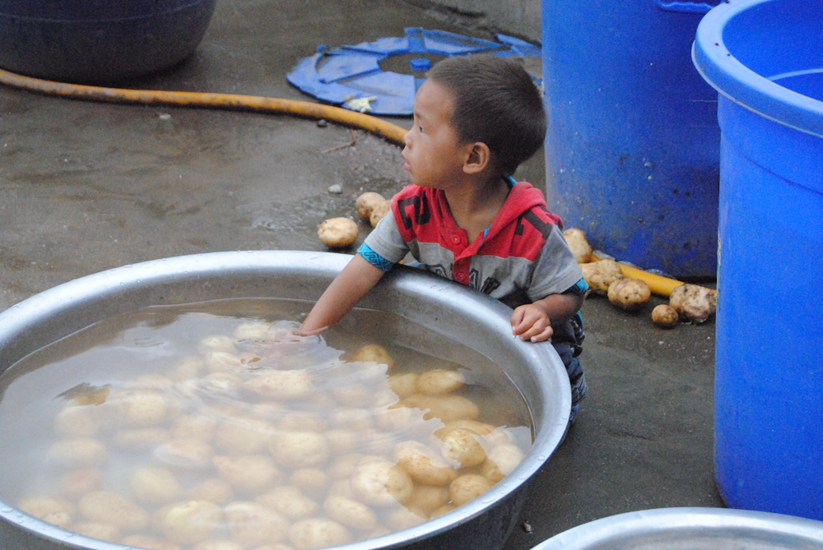
Figure 1: Small children playing potatoes- potatoes are the main food there
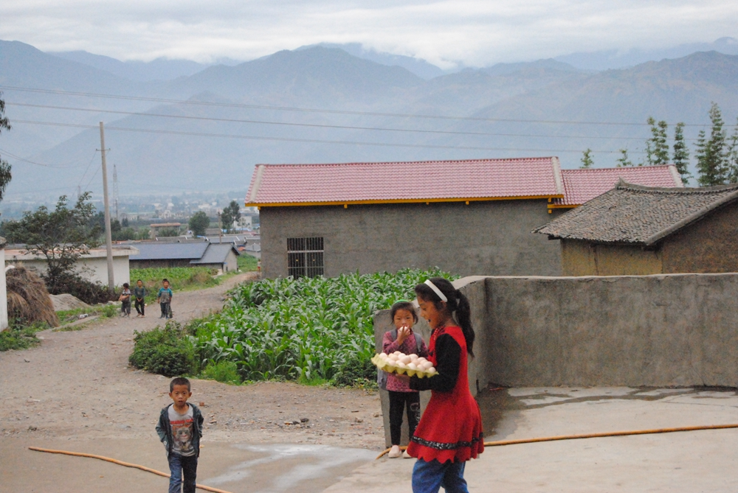
Figure 2: Students assume as “egg volunteers”. After boiled the egg, they help transport eggs to the classroom.
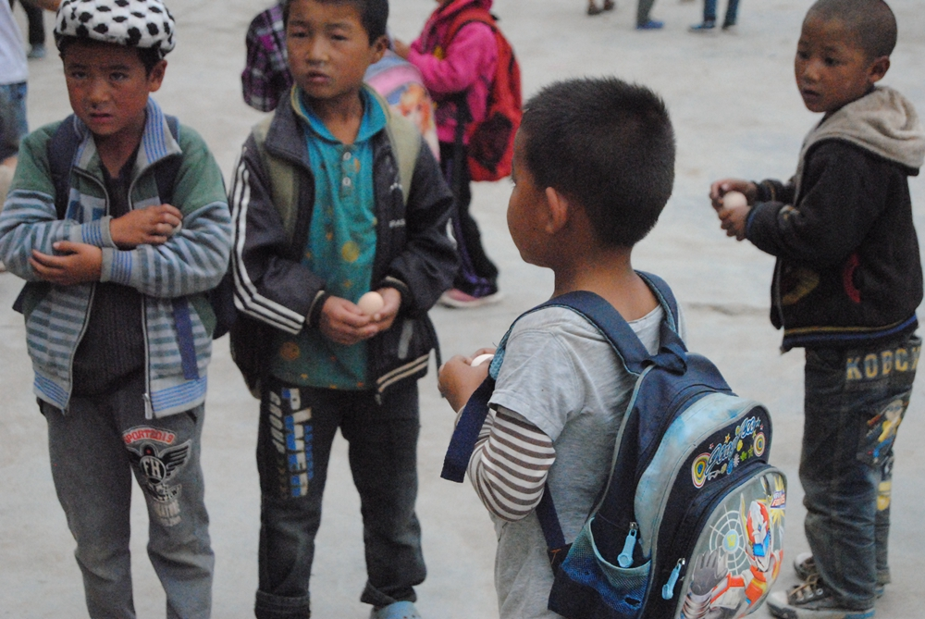
Figure 3: Several school boys got hot boiled eggs
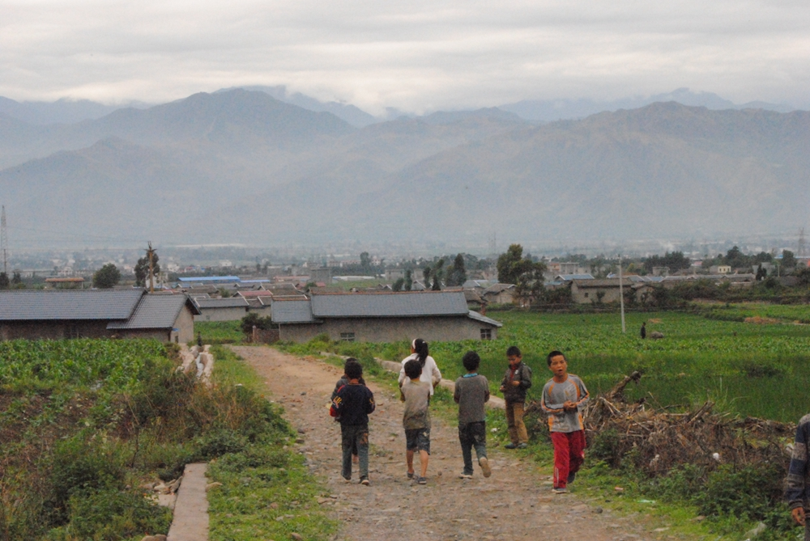
Figure 4: Field behind the school.
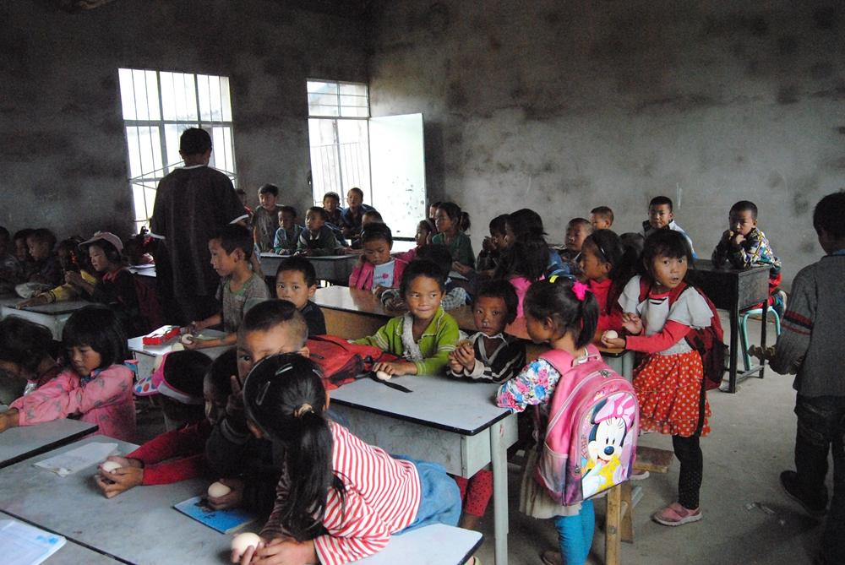
Figure 5: Preschool children eat eggs during the class break.
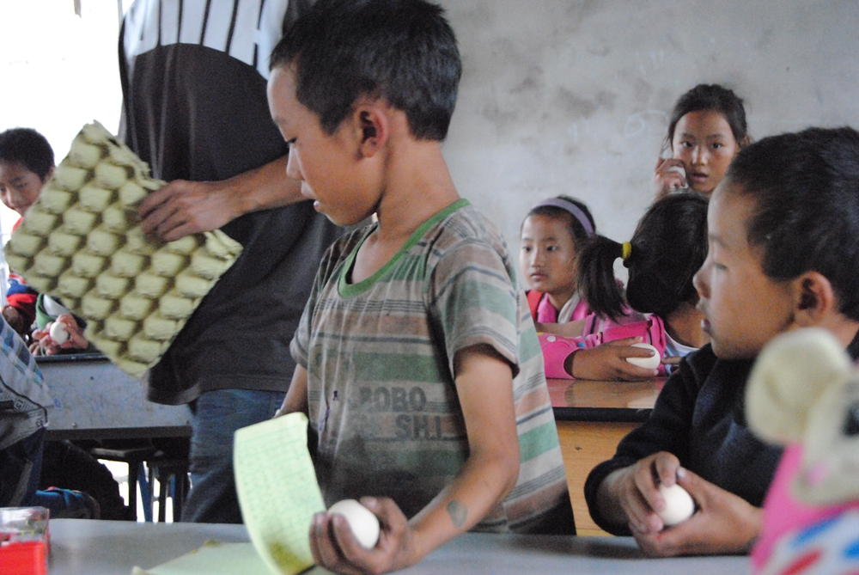
Figure 6: Kids in their first grade
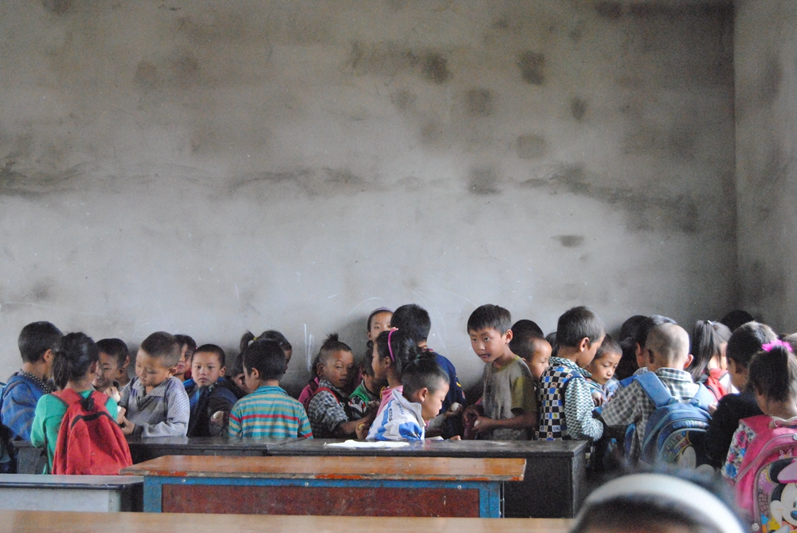
Figure 7: Kids collectively throw away the eggs shells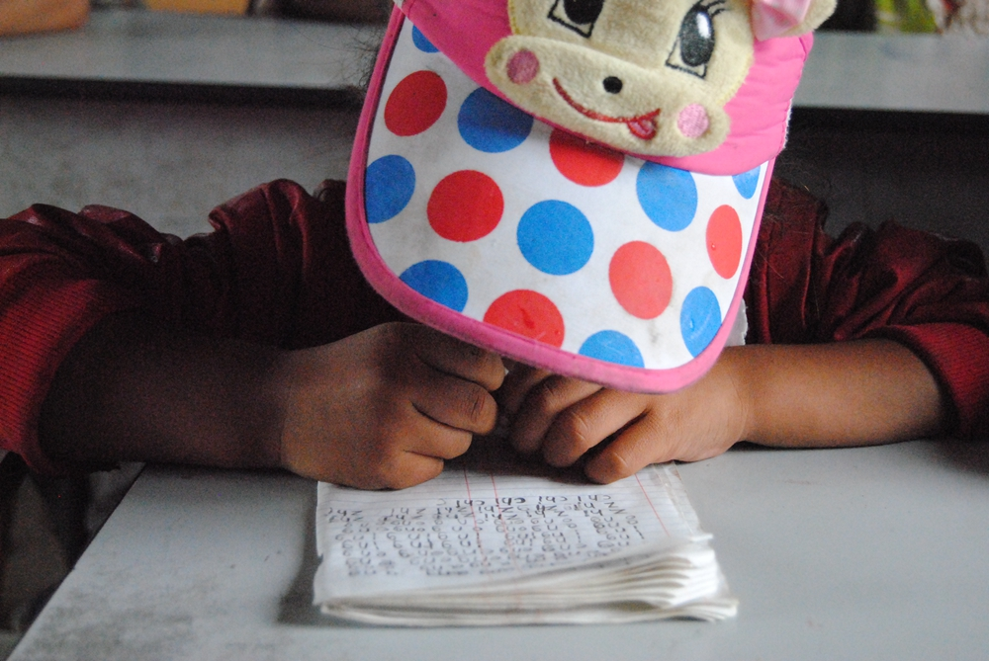
Figure 8: After the egg break, she starts to do the homework~
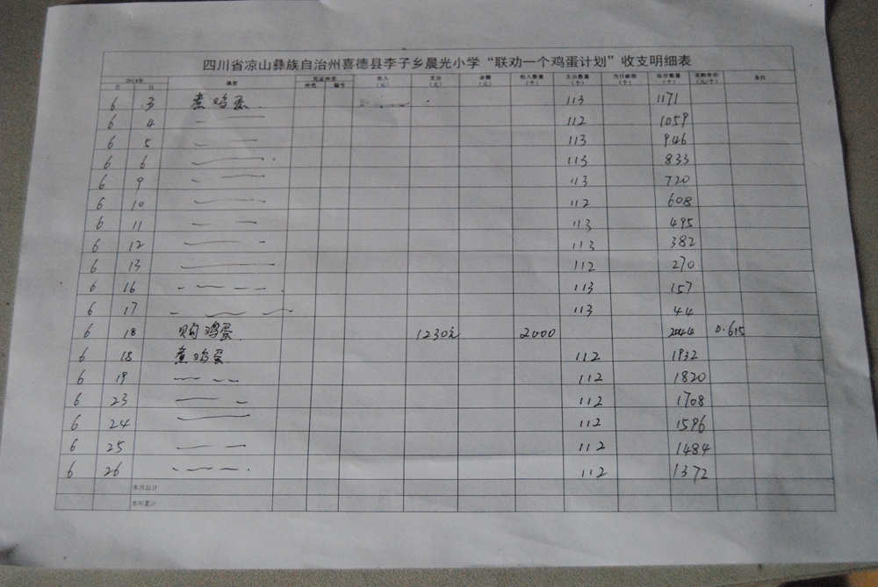
Figure 9: The school keeps all receipts and details of egg purchase.

