
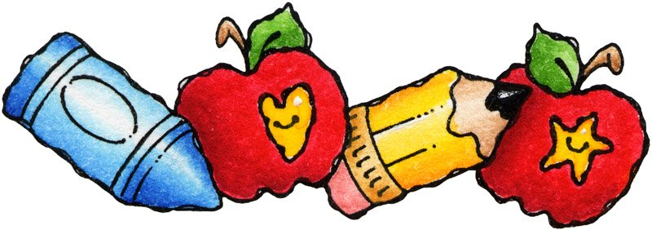


At Regazo de Paz we supply the children all their basic needs. We provide all the basics as; shelter, clothes, shoes, medical attention, a balanced diet, personal hygiene, 24 hours supervision by capable resources, after school tutoring and other services. We also work to restore their character and for the healthy personal development of these children in all aspects. Above all, they receive here what was not provided at their original homes, Love. Beyond services to ur child population, another part of our work consists of providing conferences and educational presentations related to Child Abuse Prevention at schools, public and private agencies and community organizations.
In 1989 God put in Myrna Velez’s heart a great concern for the children of our country, specially for those suffering abuse and negligence at the hand of their parents or legal tutors. This concern led her to a Shelter Home in the city of Quebradillas to work and acquire experience. There her burden grew as she saw the high incidence of child abuse in our small island, and she decided to go out and do something about it.
How Does It Start
In 1990 a Board of Directors is organized and in that same year Regazo de Paz is incorporated as a Non Profit Organization in Puerto Rico, register number 21,016 of December 1990. In 1992, after several fund raising activities, a total of $20,000 was collected and used as down payment for the property actually being occupied. After furnishing the property, in April 1995 the facilities were inaugurated and immediately we began to shelter and render services to children from all the island, specially from the Eastern part of Puerto Rico.
Where Is It Located
Hogar de Niños Regazo de Paz, is located at Bo. Caimital Alto interior, Zambrana Sector, Road #2 Km. 120.2 in Aguadilla, Puerto Rico.
What Services Are Provided
For our operations, Regazo de Paz, relies on economic support from government programs, public and private corporations, community organizations, churches and civic groups, but above all from donations by families and citizens which have evidenced the work being done, and have decided to be a part in the struggle for these children future.
How Are Operations Sustained
Donations to Regazo de Paz are carefully administered by the Executive Director and The Board of Directors according to the Home’s needs. Monthly regular expenses include among others; payroll expenses, food, clothes, medical supplies, transportation, utilities, maintenance and others.
Besides the support of various institutions, Regazo de Paz has monthly donations programs for those who wish to become part of the family and help in the re-shaping of these children’s future.
► We have the 1500 Club, made up of those who have committed $1 to $19 monthly. These are our “Uncles”.
► We also have the “Godfathers” which are those with a $20 or more monthly commitment.
Your help is very important, because we all together can make a difference in the life of a child.
How Can I Help
Hogar de Niños Regazo de Paz also needs Volunteers, people who would like to give some of their time to help in the job of restoring hope to these small lives, or that witch to contribute professional services, their talents or skills to the struggle against Child Abuse.

How Are Donations Distributed

How Does it Start

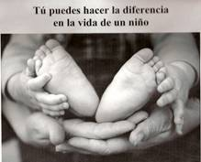
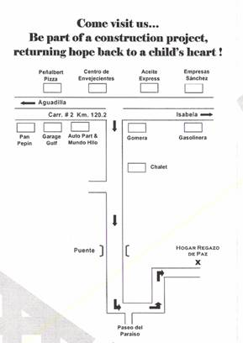

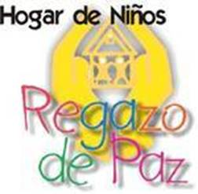
United for a purpose...
The Institution's vision is to provide children; batered, abused, abandoned or victims of domestic violence; with a home where their basic needs are met, offering them to proper environment for a healthy development of their character.
The Board of Directors of Hogar de Niños Regazo de Paz has established the following as their Main Objectives:
• Accept and shelter children from anywhere in the island, orphans, abandoned, or victims of abuse or domestic violence, without considering sex, race, color, origin, age, physical conditions and/or religion. The maximum capacity will be fifteen (15) children.
• Provide a home environment capable of responding to the urgent human priorities of these children, assuring them a secure place where all their basic needs are fully satisfied.
• Facilitate the restoration of their individual, familily and social values through good example, family coexistence and the participation of these children in safe and healthy community activities.
• Increase public awareness and knowledge through presentations, conferences and orientation sessions in different community forums, covering topics related to children and their well being.

Vision & Objectives
Phone/Fax: 787-882-3072
Email: hogardeninosregazodepaz@yahoo.com
www.regazodepaz.org
To STOP Child Abuse!
Help us to break
The Child Abuse Cycle!
It is our struggle to eradicate this terrible evil that puts chains and scars on our
children that last a lifetime..
PO Box 4721— Aguadilla, PR 00605
Phone/Fax: 787-882-3072
Phone/Fax: 787-882-3072
Email: hogardeninosregazodepaz@yahoo.com
www.regazodepaz.org
Physical Address:
Road #2 Km. 120.2 Int. Zambrana Sector,
Bo. Caimital Alto, Aguadilla PR
Office Hours:
Monday to Friday 8:30 am—4:00 pm
Visiting Hours:
Call to make and appointment
Saturdays 2:00 pm—4:00 pm
Regazo de Paz Children’s Home
An Institution committed to the well being of the less fortunate children, providing services mainly to the Northwestern community of the island of Puerto Rico.

