PROJECT PROPOSAL
OF
SANITARY TOILET FACILITIES FOR POOR DISABLED


Submitting by:

CHAITANYA EDUCATIONAL
AND
RURAL DEVELOPMENT SOCIETY

Administrative Office:
H.No: 3-68/1,
5th Lane, Pandaripuram,
Chilakaluripet – 522616,
Guntur District,
Andhra Pradesh,
INDIA

THE ORGANISATION

Name of the organisation : Chaitanya Educational and Rural Development Society

Name and details of the contact person : N.Srinivasa Rao, Executive Secretary

Address : H.No: 3-68/1, 5th lane, Pandaripuram, Chilakaluripet, Guntur District, Andhra Pardesh

Country/City/ Postal Code : India, Chilakaluripet - 522616

Tel : +91 8647 252333

E-mail : cerdsns@gmail.com

Website: www.cerds-india.org

Date the organisation was created : 05.11.1996

THE PROJECT

Need of sanitary facilities for disabled:

Unfortunately, more than 8% of the population in India are disabled eigther by birth or accident or ill health. Among them 6% live in rural India. There are several causes effecting disabilities by malnutrition, lack of immunisation practices, early marriges and marriages within the kins etc. Most of these disabled persons are very poor and could not afford even to meet their daily living standards. In these circumantances, these disbaled persons are not taken proper care by their family members. Because of disability, these volunerable people have to face much hardships to depend up on others for their living needs. Especially, these people suffer lot with lack of sanitary facilities in their living places. They have to depend on others for attending their nature calls to take them to out of the village, which has become more burden to the other family members. Some times, these people get releaved their natural calls by the side of their house or within the house premises, which is making nuisance for the neighbours and other family members. Even, the teenage disabled are also using open places for their defecation, which is objectionable and not dignifible among villagers. Hence, it is a great necessity to provide sanitary facilities for these poor disabled to protect dignity and honour, which is the responibility of the civil socity.

Project location :

The project covers 19 villages in Prakasam District and 6 villages in Guntir District in Andhra pradesh State.

Field of involvement :

Sanitation

Beneficiaries of the project :

The target 100 disabled people are economically very poor and belong to dipressed castes i.e., Scheduled Tribes, Scheduled Castes, Fisher Folks and Weaker Sections. All these are suffering from malnutrition and living with poor civic amenties.

Main objectives:

- To provide accessbility of sanitary toilet facilities to disabled
- To protect human dignity and honour and rights of disabled
- To sensitise people on the affects of malnutrition, lack of immunisation, early marriages and marriages within the kins
- To make disabled persons not to depend up on others for their natural calls

Descriptive summary of activities to reach objectives :

- Identify disabled persons in the villages
- Contact disabled and their family members and sensitise them the need of sanitary facilities
- Ensure participation of all stakeholdes in the project
- Raise contributions from families of disabled persons and other civil societies
- Installation sanitary toilets suited to disabled
- Monitor utilisation of sanitary toilets properly

Photograph of the completed toilet for sample view:

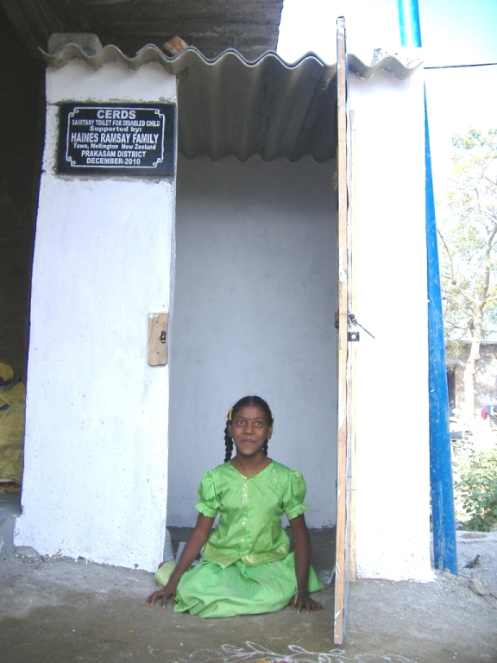

Required support (In USD) :

 | TOTAL
Human resources  - Communtiy Organisors – 2 Nos @ $100 per each per month x 12 months | 2400
Cost of activities  - Sensitisation programmes – 25 camps @ $200  - Cost of construction of sanitary toilets – 100 Nos @ $222 | 5000  22200
Total | 29600

Place: Chilakaluripet

Date: 02.11.2012

Submitted by:

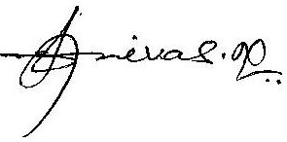
(N.SRINIVASA RAO)
EXECUTIVE SECRETARY

