GLOBAL GIVING
NOVEMBER 2012-13

NOWHERE TO HOME
INTRODUCTION
CHILDLINE 1098 is a national, 24x7, emergency phone outreach service for children in distress. Present in 252 cities and having responded to 21 million calls since its inception in 1996, it is the only helpline service offering a comprehensive package of child protection services to children in India. Presently CHILDLINE receives about 20,000 calls daily from children as well as concerned adults.
THE SERVICE
Once a call is received on 1098, CHILDLINE swings into intervention operations with the assistance of nearly 520 local voluntary organizations partnering with CHILDLINE across the country. Our mandate is to reach a child within 60 minutes of receiving a call and to ensure that the issues faced by the child are addressed. CHILDLINE in this process also catalyses every entity that is directly or indirectly commissioned with protecting the rights of a child. With the expansion of the service to all the districts of India, CHILDLINE shall be accessible to all children in need of care and protection.
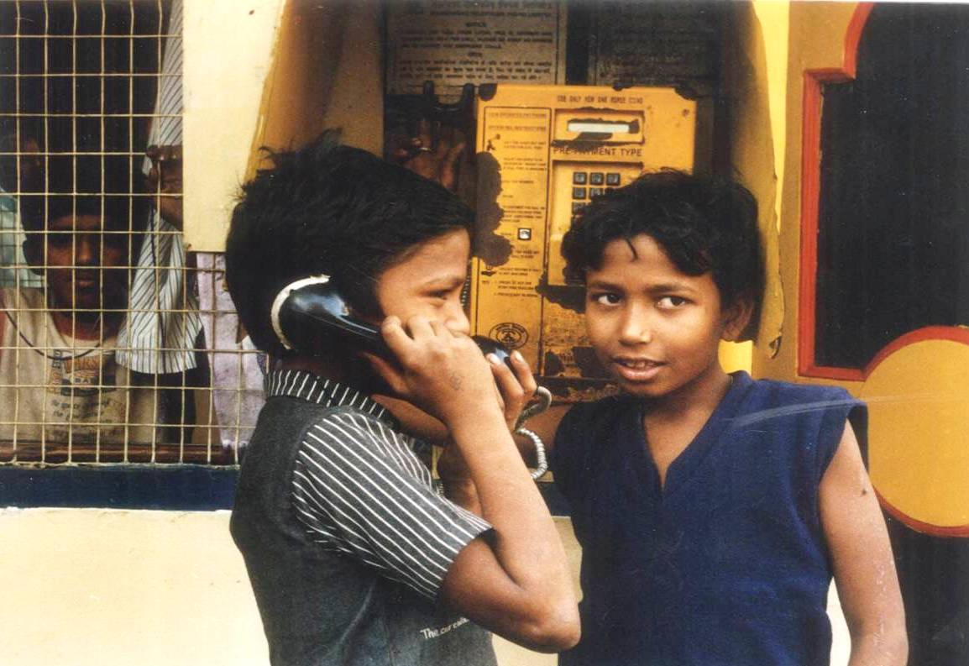
Children normally call 1098 for shelter, medical help, rescue, restoration, protection from abuse, education, and even guidance. It can also be towards support for a mentally or physically challenged child or children in institutions, children whose families are in crises, children affected by disaster, those in exploitative situations, missing children and so on. After the emergency needs of the child are addressed, CHILDLINE ensures that the child is integrated to systems providing for their rehab and development.
THE PROJECT
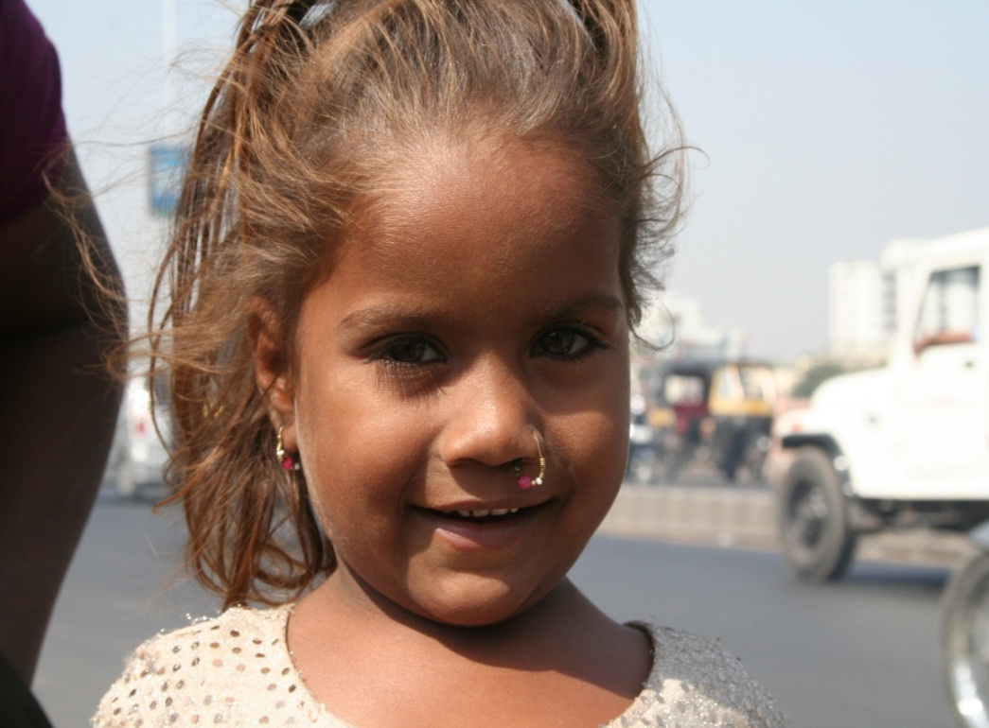
Normally about 15 per cent of the calls received from children are for shelter and accommodation. We, therefore, propose to support about 100 shelters across India, in the first phase, in order to improve the conditions in these homes, upgrade their facilities, and provide for educational value add programs. Childline accommodated about 10,000 children in various homes run by local voluntary organisations across the country during 2011-12. We would like to ensure that children find the joys of hearth and home at these shelters, rediscover their lost childhood, find supportive guardians and friends, and be able to rebuild their lives and blossom as individuals.
For more information please visit us on : http://www.childlineindia.org.in

____________________

