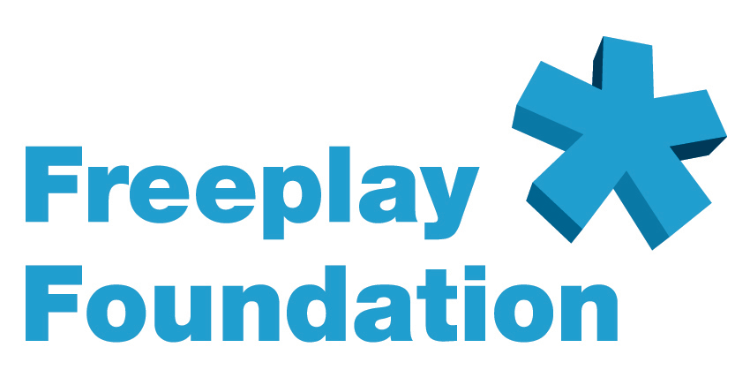

In Touch for China

A radio initiative of the Freeplay Foundation, in partnership with Beijing Hongdandan Center, Beijing People’s Radio and the BBC World Service Trust

The Freeplay Foundation seeks project funding of $35,750 for In Touch for China, a radio communications initiative designed to provide essential information and education to visually impaired people in China. Its primary goal is to empower blind listeners who are socially, economically and geographically isolated, by providing sustained access through specially adapted self-powered radios, to programming that can connect them to each other, to their communities and to the world.

A radio program for the blind and partially sighted was piloted successfully in Beijing from mid-2004. From September 2006, training of in-country journalists will begin. From October, thanks to UK Lottery funding, full broadcasting of the BBC’s In Touch for China radio program will begin. In 2007, a mobile clinic will provide advice to disabled people especially in rural areas and radios shows about eye health and blindness prevention will begin.

The Freeplay Foundation, in partnership with the Beijing Hongdandan Center, BBC World Service Trust (BBC WST) and Beijing People’s Radio, seeks - by extending the reach of In Touch for China radio programming to the most vulnerable among China’s rural blind - to leverage the project’s early success.

Sustained radio access via the provision of Lifeline radios to listeners to the In Touch for China program will connect and support blind people in their rural communities and open ‘windows of hope and change’ for up to 100,000 of China’s most seriously marginalized people.

The Need

The gap between rich and poor in China is large and increasing. Alongside dazzling urban prosperity, millions in the countryside remain impoverished. This is especially true of the blind and disabled, most of who live unseen in rural areas, where they routinely suffer economic deprivation and social exclusion.

China has the largest disabled population in the world - an estimated 60 million - with limited access to education, services and employment opportunities. Long-held prejudice and discrimination are widespread. Ten million blind people are further disadvantaged by lack of access to all visual information.

Radio programs open the door to a world of information, advice and community connection for blind and disabled people throughout China’s vast rural tracts. Yet unreliable electricity supplies combined with the short lives and high replacement costs of radio batteries remain major barriers to regular listening access for most blind people in rural areas.

The Project: Radio Programming and Access

Radio Programming

Until recently, no formal radio broadcasts in China offered practical information and support to met the daily needs and wider concerns of the nation’s blind and visually impaired. From July 2004, Beijing Hongdandan Center and Beijing People’s Radio addressed this serious gap, by means of an innovative pilot collaboration with the BBC World Service Trust.

Drawing on the BBC’s international experience with a model used elsewhere around the world for more than 40 years, the Hongdandan Center produced an exciting program called In Touch for China. Transmitted in Mandarin via Beijing People’s Radio, it featured news, views and information of particular interest and concern to the blind and partially sighted. Listeners to the new magazine program learn about educational opportunities, legal rights, mobility solutions, health issues such as blindness prevention, and how to solve daily living problems.

In Touch for China provides an informative and entertaining forum for the visually impaired to share experiences. Views of other disabled people and information about disability in other countries inform both the visually impaired and a much broader listening community. As in other countries, the program has begun to challenge entrenched stereotypes and inaccurate perceptions of blind and disabled groups across the wider community.

Still in its infancy, and having operated significantly through volunteer support during its first years, In Touch for China will shortly be broadcast three times weekly, free of charge, on Beijing People’s Radio. Inner Mongolia Radio, Tianjin People’s Radio, Shandong People’s Radio and Xinjiang People’s Radio have expressed interest in transmitting the program in their own regions.

As the In Touch for China pilot project expands in 2006, thanks to funding from the UK Big Lottery Fund, support from the BBC World Service Trust is enabling the Beijing Hongdandan Center to develop an independent training and production base, staffed by a mix of visually impaired and sighted people. Blind journalists are being selected from around the country to train from September2006. Once trained, these journalists will develop and extend the magazine program regionally throughout Chinese radio. Program-makers will benefit from access to world-class professional training and the development of a skill base that can open a window to employment opportunities. An accessible Internet website and on-line letters page will be established as an extension of the project and mobile clinics will provide vital additional advice and support to blind people in rural areas.

Program Access

In Touch for China radio broadcasts can provide critical information and education to empower their listeners. Yet to fully realize the project’s goals, regular transmissions must reach the project’s target audience. Self-powered Freeplay Lifeline radios will leverage initial pilot success by connecting many thousands of those currently without reliable radio access, who need In Touch for China the most yet can currently afford it the least.

In 2007 a Mobile Advice Clinic (MAC) will provide grass-roots advice and assistance to visually impaired people in the Chinese countryside. The MAC, comprising disability experts, medical specialists and lawyers visits villages in poor and remote regions of North China, assisting blind people and their families to access health and educational services and make them aware of their legal and civil rights. With funding achieved for this self-powered radio project it is through the MAC that 500 Freeplay Lifeline self-powered radios will be distributed, listening groups established and training provided to selected blind ‘radio guardians’ within the rural districts.

Empirical evidence from other Freeplay Foundation radio listening group projects shows that, conservatively, one Lifeline radio can open regular radio access to at least 20 listeners and often more. The Freeplay Foundation’s 500 Lifeline radio pilot project can reasonably be expected to transform daily life for up to 100,000 Chinese people. The radios will enable visually impaired radio guardians, their listening groups and other family members to receive many types of news, current affairs and advice programs. They will also, importantly, act as a focal point for community connection.

Sustained radio access places hitherto disenfranchised people on the vital first rung of a ladder to self-empowerment. Success in the pilot radio distribution and training project can serve as a vital springboard for scaled up radio access, both within the Beijing region and to other regions throughout China.

Project Monitoring and Evaluation
Freeplay Foundation radio projects are submitted to different types of evaluation, according to the specific requirements of project donors, as well as the methods and techniques adopted by partner organizations. In Touch for China will be monitored by the Foundation’s own project management team, in terms of delivery against specified objectives of Lifeline radio product quality, listening group effectiveness, timeliness and budget.

Two field visits are envisaged during the two-year pilot project life. The second evaluation visit will include an assessment of project delivery against previously agreed success indicators and field interviews with radio beneficiaries and listening groups, using ‘significant change’ methodology.

Several independent evaluations of radio program effectiveness will take place during the project lifecycle, conducted by consultants from the BBC, Royal National Institute for the Blind and the World Blind Union. All participants in the September 2006 journalism training will asked to complete an evaluation of the following key areas: course content, training methods, impact and general levels of satisfaction.

###

Freeplay Foundation contacts in the USA:

Midi Berry, Senior Development Consultant: freeplayfoundation@mac.com

Michelle Riley, Senior Consultant: riley.freeplayfdn@gmail.com

PLEASE SCROLL DOWN FOR MORE INFORMATION ABOUT THE FREEPLAY FOUNDATION, TOM HANKS, AND THE LIFELINE RADIO:

EXECUTIVE SUMMARY:

OVERVIEW OF THE FREEPLAY FOUNDATION

AND THE LIFELINE RADIO

Description of the Organization

The Freeplay Foundation mission is to help vulnerable people transform their lives using sustainable, self-sufficient and environmentally friendly technologies.

With access to resources, people seize educational and economic opportunities to improve health, create jobs and advance quality of life. We are committed to act as stewards of the environment to make clean energy technologies available to those in need.

The non-profit Freeplay Foundation works mainly in Africa. By addressing the pressing needs of its women, orphans and vulnerable children, we aim to contribute to total community well being.

Since 1998, the Freeplay Foundation has been creating access to radio information and education for the most vulnerable populations via self-powered radios.

The Foundation is committed to promoting the importance of radio as a vital medium in the developing world. Through the use of self-powered Freeplay Lifeline radios, it also advocates the necessity of ensuring access to broadcasts and sustainability of programming, especially for the most vulnerable groups, women and children.

In communications projects, the Foundation can ensure that information is delivered the “last mile” to populations in the most inaccessible locations. It can serve as the final point in a seamless line of communication -- from satellite and internet-based information, through television and published information -- all the way to Lifeline self-powered radio access in the poorest, most remote villages and refugee camps. The Freeplay Foundation works in a dozen African countries and is on the cusp of becoming a major force within the humanitarian development world, because no one else can offer what Freeplay can. In a global communications campaign, the Foundation is the final step.

In developing countries, especially in areas with large, non-literate populations, radio is the primary means of communication. In sub-Saharan Africa, for example, it is estimated that there are up to 75 times more radios than televisions. However, in most of the developing world, electricity is non-existent and the high cost of batteries makes them unaffordable on an ongoing basis, especially to women and children. Millions of dollars are spent worldwide each year to produce excellent radio programming for development purposes, yet the poor may never hear it. They are unlikely to receive critical information that can help them prevent deadly diseases, improve hygiene, raise agricultural productivity, learn English and math through radio distance learning, or enjoy any educational instruction that could help lift them out of abject poverty and lower mortality rates. Lifeline radios can solve the problem of access for these audiences.

Established in 1998 in the UK by the Freeplay Energy Group as a separate entity, the Freeplay Foundation is a tax-exempt 501(c)(3) charitable organization in the USA, with its senior consultant working from Savannah, Georgia. Additionally, it enjoys Section 21 charitable status in South Africa and is a registered charity in the UK. The Foundation’s main office is in Cape Town. It also maintains an office in London and has consultants based in the USA in Los Angeles and Savannah, Georgia.
Description of the Work

The Foundation’s goal is to utilize radio to ensure that as much accurate information is disseminated to the widest possible population. To this end, the Foundation works with international and local NGOs in a structured distribution methodology of radios to rural communities. The Freeplay Foundation team includes experts that can survey and assess target populations’ radio information needs, work with local broadcasters to set up appropriate content and structure, assess and determine radio distribution criteria, implement radio distribution, form listening groups and focus groups, and monitor and evaluate the impact of the process. Radios are never “just given away.”

In addition, the Foundation has devised unique ideas for delivery and packaging, such as the creation of “health boxes.” The radio boxes can contain other health-related items and print materials to form a complete community package. For instance, supplies could include malaria nets, information booklets, rubber gloves and water purification tablets. Health messages that support a particular project can be printed on the boxes. For example, HIV/AIDS prevention messages are relevant to the entire world, while malaria treatment messages are relevant only to some countries.

The Foundation supports project partners through the sharing of best practices and experience. For example, the Foundation has experience in how to most effectively introduce radios into communities and address potential issues regarding community listening behavior. For many projects, a listening group format is adopted, whereby 10-20 people gather to listen and to discuss or debate a radio program. Freeplay radios are designed for group listening - they are large and robust with excellent speaker quality – easily accommodating up to 40 listeners.

The Foundation also creates project-specific cartoon instruction sheets showing how to use the radio correctly and how it is used in a community setting. The cartoonists are hired locally, wording on the cartoons is printed in vernacular or the national language, and the cartoons are pre-tested first. Oftentimes, the reverse sides of the instruction sheets are also used to augment the program’s key messages and to advertise the program’s station and broadcast time.

The Lifeline Radio

The Lifeline radio is the first radio ever produced solely for humanitarian use.
After extensive fieldwork during the first two years of the Foundation’s existence, the executive director determined a real need expressly for the humanitarian sector, especially children living on their own. The idea for the Lifeline was born.

In 2001, the Freeplay Foundation received the $50,000 education award, underwritten by NASDAQ, as the winner of the Tech Museum of Innovation Awards -- Technology Benefiting Humanity. The Foundation allocated the award money to seed the research and development of the Lifeline radio. All funding needed to bring the Lifeline radio to fruition, including tooling and testing, was received from donors in October 2002. The other donors included the Body Shop Foundation, Anglo American Corporation, the Vodafone Group Foundation, Vytek Chairman Leonard Fassler, and well-known technology entrepreneur Bradley Feld.

Exactly two years after the concept paper for the Lifeline was written, the new radio was launched in April 2003 in a Voice of America (VOA) sponsored project benefiting Burundian youth living in refugee camps in Tanzania. The United Nations High Commissioner for Refugees (UNHCR) was the implementing partner. VOA deemed the project to be so successful that they funded a major expansion of the initiative into the camps.

Already more than 2 million people throughout sub-Saharan Africa are benefiting from access to self-powered Lifeline radio and the Foundation is committed to increase this number manifold in years to come.

A few projects that include the Lifeline radio:
South Africa – Lifeline radios are integrated into the youth radio programme Soul Buddyz. The radios are used to augment Soul Buddyz listening clubs. Radios have been given in support of the Nelson Mandela Children’s Fund’s Goelama Project, which supports child heads of households in the Kwa-Zulu Natal province. Lifeline radios are included in the expansion of the radio version of Sesame Street, called Takalani Sesame, and are distributed to teachers in early childhood learning centers in rural areas. In 2005, Takalani Sesame won the prestigious Peabody Award. The Media Monitoring Project uses Lifeline radios to monitor the listening habits and preferences of child heads of households. UNICEF is the project’s primary funder.

Tanzania – Lifeline radios are used in six different projects in Tanzania, all funded by the Vodafone Group Foundation: The African Youth Alliance (AYA) radio program called Mambo Bomba; a major radio distance learning project called Mambo Elimu that offers a primary school education; a Ministry of Labor, Youth Development and Sport-sponsored youth sports and HIV/AIDS awareness campaign; a project that supports youth development through a variety of media, including radio; a Ministry of Health initiative where Lifeline radios will be placed in prenatal clinics where women gather; and a community radio station/telecenter near Lake Victoria where the radios are used for primary education and to teach children about various technologies.

Afghanistan – Lifeline radios have been distributed to female teachers in remote areas, enabling them access to teacher training programs. This groundbreaking project is coordinated by Media Support Solutions.

###

PLEASE SCROLL DOWN FOR INFORMATION ABOUT TOM HANKS AND THE LIFELINE RADIO

Sept. 29, 2003

Tom Hanks Assists World’s Poor
As Freeplay Foundation Ambassador

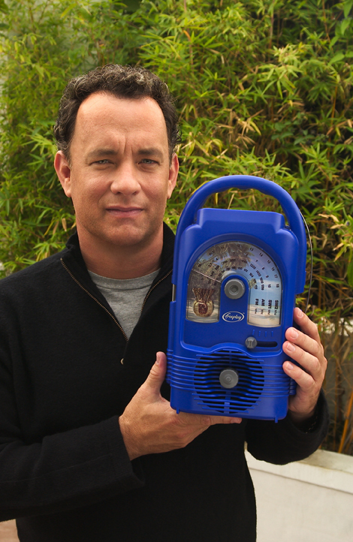

Cape Town, South Africa....The Freeplay Foundation today announced that two-time Academy Award® winner Tom Hanks has become their American ambassador. In this advocacy role, Mr. Hanks will help gain support for the Foundation in the U.S. and promote understanding of the Foundation’s work.
Using Lifeline radios, which do not require batteries or electricity, the Freeplay Foundation provides sustained access to information to the world’s poorest populations, especially children living on their own.

“The extraordinary technology of the Freeplay Foundation’s Lifeline radio can bring vital information to isolated people all over the world,” said Mr. Hanks. “For example, right now there are more than 13 million children orphaned by AIDS. Most can’t attend school and can’t afford batteries or electricity to power a radio. The Freeplay Foundation can hand these children a lifeline to the outside world by giving access to radio programs that teach them how to grow their small garden plots to feed themselves, take care of their chickens or goats, and prevent deadly diseases like malaria and AIDS.”

Freeplay Foundation Executive Director Kristine Pearson said, “We are deeply grateful that Mr. Hanks has chosen to serve as our American ambassador.
By lending his voice in support of the most vulnerable people, especially orphans and other children living on their own, Mr. Hanks will help bring them critical, even life-saving information and education.”

In developing countries, radio is the primary means of communication. The Lifeline radio plays non-stop using wind-up energy and solar power and is the first radio ever produced solely for humanitarian use. Using a structured methodology developed by the Freeplay Foundation, radios are distributed to youth, community health workers, village chiefs, listening groups, teachers, and informal classrooms in the developing world, primarily in Africa. Recipients are trained in how to most effectively listen to radio programming and transfer knowledge they gain to others in their community.

Mr. Hanks joins humanitarian Terry Waite, who serves as the Foundation’s European ambassador. Mr. Waite is well known in the U.S. as the special envoy to the Archbishop of Canterbury in the 1980s. While negotiating the release of U.S. hostages in Lebanon, Mr. Waite was himself taken hostage, serving most of his five years in captivity in solitary confinement.

The Freeplay Foundation works in more than a dozen African countries. It is a fund seeking, U.S.-registered 501 (c) (3) tax-exempt charity. It works with governments, international agencies such as the United Nations Development Program, non-governmental organizations (NGOs), and local communities. With offices in Cape Town, South Africa and London, the Foundation also enjoys charitable status in South Africa and the UK. Learn more at www.freeplayfoundation.org.

###.

PLEASE SCROLL DOWN FOR INFORMATION ON THE LIFELINE RADIO:

Key Design Features and Benefits of the Lifeline Radio

Below describes the features and benefits of the Lifeline Radio. Orphaned children in South Africa, Rwanda and Kenya were consulted throughout the design and development process. The size and shape of the Lifeline Radio is a result of focus group research. The more it is wound, the longer it will play.

Children can grip the handle without difficulty. While the Lifeline Radio is large, it is lighter than other Freeplay radios used in development projects.

The antenna is an ordinary piece of wire, which can be replaced with any piece of wire. It can be taken off and put back on at will as antennas break easily.

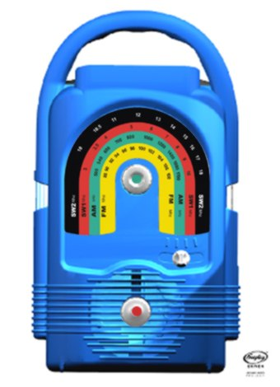

The solar panel is housed in a detachable waterproof casing on a three-meter lead with magnetized clips on top to hold it securely in place. The Lifeline Radio operates in the harshest of conditions in extreme temperatures, rain, moisture, dust, sand and humidity.

The rainbow shaped dial scale has large print making it easy to read even for the visually impaired. As AM/FM/SW is difficult to understand for some, each band is color-coded.

The winding handle (on back) can be turned in either direction to charge the radio. Earlier Freeplay models could only be wound clockwise. Fully charged, the Lifeline Radio can play for many hours.
The dial scale and Lifeline Radio can be custom produced in any combinations of colors, which cannot reflect political parties.

Four-band coverage, AM/FM/SW1/SW2 ensures access to many channels and perspectives. For example, in Zimbabwe where programming is government controlled, SW broadcasts can be received.
The sound quality is excellent enabling at least 40 people to hear it clearly.

Each knob is purposely a different shape.

