“Stand by Together” Forum Report

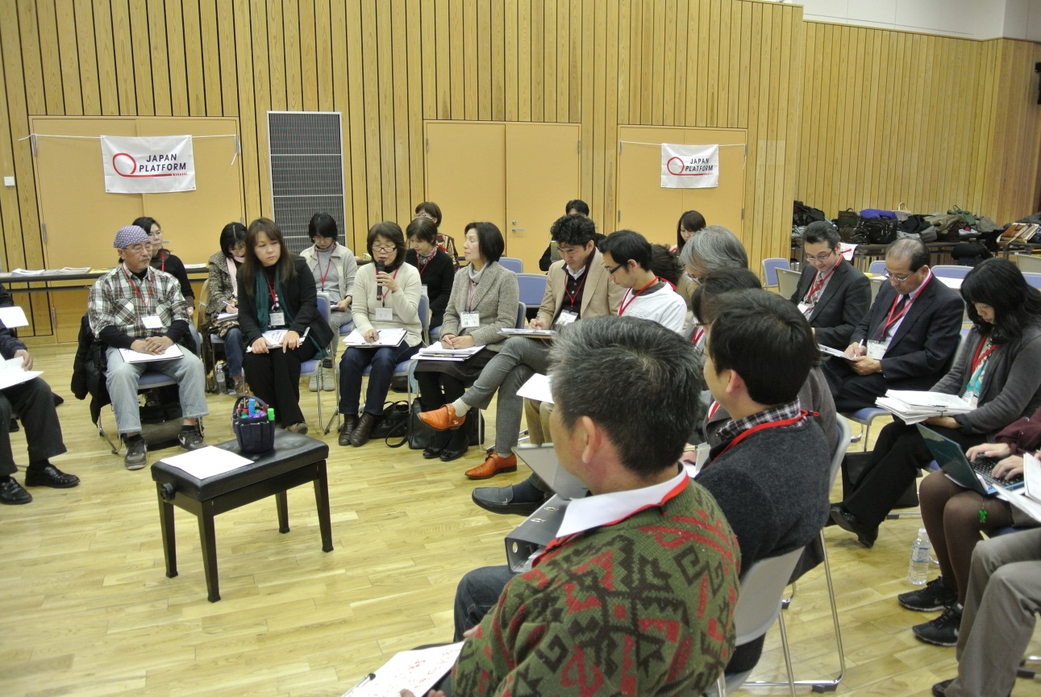
Stand by Together Forum in Koriyama (Fukushima)

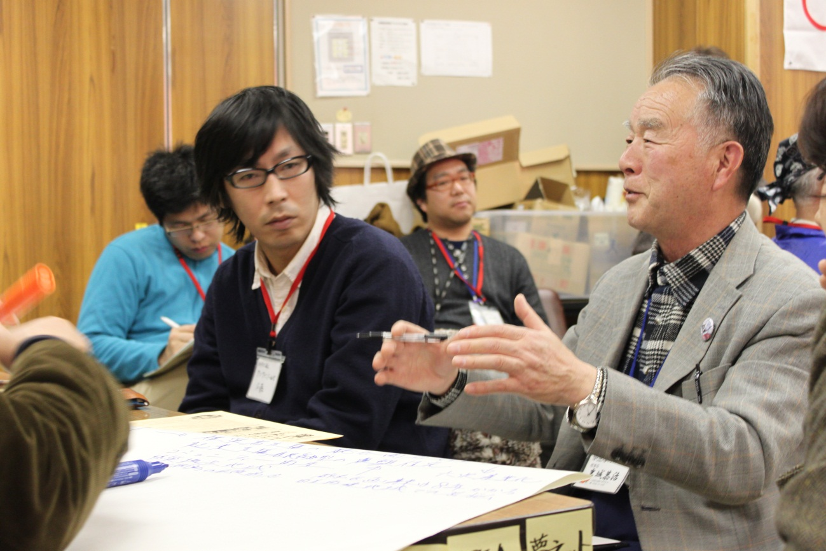
NPO One Family Snedai (left) NPO Yumenet (right)

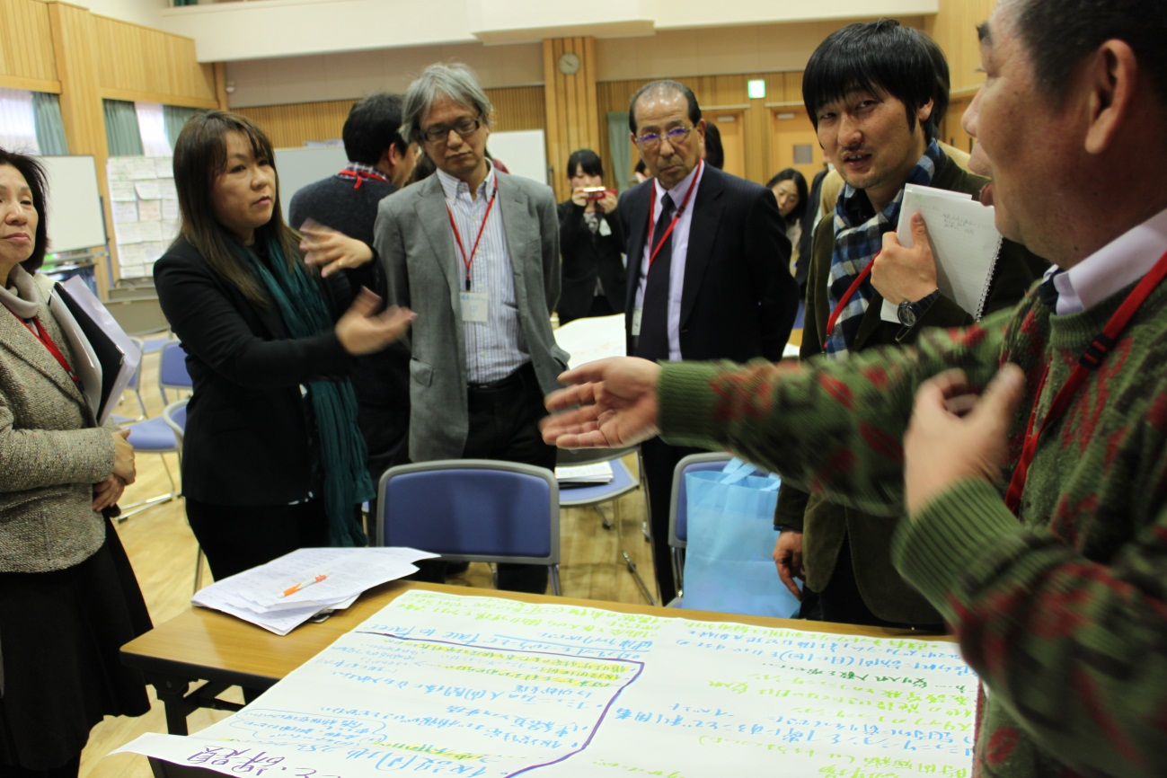

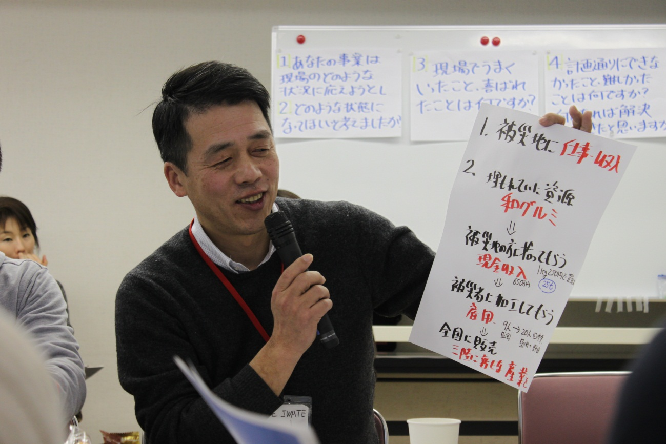
NPO SAVE IWATE

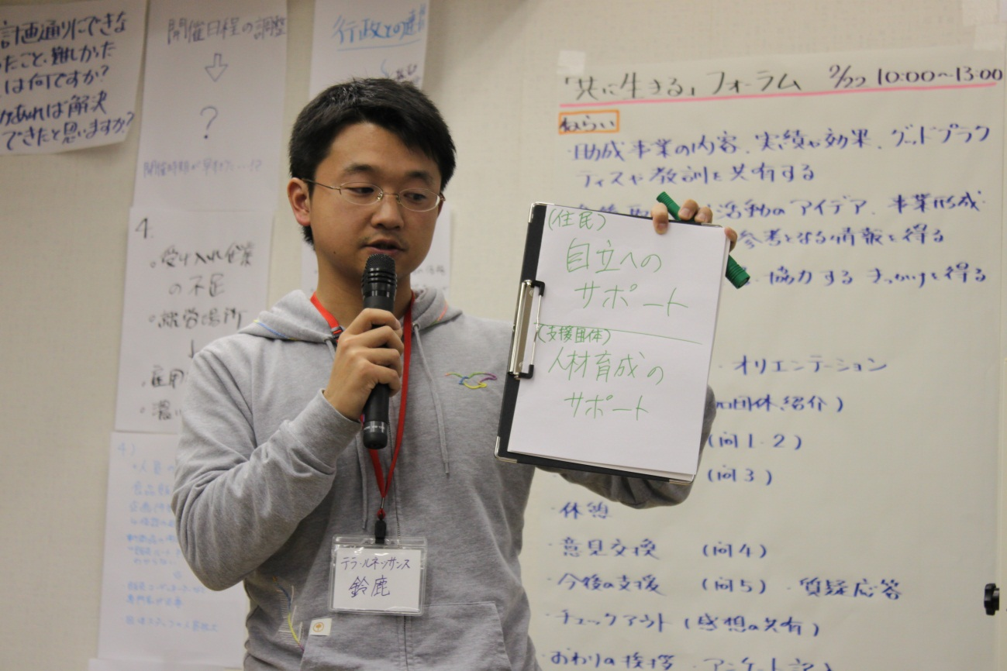
NPO Terra Renaissance

