project documentation

Developing afghan grassroots service organizations

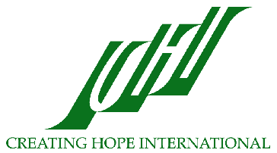
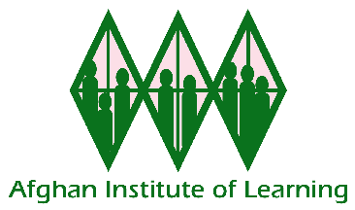

table of contents

Overview of Creating Hope International................................................2

Overview of the Afghan Institute of Learning (AIL)...............................5

Lolenge Educational Center: A Grassroots Educational Organization Supported by AIL...................................................................................11

Creating Hope International
Empowering Communities Throughout the World

Mission and History

Creating Hope International’s (CHI) mission is to provide education and health assistance to the people in the world with the greatest needs. CHI works at the grassroots responding to community needs, fostering community participation, and empowering people through culturally sensitive education and training. Creating Hope International is a Michigan based non-profit organization with 501(c)3 status.

CHI primarily focuses on providing technical and financial assistance to those in need with the goal of empowering the recipients to ultimately be able to meet their own needs. In the past, CHI has:
- Provided technical assistance and training to Mexican villagers in public, maternal, and child health services as well as building latrines
- Trained teachers in Pakistan and Afghanistan
- Raised funds to support refugees in Iran and Pakistan
- Designed and provided educational materials for teacher trainers
Currently, CHI staff members are directing their efforts toward four projects; the Afghan Project, the Tibetan Bon Project, the Public Education Project, and the Alternative Health Project.

Afghan Project

CHI has been helping Afghans for over 30 years by working in refugee camps and helping local groups of Afghans establish grassroots NGOs that will meet the health and educational needs of Afghans for years to come. CHI has a long history of empowering Afghans through health and educational services, community building, and culturally sensitive programs. Since 1996, CHI has worked closely with the Afghan Institute of Learning (AIL) under a technical assistance agreement and provides training and assistance with administration, finance, program strategy, fundraising, budgeting, and proposal writing. AIL is now one of the largest Afghan women-led NGOs and provides health and education services to 350,000 women and children annually.

In the last three years, CHI has helped AIL quadruple it’s annual funding to $650,000. CHI has also been working to build the capacity of AIL to procure its own funding. Last year AIL was able to raise more than 50% of its own funding. Building the capacity of AIL staff to manage book keeping and finances independently continues to be a high priority for CHI. During the summer of 2004, a CHI representative traveled to Afghanistan and provided one month of intensive training to AIL staff on these topics.

CHI staff have also provided advanced teacher training to AIL teacher training staff. AIL is now considered the pre-eminent teacher training organization for Afghans. CHI has helped develop training curricula for culturally relevant human rights education, health education, and counseling materials for Afghans. CHI staff has trained AIL staff in human rights and helped AIL to successfully introduce human rights training to Afghan women in Afghanistan and Pakistan.

With CHI’s help, AIL has grown from a small, local Afghan women’s community-based organization with an annual budget of approximately $30,000 to a large, internationally recognized, non-governmental organization with a broad array of quality health and education services that are changing hundreds of thousands of lives for the better. Now that it is an established NGO with a track record of success, AIL has begun to provide training and technical assistance to small local Afghan community-based organizations to help build the capacity of Afghanistan’s civil society sector.

Tibetan Bon Project

The Bon are a minority Tibetan ethnic group that fled to India when the Chinese invaded Tibet in 1959. In 1968, the Bon established a community in Dolanji, India on donated land. Today, 75 Tibetan Bon families (including 300 children) are settled there. The community has an orphanage, children’s hostel, school (to the 9th class), health center, and community farm. CHI assists the Bon to organize an administrative structure to effectively and efficiently meet the health and education needs in their community. CHI also helps them write grants and reports to improve their water, sanitary, health, education, and living conditions. Projects that CHI has worked on with Bon community leaders include fundraising for water tanks, a storage building, health facility equipment, a drinking water well, and public toilets. CHI has also provided funds to purchase a milk cow and improve water and living conditions.

Now, CHI is working with Bon leaders to make secondary education possible for the community’s children through scholarships. During 2003, CHI funded scholarships that allowed ten Bon youth to obtain secondary education. CHI is also helping Bon community leaders launch a new essential oils project to generate income for the community. Essential oils, which are valuable for their healing properties, have been used at the clinic to treat disease. The Bon leaders have recently been able to produce their own essential oil. They hope to eventually produce enough essential oils to stock the clinic and sell for profit.

Public Education Project

CHI’s public education efforts promote awareness and sensitivity to cultural differences, increase understanding, and help others value the cultural diversity of the world. Through presentations to small and large audiences in local, national, and international settings, CHI representatives educate people about the needs of Afghans and others in developing nations around the world.

CHI staff members have been interviewed on the radio (including National Public Radio and Equal Access Radio), and by television and print media. During 2003 and 2004, CHI staff presented at Sabanci University in Turkey, Katholieke Universiteit in Belgium, and Harvard University in Boston. One CHI staff person presented at the Council on Foreign Relations in New York, the California Governors Conference on Women and Families, and for the United Nations Population Fund in Afghanistan. Additionally, CHI staff have presented to local civic organizations, schools, colleges, universities, and a nursing home.

Alternative Health Project

Americans today expect to live longer than ever before. Unfortunately, increases in life expectancy also mean that people cope with chronic and terminal illnesses for years and even decades. This situation has prompted interest in healing alternatives to complement allopathic medicine. In 2001, Creating Hope International (CHI) began supporting the research and work of alternative healers who have helped and healed many people.

Future Directions

In addition to continuing its work on these important projects, CHI has begun work on a number of new projects. CHI staff is currently working on:
- Training modules to teach Afghan women basic counseling skills, so that they can provide relief and comfort to traumatized Afghan women
- Training for rural Afghans to begin and sustain their own, grassroots NGOs
- Expansion of Gawhar Shad University for Afghan women and men
- Fostering the leadership qualities of women in the United States and abroad.
With over 35 years of expertise in advancing the health and education of women and communities all over the globe, CHI board members, staff, volunteers, and constituents are enthusiastic about applying their skills and passion toward new projects as new needs and opportunities arise.
The Afghan Institute of Learning (AIL) is committed to bringing peace and dignity to Afghan people as they struggle to overcome poverty, oppression, devastation, and injustice wrought by the last quarter century of war and instability. AIL's internationally recognized work is improving the health and education of Afghan women and children, relieving their suffering after three decades of war and civil strife, and enhancing the quality of their lives.

About the Afghan Institute of Learning

The Afghan Institute of Learning (AIL) is an Afghan women’s non-governmental organization (NGO) which was founded in 1995 by Professor Sakena Yacoobi to help address the problem of poor access for Afghan women and children to education and health services, their subsequent inability to support their lives, and the impact of this lack of education and health on Afghan society. AIL is an organization, run by Afghan women, that plays a major part in reconstructing education and health systems capable of reaching the women and children of Afghanistan--whether in refugee camps or in their homes in Afghanistan.

AIL presently has offices in Kabul and Herat, Afghanistan and in Peshawar, Pakistan. AIL serves 350,000 women and children annually, is run by women and employs about 300 Afghans, over 70% of whom are women. AIL offers pre-school through University education and training opportunities to over 20,000 women and children each year and health education and health care to 160,000. AIL has been project partner with Creating Hope International (CHI)--a 501(c)3 non-profit in the U.S.--since 1996. Through a long-term technical assistance agreement, CHI provides advice, training, financial management, and fund-raising assistance and acts as fiscal sponsor for AIL upon request.

AIL believes that educated people are the key to a future, developed Afghanistan. With that in mind, AIL works to empower all Afghans who are needy and oppressed by expanding their education and health opportunities and by fostering self-reliance and community participation. AIL’s goals are to lay a foundation for quality education and health for years to come and to provide comprehensive education and health services to Afghan women and children, so that they can support and take care of themselves.

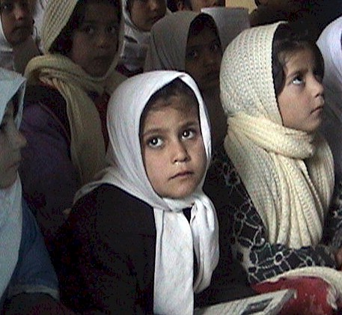
AIL requires community participation in all of its projects. Believing that the best results are achieved when everyone is integrally involved, AIL works with community leaders in the planning, developing and implementation of all projects. No project is started unless the community has requested it and is involved in it. Utilizing this visionary strategy, communities now contribute 30 to 50 percent of the resources needed for a project. These community contributions have come in many forms, including volunteer help, assistance with security, and donated space, materials, and supplies. These contributions have strengthened the communities’ involvement in and ownership of AIL programs. AIL will continue to strengthen community contributions to and ownership of programs as a part of ongoing efforts towards sustainability.

The Afghan Institute of Learning and its founder, Professor Sakena Yacoobi, have received international recognition for their efforts on behalf of Afghan women and children. AIL and Professor Yacoobi are co-recipients of the 2004 Women’s Rights Prize of the Peter Gruber Foundation and the 2003 Peacemakers in Action Award of the Tanenbaum Center for Inter-religious Understanding. Yacoobi and AIL have also received recognition of service awards from the Ministry of Education in Herat, Afghanistan and the district government of Mir Bacha Kot, Afghanistan. In 2001, Professor Yacoobi was awarded the Bill Graham award from the Rex Foundation in recognition of the efforts of the Afghan Institute of Learning to assist children who are victims of political oppression and human rights violations. In 2005, Professor Yacoobi was awarded the Democracy Award from the National Endowment for Democracy.

Accomplishments of the Afghan Institute of Learning

AIL was the first NGO to start Women’s Learning Centers (WLCs) in refugee camps in 2002. Requested by the women in the camps, the WLCs are designed to meet the multiple needs of Afghan women and children at a location close to their homes. AIL’s WLCs provide culturally sensitive health care, education, and training services to 350,000 Afghan women and children each year. Because AIL’s uses a grassroots, participatory method of establishing WLCs in Afghan communities, AIL has been able to expand WLC services to thousands of women and children who urgently need assistance with education and healthcare.

WLCs train teachers, provide health education, and offer preschool through university classes. Workshops that train women to be leaders and to advocate for their basic human rights are offered in the WLCs. Women also learn income generating skills like sewing and carpet weaving.

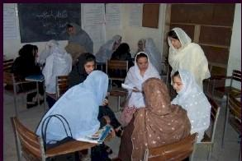
In addition to skills training, Afghan women are eager to return to school after years of having no opportunity to learn. After years of war, the literacy rate of Afghan females is among the lowest in the world. Widows and poor women wish to become literate. Older girls, who were prevented from attending school, want to learn on an accelerated basis and study with girls their own age. Women, who were forced to marry young and stop their schooling want to finish their education. In response to these needs, WLCs offer women and girls Fast Track classes that allow them to study on an accelerated basis to complete grade certificates, learn subjects like English and computers in enrichment classes, and/or learn basic reading, writing, and arithmetic. Some younger girls study in fast track programs, complete grade certificates within a few months, and mainstream into public school at a grade level appropriate for their ages.

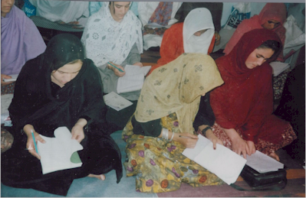
When the first WLCs opened in Pakistan and began providing education and health services, word about the success of the programs spread quickly. Soon, AIL was showered with requests from other communities for their own WLCs. AIL now has eighteen Women’s Learning Centers, where there were none in December of 2001. One of the striking impacts of AIL’s work with Women’s Learning Centers is that this model of providing health and educational services to women has been successfully expanded to hard-to-reach rural areas in provincial Herat, Parwan, and Kabul (e.g. Sar Asia, Lolenge, Shakardara) at the request of those communities. Many of these rural communities have historically been resistant to women’s and girls’ education but through AIL’s principles of community involvement and cultural sensitivity, the organization has been able to reach women in these communities with critically needed services. In fact, AIL continues to receive requests for services from other rural communities who have learned about the quality of AIL’s work with women and girls. AIL is working hard to meet this demand.

Some of the other activities that AIL supports through its WLCs include:

  - Teacher Training: AIL has trained over 9,900 teachers in student-centered teaching techniques, dramatically improving educational quality for hundreds of thousands of Afghan students. These interactive teaching methods have revolutionized both teaching and learning in Afghanistan. Teachers have moved from teaching through rote memorization to teaching youth critical thinking skills, logic for problem solving, and skills for interpreting and evaluating information. These new patterns hold promising implications for the future of education in Afghanistan. AIL teacher training staff have also developed new student-centered, interactive curriculum and training seminars. AIL has developed eleven seminars, 30 workshops, and numerous lesson plans.

  - Human Rights and Leadership: Afghan women have learned how to advocate for their basic, human rights and developed leadership skills through the Afghan Institute of Learning’s Human Rights and Leadership Workshops. Human Rights Workshops are culture-based, grassroots-oriented, participatory, and dialogical. The workshop relates the struggle to eliminate violence (of all types) against women in Muslim societies to empowering women. Women develop skills in communication and preventing violence against themselves and knowledge to affect positive change within their families. Leadership Workshops provide culturally-sensitive training that enhances women’s leadership skills, empowering them to participate in local, regional, and global decisions. During Leadership Workshops, women use scenario-based materials to cultivate leadership skills that are horizontal, inclusive, and participatory. AIL has trained over 1,200 Afghan women in Leadership and Human Rights. Empowered by Leadership and Human Rights workshops, women now ask for more Women’s Learning Centers, take literacy courses, and stand up to abuse.

AIL is also cultivating Afghan women’s leadership as one of the largest employers of Afghan women. AIL employs women in management positions. As a result of employment opportunities, education, and empowerment through AIL programs, women have moved on to become representatives in the Loya Jirga (Afghan Assembly) and candidates for Parliament. In the words of Habiba Surabi, the governor of Bamyian province who was trained as an AIL Teacher Trainer; “It was AIL that trained me and was sending me to camps in order to hear and feel the problems of my poor countrymen, that is why people in America call me ‘People Minister.’ The training and experience I received from AIL is unforgettable for me.”

  - Home Schools: Through the Home School Project, AIL kept education for girls alive during the Taliban regime by providing grade one through eight education for girls underground. Underground home schools were the only educational option available to these girls for more than four years. In 2001 (the last year of the underground home schools), AIL had 3,000 girls in 80 home schools in Jalalabad, Kabul, Herat, and Logar. AIL had trained more than 80 teachers for the schools and mobile libraries in Herat and Jalalabad transported reading material between the underground schools. AIL had also begun health programs in Kabul and Jalalabad and an income generating skills class in Herat. The underground schools and health programs gave hope to the students, the community, and the nation. AIL worked with community members to realize their common desire to keep education alive in Afghanistan by allowing some girls to continue their education. Community members cooperated with each other and AIL to secure space for the schools and to ensure that the schools, teachers, and students could teach and learn safely.

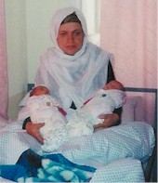
e. Health Programs: AIL has four basic health clinics and mobile health clinics that serve over 6,000 Afghans each month with health services. The clinics also provide health education to over 8,000 women and children each month. Women and children come to the health clinics for medical examinations, midwifery services, reproductive health care, nursing services, nutrition services, and vaccinations. Women are also taught health lessons about reproductive health, hygiene, the proper use of medicine, disease prevention, and other topics. Afghan women have the highest maternal mortality rate in the world and one of the highest child mortality rates. AIL’s clinics are helping thousands of women each year to deliver healthy babies safely through their focus on reproductive health, including pre and post-natal care and baby delivery. AIL’s clinic in Mir Bacha Kot, which was officially opened in February of 2004, has begun a special nutrition program to provide nutrition education to mothers and intensive medical interventions that save the lives of malnourished and undernourished children.

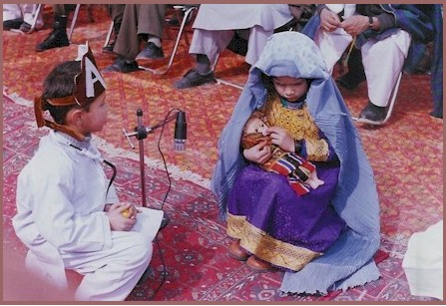
f. School Support, Advanced Classes, and Pre-schools: Through its teacher training and school support program, AIL provides assistance and an administrative structure to schools and home schools in Pakistan and Afghanistan. This has been an invaluable service for tens of thousands of Afghan children whose education was interrupted by the war and civil strife in Afghanistan. School support includes teacher training, onsite monitoring and supervision of teachers, teachers’ salaries, administrative support, and provision of school materials and supplies. Teachers are trained to use interactive, student-centered teaching techniques. AIL continues to support refugee schools in Pakistan with over 1,600 Afghan students and advanced classes for over 500 children each month in rural Afghanistan in addition to its Women’s Learning Centers. AIL provides pre-school education to about 200 students and trains its pre-school teachers to teach very young children over nineteen curricular topics.

g. Afghan Women’s University: Gawhar Shad University was founded in 2003 by AIL in response to the lack of post-secondary education opportunities for Afghan women. Today, the University has three curriculum tracks; the College of Nursing/Health Education, the College of Math and Computer Science, and the College of Education. The Nursing/Health Education program provides female students with a broad knowledge-base and skill set in nursing, health education, vaccination, midwifery, and disease prevention. This nine-month intensive course requires students to complete practical as well as classroom work and provides instruction on over 100 medical topics. To date, 59 women have graduated from this course and are providing urgently needed health care services to thousands of Afghan women who would not otherwise have access to care. The College of Math and Computer Science course subjects include Computer, Math, Dari, Psychology, and English. In 2004, 324 students studied in this college. In the College of Education, teachers study student-centered, interactive methods of teaching and learn how to train other teachers to use these methods. They also learn to develop workshops and curriculum. To date, the College of Education has graduated 14 Master Teacher Trainers and 23 teacher trainers.

- Support for Community-Based Organizations: AIL has begun providing training and seed grants to community-based Afghan educational organizations to improve their management, implement interactive teaching methods, and increase their student enrollment, particularly for female students. Currently, AIL is supporting four community-based organizations that are serving over 2,200 students. AIL teacher training staff visit the organizations regularly and provide their teachers and managers with needed training. AIL also provides needed materials and supplies to the centers. Before AIL started supporting the Lolenge Educational Center, they had no black board, chalk, chairs, tables, or books. This important project is dedicated to building the base of local non-governmental organizations in Afghanistan that will continue to meet the health and education needs of Afghan women and children for generations. With training and assistance from AIL, these organizations are developing the capacity to provide quality services independently.

- Voice of Education Magazine: Nida-e-Talem (Voice of Education) magazine is compiled and published by the Afghan Institute of Learning to provide a forum for informed commentary by Afghans on important issues in Afghan society today, with a particular focus on health, education, and current events. Article authors for this popular magazine come from every province of Afghanistan and the magazine celebrates Afghan culture and traditions. The magazine’s readership, which numbers in the thousands, are students, teachers, NGO-staff, government workers, and others. To date, seven issues of the magazine have been published and the publication continues to be popular with readers.

Afghan women started and grew the Afghan Institute of Learning, The successes of the Afghan Institute of Learning and the organization’s ability to expand and respond with immediacy to needs identified at the grassroots level, demonstrate just how powerful an impact Afghan women can have when they are empowered through education. AIL will persist in its efforts to reach even more underserved women and children during the rest of 2005 and in the future, especially in rural areas. AIL remains committed to empowering women and communities through training that helps them develop skills to manage and sustain needed health and education programs themselves. AIL will also continue its model programs which are setting a new standard of quality for NGO services in Afghanistan and are demonstrating the powerful impact that high-quality programs can have. Through this combination of short and long term strategies, AIL is forging ahead in its efforts to achieve a new beginning for Afghanistan.

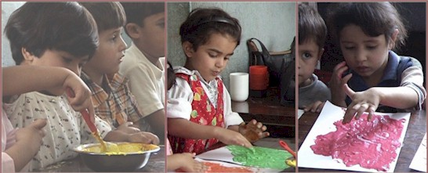

Lolenge Educational Center: A Grassroots Educational Organization Supported by AIL

Each community-based organization that AIL has supported to date through this project has its own unique story. Each organization was developed by community members in response to the specific local needs. The story of one of these organizations, the Lolenge Educational Center, provides some insight into the challenges and needs that local grassroots organizations face as they struggle to improve education and opportunity in their own communities.

The Lolenge Educational Center is located in Parwan province and is on record with the Ministry of Women’s Affairs. The Lolenge Educational Center is a community-based, non-governmental, non-political organization and was established in 2002. Its mission is to give poor Afghan women the skills they need and empower them to take their rightful place in the society.

Lolenge is located in a very rural and mountainous area. Most residents are farmers. There is no electricity or water supply other than wells or streams. Essentially, there is no bazaar. There are a few shops which are closed most of the time. When someone needs something, the shop owner is contacted and he comes and opens the shop for that period of time. The Center is actually located in the home of a family in the community. It is remarkable that in such a remote location there is a center at all.

AIL began supporting this educational center in Lolenge during May of 2004. A young man who is originally from Lolenge approached AIL to ask for support for the Center. He is an educated man and works for an NGO in Kabul. He found out about AIL when he attended one of AIL’s information technology seminars. He also knew of some women in Peshawar who had worked for and studied at AIL. When he visited AIL to talk about the possibility of AIL supporting the center in Lolenge, he shared his concerns about the orphans and widows in his family and community. He said that in Kabul and other places, he sees women advancing but women are not advancing in his home village. He believes that it is better for families if women are educated and he worries about the ability of women in Lolenge to support themselves. Some do not have extended family to rely on for support. In his case, he is working in the city and the women in his family are at home with no help. He would like some opportunities for them.

In order to start the center in Lolenge, the family of this young man donated their whole house as space for the center. Now the family lives in one room. They have given all their sitting rooms away to be used as classrooms. During the day while classes are in session, they sit outside. The young man visits the center in Lolenge twice per month himself and brings supplies. However, he is not able to stay in Lolenge to teach and train the teachers and CBO managers. He asked AIL for help with training.

The man from Lolenge who initially approached AIL and asked for support for the center is fervently committed to the program. He said that he really wants the women and girls in his community to learn something and he is very thankful to AIL for working to increase the capability of the teachers. Two women in the community manage the center day-to-day. One of the women is young and unmarried and has a university education. She teaches some classes. The other woman is old and illiterate but she is good at organizing and a strong leader. She is a well-respected and powerful woman in the community. These women work well as a management team for the center, one educated and the other well-respected.

However, a lot of work needs to be done to improve the professionalism of the teaching and the quality of the education in the center. Until AIL began supporting the center, classes ended up being more ad hoc discussions. AIL teacher trainers have also discovered and are concerned about knowledge deficits that the students and teachers have. Students could not answer basic questions about Afghanistan’s system of government or who was Afghanistan’s last king. Subject matter education is needed in Lolenge. The teachers and managers are eager to learn from AIL.

Since AIL began working with this center, the teachers have started on the road to more professional teaching. Now when they stand up in front of a class, they have in mind an outline of the things that the will be teaching. They do not stand up before a class and teach off the cuff. Before, students did not receive a proper foundation for a class before they began studying it. For example, students in a poetry class had not yet learned the alphabet. They were reciting poetry without having the capability to read or really study it. AIL teacher trainers have taught the teachers of the Lolenge Center to teach subjects in logical order so that new knowledge builds on what the students have already mastered (e.g. first students learn the alphabet, then they learn reading, then they learn poetry).

Because of the training they have received from AIL, the Lolenge teachers now arrange their students into seating assignments. Now when an AIL teacher trainer visits a class, the room is more orderly and it is clear who the teacher is and who are the students. Classes are more standardized.

Because Lolenge is a very isolated community, the teachers were not aware of many of these basic concepts of teaching and learning that AIL has taught them so far. They have not had access to better models of teaching, learning, and CBO management. For this reason, the community of Lolenge is profusely grateful to AIL teacher trainers for making the time consuming and difficult trek to their village to help them learn.

By July, 2005, the center had 16 teachers and was instructing 128 students (76 of the students were female). The organization and discipline of the center is very good so the students are increasing day by day. The center is for students who have never gone to school, students who are not able to go to school during regular school hours because of their family or employment responsibilities, and students who are currently school students but take extra classes to help them in their studies.

Classes taught include English, Literacy, Math, Arabic, Social Studies, History, Dari, Science, and Fast Track classes. Fast track students are currently studying grades one through seven. They study three periods per day and learn the established curriculum for each grade level. Math class students are studying addition, subtraction, multiplication, and division. The Science class is especially arranged for school students who have difficulty in this subject. Eight English teachers are studying in the advanced English course. The literacy class includes older as well as younger students who would like to become literate. Literacy class students range in age from 15 to 50 years.

AIL provides needed materials to the Lolenge center, including notebooks, blackboards, boxes of chalk, attendance charts, and textbooks for classes one through five in subjects like Dari, math, social studies, history, and science. The center had been operating with no materials, no blackboards, no chalk, no chairs, no tables, and no books before AIL began supporting it. Through this pilot project, AIL has been able to make these learning materials available for the students in this center despite its remote location. AIL teacher training staff supervise the center regularly but it is not an easy location to reach. On one trip, the teacher trainers’ car had a flat tire three times and the journey took fourteen hours.

Teachers in Lolenge are working hard and working according to AIL’s plans and policies. In the future, Lolenge students and teachers would like AIL to help them begin computer classes.

