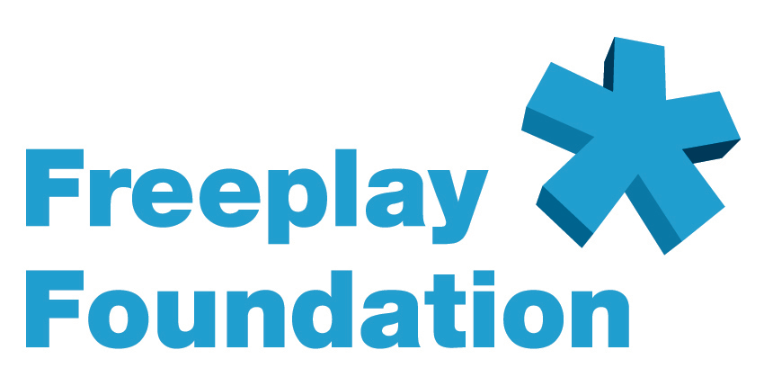


The Story of Mambo Elimu and Freeplay’s Project for
Radios to Educate Child Laborers in Tanzania

In 2002, one of the Freeplay Foundation’s most effective partners, the U.S.-based Educational Development Center (EDC), undertook a pilot distance-learning initiative in Tanzania called Mambo Elimu or “Education is Everything” in Swahili. In Tanzania due to the AIDS pandemic, two teachers are dying for every one that is trained and life expectancy is only 42 years. An estimated four million Tanzanian children are not in school and 300,000 are engaged in the worst forms of child labor. Children work for nominal wages in commercial farming, mining, dump scavenging, domestic service, hawking and as street vendors. Girls as young as seven are subject to sexual exploitation.

EDC created 100 interactive radio instruction (IRI) lessons for grades 1-4, which are offered through Mambo Elimu centers in areas with high concentrations of child laborers and orphans. Originally aimed at reaching over 30,000 such children, the curriculum includes: Swahili, math, English, and science. Life skills to improve problem solving, first aid, hygiene and health are also taught. After completion of the fourth grade, children are helped to integrate into either the formal school system or a vocational program to prepare them for more stable, less dangerous work. Children up to 17 years are welcome in first grade, whereas in government schools, if children do not begin school by age 7 it is very difficult for them to enter. After 14, they cannot be admitted and are forever excluded. EDC currently is developing scripts for Grades 5 and 6.

When Mambo Elimu was first broadcast, EDC tried battery-operated radios. The program failed. Neither EDC nor mentors could afford the ongoing cost of batteries and had difficulty in obtaining them in many areas. EDC turned to us for help and we were able to donate more than 1,300 Freeplay Lifeline radios, which could reach 52,000 Mambo Elimu students, assuming one radio services a classroom of 40 children. Today, Lifeline radios have become integrated into the classes and children say it is an honor to take turns winding the radio and therefore forgo using the solar panel. Mentors say that without the Lifeline radio, they would not be able to broadcast the program every day and fear children would drop out. Quite a few mentors have asked for additional radios because their classes have grown so large.

The Tanzanian government’s own quantitative measures prove the success of Mambo Elimu. Children attending classes take the standard Tanzanian government exams. Ninety-five percent of the Mambo Elimu children achieved better results than the average scores for their grade.

One telling example is an inter-school exam that included the formal Image Primary School and the informal Mambo Elimu Image Centre in Iringa. The exam was prepared by the headmaster of the formal primary school. The top 13 scores were from the Mambo Elimu learners. The teachers and children from the primary school were unhappy about the results. They requested another exam where, again, the top scorers were the Mambo Elimu students. A Freeplay Lifeline radio was used in the Mambo Elimu Image Centre.

EDC’s interactive radio instruction is a long-proven, successful method that encourages children to engage in learning with the mentor, their peers and their environment. IRI lessons spark children’s imagination. They learn more by interacting with others rather than by simply memorizing their lessons from their seats.

The Freeplay Foundation’s American Ambassador, Mr. Tom Hanks, and his wife Ms. Rita Wilson kindly donated funding for 1,000 of the radios that we have been able to provide to Mambo Elimu so far.

###

Freeplay Foundation contacts in the USA:

Midi Berry, Senior Development Consultant: freeplayfoundation@mac.com

Michelle Riley, Senior Consultant: riley.freeplayfdn@gmail.com

PLEASE SCROLL DOWN FOR MORE INFORMATION ABOUT THE FREEPLAY FOUNDATION, TOM HANKS, AND THE LIFELINE RADIO:

EXECUTIVE SUMMARY:

OVERVIEW OF THE FREEPLAY FOUNDATION

AND THE LIFELINE RADIO

Description of the Organization

The Freeplay Foundation mission is to help vulnerable people transform their lives using sustainable, self-sufficient and environmentally friendly technologies.

With access to resources, people seize educational and economic opportunities to improve health, create jobs and advance quality of life. We are committed to act as stewards of the environment to make clean energy technologies available to those in need.

The non-profit Freeplay Foundation works mainly in Africa. By addressing the pressing needs of its women, orphans and vulnerable children, we aim to contribute to total community well being.

Since 1998, the Freeplay Foundation has been creating access to radio information and education for the most vulnerable populations via self-powered radios.

The Foundation is committed to promoting the importance of radio as a vital medium in the developing world. Through the use of self-powered Freeplay Lifeline radios, it also advocates the necessity of ensuring access to broadcasts and sustainability of programming, especially for the most vulnerable groups, women and children.

In communications projects, the Foundation can ensure that information is delivered the “last mile” to populations in the most inaccessible locations. It can serve as the final point in a seamless line of communication -- from satellite and internet-based information, through television and published information -- all the way to Lifeline self-powered radio access in the poorest, most remote villages and refugee camps. The Freeplay Foundation works in a dozen African countries and is on the cusp of becoming a major force within the humanitarian development world, because no one else can offer what Freeplay can. In a global communications campaign, the Foundation is the final step.

In developing countries, especially in areas with large, non-literate populations, radio is the primary means of communication. In sub-Saharan Africa, for example, it is estimated that there are up to 75 times more radios than televisions. However, in most of the developing world, electricity is non-existent and the high cost of batteries makes them unaffordable on an ongoing basis, especially to women and children. Millions of dollars are spent worldwide each year to produce excellent radio programming for development purposes, yet the poor may never hear it. They are unlikely to receive critical information that can help them prevent deadly diseases, improve hygiene, raise agricultural productivity, learn English and math through radio distance learning, or enjoy any educational instruction that could help lift them out of abject poverty and lower mortality rates. Lifeline radios can solve the problem of access for these audiences.

Established in 1998 in the UK by the Freeplay Energy Group as a separate entity, the Freeplay Foundation is a tax-exempt 501(c)(3) charitable organization in the USA, with its senior consultant working from Savannah, Georgia. Additionally, it enjoys Section 21 charitable status in South Africa and is a registered charity in the UK. The Foundation’s main office is in Cape Town. It also maintains an office in London and has consultants based in the USA in Los Angeles and Savannah, Georgia.
Description of the Work

The Foundation’s goal is to utilize radio to ensure that as much accurate information is disseminated to the widest possible population. To this end, the Foundation works with international and local NGOs in a structured distribution methodology of radios to rural communities. The Freeplay Foundation team includes experts that can survey and assess target populations’ radio information needs, work with local broadcasters to set up appropriate content and structure, assess and determine radio distribution criteria, implement radio distribution, form listening groups and focus groups, and monitor and evaluate the impact of the process. Radios are never “just given away.”

In addition, the Foundation has devised unique ideas for delivery and packaging, such as the creation of “health boxes.” The radio boxes can contain other health-related items and print materials to form a complete community package. For instance, supplies could include malaria nets, information booklets, rubber gloves and water purification tablets. Health messages that support a particular project can be printed on the boxes. For example, HIV/AIDS prevention messages are relevant to the entire world, while malaria treatment messages are relevant only to some countries.

The Foundation supports project partners through the sharing of best practices and experience. For example, the Foundation has experience in how to most effectively introduce radios into communities and address potential issues regarding community listening behavior. For many projects, a listening group format is adopted, whereby 10-20 people gather to listen and to discuss or debate a radio program. Freeplay radios are designed for group listening - they are large and robust with excellent speaker quality – easily accommodating up to 40 listeners.

The Foundation also creates project-specific cartoon instruction sheets showing how to use the radio correctly and how it is used in a community setting. The cartoonists are hired locally, wording on the cartoons is printed in vernacular or the national language, and the cartoons are pre-tested first. Oftentimes, the reverse sides of the instruction sheets are also used to augment the program’s key messages and to advertise the program’s station and broadcast time.

The Lifeline Radio

The Lifeline radio is the first radio ever produced solely for humanitarian use.
After extensive fieldwork during the first two years of the Foundation’s existence, the executive director determined a real need expressly for the humanitarian sector, especially children living on their own. The idea for the Lifeline was born.

In 2001, the Freeplay Foundation received the $50,000 education award, underwritten by NASDAQ, as the winner of the Tech Museum of Innovation Awards -- Technology Benefiting Humanity. The Foundation allocated the award money to seed the research and development of the Lifeline radio. All funding needed to bring the Lifeline radio to fruition, including tooling and testing, was received from donors in October 2002. The other donors included the Body Shop Foundation, Anglo American Corporation, the Vodafone Group Foundation, Vytek Chairman Leonard Fassler, and well-known technology entrepreneur Bradley Feld.

Exactly two years after the concept paper for the Lifeline was written, the new radio was launched in April 2003 in a Voice of America (VOA) sponsored project benefiting Burundian youth living in refugee camps in Tanzania. The United Nations High Commissioner for Refugees (UNHCR) was the implementing partner. VOA deemed the project to be so successful that they funded a major expansion of the initiative into the camps.

Already more than 2 million people throughout sub-Saharan Africa are benefiting from access to self-powered Lifeline radio and the Foundation is committed to increase this number manifold in years to come.

A few projects that include the Lifeline radio:
South Africa – Lifeline radios are integrated into the youth radio programme Soul Buddyz. The radios are used to augment Soul Buddyz listening clubs. Radios have been given in support of the Nelson Mandela Children’s Fund’s Goelama Project, which supports child heads of households in the Kwa-Zulu Natal province. Lifeline radios are included in the expansion of the radio version of Sesame Street, called Takalani Sesame, and are distributed to teachers in early childhood learning centers in rural areas. In 2005, Takalani Sesame won the prestigious Peabody Award. The Media Monitoring Project uses Lifeline radios to monitor the listening habits and preferences of child heads of households. UNICEF is the project’s primary funder.

Tanzania – Lifeline radios are used in six different projects in Tanzania, all funded by the Vodafone Group Foundation: The African Youth Alliance (AYA) radio program called Mambo Bomba; a major radio distance learning project called Mambo Elimu that offers a primary school education; a Ministry of Labor, Youth Development and Sport-sponsored youth sports and HIV/AIDS awareness campaign; a project that supports youth development through a variety of media, including radio; a Ministry of Health initiative where Lifeline radios will be placed in prenatal clinics where women gather; and a community radio station/telecenter near Lake Victoria where the radios are used for primary education and to teach children about various technologies.

Afghanistan – Lifeline radios have been distributed to female teachers in remote areas, enabling them access to teacher training programs. This groundbreaking project is coordinated by Media Support Solutions.

###

PLEASE SCROLL DOWN FOR INFORMATION ABOUT TOM HANKS AND THE LIFELINE RADIO

Sept. 29, 2003

Tom Hanks Assists World’s Poor
As Freeplay Foundation Ambassador

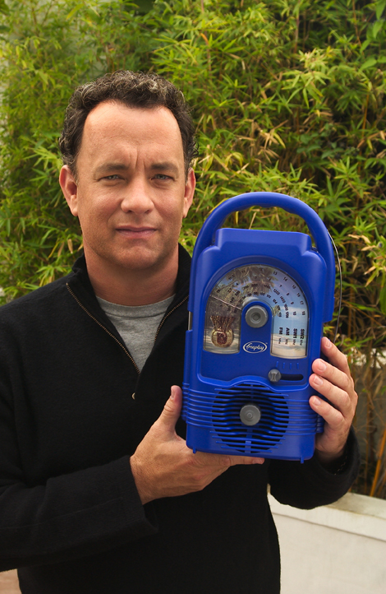

Cape Town, South Africa....The Freeplay Foundation today announced that two-time Academy Award® winner Tom Hanks has become their American ambassador. In this advocacy role, Mr. Hanks will help gain support for the Foundation in the U.S. and promote understanding of the Foundation’s work.
Using Lifeline radios, which do not require batteries or electricity, the Freeplay Foundation provides sustained access to information to the world’s poorest populations, especially children living on their own.

“The extraordinary technology of the Freeplay Foundation’s Lifeline radio can bring vital information to isolated people all over the world,” said Mr. Hanks. “For example, right now there are more than 13 million children orphaned by AIDS. Most can’t attend school and can’t afford batteries or electricity to power a radio. The Freeplay Foundation can hand these children a lifeline to the outside world by giving access to radio programs that teach them how to grow their small garden plots to feed themselves, take care of their chickens or goats, and prevent deadly diseases like malaria and AIDS.”

Freeplay Foundation Executive Director Kristine Pearson said, “We are deeply grateful that Mr. Hanks has chosen to serve as our American ambassador.
By lending his voice in support of the most vulnerable people, especially orphans and other children living on their own, Mr. Hanks will help bring them critical, even life-saving information and education.”

In developing countries, radio is the primary means of communication. The Lifeline radio plays non-stop using wind-up energy and solar power and is the first radio ever produced solely for humanitarian use. Using a structured methodology developed by the Freeplay Foundation, radios are distributed to youth, community health workers, village chiefs, listening groups, teachers, and informal classrooms in the developing world, primarily in Africa. Recipients are trained in how to most effectively listen to radio programming and transfer knowledge they gain to others in their community.

Mr. Hanks joins humanitarian Terry Waite, who serves as the Foundation’s European ambassador. Mr. Waite is well known in the U.S. as the special envoy to the Archbishop of Canterbury in the 1980s. While negotiating the release of U.S. hostages in Lebanon, Mr. Waite was himself taken hostage, serving most of his five years in captivity in solitary confinement.

The Freeplay Foundation works in more than a dozen African countries. It is a fund seeking, U.S.-registered 501 (c) (3) tax-exempt charity. It works with governments, international agencies such as the United Nations Development Program, non-governmental organizations (NGOs), and local communities. With offices in Cape Town, South Africa and London, the Foundation also enjoys charitable status in South Africa and the UK. Learn more at www.freeplayfoundation.org.

###.

PLEASE SCROLL DOWN FOR INFORMATION ON THE LIFELINE RADIO:

Key Design Features and Benefits of the Lifeline Radio

Below describes the features and benefits of the Lifeline Radio. Orphaned children in South Africa, Rwanda and Kenya were consulted throughout the design and development process. The size and shape of the Lifeline Radio is a result of focus group research. The more it is wound, the longer it will play.

Children can grip the handle without difficulty. While the Lifeline Radio is large, it is lighter than other Freeplay radios used in development projects.

The antenna is an ordinary piece of wire, which can be replaced with any piece of wire. It can be taken off and put back on at will as antennas break easily.

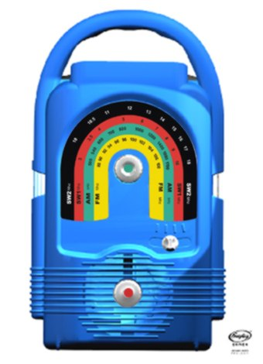

The solar panel is housed in a detachable waterproof casing on a three-meter lead with magnetized clips on top to hold it securely in place. The Lifeline Radio operates in the harshest of conditions in extreme temperatures, rain, moisture, dust, sand and humidity.

The rainbow shaped dial scale has large print making it easy to read even for the visually impaired. As AM/FM/SW is difficult to understand for some, each band is color-coded.

The winding handle (on back) can be turned in either direction to charge the radio. Earlier Freeplay models could only be wound clockwise. Fully charged, the Lifeline Radio can play for many hours.
The dial scale and Lifeline Radio can be custom produced in any combinations of colors, which cannot reflect political parties.

Four-band coverage, AM/FM/SW1/SW2 ensures access to many channels and perspectives. For example, in Zimbabwe where programming is government controlled, SW broadcasts can be received.
The sound quality is excellent enabling at least 40 people to hear it clearly.

Each knob is purposely a different shape.

