Positive Change of A Shy Boy
By Syafawati

“The best and most beautiful things in the world cannot be seen or even touched - they must be felt with the heart” – Hellen Keller.
Have you ever imagine life without knowing how your parents’ face looks like? Raju was a premature baby born at 26 weeks of pregnancy due to leaking of amniotic fluid. He has been incubated for 100 days and he was diagnosed as retinopathy of prematurity with stage II-III. At the age of 5 months, he went for an operation which he has to remove his left retina. Raju is very close with his foremost love, his mother. He is very motivated and will never let his mother feel down.
Raju was enrolled in our Early Intervention Programme at age of 5. Raju’s condition was never an issue for his family who always love and take care of him; including his extended family members. They lived happily in their small paradise home which was aided by the government under the Poor People Housing Program. Raju’s mother is a fulltime housewife and the one who is responsible for taking care of Raju and 3 other siblings wellbeing. His father works as a security guard.
In spite of being born with no vision, Raju was able to move independently at the young age and is also able to interact well with his family members. Nevertheless, he was still very dependent on his family especially his mother for his daily routines and was very shy with strangers. His speech was also not coherent. Raju has difficulty understanding other languages except his mother tongue. Besides that, Raju has difficulty in differentiating shapes and counting. So his teachers have planned an Individual Educational Plan for him to improve his learning ability.
Despite of having learning difficulties, Raju never once gave up. His parents never stop him from exploring new things. They did their best to provide and fulfil Raju’s needs. Raju’s parents and teachers are always working together tirelessly to transform his life meaningfully. One of the significant improvements seemed recently was when Raju greeted and helped the teachers to carry the boxes into his house. His recent attitude was the direct opposite of what his teachers first met Raju where he hid behind his mother the entire time. Raju is able to sort the shapes and distinguish surfaces now!

Raju shows the world that his blindness is not a hindrance for him. Just like the quote by Hellen Keller which goes something like “A happy life consists not in the absence, but in the mastery of hardships.”

Your strong support could make a big difference for Raju as the donations is used for buying new learning aid that would expand his learning experience.

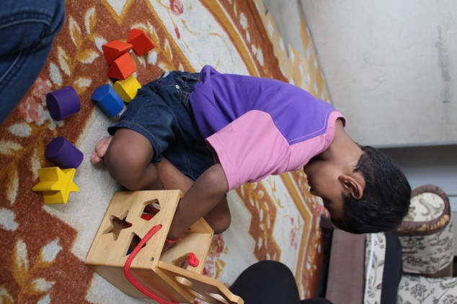
Raju is sorting various shapes.
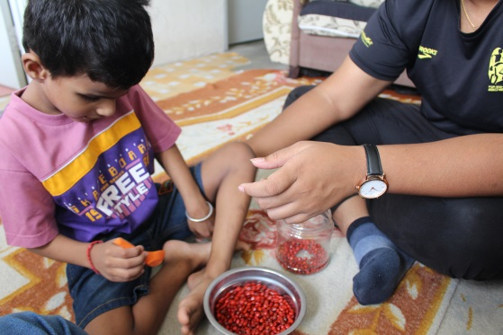
One of Raju’s Individual Education Plan goals is to be able to eat independently. So, the teachers taught him how to scoop his food correctly.
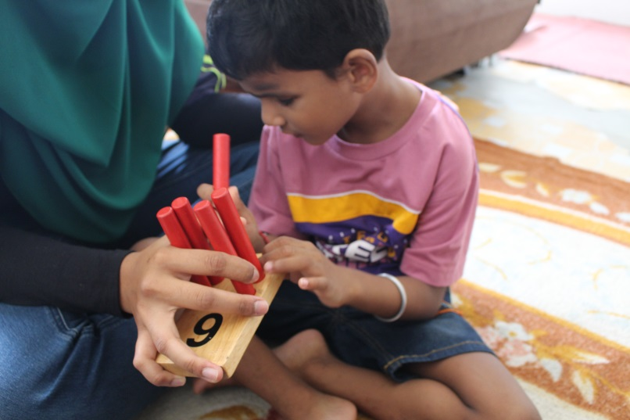
Raju is doing hand coordination activity. In this activity, Raju learned how to coordinate his 2 hands, counting the wooden poles and braille numbers.
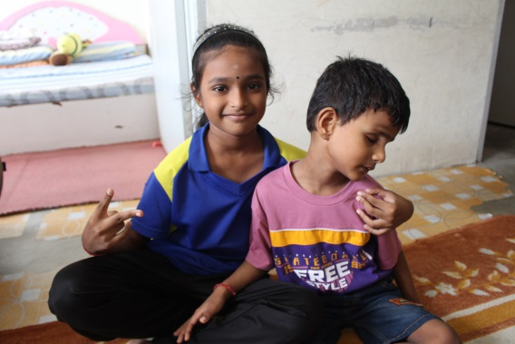
Raju with his older sister, Bhavithra, 8 enjoying great moments together.

