Kambanga, Malawi

School # 572

Thank you for sponsoring the buildOn school in Kambanga, Malawi. According to a recent UNESCO report, about one in five adults in today’s world - 774 million men and women - are illiterate and 75 million children remain out of school. Literacy leads to empowerment and is a vital means of human development. With your help, buildOn is breaking the cycle of poverty, illiteracy and low expectations through service and education in Kambanga.

KAMBANGA COMMUNITY profile

buildOn MALAWI

Malawi schools: 75 complete
Current impact area: Kasungu

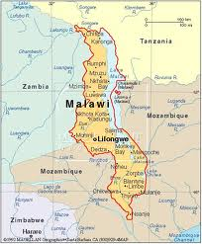

Why we work in Malawi:

● Malawi ranks #153 amongst 169 countries with data on the United Nations Human Development Index, a comparative measure of life expectancy, literacy, education and standard of living.

● Malawi has one of the highest rates of HIV/AIDS infection in the world - 15% of adults ages 15-49 are infected - and a growing population of children orphaned by this disease.

534 schools built
1 million volunteer workdays
81,220 children, parents and
grandparents in school daily

Kambanga village is 35km from the buildOn office in Kasungu, and has a population of approximately 1400 people. Most of them belong to the Chewa ethnic group and the majority practice Christianity. The leaders of the community are Traditional Authority Wimbe, Senior Group Village Head Kambanga, and may Group Village Heads (Kolowole, Godo, Nsilinde, Chibati, Gunda, Nyamanjati, Kawaka, Chikomeni, Kozentari and Chatsalira).

The closest medical center to Kambanga is the Kamuzu Academy Clinic, which is 6.7km away. To get there, villagers must travel 3km on a dirt road before reaching the paved road. Most families in Kambanga farm tobacco to generate income. The climate is typical of Malawi’s savannah, with a warm dry season from August to November and a cooler rainy season from December to April.

CURRENT SCHOOL CONDITIONS

Guchi Junior Primary School
There are currently 348 students (182 girls and 166 boys) enrolled in Guchi Junior Primary School in Kambanga. They study in standards 1-7 with 7 teachers in one existing school block. Due to insufficient infrastructure, many children walk to Mswa or Msulira Primary Schools, 4km from Guchi School. Formal education has been available in Kambanga since 1992.

“The school we have here is completely unsuitable for learning for our children due to its poor condition. We need a decent school block here to ensure proper environment for learning and to promote hard work and prosperity among our children while enhancing the education standards.”
- Wisten Phiri, age 63, GVH Chikomeni
Current School in Kalufu

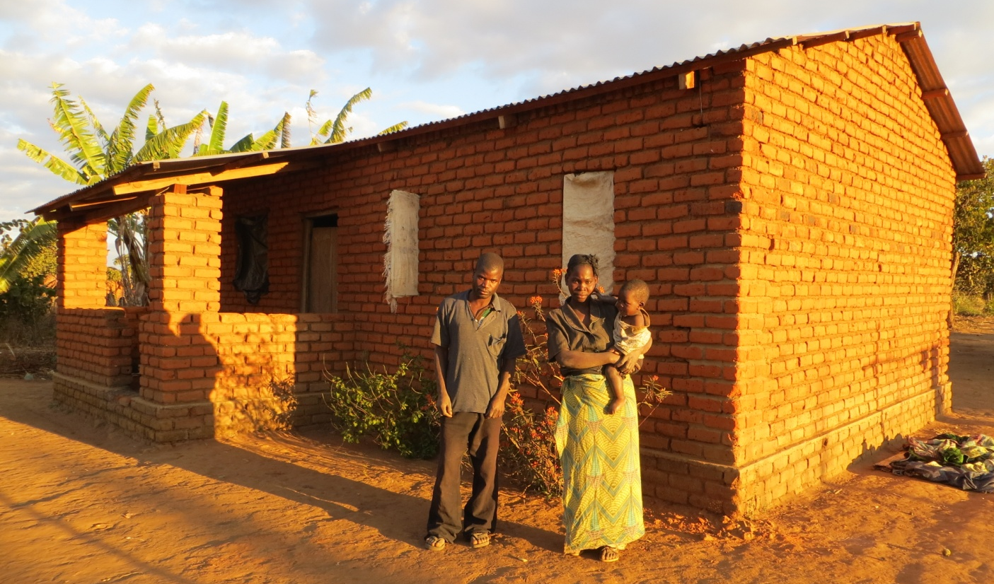

Above: one of the host families for the Trek team
For more photos from Kambanga please visit http://www.flickr.com/photos/40414327@N07/

YOUR SCHOOL PROJECT
The buildOn school block in Kambanga will have 2 classrooms with a corrugated metal roof and a poured concrete floor. It will be built with more than 50,000 fired clay bricks molded by members of the community. The people of Kambanga have already begun work on the bricks, gathered local materials, and attended several mass meetings with their buildOn Field Coordinator to prepare for the project. This project will begin in July 2013 with the help of a Trek team from the US. The entire community will gather with the US ambassadors before beginning construction to sign a covenant outlining the following responsibilities:

Community Contribution
- Unskilled labor: 30 workers (15 women and 15 men) per day, six days per week
- Commitment to educating girls and boys equally
- The land on which the school is built
- High quality local materials: sand, gravel, water & rocks
- Volunteer management committee made up of 12 villagers (six women, six men)
- Lodging for buildOn Field Coordinator and skilled laborers in local houses
- Basic construction tools (picks, buckets, etc.) when available

buildOn Contribution
- Architecture and engineering
- Construction materials (excluding local materials) for school and latrine
- Skilled labor and plans needed to build the school
- Project management (buildOn coordinators)
- Instruction in basic construction techniques

THANK YOU FOR YOUR SUPPORT!

