“Support for large families – under one roof”
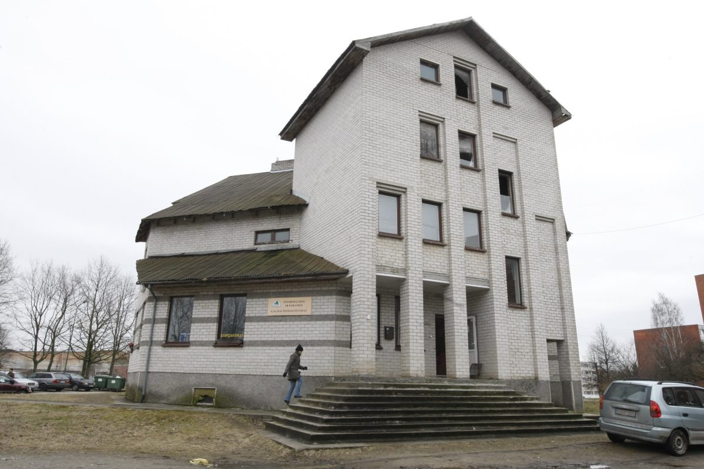
All organizations, providing aid for large families and other social groups, will be located under one roof. The idea was born five years ago , not without difficulties , but still making its way toward the goal .
Currently, “Information and Support for Large Families Center” is located in Debrecen street number 3.
"When we bought the building , there were two working organizations , one of them is now retired . Premises are too big for only our usage , that’s why we were faced with the question whether to sell the building , or come up with something useful to make from it. However, to sell it would be a bad decision , only on rare occasions a non-governmental organizations have their own building/office space" - interpretation of ”Information and Support for Large Families Center” director Regina Ševelkaitienė .
Interlocutor noted that very often non-governmental organizations come together because they have a lot of ambitions , hopes, wishes to act, but do not have a place where to choose and develop their business. For this reason, organizations often break up.
Therefore it was decided to bring all non-governmental organizations, that work with families and provide them with assistance , under one roof.
It is planned that 1,000 square meters of space in the building will fit seven non-governmental organizations.
“Information and Support for Large Families Center” is currently working with Klaipėda’s large families community „Šeimyna ", a social aid agency for disabled and a number of elderly people organizations.
It is planned that these organizations would settle down in this building.
In winter 2009 “Information and Support for Large Families Center” organized a contest for young architects. Their objective was to create building development visions.
At the end of a contest, five best possible visions were chosen and the best one was selected using discussion method.
"Currently we are working very actively and trying to get the money for project’s implementation . In order to be able to benefit from the EU funds , we need a good technical design project " - interlocutor assured .
During the year this center is visited by 2,300 children. Therefore, the project was named " Renovating 2300 children” .
50,000 LTL are needed to develop all the required documents before beginning of the construction.
"While looking for money while being unable to discover partners . Some people occur , but eventually they disappear . No one wants to suffer difficulties , but when all is finished and it’s time to celebrate, no doubt, there will be plenty . Rest assured, we will also celebrate that " , - R.Ševelkaitienė assured.

