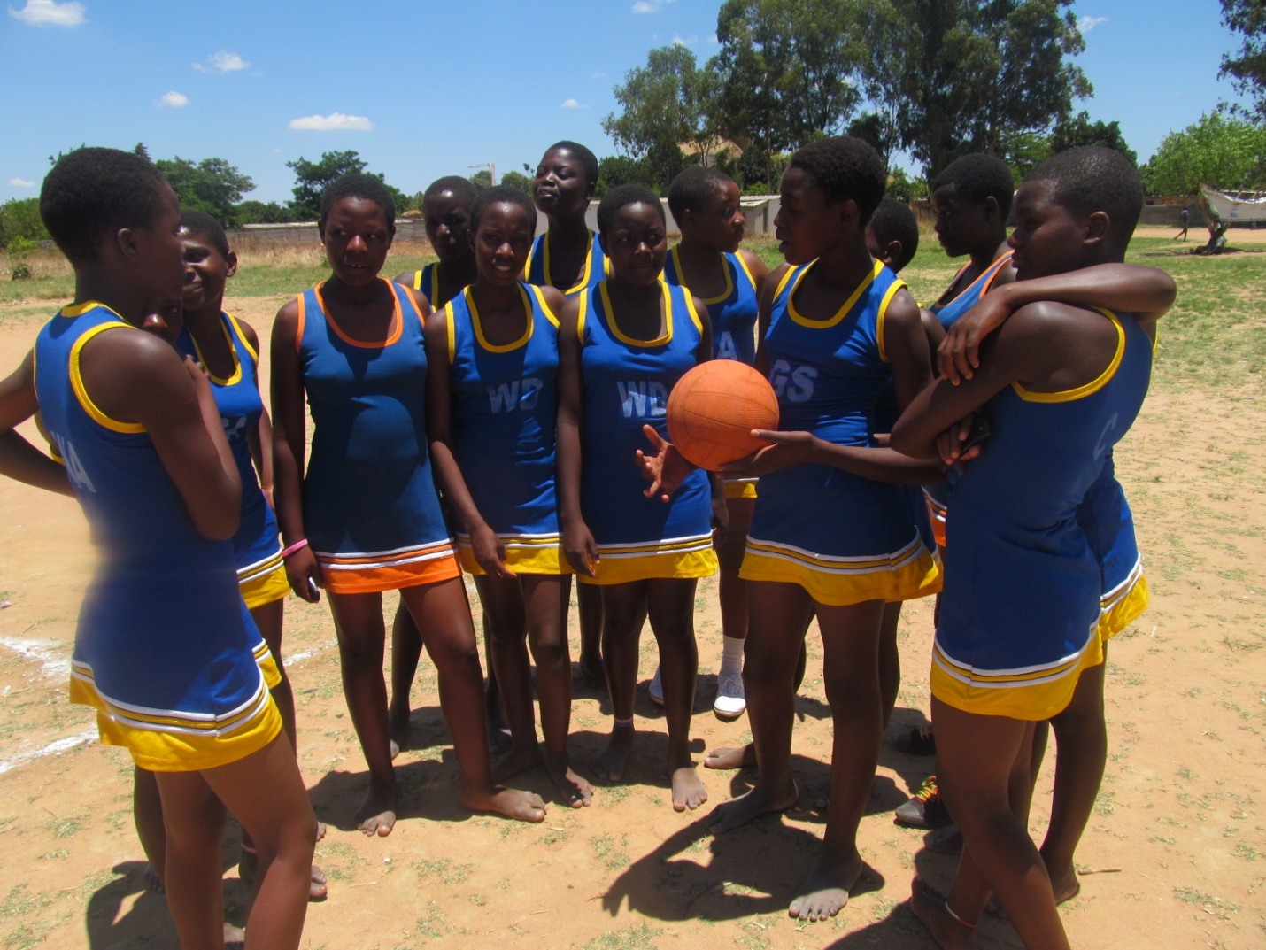

Figure Chiedza Netball Team

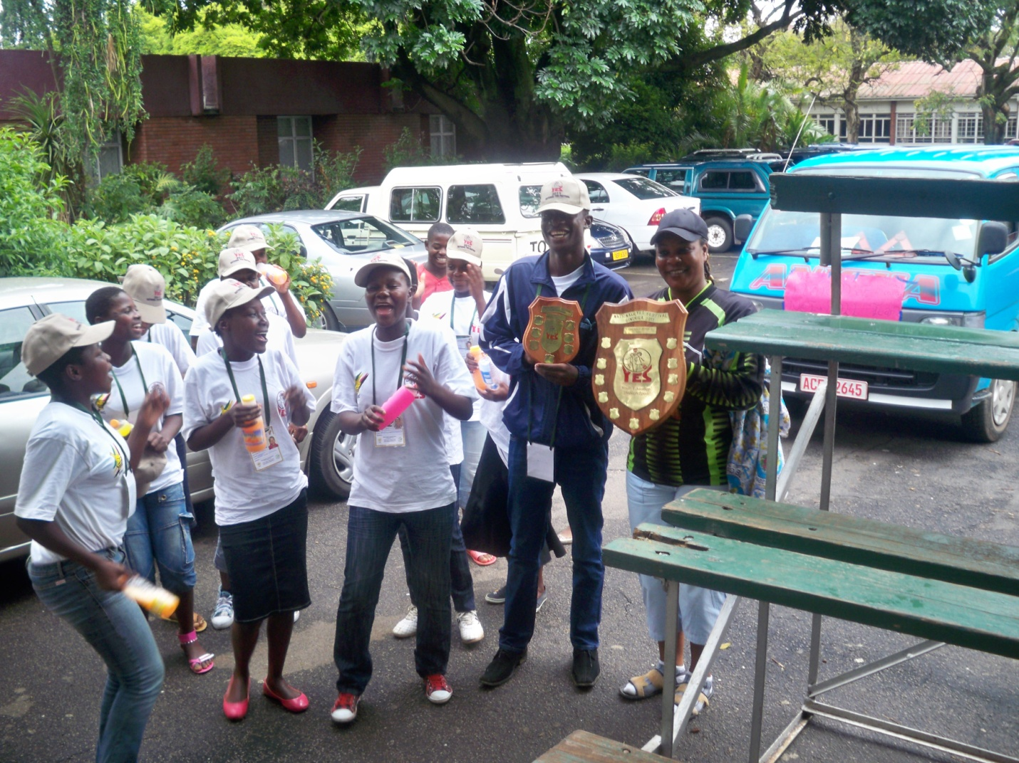

Figure Chiedza netball team holding their trophies in Bulawayo

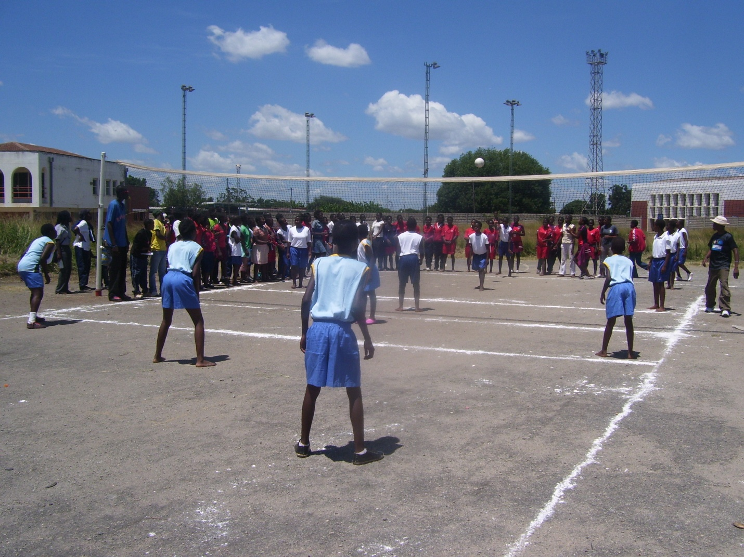

Figure Chiedza Volleyball team

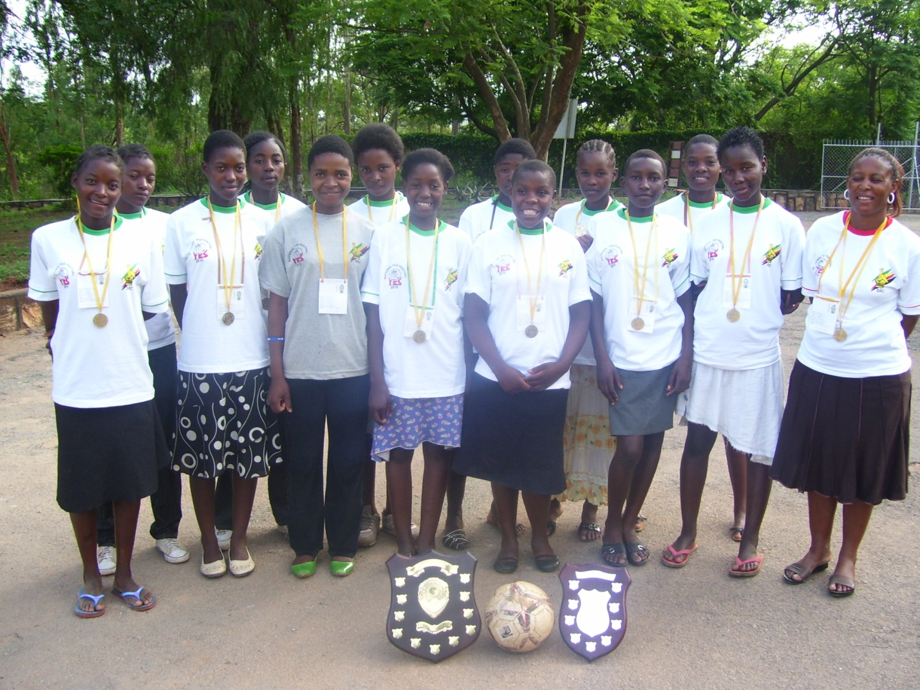

Figure Chiedza netball team-shining on!

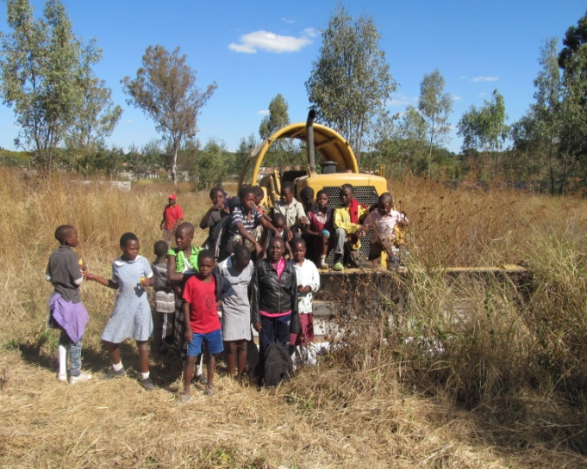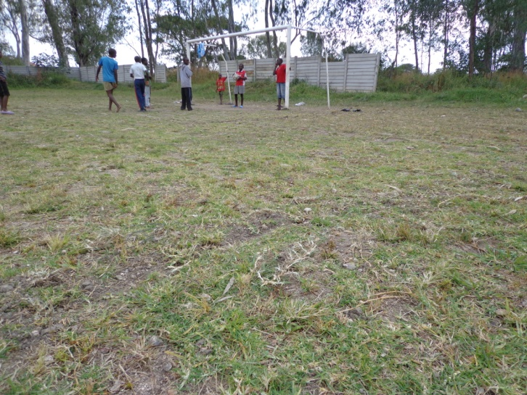

Figure Soccer Field before

Figure Soccer Field After