1. Project Name: Central India Tiger Corridor Securement Project
2. Project Overview
The Central India Tiger Landscape—spanning parts of Madhya Pradesh, Maharashtra, Chhattisgarh, and Telangana—supports nearly 37% of India’s wild tiger population and remains a global priority for conservation. However, increasing fragmentation from infrastructure and human pressures threatens vital ecological connectivity across this mosaic of forests and human-use areas. WTI’s project focuses on securing key corridors such as the Kanha–Achanakmar–Nagzira–Navegaon and Nagzira–Nawegaon–Tadoba linkages, which are essential for tiger dispersal, gene flow, and long-term population stability. Building on long-term work in the Navegaon–Nagzira Tiger Reserve landscape, the initiative combines scientific assessments, community engagement, and institutional collaboration to strengthen functional connectivity.
The project integrates occupancy surveys, camera trapping, and spatial analysis to assess corridor health and identify threats, alongside targeted mitigation measures such as anti-snare patrols and interventions to reduce electrocution risks. Community-based approaches—including the Green Corridor Champions network—support local stewardship, conflict mitigation, and awareness generation, while capacity building of frontline forest staff enhances enforcement and response. Through a science-based and community-rooted strategy, the project aims to secure critical wildlife corridors, enable natural tiger dispersal across state boundaries, and build resilient, locally supported conservation systems across Central India.
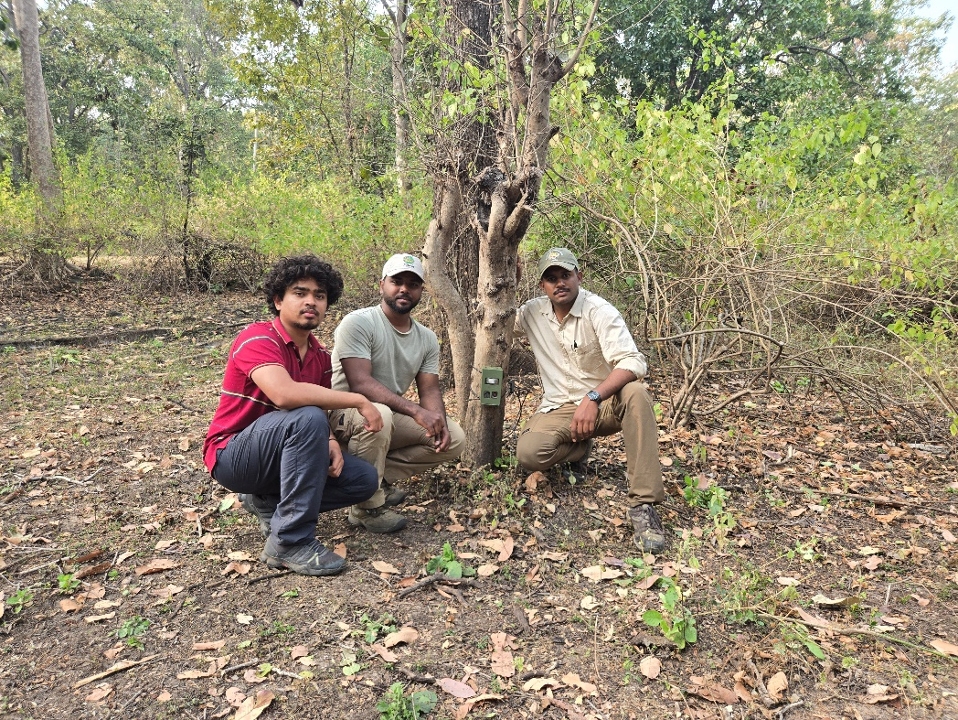
3. Project Photographs

Figure 1: Camera Trapping in Kanha-Achanakmar Corridor
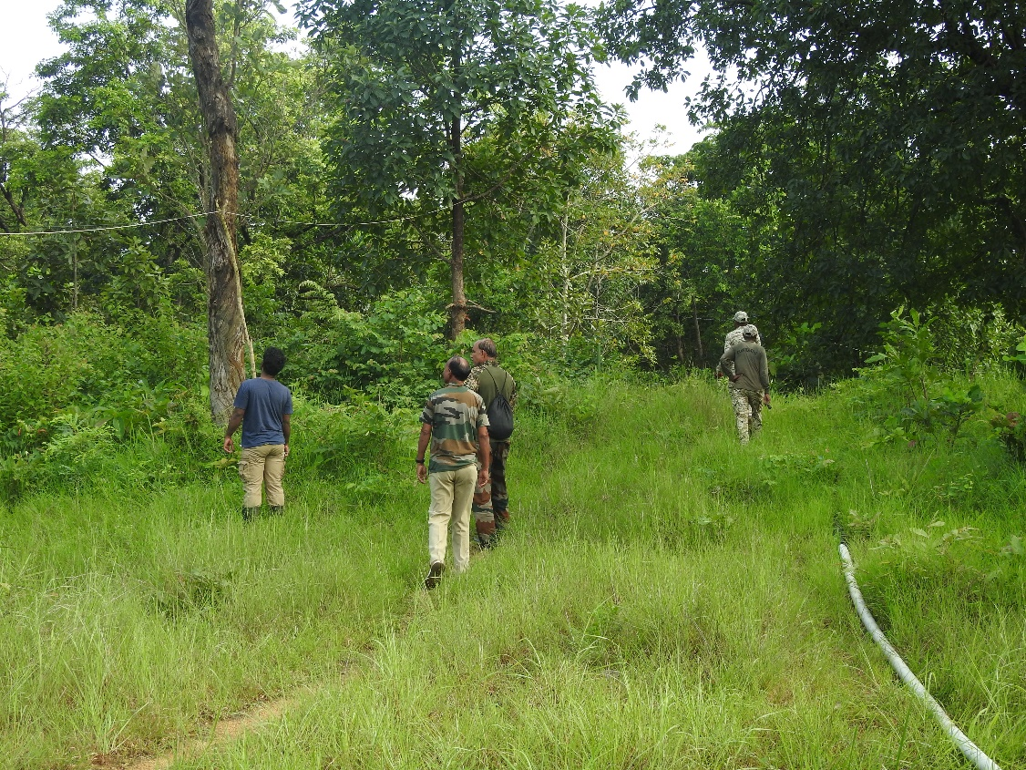

Figure 2: Anti Snare and Anti Electrocution Walks across the NNTR Corridor
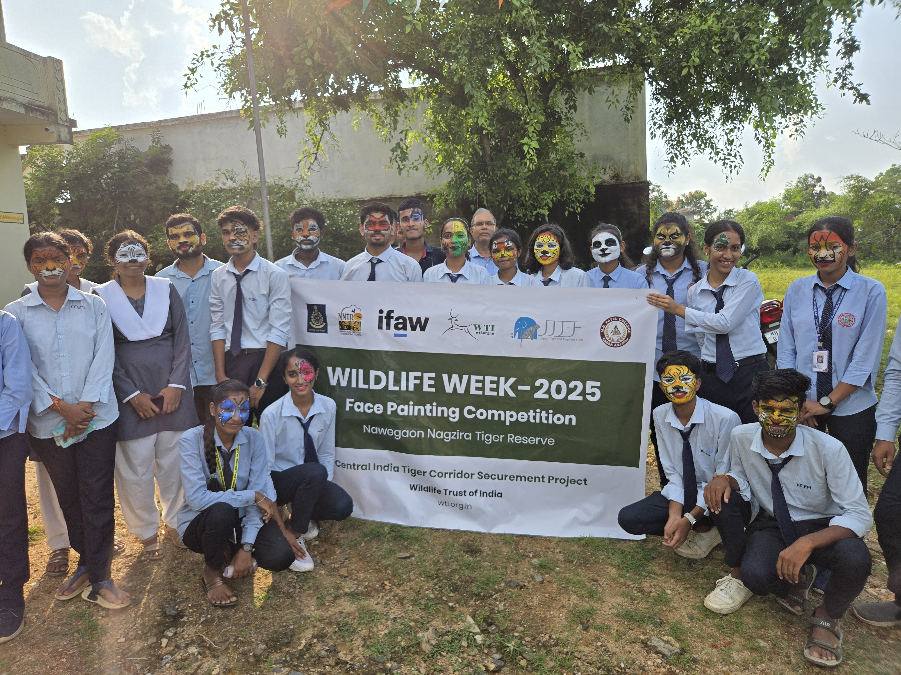
Figure 3: Face Painting during Wildlife Week 2025


Figure 4: Seized Snares during Anti-Snare Walks

4. Key Highlights from 25-26
- The NNTR Corridor where WTI has been working since 2006, has now been designated as a buffer of the tiger reserve with unified control. Jurisdiction has been transferred from the territorial forest department to the tiger reserve authorities, strengthening protection and management. The buffer of NNTR, notified in 2016, had remained outside the control of the tiger reserve for the past nine years. With unified control, the buffer area will now receive much-needed protection and management interventions, thereby enhancing the productivity of the Protected Area. This also marks a significant achievement for WTI and all relevant stakeholders for their efforts in getting a corridor included in the PA network.
- 104 anti-snare and anti-electrocution walks were conducted, covering 622.9 kms of distance. During these walks, 92 beats were covered. As a result of these walks, 131 multi-loop snares, one live wire setup, 12 inactive electrocution setups were found and removed. These actions deter illegal hunting and accidental wildlife deaths.
- A detailed survey was conducted along a 14 km railway stretch passing through the NNTR corridor. A Land Use Land Cover (LULC) map was prepared for a 2 km buffer on both sides of the track to assess habitat characteristics and potential wildlife movement zones. The team also mapped chain-link fencing along the railway line to assess its spatial extent and implications for wildlife movement.
- WTI has compiled an SOP/guidelines for conducting Anti-Snare Walks (ASW) and Anti-Electrocution Drives (AED) in the landscape. This initiative aims to enhance accessibility and understanding of standard protocols among frontline forest staff and local stakeholders, thereby strengthening the effectiveness of field-level implementation and wildlife crime prevention efforts.
- A three-day orientation for frontline forest staff from three ranges of the Gondia Forest Division was held in August 2025. Conducted by WTI, it trained 82 participants on anti-electrocution and anti-snare patrols, covering snare/trap identification, electrocution points, and patrol safety. Post-training scores rose from 53% to 68%, showing a 14% knowledge gain among the participants.
- The team completed sociological surveys in 25 villages within the identified bottleneck of the Kanha–Nawegaon Tiger Corridor. These surveys provided critical insights into community livelihoods, practices, and perceptions towards tigers and conservation, and helped identify hotspots of wildlife crime and retaliatory incidents
- Camera trapping and wildlife sign surveys were conducted across the NNTR and Kanha–Achanakmar corridors using standardized occupancy protocols, including replicated transects and systematic recording of indirect evidences such as pugmarks, scat, and scrape marks with GPS-enabled devices. Camera traps were strategically deployed based on habitat features and movement signs. Preliminary findings indicate active tiger presence in monitored areas, highlighting corridor use and strengthening baseline understanding of wildlife distribution, with detailed results to follow after analysis.

