Wash rooms increase school enrolment for girl child at KEA Green Hill Education Center Mityana
Dear our beloved donors,
Our heart is always about helping the children in need, we thank you to our loyal supporters, donors, volunteers and community feeling part of our community, you are so wonderful in supporting our work by donating to our community, I have strong feeling that one day our dream will come true and our community will be vibrant to community development and the challenges the community is facing currently will be overcome.
Through the tireless efforts of KEA and support from donors (www.globalgiving.org), and continued support to KEA Green Hill Education Center located in Kasejjere village Kikandwa sub-county Mityana District Uganda, the school lacked good wash rooms facilities often that to girls dropping out of school during the menstrual periods. There is evidence that as many as one ten school girl classes or drop out completely.
The donations have helped to construct toilets and washrooms to reduce the high pupil to latrine ratio and offer separate toilet for boys and girls and raising awareness to ensure school attendance of girls during menstruation and increase the number of girls attend school, expanding and improve on the structures around school, the school lacked good sanitation facilities , in the recent participatory meetings organized by the community and school set-up goal to improve on the sanitation around school especially for a girl child by constructing a wash room and good toilets. A ventilated improved pit latrine was designed to improve crucial health interventions, this has been realized with proper construction and use of facilities of good personal and domestic hygiene.
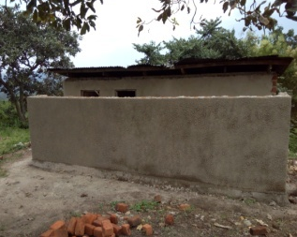
The goal of the construction of the wash room was to prevent the transmission of diseases as it prevents contamination of water and soil. Lack of proper sanitation facilities was significant portion of infections affecting girl child hence a burden to a children missing school. “WHO, disease due to poor water supply sanitation, and personal domestic hygine 4.0% of all the deaths and 5.7% of all disability or ill health in the world. Moreover, water bone illness predominantly affect the poor and the young. When basic water, sanitation, and hygiene innervations are applied, waterborne illness can be effectively reduced( www.who.int).
The school had a filled up or no latrine completely which resolved to a new construction of a latrine serving over 170 girls and 100 boys, the school children especially girls feared to the toilet the resolved to visit homestead this was at risk to closure of the school due to poor hygiene conditions at the school, with a limited budget the school with the money raised by donors a new wash room and toilets were constructed.
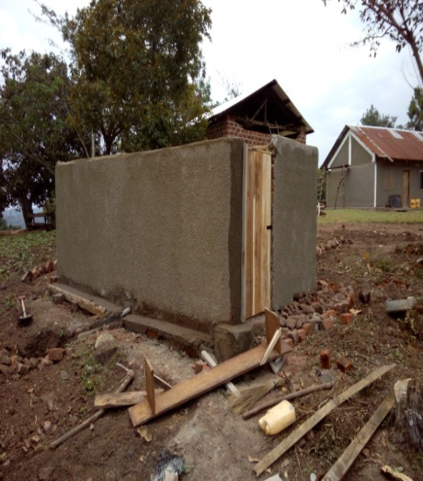
The school has safe disposal of waste and future trained the children on good hygiene habits WASH, and has formed health clubs responsible for general hygiene within the school compound, that is committed to long lasting change to measure key performance indicators of constructed washrooms.
We seek to ensure that KEA Green Hill Education Center continue to prosper by enabling the school and the community manage the school new constructed washrooms and toilets, train children in hygiene, think creatively about solutions appropriately for girl child keep in school through continued support and remaking a happy cheerful and confident children in the community.
Thank you for the continued support and all the donations are driven to community development

