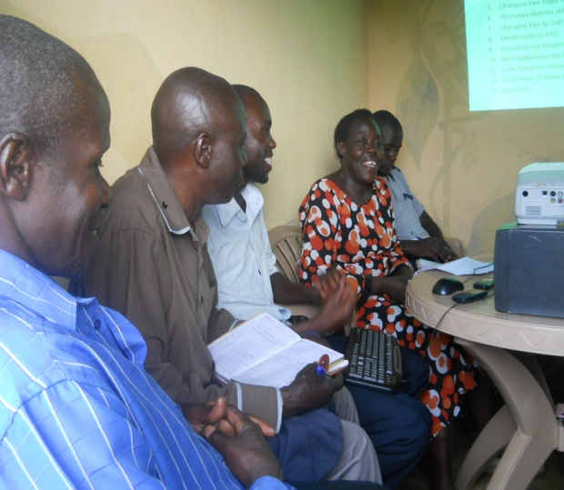
REPORT ON THE COMMUNITY INNOVATION RESOURCE CENTER
Figure 1: Staff and board members of the resource center during a meeting with students
Since we started the campaign for fundraising for the resource Centre, we have been reflecting and evaluating the love, generosity, knowledge, advice and guidance support you people have rendered to us in our struggle to make Kikandwa people computer literate. We continue to think of finding appropriate words to say thank you but we continuously fail; but allow us to express our sincere gratitude towards what you have done for us so far, the community is very grateful with all what you have done.

We are so thrilled to be a piece of the Global Giving Community and we fully understand that the center could not be in place without you.
The center is a multi-purpose place where information is generated, disseminated, managed and shared. It is a place of reference and referral whose main target is the local community, researchers, and government and non-government organizations.
It has had working staff members who are determined to make it a success on ground in the local community and this is what they have achieved and encountered along their endeavors.

Achievements
- We are now training over 15 people (majority are students and school teachers) to become computer literate and they have started to learn to use computers in their day to day lives. They have learnt to use both software and hardware and how to use IT to earn a living.
- The center has now 3 graduates from the computer training studies and these students are set to join leading institutions in the capital city Kampala to further upgrade their studies. The students will be awarded certificates to recognize their efforts in their struggle to become computer literate.
- The center is now about to start a schools outreach programme and community workshops in the area. The major aim of this programme is;
- Let the community fully understand what is being done at the center.
- To offer career guidance to school going children.
- To address the issue of community development through avenues like volunteerism.
- To make the society understand the need for food security and how we can address it.
- To address the need for sustainable agriculture practices.
- To understand Climate change challenges and what can be done to mitigate it

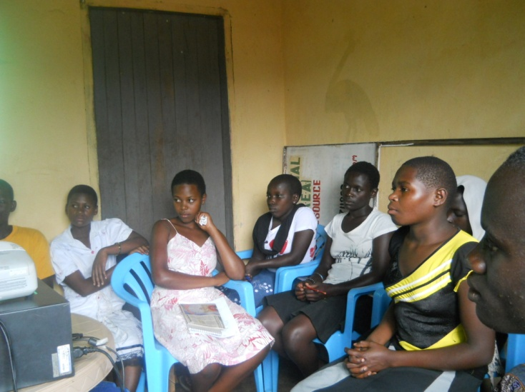
Figure 2: Students of the resource center having a meeting with the staff

Challenges
Since the time we opened up the resource center, we met a lot of challenges. These ranged from financial to every day challenges that arise from change of environment.
- Our main objective of starting the resource Centre was to provide internet services to the community to save them from moving 60 kilometers to the capital city to access such services, we also need regular funding to recharge the modems for internet access with limited funds.
- The center is now facing a problem of lack of monitors since all the monitors were damaged by unstable electricity.
- One of the toughest the staff members face is transport to the center. They have to walk a very long distance (more than 16 km to and fro) every day to be able to deliver the services to the students. This distance most times takes a toll on their bodies daily as they have to walking almost a third of the day and we do not have the money to rent for them a nearby room where they can stay.
Future Plans
The center is planning on introducing a photo studio in the area since there is nothing like a photo studio in the area.
Due to the above mentioned challenges, we are looking for all avenues where we can raise money to especially buy new computer monitors (as the students now are dependent on the projectors to have lessons) and to install internet at the center so that we can serve our community better. We continue to dream of the day when we will have our own Internet connection and know that the Community Innovation Resource Centre can be open every day to provide services to the community.
We are so thankful for your support. So thankful! Your donations are exciting the whole community each time we receive them.
The whole of the future is built in global partnerships and we are so honored to have this relationship.
To donate, please follow the link below
http://www.globalgiving.org/projects/community-innovation-resource-centre/
Items which are urgently needed per year for the resource Centre to be fully operational.
Item | Subtotal per year
Cost of internet setup | $900 (a one time payment)
Cost of internet services | $1800
Allowances for the computer trainer | $2400
Cost of electricity | $600
Cost of stationery, computer repairs, printer and photocopier maintenance | $3600
Binding machine | $200
Radio and television | $950
Daily newspapers both English and local languages | $720
Purchasing of 4 new computers | $2000
Transport (2 bicycles) | $300
Grand total | $13,470

Best regards from
Kaganga John

The Million Person Project!
Check it out: http://millionpersonproject.org/

