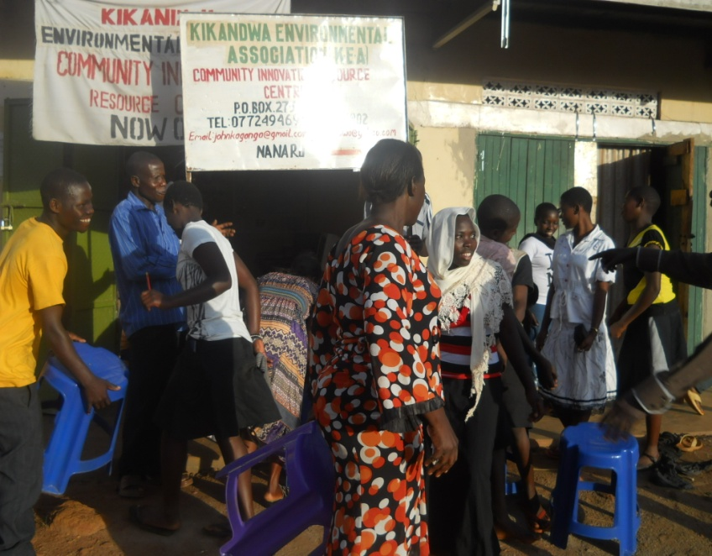
We are so delighted with our donors for the initiative they took to support our people to get a community resource center; all activities are going on well.

In a special way, we thank the recurring donors because without their continued donations, the centre wouldn’t be in existence. Your donations help in the day to day expenses although it is still inadequate. We currently have six recurring donors only who contribute a total of $100 per month whereas the expenses are approximately above $300 per month. Therefore we would like to increase the number up to thirty recurring donors for the center to be sustainable.
From July up to the end of October, we have been busy looking for funds to maintain the resource center as well as fundraising for the internet. We thank The Pollination Project who gave grant of $1000 towards the installation of internet. We also thank those who have supported us very much during the campaign which is still going on where we want to raise money to completely cover for internet and other expenses.
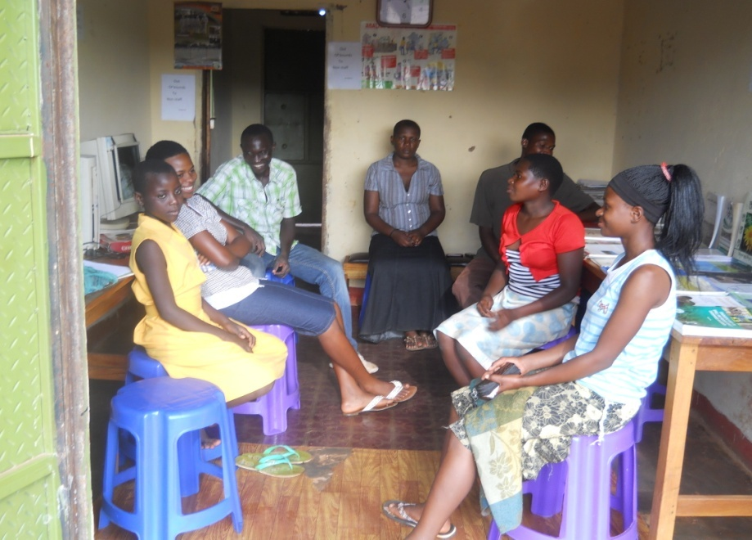
Although the Community Innovation Resource Center (CIRC) was launched in December 2012, we will be celebrating our one year anniversary on 21/11/2013 where we will be awarding certificates to our pioneer students who were trained on basic computer packages of Microsoft (Word 2007, Excel 2007, and PowerPoint 2007), Adobe illustrator and they were all introduced to social media sites like facebook and twitter.

We will be inviting the entire community, National NGOs, government officials and development partners to celebrate that day with us. Therefore you are all invited.
We have started the registration for the December intake for courses that will begin on 10/12/2013 up to February 2014. We have registered 46 students which include farmers. Out of the 46 students, only 5 students can pay for the full training fee of $150 per semester including new courses that have been introduced.
The administration can only offer only 5 full bursaries and give 20 students half bursaries. But even with the bursary scheme in place, only 5 of the half bursary students can afford to pay for the training and the remaining 15 cannot afford to pay anything but are very much interested in learning how to use ICT in the agricultural sector so they need sponsorship. Therefore we appeal to you to continue donating generously so that we can increase on the number we can offer full bursaries. If anyone can sponsor one or more students half or full bursaries are most welcome (Full bursary is $150 and half bursary is $75).
We are also requesting you to become a recurring donor so that we can move from 6 to 30 recurring donors. We would like to thank the Global Giving staff for the efforts they put in to make our efforts worthwhile. Once we thank you for your generous donations and contribution.
To donate please visit: http://www.globalgiving.org/projects/community-innovation-resource-centre/.

