Dear Members and Partners!
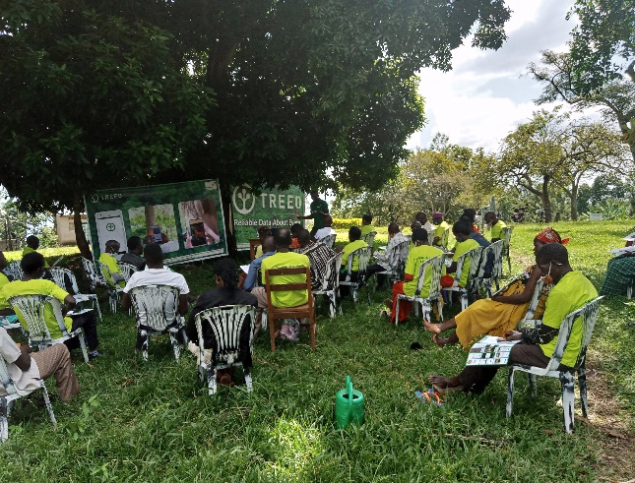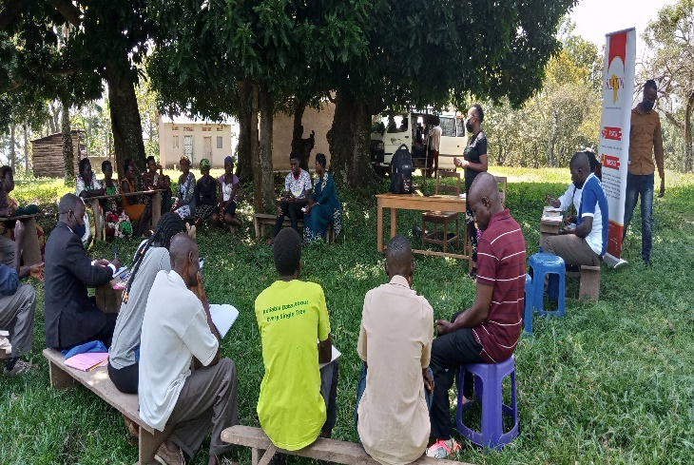
Seasonal Greetings from the Kikandwa Environmental Association-Uganda Secretariat!!! Reflecting back to the beginning of 2020—when we were just starting to grapple with the unprecedented challenges posed by COVID-19-Its commendable how gradually we continue to support one another and articulating ideas for climate action amidst the challenging recovery. As our awareness awakes to the devastating scale of the COVID-19 pandemic, we continue to reflect and re-image- a space to form a collective memory of the realities being faced and the injustices being exacerbated by the two-pronged crises of COVID and Climate. We have continued to augment our virtual organizing as we advocate for just recovery policy responses, and contribute to building a collective resilient future.
We look forward to a fruitful and prosperous year 2022- as we wish you a restful and safe end of year. Merry Christmas and a Happy New Year From Us to you and Your Families!!!
Director-KE
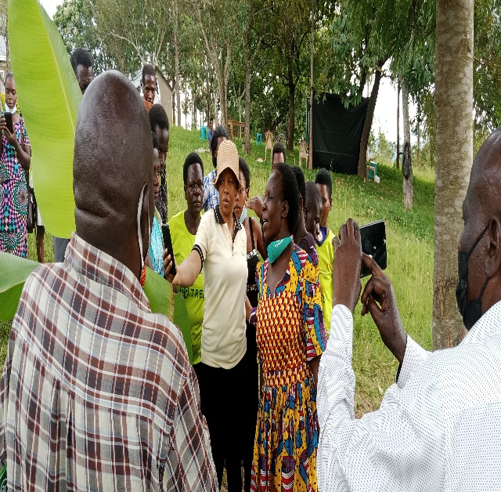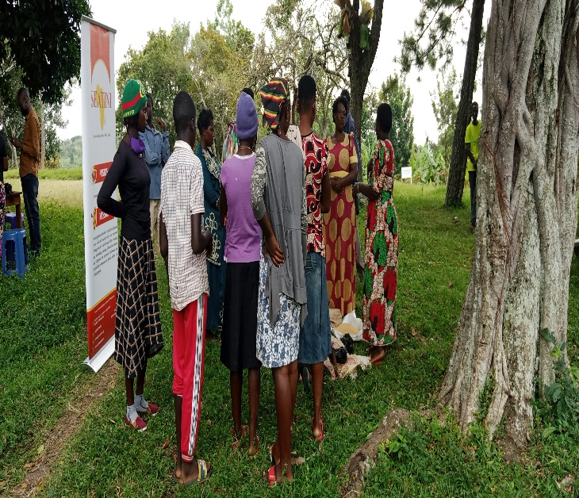
This year, we worked towards recovering from a global pandemic to just tree planting recovery for a socially and environmentally just society - if anything, we stood stronger! Now, as we reflect on the progress we have made in 2021, we would like to look back at the top moments we’ve accomplished together with partners moments we should all be proud of and thankful for:
The tree planting campaign that took place from July to December 2021 was a celebratory moment that saw people from over 150 families come together for interactive workshops, hands-on trainings that helped planting 3000 trees spices, helping in new energy in this crucial movement to halt the climate crisis fights against, climate inequality, that we need to keep showing up, and to take a stand against both hateful, destroyers of climate we are facing.
With a focus on climate change adaptation, poverty alleviation and food security, the project has sensitized farming households about the benefits of agro forestry. The tree planting project targeted subsistence farmers mainly women and the youths in Kikandwa sub-county Mityana District -Uganda.
Among some of the key problems faced in the target regions was extreme climates with prolonged drought, loss of productivity of agricultural land, severe land degradation as well as abnormally high levels of deforestation and over utilization of natural resources exacerbated by unpredictable climate changes. Climate change in the target regions negatively affects food and water security and livelihoods. Therefore, through the project, we encouraged targeted communities to grow more trees and also train farmers and community members on improved agro-forestry techniques and how to construct fuel saving stoves to reduce the current rate of tree cutting in the region. This was done with the aim of contributing to the overall goal of mitigating the adverse effects of climate change which is a global challenge. This also helped to alleviate the social-economic and environmental problems facing people in the region such as recurrent drought, insurgency of pests and diseases and food shortages. Additionally, through the project, communities are taught better land management in order to increase overall crop yields, production of trees, reduction in fuel-wood consumption, and income generation through alternative livelihoods especially for women and children.

SUMMARY
In 2021 the funding raised has supported more than half of the total project cost helping 150 farming families comprising 1,696 people - to improve their lives through planting trees in sustainable farming systems. The project began in July 2019 and, as of December 2021, the farmer participants have planted nearly 3000 trees on 70 acres of land. The area is known for growing high-value food crops. However, to thousands of acres of trees have been cut in the last few decades to make room for additional farmland for growing food crops. In addition to corn is grown as a staple crop. However, the cutting of trees and monocropping of corn have left the soil depleted of nutrients. The environmental impacts of growing monocrops corn cannot be separated from that of modern agriculture in general. The most detrimental impacts from agriculture occur due to land-use change, poor farming practices, loss of soil fertility and tree cover, and runoff from fertilizers and insecticides. Many farmers have chosen to develop their forest gardens on farmland that they had abandoned due to soil infertility. This is particularly interesting because it gives us an opportunity to see enormous changes in soil fertility as the Forest Garden develops. In just under a year, farmers are beginning to restore this land by planting live fencing/ green walls around their fields and alley cropping with nitrogen-fixing species.
The project has achieved are as follows:
- Ecosystem synergies that allow the entire intercropping system to produce higher yields protects the fragile ecosystem with semi-arid and complex soil conditions in Kikandwa, which cannot support typical monoculture palm oil plantation.
- Large quantities of biomass for mulching and moisture retention.
- Increased farmer incomes and food security
- Adaptation to climate change and resilience to rainfall variability, including drought and flooding: reducing the effects of climate-induced hydro-meteorological events by transforming dryland into a sponge that can absorb and channel rainwater into the ground during heavy rain events and release green water during months of drought.
- CO₂ sequestration-intensive farmland
- Improved soil fertility through intensive pruning, mulching, use of manure and the introduction of nitrogen-fixing (leguminous) cover crops.
- Adopted organic practices - no pesticides or chemical fertilizers.
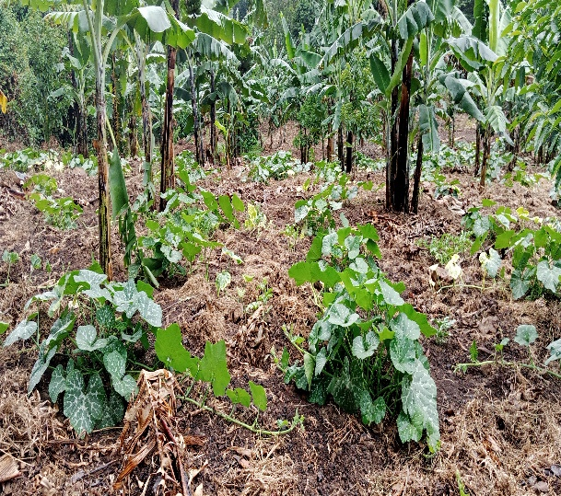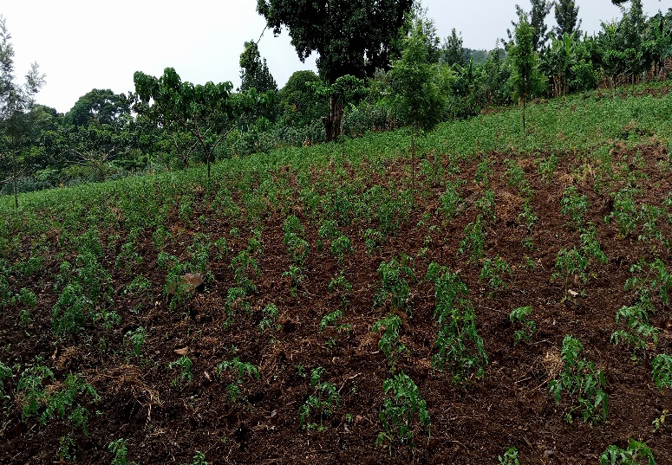

 | Project Total | Total Supported by KEA
Number of Farmers  Female 66%  Male 33% | 187 | 292
Families Beneficiaries | 150 | 1118
July to December 2021 farmers plant nearly 3000 trees. Throughout the year they held4 training sessions on 10 Forest farms .

 | Project  Total | Total Supported by Global Giving
Number of Trees Planted | 3000 | 20,000
Number of Training Conducted | 4 | 6
Number of Acres Planted | 12 | 70

Trees | Vegetables
Leucaena leucocephala – animal fodder, live fence  Moringa olifera - food, intercropping  Acacia polyacantha - live fence  Gliricidia sepium - animal fodder, live fence Grevillea robusta (Grevillea, Silky Oak) - timber  Pasiflora edulis (Passion Fruit) - fruit  Carica papaya (Papaya) -fruit  Mango - fruit  Avocado- fruit | Kale Okra  Carrot  Onion  Tomatoes  Pumpkin  Cassava  Beans  Watermelon

MONITORING AND EVALUATION
Monthly farmer visits are conducted by technicians to observe progress and provide one-onone mentoring and technical support. Technicians also record the amount of training conducted, and trees planted and report this information through feedback meeting and checklist.
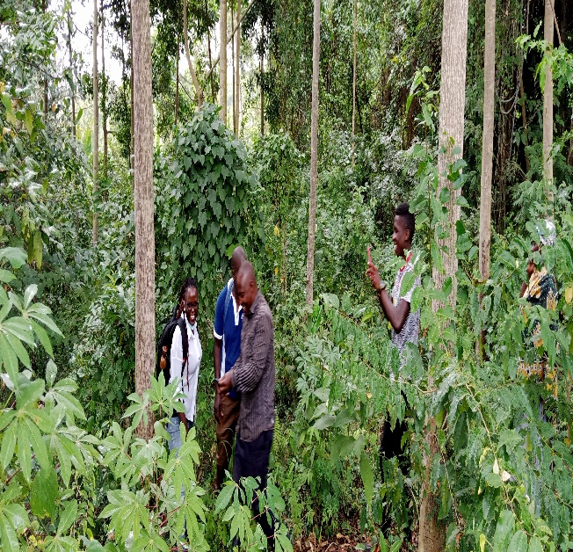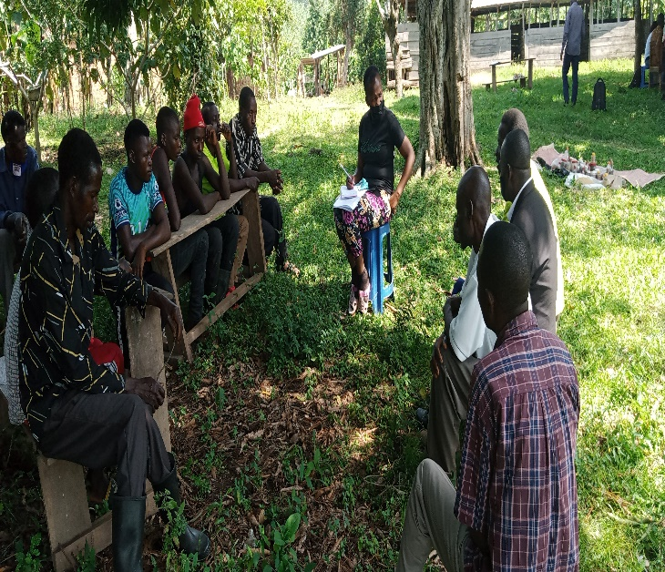
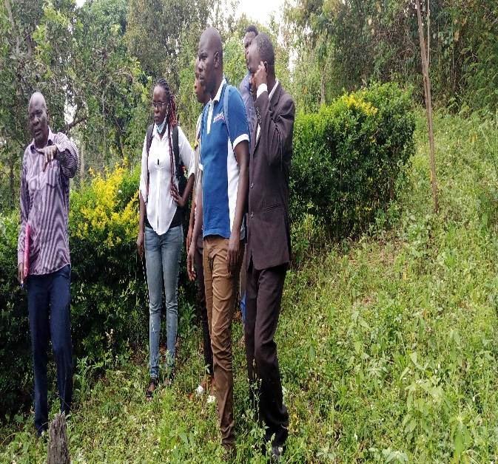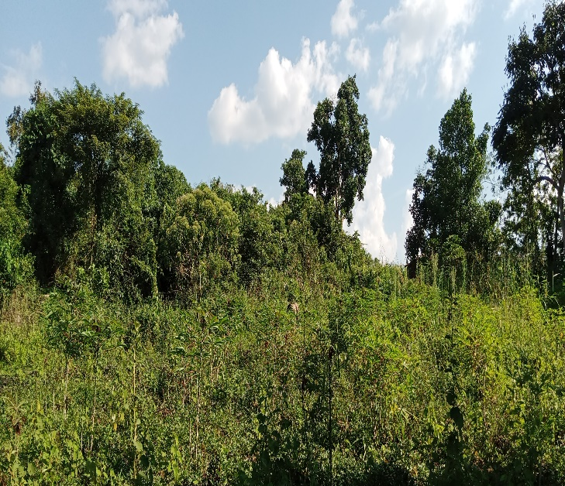

2021 has posed quite a number of challenges but also brought some opportunities which we need to reflect on in 2022. As KEA, we take the opportunity and honor to thank you for the tremendous support and contribution toward the fight against climate change and malinuturtion amidst other challenges. on the note we would like to wish you a happy holidays and a prosperous 2022 moving forward
Happy new year 2022 and Marry Marry Christmas

