

About Organisation:

Literacy India was set up in 1996 as a non-profit organization, with the objective of empowering and educating children and women. It has clearly set three E’s as its goal on coarse to achieve in the next one decade i.e. Education, Empowerment and Employment. It focused on bringing about a qualitative change in the lives of underprivileged, underserved children by giving a different meaning to education

The objectives of the organization are as follows:

• To identify young girls from under privileged backgrounds and help build their confidence and awareness
• To support children in active schooling to provide minimum levels of learning.
• To use role models to inspire the youth to take up issues concerning their communities.
• To provide women and children with vocational skills.
• To empower women economically from rural & slum areas.
• To nurture, mentor and assist children to become human resource assets in the community and to restore dignity amongst the underprivileged.

Literacy India endeavor to meet this objective through imparting basic education and through exposing students to a variety of vocational skills in performing arts, computer animation, etc. Organization believes in innovative pedagogy in order to retain the children within the purview of education.

Project Karigiri:
This was established to provide a platform for vocational training especially for those students who showed a lack of interest in continueing formal studies or were dropouts from school. Here we organise programs specially keeping an eye on providing employable skills to the youth. Courses offered had been O – level Classes( basic computer programming) under NIELT( Govt. regd.),DTP, Web Design, Networking, Tally for Accounting, Spoken English, Retail Management, Paper Products training and Housekeeping. We have partnered with Maruti Suzuki under their Road Safety Program for training in driving. It is a matter of pride that many graduating students are working with organizations like Maruti Udyog Ltd,Kuoni Destination Management , B-CUBE, Reliance Fresh, and Big Bazaar etc. Corporate like Wirkle technogies, Dell- India, and Aricent have given technical teaching support to this program.Over 7000 students have completed ICT training and using their skills in various trades including teaching & starting their own computer centers.Literacy India has taken the initiative to empower rural & Slum women by equipping them with special skills to earn a little income along with managing their household work. Skills offered to them had been sewing, Tailoring, Beauty culture,Driving,computer-literacy , embroidery , pottery , Recycling of paper manufacturing , Paper products and many other. High skilled women under this program are under the project as well as their own brand – INDHA – which has become a household name in Delhi NCR with their exhibitions of handcrafted bags , furnishing & many others items.
These women are also being exposed to the world of search engines to explore how IT can help increasing their productivity. ndha is using Technology to show their Craft to the world – its own website www.indhacraft.org along with online sales in ebay international , shopclues , Feumo & Craftsville.

Objective of Vocational computer Training under Karigari Project

- Provide & promote professional IT skill to community so that they are equipped with industry oriented quality education and training.
- Imparting education and training to generate quality human resources in the areas of IT industry.
- Impart continuing education/refresher training/re-training for rural & Semi urban unemployed youth and Women.
- Develop training & professional programmes to promote self-employment and entrepreneurship.
- Imparting a basic level IT Literacy programme for the rural & Semi urban people.
- Offering job oriented courses like DTP, Tally, and Web designing to enhance IT skill.
- Using Technology based – Spoken English Programs, Online Commerce & Retail Management courses.

Need for vocational training:

In the age of information and Technology, nation’s overall development is connected with the quantity and quality vocational skill possessed by nation’s workforces. The wider the range and higher the quality of vocational skills, the faster is the growth.
There is a great unmet need among the present day’s youth for short, abridged, concise and condensed vocational training programmes. The youth and modern job seekers are trying to impart vocational training according to their own time and pace with relatively low cost. Besides, there is also need for a wide range of vocational courses for those who are already employed but seek to broaden or upgrade their skills to keep pace with changing needs and to further their career opportunities.
The lack of vocational training applies at all levels, from basic mechanical skills needed for operating and repairing equipment to jobs in sales, administration and management, including specialized occupations such as bookkeepers, insurance agents, pharmaceutical marketing, travel agents, food service managers, journalism, etc. It applies also to a wide range of value-added skills for enhancing the performance of workers in different occupations, such as safe driving, rainwater harvesting, energy conservation, customer service, etc.

WHAT WE PROPOSE

This proposal is intended to meet the need for short, low cost and easily accessible vocational training courses. The aim is to establish computerized vocational training programme that can benefit 10000 youth in next three years.

Computer Literacy Program for children:

Computer has become a part and parcel of our day-to-day life. Literacy India started Computer Literacy centre to help the children, develop interest in their studies using digital educational content, increase their self-confidence and help them acquire certain skills, which will help them to be established in life.

Development strategy of Youth through Skill Development, Career Guidance, Training and Placement

Through this proposed project, Literacy India plans to work with youths, adolescent. These are the adolescents from the deprived section of the society, have passed XII Standard. In this proposed 1 year project period, Literacy India’s aim would be to develop skills and provide future job opportunities to these adolescent. They will be trained not only through vocational training but also will be oriented and provided with the necessary inputs to develop their skills, knowledge, and guide them to develop a positive attitude and behavior through organizing Personal grooming workshops, Career Guidance Workshop & Career orientation session at the center with the support of Network organization, volunteers groups, Professional consultancy services and other sources. In one year time, every adolescent will be able to develop themselves as an educated skilled person with better placement opportunities. This will not only help them to bring positive changes in the family but also they would become role models within the community and an inspiration for others.
Literacy India children has got successful placement in Various MNC, retails sales outlet and other sectors including developing manpower or making resource for literacy India itself.

Placements example are as follows:

Oxygen, Big Bazaar, Net Ambit Sales Academy.

Success Case Study:
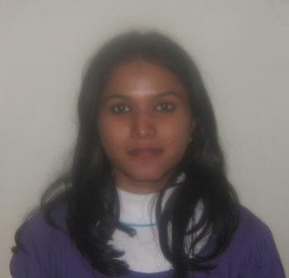

Name: Padma Singh
Father Name: Anup Singh
Address: Chaupal , Near Ration Dafter
V.P.O : Bijwasan, New Delhi
Padma was a very bright student in computer classes in Bijwasan. She had finished her exam of XII standard in the year 2009. She had joined in Bijwasan Literacy India center in the month of January, 2010. She was very regular in the class. She has one brother and one sister. She was very ambitious while she had joined into the computer class. She used to say that as a woman she should have the economic rights so that she can decide on her own. Even her father is a govt. employee in group “D” she did not think as stereotypical foundation of life of a woman being housewife. At present she is getting Rs. 5000/- per month as trainee. She is having probation around 3 months and after the successful completion of probation she will be absorbed in the pay roll with a hike in her salary.



2. Name: Pooja Gupta
Father Name: Pramod Gupta
Address: Near Old water Tank
V.P.O : Bijwasan, New Delhi

Pooja had been migrated from UP with her family while she was too young. Her family stays here since last 18 years. She is the only child within the family. Her father is running a tea-shop.
From the very beginning while she joined into the computer classes, she was trying to get job. She thought she has the responsibility to look after her family and parents.
She had completed the academic exam of class XII standard and now she is doing graduation in Art subjects through private.
She was also regular and bright in the computer classes. She will also earn Rs. 5000/- per month as trainee; after the completion of her 3 months probation there will be hike in salary and she will be absorbed in organizational pay roll.

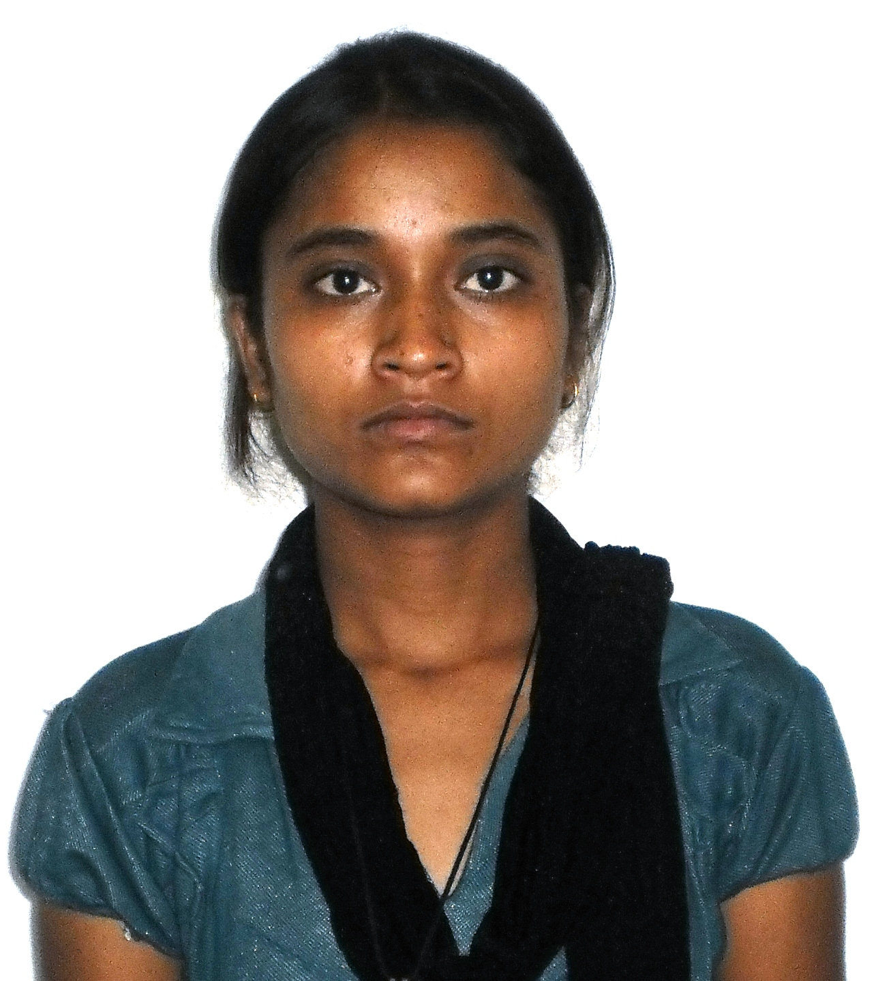
1Parvati Rajput is twenty two years old lady. Since beginning to her childhood she used to play the role as teacher with her friends. From play situation to the present context her role which was dream to her is coming to true. Parvati completed her XII th standard and joined as a student in Literacy India, Bijwasan in order to learn computer. She completed CCA courses with an excellent performance; then she got admission for O level- advance courses on Computer in the same centre. After the completion of CCA, she was provided with scholarship and opportunity to instruct and teaching. At present, she is instructing and managing the class of CCA. She is also undergoing the graduation course as regular from a college.
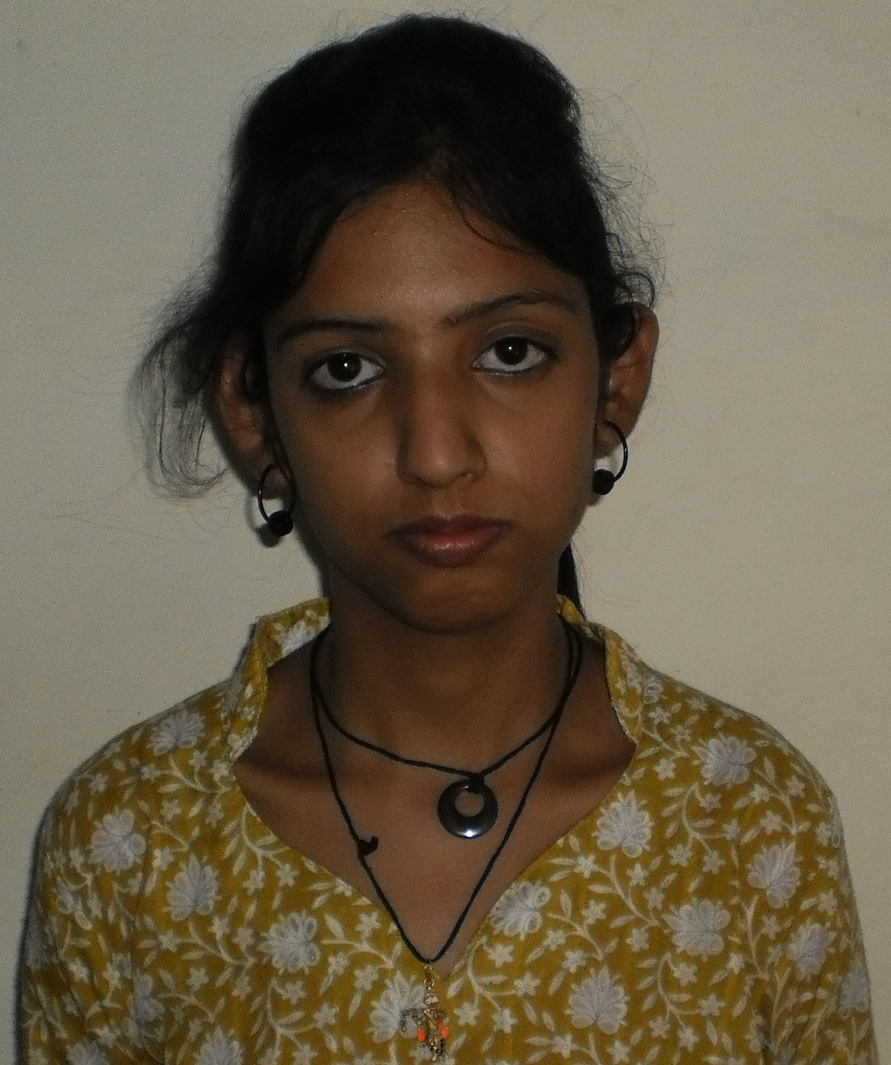
2. Megha Sharma did her B.Com from Gurgaon Dronacharya College. She is staying at Palam and daily passenger of Indian Railway from Palam to Bijwasan. She came to Bijwasan for O level study as she completed her basic level computer course in college level. Although she came to learn Tally in initial stage then she started Tally and O level at the same time. She had a very poor economic background and she had struggled a lot to learn.At present she was provided with scholarship to teach.

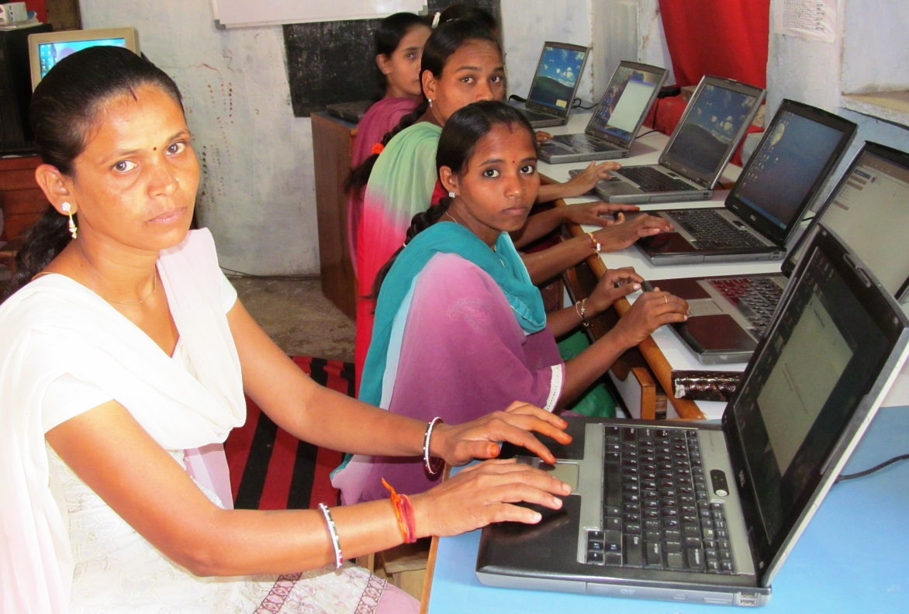
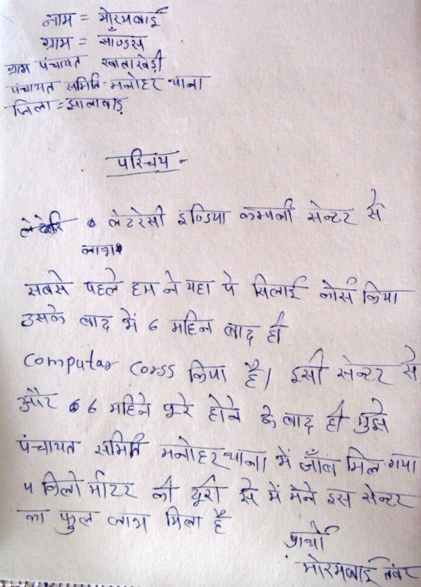
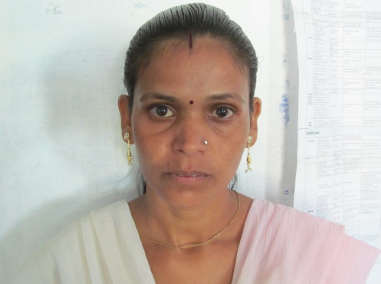

Rajasthan (of India) is known to be sunny and dry state of India. However, one young woman would walk under the scorching sun for six months as she sought to be a computer literate. For the period of May- September, 2012, the 27 year old Moram would walk for 3 hours daily, covering 16km to and from her home to Manoharthan Centre for CCA (Takshan) course, offered by Literacy India. For Moram Bai Tanwar, the scorching sun was nothing compared to the tragedies which she faced in her 27 years’ life. She belongs to a very poor family. During her marriage, her father had to bear the burden of dowry. But she became a victim of domestic violence. Finally, she had been driven out from her husband’s house. In rural India, the tradition of divorce is not quite common. One of her nearest friend recapitulates, ‘Moram forgot to smile’.
It was not an end, but it was a beginning. 10th passed Moram decided to support her family and obviously herself also. She planned to be a tailor. She got training from Literacy India. During this period, she came to know about the CCA course. She started to weave a new dream, a dream to secure her family. And true to her dreams, the young lady has something to smile about; she has secured employment, and conveys thanks to the Literacy India for the opportunity. She got a job of ‘Data Operator’ in local panchayet office and earning Rs. 3000.00 per month.
“It brings my smiles back” says Moram. “It was a golden chance that I couldn’t let go off since in other training institutions, one has to pay to train and most of us cannot afford the fee charged.” She continues. She attributes this opportunity to Literacy India and conveys thanks them for the fantastic work they are doing to instill the locals with skills that will catapult their standards of living.
Moram recalls everything with a smiling face. Water drops come out from her twinkling eyes. She smiles again.

Project Location:

- Delhi NCR
- Rajasthan
- Jharkhand
- West Bengal
- Haryana
- Himachal Prdesh

How this program serves the neediest and/or an underserved community

Established in 1996, Literacy India provides diverse educational support to children of all age groups from underprivileged communities located in and around Delhi, NCR, and in Rajasthan, Himachal Pradesh and in West Bengal. It aims at providing a broad-based educational framework. Apart from basic primary education the emphasis is on overall personality development, which helps to instill confidence and equality among the children.

Here "Underprivileged beneficiaries" refers to all the beneficiaries who have to struggle for, and are often denied, their basic rights. The term covers all categories of less privileged Adoloscent children or women and children of all age groups including street children, child laborers, girl children, tribal children, children of commercial sex workers, physically and mentally challenged children, children in juvenile institutions.

How we are most qualified to address this learning opportunity?

The organization’s main objective is to promote Education with Purposes. The main target communities are women, girls and children. Since beginning, organization is working to empower women through mainstreaming in education and placing them into livelihood program. Till today, every year at least 500 girls completed stitching, sewing, embroidery along with computer courses from Delhi NCR and Pan India Centre. There are 15 underprivileged girls already completed “O” level computer from NIELT society. One girl is undergoing animation from OXFORD study centre and also helping training other girls on Animation course.

Apart from that,

The organization has a good IT team and each center is highly focused on computer learning implementation

The organization regularly upgrades the skill of the IT team as well as teachers and maintains high discipline.

Regular teachers training and refresher courses are taking place in the organization

Organization has computer lab in almost every centre; these are old ones provided to us by various companies or volunteers. These are in need of up gradation.

National Institute of Electronics & Information Technology (NIELIT)is an autonomous body of the Department of Information Technology, Ministry of Communications & Information Technology, and Government of India. Literacy India has been accredited to impart IT training and continuing through NIELIT:

Certificate Course on Computer Concepts (CCC)

Foundation (O) level

Besides, the organization had already trained artisans who are able to organize training for others on stitching and sewing. Organization has good network with Corporate that can place girls as internship and also for job opportunities.

Activities Plan:

Activities Plan for the year

The activities are to be carried out in following manner:

  - Survey of the Existing area
  - Selection and identification of beneficiaries for IT
  - Computer labs are to be set up with internet connectivity
  - Assessing the existing skills in computers if any and requirements
  - Preparation of Module for the Children (the quality of the module will tailor made)
  - Recruitment of the Instructors for both IT
  - Preparation of Lesson Plan on the basis of Module
  - Implementing it in the class-room activities
  - Mock presentation and Mock interview are to be organized
  - Quarterly evaluations are to be held
  - Exposure visit of the trainee to any Software Corporate organisation
  - Leading to set up a resource centre for computer software.
  - Evaluation after 6 months
Expected Outcome of the project:

• These sponsored girls and young boys will impart both CCA courses, CCC level.

• At least 950% students will be able to complete the courses successfully
• 75% students will be able to get job after the completion of Training/ Employability skill development

• At least 30% students will be taking future advance courses in Software or advance level training.
• Independent earning along with decision making will be possible among them.

• Leading to set up a resource centre for software and hardware training at the rural base where underprivileged girls and women will get the opportunity.

What Literacy India will do in order to make the project successful?

1. Preparing the trainees: In the first week of commencement of program the process of career counseling and mentoring program will start. Every trainee will be guided and informed with course content with areas of employment opportunities.
2. Preparing for the interviews: During the course the students are guided with aptitude, written communication, improvement for analytical skill, presentation, confidence building so that they will be able to face the interview. Before actual interview, a mock interview session should be organized and feedback should be given to students will stress the areas of improvement.
3. Candidate Data Bank for Placement Cell: A candidate data bank is to be kept ready for the companies & recruitment agencies. Similarly organization databank has to be prepared to place the trainees as soon as they complete their courses. The format for the candidate data bank can be prepared when required.
4. Tie-up with companies and Placement Agencies: LI will take initiative to make a tie-up with local companies and agencies to provide placement to these trainees.

Time Line: 1 year duration

Course Planned

Computer

In computer, basic i.e. definition of computer, importance of computer, parts of computer and functions, types of computer, generation of computer, hardware and software, windows XP etc. – Paint – WordPad – Notepad – MS Office, MS Excel & Power Point.
Communication English
In spoken English, TVC software to develop both understanding and fluency development will be the curriculum. The basics of grammar like tense, types of sentences, construction of sentence will be taught to the students. The basic issues are to develop English understanding and English listening skill so that the girls are able to pick up.
Personality Development:
Sessions on how to face interview, the basic formalities of interview etc.

Project Locations & targeted beneficiaries:

Sr. No. | Literacy India centers | Location | Target Beneficiaries / Youth
1 | Literacy India Vidyapeeth | Bajghera ,Gurgaon | 350
2 | Literacy India Recycle Paper Unit | Bajghera ,Gurgaon | 200
3 | Literacy India Learning center | Sheetala Colony ,Gurgaon | 500
4 | Literacy India Vocational training cum Livelihood centers | Daultabad ,Gurgaon | 300
5 | Literacy India Learning center | Bijwasan ,Gurgaon | 3000
6 | Literacy India Learning center | Bhati Village ,Gurgaon | 500
7 | Literacy India Learning center | Nebsaray ,Gurgaon | 1000
8 | Literacy India Learning center | Manohar Thana ,Rajshthan | 750
9 | Literacy India Learning center | Sadla ,Rajshthan | 500
10 | Literacy India Learning center | Lowakui Purulia West Bangal | 500
11 | Literacy India Learning center | Jhalda West Bangal | 750
12 | Literacy India Learning center | Khedadih Purulia West Bangal | 750
13 | Literacy India Learning center | Chandan Kiyari Jharkhand | 500
14 | Literacy India Learning center | Chuikhim , Darjeeling, WB | 300
15 | Literacy India Vocational training cum Livelihood centers | Palampur himachal Pradesh | 100
 | TOTAL |  | 10000

Visual Overview of the objective to reach out the project targeted beneficiaries and logframe matrix

Mainstream and improved livelihood of underprivileged Youth beneficiaries through enabling and empowering them use of ICT and linkage with Vocational programs.
Enrolling for Training
Vocational training
Train women effective use of ICT tools for efficient business operations and marketing of their products.
Aptitude test / Pre screening
TVC/BBC MODEL
BASIC COMPUTER EDUCATION
Vocational training
Tailoring, Embroidery, Beauty culture
Placement Cell, Women enterprise group formation and operational activity
Linkage to local market and finding job opportunities
Train community facilitators among women
Establish and train community women using ICT, internet to promote business and job.
Strengthen and support the group by Skye and interaction with other group.
INTERNET SKYPE
FACEBOOK, MAINSTREAMING INTO FORAML SCHOOL/NIOS

Placement for right job, financial assistance for entrepreneurship, livelihood generation work, Self enterprise model
Conduct review of all above ongoing activities and work assessment, impact assessment of program

Activity plan
Month wise distribution of activities- Activity Chart
 |  | 1 | 2 | 3 | 4 | 5 | 6 | 7 | 8 | 9 | 10 | 11 | 12
1 | Setup plan | X
2 | Manpower - Recruitment of the trainers - this has to be made in the first month who will conduct training for trainees | x
3 | It is an ongoing activity. Trainers will start training after recruitment | x | x | x | x | x | x | x | x | x | x | x | X
4 | Workshops/Business Development- Trainees will participate in the workshop for marketing, financial literacy and overall empowerment/ Interview skill &Grooming session |  |  | x |  |  | x |  |  | x |  |  | X
5 | Regular Project visit & Monitoring- Visit by Co-coordinator monitoring of the project at the centre |  |  | x |  |  | x |  |  | x |  |  | X
7 | Project evaluation/Audit |  |  |  |  |  | x |  |  |  |  |  | X
8 | Analysis of Survey data | x |  |  |  |  |  | x |  |  |  |  | X
9 | Centre visits/Travel | x | x | x | x | x | x | x | x | x | x | x | X

Project Flow:

Objective 1 | Activity | Outcome | Means of Verification | Time frame
ICT Empowerment & Training | • Selection of beneficiaries | • Survey analysis done | • Survey takes place and beneficiaries identified | 1st month
 | *Enrolment of Benfificires | • Enrolment completed | • Analysis takes place | 1st month
 | Facilitation and classroom set up | • training identified | • Identified skill based training to take up | 1st month
 | ICT classes implementation as per plan | beneficiaries’ enrolled for specific training program | • No. of trainees enrolled in each training courses | 1st month
 | Traning for 3 months/ 6 months | Pass out Beneficiaries & placement | placement & internship | 6 months
Objective 2 | Activity | Outcome | Means of Verification | Time frame
Encourage the girls and women to participate in the skill- based training program using local resources | • Selection of beneficiaries | • Survey analysis done | • Survey takes place and beneficiaries identified | 1st month
 | • Assessing the existing skills and requirements of the villagers | • Skills mapping completed | • Analysis takes place | 1st month
 | • Facilitating the preparation of micro plans by the villagers | • Skill based training identified | • Identified skill based training to take up | 1st month
 | • Emphasis will be on identifying existing skills for enhancement | beneficiaries’ enrolled for specific training program | • No. of trainees enrolled in each training courses | 1st month
 | • Implementing the models as per the micro plans | Training Completed & Entrepreneurship promotion/ business set up | • Formation of SHG/ Clusters to promote group entrepreneurship program | 6 months
 | • Training will start for 6 months. | Pass out beneficiaries | Training Completed | 6 months

Volunteering:
Volunteers from corporate to participate in the program for mentoring, knowledge sharing and also supporting artisans to make a good marketing link with product they produce, buying of products, exhibition of product in office premise, financial literacy workshop. Apart from that, volunteers may provide trainings on entrepreneurship and new initiatives, using the 'LI financial literacy module/ entrepreneurship module. This will help beneficiaries develop business plans for social activities in their communities. It focuses on the development of women entrepreneurial skills. ICT skill sharing with community.

Project Budget:

Sr. No | Item | Unit cost | recurring cost | total cost | Remarks
A
1 | Average Course Material Cost | 500 | 500 | 5000000 | Books , Computer Library, Raw material , etc.
2 | Registration for NIELIT society National Institute of Electronics & Information Technology | 500 | 500 | 1000000 | Registration for CCA for beneficiaries
3 | Stationary including Class Room consumables | 200 | 200 | 54000 | Regular class room Consumables
4 | Internet facility ( set up cost & recurring cost) | 1500 | 1500*12*15 | 270000 | Internet connection requires for centers
5 | Excursions and workshops for Value added courses and visit to Industry | 2500 | 2500 | 900000 | On Going activities
6 | Project Publicity , promotional and survey | 1000 | 1000 | 168000 | Project Promotions/Survey
8 | Honorarium for Faculty | 6000 | 6000*12*5 | 1080000 | Apportioned cost of faculty
10 | Maintenance and repair of the computer in the lab | 3000 | 30000 | 180000 | On Going activities
11 | Electricity and Back up Generator | 5000 | 5000 | 75000 | On Going activities
 | Subtotal |  |  | 8727000
12 | Administrative cost |  |  | 872700
 | Total |  |  | 9599700

ABOUT ORGANISATION

Organization Name:
Literacy India

Main Contact’s Name:
Capt. Indraani Singh

Post Held in Organization:

CEO & Managing Trustee

Address:

C1/11 Vasant Vihar New Delhi -110057
Correspondence address:
J-1365 Palalm Vihar Gurgoan haryana-122017

Organization telephone number:
9810049692/ 01243390769/9811830622

E-mail address:

indraani@literacyindia.org info@literacyindia.org,

Website:
www.literacyindia.org / www.indhacraft.org

