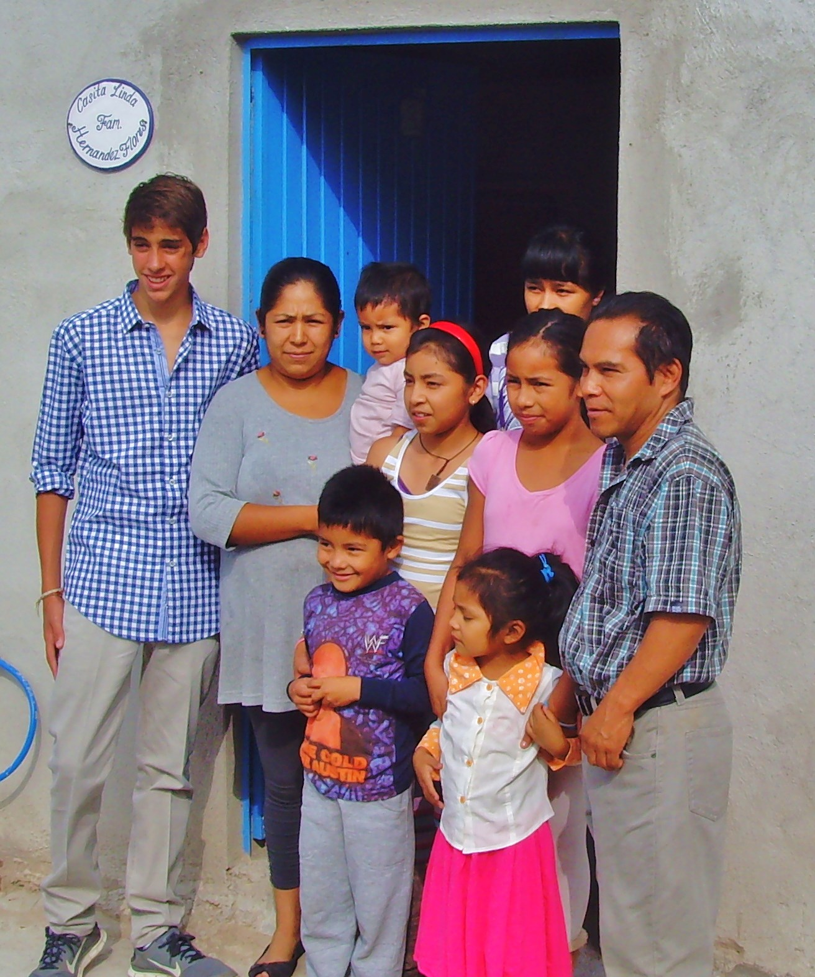
Alex Renaud with Hernandez Flores family

