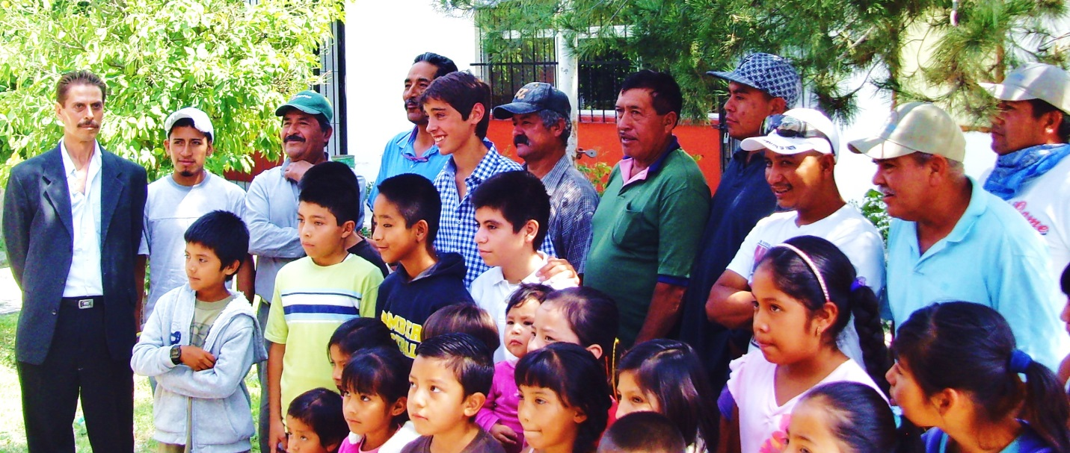
Alex Renaud posing with school children and Casita Linda workers

