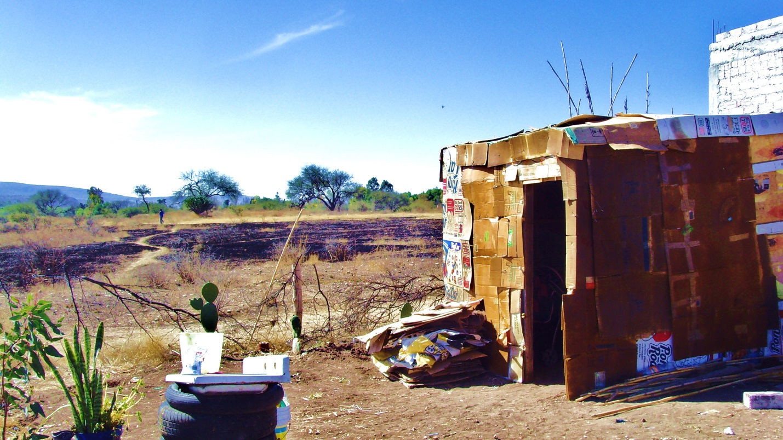

**Site of typical shelter of found materials**