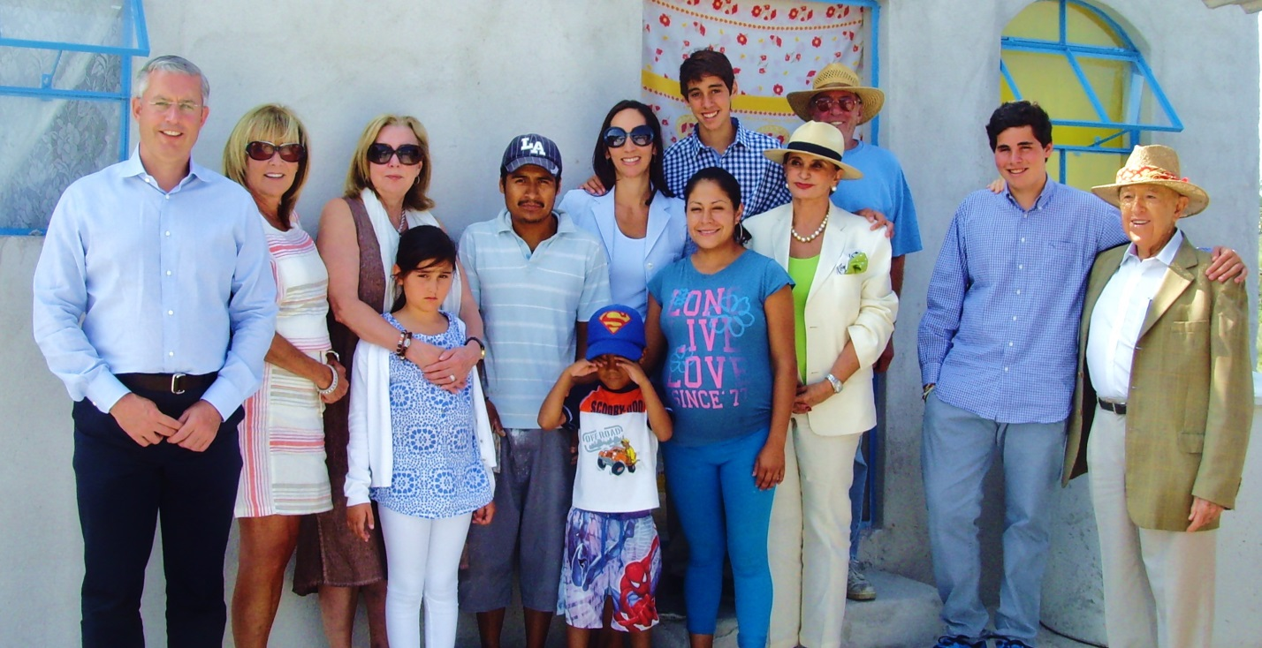
Alex Renaud and family with Casita Linda family

